Mental Health, Well-being and Support For Families – Directory of Services:
Our aim is to create a mentally wealthy school, where our pupils, Parents and Carers and staff have the tools and the resilience to deal with life and flourish academically emotionally and within their relationships.
For full details of activities and interventions for children at The Coppice (insert link to the well-being page in the key information section of the website).

Below are a number of third-party websites which we believe provide very valuable content and support related to mental health and well-being. Links and a brief description of each service are provided:

Worcestershire Family Hub: Support for Parents, Carers and Families | 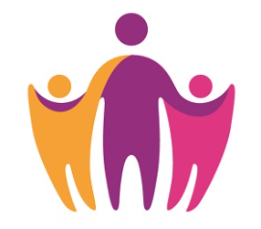 | - This site is run by Worcestershire County Council  - The aim of the site is to ensure families know where to go and get help. The virtual family hub explains the range of different types of resources that are available to you online, on the phone or face to face that you can access directly yourself  - The latest directory of Useful links - Well-being Support For Children & Families can be accessed here:  https://www.worcestershire.gov.uk/council-services/childrens-social-care/virtual-family-hub
Lumi Nova |  | - Lumi Nova is an intergalactic adventure game to support young people to fight fears and manage worries. Whilst exploring planets, customising characters and earning treasure your child breaks their fears and worries down into manageable steps, learning life-long skills and building resilience.  Lumi Nova was created for 7 - 12 year olds (school years 2 - 7) who are having difficulties with fears, worries, or anxiety related to social situations, separation or phobias. However, some Parents or Carers may feel it is also appropriate for their Year 1 child and, therefore, we will leave it to your discretion to decide on this.  https://luminova.app/
Melo | 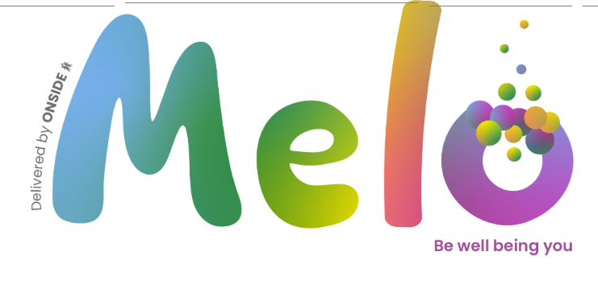 | Melo provides a range of early intervention and preventative support options to improve the mental wellbeing and mental health of a child or young person from birth to 25 and that of their family. This is a service that parents can self-refer into. You will be told about this service if your child is suffering with their mental health and you are concerned. Melo run by Onside.  https://www.onside-advocacy.org.uk/melo
Young  Minds |  | Young Minds is full of advice and information to give young people the tools to look after their mental health. They aim to empower parents and professionals to be the best support they can be to the young people in their lives. Their mission is to give young people the space and confidence to get their voices heard and change the world they live in in order to ensure a world where no young person feels alone with their mental health.  https://www.youngminds.org.uk/
The Lily Jo Project |  | - This site is excellent and provides support and guidance on a whole range of mental health topics such as self-care, anxiety and stress, low self-esteem, grief and loss and childhood trauma  - It is for both adults and children and is a very accessible platform that we see as the ideal starting point for all matters related to mental health and wellbeing  https://www.thelilyjoproject.com/
Kooth |  | - Kooth is a digital mental health and wellbeing company working to provide a welcoming space for digital mental health care, available to all  https://www.kooth.com/
Place2Be | 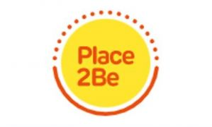 | - Place2Be is a children’s mental health charity with over 25 years’ experience working with pupils, families and staff in UK schools  - Provide mental health support in schools through one-to-one and group counselling using tried and tested methods backed by research.  https://www.place2be.org.uk/
Mental Health UK | 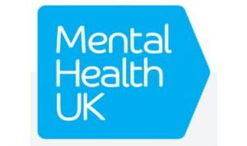 | - Provides support and services for some of the biggest societal challenges that pose a threat to people’s mental health, including money problems, navigating the system to get the right support, understanding mental health, loneliness and isolation, and resilience in young people  - https://mentalhealth-uk.org/
Mind |  | - Provides advice and support to empower anyone experiencing a mental health problem Mind also campaigns to improve services, raise awareness and promote understanding.  https://www.mind.org.uk/
NHS |  | - Find out how to access NHS mental health services and where to get urgent help.  https://www.nhs.uk/nhs-services/mental-health-services/
Child Bereavement  UK | 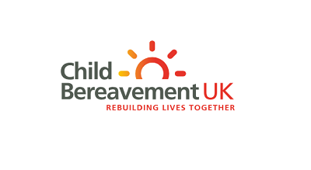 | Child Bereavement UK helps families to rebuild their lives when a child grieves or when a child dies. We support children and young people (up to the age of 25) when someone important to them has died or is not expected to live, and parents and the wider family when a baby or child of any age dies or is dying.  https://www.childbereavementuk.org/
Winston’s Wish | 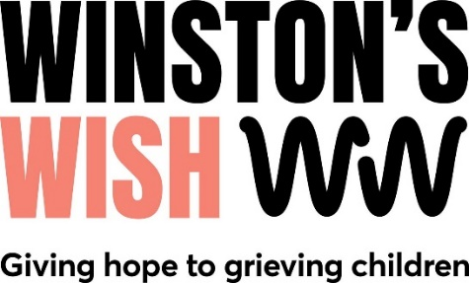 | Winston’s Wish is a charity that offers free, accessible online grief support to children and young people (aged 25 or under) across the UK who are bereaved or facing the death of someone important.  https://winstonswish.org/
Cranstoun | 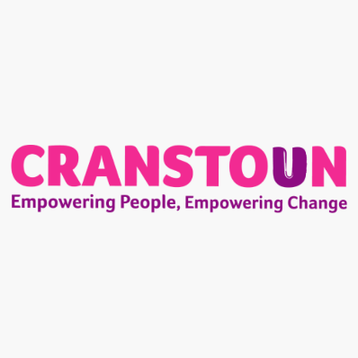 | Cranstoun provides services for adults and young people who need support around alcohol and other drugs, domestic abuse, housing and criminal justice.  Their job is to make people feel safe and to empower them with the tools to create lasting change and reduce harm.  https://cranstoun.org/

