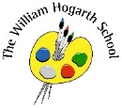
Autumn 1 Term Newsletter Year 5
Maths
We will begin with place value and have a real emphasis on mental calculation/arithmetic using the four operations (addition, subtraction, multiplication and division). We will be looking at problem solving and reasoning strategies.
Science
We will be learning about ‘energy’. Our main focus will be on the different types of energy stores and using maths to calculate forces.
P.E.
We will be taking part in invasion games this term (Monday) and learning how to swim. (Thursday)
Story time Book
The Secret of Platform 13
English
This term we shall explore the book “Henry’s Freedom Box”. When Henry Brown climbed into his Freedom Box, he hoped he'd be carried to a safe world. He brought along a small tool to make air holes, a little water, and a few biscuits. Henry arrived in Philadelphia, having travelled 350 miles from Richmond, Virginia, in 27 hours. We shall use the text to study Fiction and Non-fiction writing, such as - diary and biography.

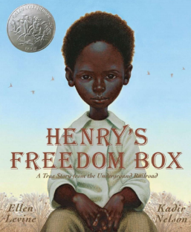
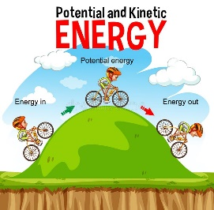
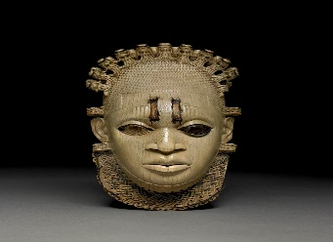
PSHE
Year 5 will be focusing on ‘Being Me’. This will helps us to understand what it means to be ‘me’ and knowing our rights and responsibilities.

Humanities
Year 5 will be learning about the Benin Kingdom. The children will explore how it began, what life was like, how were trade links established, what led to the civil war in the 1700s, the Transatlantic Slave Trade and why the British colonised Benin and what type of impact this had.
Music
We will learn what a PULSE or a steady beat means. To learn to keep a pulse through actions while singing a song and to follow a changing tempo.
Computing
We will be deepening our understanding of On-Line safety. Our focus will be - Social media, Cyberbullying, Online communication and Digital footprints

R.E.
This term we will be learning about Hinduism and understand how to put it into practice.
Our key question is: - What is the best way for a Hindu to show commitment to God?

