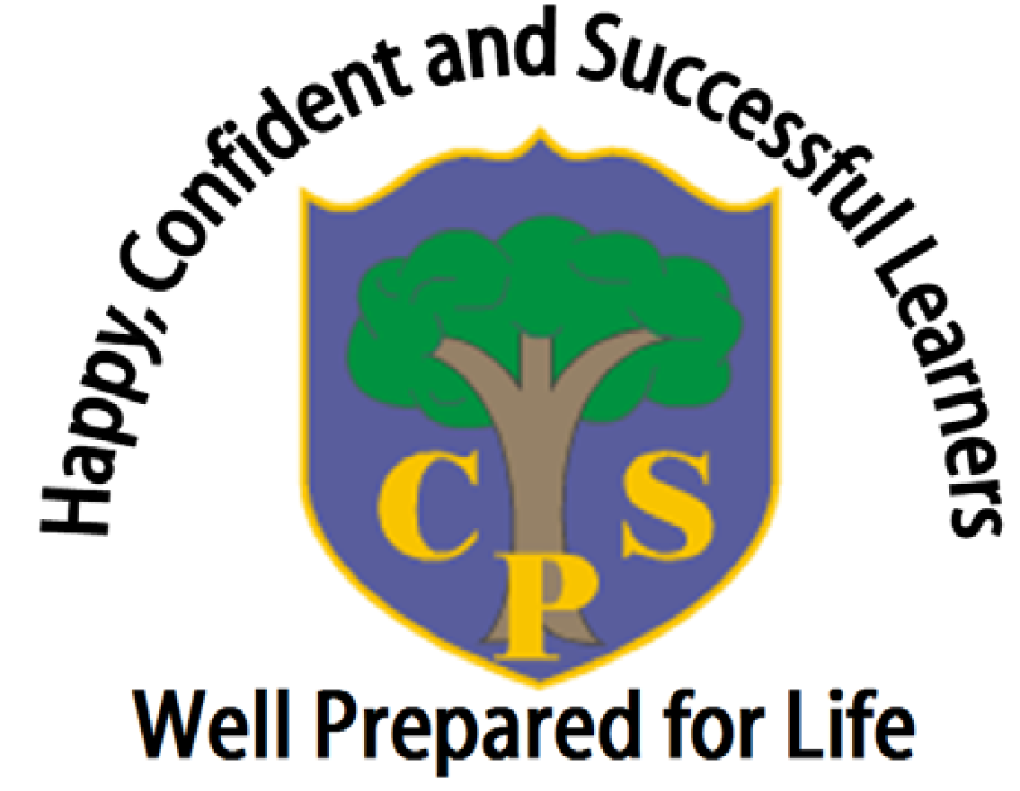
The Coppice Primary School
Religious Education Policy

Written by | Jessica Danby
Approved by Trustees | June 2026
Date for Review | June 2027

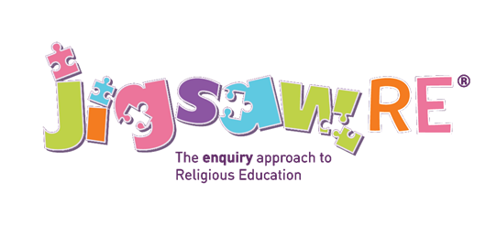

1. School Vision:
‘Happy, confident and successful learners that are well prepared for life’
2. Purpose:
This policy reflects the school’s values and philosophy in relation to the teaching and learning of RE at The Coppice Primary School. It sets out a framework within which teaching and non-teaching staff can operate and sets out the school expectations of planning, teaching and assessment. The policy should be read with each year group’s curriculum planning.
3. This document is intended for:
-All teaching and school management staff
-All Teaching Assistants and pupil support staff
-School Trustees
-Parents and carers
-Inspection teams

4. Introduction:

Religious Education is unique in the school curriculum in that it is neither a core subject nor a foundation subject but the 1988 Education Act states that ‘Religious Education has equal standing in relation to core subjects of the National Curriculum in that it is compulsory for all registered pupils’.
Religious Education is taught in our school because:
“In religious education, pupils enter into a rich discourse about the religious and non-religious traditions that have shaped Great Britain and the world. RE in primary and secondary schools enables pupils to take their place within a diverse multi-religious and multi-secular society. At its best, it is intellectually challenging and personally enriching. It affords pupils both the opportunity to see the religion and non-religion in the world, and the opportunity to make sense of their own place in that world” (Research Review Series: Religious Education, Ofsted, 2021).
Coppice Primary School is an academy school that delivers RE in line with the Worcestershire Agreed Syllabus for Religious Education (2020-2025). We use the Jigsaw RE programme as our scheme of work which fits with our school vision statement, ‘happy, confident successful learners, prepared for life’ through its engaging and enquiry-based approach.In the most effective RE teaching, enquiry is placed at the heart of learning (Religious Education – Realising the Potential, 2013). Jigsaw RE also supports our mission statement of cherishing and valuing.

4.1 Legal Guidance:

All schools that are state-funded are legally required to provide RE as part of their curriculum. All schools are required to teach RE to all pupils at all key stages (including sixth form), except for those whose parents have exercised the right to withdrawal.

In accordance with The Education Act (1996), The School Standards and Framework Act (1998) and The Education Act (2002), The Coppice Primary School provides Religious Education (R.E.) for all pupils registered at the school - this requirement does not apply for children below compulsory school age. R.E. is a statutory subject but not part of the National curriculum. It must be taught in accordance to a locally agreed syllabus, prepared by a specially convened standing conference (Worcestershire Agreed Syllabus for Religious Education, 2025-1030). The Education Act (1944) requires that an agreed syllabus ‘must not be designed to convert pupils, or to urge a particular religion or religious beliefs on pupils’. The relevant Acts state that the R.E. syllabus should reflect the fact that the religious traditions in Great Britain are in the main Christian and that it should, at the same time, take account of the teachings and practices of other major religions.
As detailed in the School Standards and Framework Act 1998 S71 (3), parents may withdraw their children from RE on the grounds that they may wish to provide their own religious education. Where the pupil has been withdrawn, the law provides for alternative arrangements to be made for RE of the kind the parents want the pupil to receive. This will be the parents’ responsibility to state this in writing, annually, to the Head Teacher.
Teachers can also exercise their right to withdraw from teaching the subject. However, it is hoped that by following the Agreed Syllabus for Worcestershire, teachers will feel comfortable with the type of R.E. being taught at The Coppice Primary School.
4.2 Statutory guidance:

This RE policy is informed by current national guidance:
- RE in English Schools: Non-statutory guidance 2010 (https://www.gov.uk/government/uploads/system/uploads/attachment_data/file/190260/DCSF-00114-2010.pdf)
- RE : realising the potential Ofsted 2013 (www.ofsted.gov.uk/resources/religious-education-realising-potential)
- A Curriculum Framework for RE in England, REC 2013 (http://resubjectreview.recouncil.org.uk/re-review-report)

An amendment to the Children and Social Work Act 2017 has made Relationship and Health Education statutory subjects within the primary curriculum from September 2020. Although, Sex Education remains non-statutory at primary (apart from the teaching of body changes during puberty within the Science National Curriculum), the Coppice Primary School values the teaching about physical, moral and emotional development.

4.3 Withdrawal of students from Religious Education

Parents/carers have the right to withdraw their children from all or part of RE. Those parents/carers wishing to exercise this right will be invited in to see the head teacher and RE Leader who will explore any concerns and discuss any impact that withdrawal may have on the child. The school will ensure that parents who want to withdraw their children from RE are aware of the RE syllabus and that it is relevant to all pupils, and respects their own personal beliefs. Parents will be made aware of the learning objectives and what is covered in the RE curriculum and will be given the opportunity to discuss this, if they wish. Any requests received will be reviewed each year, in discussion with the parents.

The use of the right to withdraw will be at the instigation of parents and it will need to be made clear whether it is from the whole of the subject or specific parts of it. No reasons need be given. Where parents do request that their child is withdrawn, their right must be respected. Once a child has been withdrawn, they cannot take part in the RE programme until the request for withdrawal has been removed.

As a school it is our duty to inform our local Standing Advisory Council on RE regarding the numbers of children being withdrawn.

5. Aims of Religious Education, using the Jigsaw RE framework

Jigsaw RE meets the requirements of our locally agreed syllabus and is aligned to the non- statutory guidance described above.
By following Jigsaw RE at Coppice Primary School, we intend that Religious Education will:-
- adopt an enquiry- based approach as recommended by Ofsted, beginning with the children’s own life experience before moving into learning about and from religion.
- provoke challenging questions about the meaning and purpose of life, beliefs, the self, and issues of right and wrong, commitment and belonging. It develops pupils’ knowledge and understanding of Christianity, other principal religions, and religious traditions that examine these questions, fostering personal reflection and spiritual development.
- encourage pupils to explore their own beliefs (religious or non-religious), in the light of what they learn, as they examine issues of religious belief and faith and how these impact on personal, institutional and social ethics; and to express their responses.
- enable pupils to build their sense of identity and belonging, which helps them flourish within their communities and as citizens in a diverse society.
- teach pupils to develop respect for others, including people with different faiths and beliefs, and helps to challenge prejudice.
- prompt pupils to consider their responsibilities to themselves and to others, and to explore how they might contribute to their communities and to wider society. It encourages empathy, generosity and compassion.
- develop a sense of awe, wonder and mystery.
- nurture children’s own spiritual development.

6. RE Curriculum Planning:
Jigsaw RE covers all areas of RE for the primary phase. Each year group will complete one enquiry based question each half term. All year groups will cover three religions each year, including a minimum of two Christianity enquiries, in addition to a range of other main religions and worldviews.

Religious Education in the Early Years Foundation Stage (EYFS)
In the Early Years Foundation Stage, RE is delivered through the statutory area of learning Understanding the World, as set out in the Early Years Statutory Framework. Planning is informed by Development Matters alongside the EYFS content within the Jigsaw RE scheme, ensuring that learning is age-appropriate, inclusive and supports children’s early understanding of religion and belief. In Nursery, the focus is on helping children develop a strong sense of self by learning about their own families, family histories and experiences, while also developing positive attitudes towards difference and diversity. Children are supported to notice similarities and differences between themselves and others in a respectful and meaningful way. In Reception, children build on this foundation by learning that people hold different beliefs and celebrate special times in different ways. As part of this learning, Reception children visit St Mary’s Church to help them develop an understanding of a place of worship within their local community. In both Nursery and Reception, RE is taught through planned focus weeks rather than weekly discrete lessons, often delivered as blocked learning around celebrations and special times throughout the year. These focus weeks are carefully chosen to reflect celebrations that children experience within their own families and communities, and learning is often planned jointly across Nursery and Reception to allow for shared experiences and discussion.

7. Curriculum Overview

Year 1  Ages 5-6 | What do Christians believe about God?  (5-6 C Autumn 1) | What gifts might Christians in my town have given Jesus if he had been born here rather than in Bethlehem?  (5-6 C Autumn 2) | Is Shabbat important to Jewish children?  (5-7 J Enquiry 2) | Why was Jesus welcomed like a king or celebrity by the crowds on Palm Sunday?  (5-6 C Spring 2) | Does visiting the synagogue help Jewish children feel closer to God?  (5-7 J Enquiry 3) | Who is God to Sikhs?  (5-7 S Enquiry 1)
Year 2  Ages 6-7 | Is it possible to be kind to everyone all of the time?  (6-7 C Autumn 1) | Why do Christians believe God gave Jesus to the world?  (6-7 C Autumn 2) | Who is God to Muslims?  (5-7 I Enquiry 1) | How important is it to Christians that Jesus came back to life after his crucifixion?  (6-7 C Spring 2) | How important is the Qur’an to Muslims?  (5-7 I Enquiry 3) | Why do Sikhs admire their Gurus?  (5-7 S Enquiry 2)  OR  Does taking part in the Baisakhi help Sikh children feel a sense of belonging?  (5-7 S Enquiry 3)
Year 3  Ages 7-8 | What is the best way for a Jew to lead a good life?  (7-9 J Enquiry 1) | How does celebrating Shavuot help Jewish children feel closer to God?  (7-9 J Enquiry 3) | Do people need to go to church to show they are Christians?  (8-9 C Summer 2) | What is ‘good’ about Good Friday?  (7-8 C Spring 2) | Does joining the Khalsa make someone a better Sikh?  (7-9 S Enquiry 1) | Do Sikhs think it is important to share?  (7-9 S Enquiry 2)
Year 4  Ages 8-9 | Does praying at regular intervals help Muslims in their everyday lives?  (7-9 I Enquiry 1) | Does belief in the Trinity help Christians make better sense of God as a whole?  (9-10 C Optional) | What is the best way for a Muslim to lead a good life?  (7-9 I Enquiry 3) | Is forgiveness always possible for Christians?  (8-9 C Spring 2) | What do some deities tell Sanatanis about God?  (7-9 SD Enquiry 2) | What is the best way for a Sanatani to lead a good life?  (7-9 SD Enquiry 3)
Year 5  Ages 9-10 | How are sacred teachings and stories interpreted by Jews today?  (9-12 J Enquiry 3) | How did Jesus create a “New Covenant” and what does that mean to Christians today?  (10-12 C Optional) | How far would a Sikh go for their religion?  (9-12 S Enquiry 1) | How do the events of Easter and Pentecost impact on Christians today?  (10-12 C Spring 2 Alt) | How are sacred teachings and stories interpreted by Sikhs today?  (9-12 S Enquiry 2) | What is the best way for a Sikh to show commitment to God?  (9-12 S Enquiry 3)
Year 6  Ages 10-11 | Do beliefs in Karma, Samsara and Moksha help Sanatanis lead good lives?  (9-12 SD Enquiry 3) | Does belief in Akirah (life after death) help Muslims lead a good life?  (9-12 I Enquiry 3) | Is anything ever eternal?  (10-11 C Spring 1) | Is Christianity still a strong religion over 2000 years after Jesus was on Earth?  (10-11 C Spring 2) | What motivates Humanists to lead good lives?  (7-9 H Enquiry 1) | How do inspirational people impact on how Humanists live today?  (9-12 H Enquiry 1)

How is RE organised in this school?
Jigsaw RE brings together learning about and from religion, questioning and spiritual development in a comprehensive scheme of learning. Each half term, the children explore a new enquiry question and receive one discrete RE lesson each week.Teaching strategies are varied and are mindful of teaching and learning theories and the need for adaptive teaching. Each enquiry starts from the children’s own life experiences using these as a bridge into the investigation of the religion being studied.
Learning is assessed and children have opportunity to express their own thoughts and beliefs and empathise with believers of that religion or belief position.

Differentiation/SEN
Jigsaw RE is written as a universal core curriculum provision for all children. Inclusivity is part of its philosophy. Teachers will add to the planning to meet the needs of the children in their classes. To support this, many enquiries suggest creative learning activities that allow children to choose the media with which they work and give them scope to work to their full potential. To further help teachers adapt the teaching, for children in KS1 and 2, each enquiry has exemplars for those children working towards the learning objective, at the expected level for this age group and those working beyond the expected level of achievement.
Assessment
Teachers are eager to ensure children are making progress with their learning throughout their RE. Therefore, each enquiry has a built-in assessment. This task is the formal opportunity for teacher assessment of the children’s knowledge of that religion, depth of critical thinking, and ability to answer the enquiry question. This stand-alone evidence is used in conjunction with other evidence such as records of discussions and annotations from other lessons within the enquiry to assist the teacher in assessing whether a child is working at the expected level or towards or beyond it. Children are assessed over three aspects of learning:
- a personal resonance with or reflection on the material/religion being studied to answer the enquiry question.
- knowledge and understanding of the material/religion being studied to answer the enquiry question.
- evaluation/critical thinking in relation to the enquiry question
- These are tracked throughout the planning stage so that teachers can utilise the appropriate evidence accordingly. In line with non-statutory guidance issued by the RE Council in 2013 (cited on page 1) descriptors of these aspects utilise age–related expectations of working towards, working at the expected attainment and working beyond.
Recording and tracking progress
- To support the teacher in tracking each child’s progress throughout the year, there is an overview sheet for each enquiry on which to record the progress of the whole class. This supports teacher overview and facilitates subject leader monitoring and moderation.
Reporting to Parents/Carers
The assessment process described above helps teachers report to parents/carers. Jigsaw RE enquiries give teachers meaningful evidence to cite in reports.
The Attainment Descriptors
The attainment descriptors contained within Jigsaw RE are 3-fold to match with what the majority of schools are using, although their language may be different.
Monitoring and evaluation
The RE leader monitors delivery of the programme through observation and discussion with teaching staff, as well as discussions with children and scrutiny of their written work to ensure consistent and coherent curriculum provision.
Evaluation of the programme’s effectiveness is conducted on the basis of:
· Pupil and teacher evaluation of the content and learning processes
· Staff meetings to review and share experience
· Monitoring of assessment to ensure progression throughout the school.

External contributors
- RE gives particular opportunities to promote an ethos of respect for others, challenge stereotypes and build understanding of other cultures and beliefs. This contributes to promoting a positive and inclusive school ethos that champions democratic values and human rights. The British Values agenda is intrinsic to Jigsaw RE and a map of coverage is available on request.
- External contributors from the community, e.g. local clergy, local members/speakers from other religions etc make a valuable contribution to the RE programme as do visits to places of worship. Their input is carefully planned and monitored so as to fit into and complement the programme.
- Teachers are always present during these sessions and remain responsible for the effective delivery of the RE programme.

The Learning Environment
- Establishing a safe, open and positive learning environment based on trusting relationships between all members of the class, adults and children alike, is vital. To enable this, it is important that respect for each others’ views and beliefs and those of the believers of that religion is encouraged at all times and that any artefacts are handled with respect and care. For this reason we provide the Jigsaw RE Charter.
Teaching Sensitive and Controversial Issues
Sensitive and controversial issues are certain to arise in learning from real-life experience and discussing personal beliefs.
Topics are presented using a variety of views and beliefs so that pupils are able to form their own, informed opinions but also respect that others have the right to different opinions. Teachers should never feel obliged to discuss their own beliefs unless they feel comfortable doing so and can ensure that this will not influence or restrict the children’s own expression.
Involving parents and carers
The school believes that it is important to have the support of parents, carers and the wider community for the RE programme. Parents and carers are/will be given the opportunity to find out about and discuss RE through:
- Response to RE comments on reports
- Curriculum newsletters
- Displays
- (Where RE is integrated- topic based homework as appropriate).

Links to other policies and curriculum areas
We recognise the clear link between RE and the following policies and staff are aware of the need to refer to these policies when appropriate.
- Teaching and Learning Policy
- Equal Opportunities Policy
- Child Protection Policy
- SMSC Policy
- British Values
- Prevent Strategy

Training and support for staff
All staff benefit from training in order to enhance their RE delivery skills. Opportunities are provided for staff to identify individual training needs on a yearly basis and relevant support is provided.

Dissemination
This policy is available on our school website where it can be accessed by the community. Training is regularly delivered to staff on the policy content. Copies are available from the school office on request from parents/carers.

8. Monitoring and Review:
The policy and practice will be monitored and evaluated by:

-The PSHE and RSE Leader.
-The Senior Leadership Team (SLT).
- The school Trustees.
-Local Authority Advisors and Ofsted Inspectors.

The PSHE and RSE Leader will agree the curriculum timetabling of PSHE/RSE with staff which will enable lesson observation through ‘drop-ins’ and full lesson observations where appropriate as part of staff development.
Feedback on PSHE and RSE will be obtained from group discussions with teachers and pupils. Parents’ views will be invited and welcomed at Parents’ evenings and through The Coppice Parent Forum.

9. Data Protection Statement:
The procedures and practice created by this policy have been reviewed in the light of our GDPR Data Protection Policy.
All data will be handled in accordance with the school’s GDPR Data Protection Policy.

Name of policy | Content | Reason for policy | Who does it relate to? | Where is it stored?
PSHE and RSE | Key information concerning the teaching and learning of PSHE and RSE | To inform all  stakeholders on  how PSHE and RSE is taught at The Coppice. | Children,  Teachers,  Parents,  Trustees and  Ofsted. | School P’ Drive  Google Drive

As such, our assessment is that this policy:
Has Few / No Data Compliance Requirements | Has A Moderate Level of Data Compliance Requirements | Has a High Level Of Data Compliance Requirements

