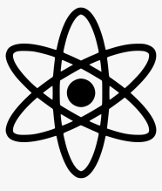
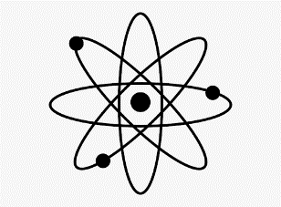
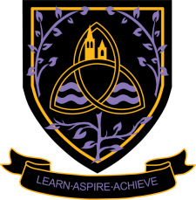
Physics
A Level 2024 - 2026
Wigston College

Examination Board
OCR Specification A H556
Entry Requirements:
GCSE Grade 6 in Physics or 6,6 in Combined Science. Grade 5 in GCSE Maths
What will I be studying?
Content is split into six teaching modules:
Module 1 – ‘Development of practical skills in physics’ (Year 12 and 13)
Practical skills are embedded throughout all the content of this specification. Learners will be required to develop a range of practical skills throughout their course in preparation for the written examinations.
Module 2 – Foundations of physics (Year 12)
The aim of this module is to introduce important conventions and ideas that permeate the fabric of physics. Understanding of physical quantities, S.I. units, scalars and vectors helps physicists to effectively communicate their ideas within the scientific community
Module 3 – Forces and motion (Year 12)
In this module, learners will learn how to model the motion of objects using mathematics, understand the effect forces have on objects, learn about the important connection between force and energy, appreciate how forces cause deformation and understand the importance of Newton’s laws of motion.
Module 4 – Electrons, waves and photons (Year 12)
In this module, learners will learn about electrons, electric current, electrical circuits, wave properties, electromagnetic waves and, of course, quantum physics. Learners have the opportunity to appreciate how scientific ideas of quantum physics developed over time and their validity rested on the foundations of experimental work
Module 5 – Newtonian world and astrophysics (Year 13)
In this module, learners will learn about thermal physics, circular motion, oscillations, gravitational field, astrophysics and cosmology.
Module 6 – Particles and medical physics (Year 13)
In this module, learners will learn about capacitors, electric field, electromagnetism, nuclear physics, particle physics and medical imaging.

How will I be studying?
Students work individually. They are expected to pre-read each topic prior to the lesson, take part in class discussion and make their own detailed notes after the lesson. Support is available in addition to lessons, each lesson is supported by multimedia resources, and a multitude of extra resources is available both written and on-line. At least one hour of independent study is required for each hour of teaching.

How will I be assessed?
Assessment is by 3 written papers
Modelling physics 2 hours 15 minutes written paper 37% of total A level.
Exploring physics 2 hours 15 minutes written paper 37% of total A level.
Unified physics 1 hour 30 minutes written paper 26% of total A level
Core Mathematics:

As this subject contains elements of mathematical content within its specification and assessments, we strongly advise that you should also elect to take the Core Mathematics course to support your studies (if not already taking A Level Mathematics). The Core Mathematics course is a one-year course specifically designed for this purpose. You would still need to pick three main Level 3 subjects plus Core Mathematics. Please see the Core Mathematics information sheet for more details.

Where Next?
Physics is a highly valued A level, because it is acknowledged to be very challenging to obtain. Students typically move on to careers in Medicine, Engineering and of course Physics. The A Level Physics course will prepare learners for progression to undergraduate study, enabling them to enter a range of academic and vocational careers in mathematics-related courses, physical sciences, engineering, medicine, computing and related sectors. For learners wishing to follow an apprenticeship route or those seeking direct entry into physical science careers, this A level provides a strong background and progression pathway.

