Pupil premium strategy statement 2025-2026

This statement details our school’s use of pupil premium funding to help improve the attainment of our disadvantaged children.

It outlines our pupil premium strategy, how we intend to spend the funding in this academic year and the effect that last year’s spending of pupil premium had within our school.

School overview
Detail | Data
School name | Brooklands Primary School
Number of children in school | 641
Proportion (%) of pupil premium eligible children | 3.59%
Academic year/years that our current pupil premium strategy plan covers (3 year plans are recommended) | 2024-2025, 2025-2026, 2026-2027
Date this statement was published | 11/2025
Date on which it will be reviewed | 11/2026
Statement authorised by | John Beith
Pupil premium lead | Tom Shrimpling
Governor / Trustee lead | Anne Madden

Funding overview
Detail | Amount
Pupil premium funding allocation this academic year | £43765
Recovery premium funding allocation this academic year | £0
Pupil premium funding carried forward from previous years (enter £0 if not applicable) | £0
Total budget for this academic year  If your school is an academy in a trust that pools this funding, state the amount available to your school this academic year | £43765

Part A: Pupil premium strategy plan

Statement of intent
At Brooklands we want our disadvantaged children to feel as valued and respected as any other group of our school community. We aim that, regardless of a child’s socio-economic context, they are given the same opportunities to succeed as their non-disadvantaged peers.
Our aims lie in three key areas: academic achievement, wellbeing and social/emotional development, and wider enrichment opportunities.
Our plan works towards achieving these objectives through a broad deployment of resources into all these three areas which we believe have equal importance and are largely interchangeable.
Children will be supported to achieve well academically by receiving extra support to fill gaps in learning, improve teacher practice and by levelling starting points. Those children requiring wellbeing support will be helped to develop a positive view of school, will receive help to overcome and regulate their emotions and as a result be happier and better learners. They will also be given wider opportunities that their peers may experience that would not otherwise be readily available to them, supporting their self-esteem and providing contextual understanding for their classroom learning.
We believe in a ‘high tide raises all ships’ approach, and that if we implement initiatives targeted at our disadvantaged children, that where possible we should attempt to roll this out to all children to benefit from. This would achieve our aim of our disadvantaged children achieving in-line with their non-disadvantaged peers nationally, whilst improving outcomes for all. That said, we have a relatively small proportion of disadvantaged children and so whilst each pupil will be worth more in terms of attainment and progress data, it also allows us to know our children individually, ensure they are receiving access to a wide range of educational opportunities and to closely monitor their progress.
All these strategies will be regularly reviewed for impact and adjusted as appropriate to seek the best value for money for our children.

Challenges

This details the key challenges to achievement that we have identified among our disadvantaged children.
Challenge number | Detail of challenge
1 | Lower academic starting points compared to peers
2 | Lower levels of early reading and access to the curriculum
3 | Lower levels of social and emotional development
4 | Lost learning time and gaps in learning caused by the pandemic
5 | Lack of enrichment opportunities

Intended outcomes
This explains the outcomes we are aiming for by the end of our current strategy plan, and how we will measure whether they have been achieved.
Intended outcome | Success criteria
Disadvantaged children make accelerated progress in subjects across the curriculum, particularly in reading | - All children make expected or accelerated progress in reading.  - Attainment in-line with non-disadvantaged peers nationally  - Internal data measures show that 70% of disadvantaged children achieving the expected level across the curriculum
Disadvantaged children engage positively with school, showing excellent attendance, conduct, behaviour for learning and report being happy at school. | - Attendance for disadvantaged children at least 95%  - Less than 10% of disadvantaged children have a behaviour incident logged against them  - Pupil reports evidence positive learning behaviours and engagement with learning  - Pupil voice evidences 95% of children are happy to attend school  - Mental Health Practitioner counselling service established within school as part of a SEMH Inclusion structure, including Inclusion Team and clear referral system
Disadvantaged children are supported to engage in extra curricular activities, including school trips, music lessons and extra curricular clubs. Money is allocated to cover the cost of school uniform. | - 100% of disadvantaged children attend educational visits (non-residential) free of charge  - 100% of disadvantaged children’ parents are offered a payment plan to attend residential trips, with school covering 50% of the cost  - 100% of disadvantaged children have attended a school club (internal or external) at some point during the academic year, with school covering the cost of an external club for a term  - 25% of children have accessed 1:1 music tuition or a paid for extracurricular club, with school covering the cost for a term  - 100% of families who request help with uniform receive effective financial support

Activity in this academic year
This details how we intend to spend our pupil premium (and recovery premium funding) this academic year to address the challenges listed above.

Teaching (for example, CPD, recruitment and retention, resources, Inclusive Practice)
Budgeted cost: £15,900
Activity | Evidence that supports this approach | Challenge number(s) addressed
Strong CPD offer for teachers to ensure QFT (quality first teach) linked to school development plan targets (Writing, Resilience, Curriculum) as well as subject specific CPD to improve outcomes across the curriculum (inc SEND and SEMH provision)  £19300 | - Excellent Teaching for All: The school prioritises high-quality teaching in every classroom to drive improved outcomes for all pupils.  - Impactful CPD: A strong CPD offer ensures Quality First Teaching (QFT), aligned with school development priorities (Writing, Resilience, Curriculum), and includes subject-specific training to enhance outcomes across the curriculum, including for SEND and SEMH.  - Universal & Targeted SEMH Support: Whole-class zones work and class-level SEMH strategies are embedded, supported by staff training and targeted interventions to meet emotional and behavioural needs.  - Inclusive Practice: A specialist SEND teacher leads adaptive teaching and inclusive strategies, ensuring disadvantaged pupils benefit from tailored support and raised attainment. Access to 1:1 chromebooks and software packagaes (eg, LBQ, GL assessments, clicker etc), allow pupils to access learning at all levels.  - Direct Benefit to PP children: Pupil Premium funding is used strategically to improve teaching quality and pastoral provision, ensuring disadvantaged pupils receive explicit, measurable benefit through enhanced engagement and academic progress. | Challenge 1  Challenge 2  Challenge 3  Challenge 4  SDP Objective 1  SDP Objective 2  SDP Objective 3  SDP Objective 4

Targeted academic support (for example, tutoring, one-to-one support structured interventions)
Budgeted cost: £7000
Activity | Evidence that supports this approach | Challenge number(s) addressed
In house weekly tutoring / group support led by a qualified teacher/HLTA  £7000 | Tutoring supports pupil premium children in a number of ways:  - Individual Attention: Pupil premium children can benefit from dedicated one-on-one instruction, allowing for focused attention on their specific needs and challenges.  - Remedial Support: Tutors can provide targeted interventions to help overcome learning difficulties, reinforcing key concepts and building confidence.  - Academic Enrichment: Tutors can offer opportunities for extension and enrichment, introducing challenging material and fostering a love for learning.  - Personalised Approach: Tutors can tailor their teaching to meet the individual learning style of pupil premium children, adapting their methods and pace as needed.  - Boosting Confidence: Tutoring can help improve self-esteem and motivation, empowering these students to believe in their abilities and succeed academically. | Challenge 1  Challenge 2  Challenge 3  Challenge 4  SDP Objective 1  SDP Objective 2  SDP Objective 4

Wider strategies (for example, related to attendance, behaviour, wellbeing)
Budgeted cost:
Activity | Evidence that supports this approach | Challenge number(s) addressed
Educational visits (inc residentials in Y5 and 6).  £2466.43 | - Improved Engagement: Trips boost pupil motivation, confidence, and participation, as shown through surveys and teacher observations.  - Social Development: Residentials foster teamwork, resilience, and independence, supporting children' personal growth.  - Equal Access: Funding ensures disadvantaged children can participate equally, reducing barriers and promoting inclusion.  - Curriculum Enrichment: Experiences outside the classroom deepen understanding and support curriculum goals.  - Evidence-Based Practice: Supported by EEF and Ofsted guidance highlighting the value of enrichment in raising attainment. | Challenge 5  SDP Objective 1  SDP Objective 2
Clubs and music tuition subsidies  £12000 | - Boosts Confidence & Self-Esteem: Participation in music and clubs helps children develop pride, identity, and personal achievement.  - Improves Engagement & Attendance: Children involved in enrichment activities often show better attendance and classroom focus.  - Supports Social Skills: Group activities foster teamwork, communication, and friendships, especially for children at risk of isolation.  - Promotes Equity: Funding ensures disadvantaged children can access the same enrichment opportunities as their peers.  - Backed by Research: EEF and Ofsted highlight the value of arts and extracurricular in supporting wider educational outcomes. | Challenge 5  SDP Objective 1  SDP Objective 2
Participation in sporting events throughout the school academic year – employment of sports coach on 25 hours a week  £3000 | - Building self-esteem and confidence by having success and building resilience.  - Improving social skills and teamwork through participating alongside peers  - Boosting engagement and motivation by having positive experiences of school life  - Enhancing physical and mental health through exercise and teamwork  - Developing discipline which will have a positive impact in being able to transfer to more academic work  - Expanding opportunities beyond those available to them outside of school | Challenge 5  SDP Objective 1  SDP Objective 2
Total budgeted cost: £ 43766.43

Part B: Review of outcomes in the previous academic year

Pupil premium strategy outcomes
This details the impact that our pupil premium activity had on children in the 2024 to 2025 academic year.

 | GLD (EYFS) | Phonics Screening (Y1) | Non Statutory SATS combined (R, W, M) (Y2) | Multiplication Check (MTC) (Y4) - % of children scoring full marks | SATS – Maths (Y6)  ARE+ | SATS – Reading (Y6)  ARE+ | SATS – Writing (Y6)  ARE+ | Whole School
 |  |  |  |  |  |  |  | M | R | W
2023 / 2024 | 100% | 50% | N/A | 67% | 100% of which 20% GD | 100% of which 20% GD | 80% | 66% ARE  10%  GD | 72% ARE  10%  GD | 52% ARE  3%  GD
2024/2025 | 100% | 100% (One Y2 resit) | N/A | 67% | 62% of which 43% GD | 43% of which 29% GD | 43% | 64% ARE  12% GD | 60% ARE  16% GD | 48% ARE  4% GD
National (from Insight)  2024/2025 | 69% | 80% | N/A | 38% | 74% ARE  26% GD | 75% ARE  33% GD | 72% ARE  13% GD

Progress
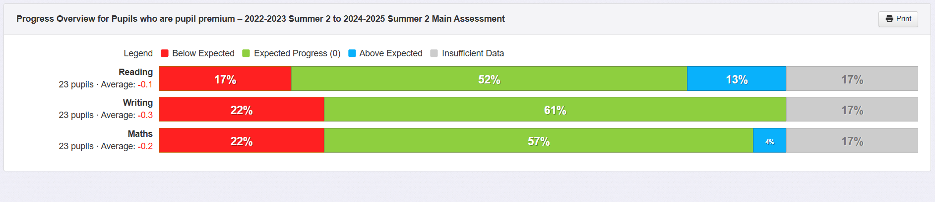

Summary
The school continues to perform above national averages in key performance indicators for Pupil Premium children, including outcomes at the end of EYFS, Year 1 Phonics Screening, and the Year 4 Multiplication Tables Check (MTC). In Year 6 this year, 2 of the 7 Pupil Premium children have an Education, Health and Care Plan (EHCP), with one pupil spending a significant portion of the year in alternative provision. Of the 7 children, 4 have identified SEND and SEMH needs, including two previously looked-after children. All four children received intensive pastoral support, including weekly 1:1 sessions with a learning mentor and access to 1:1 play therapy, to help address barriers to learning and wellbeing.
In terms of progress, our PP children continue to make good progress, with 13% making accelerated progress in reading and 4% in writing. Of the four children (reading) and five children (writing and maths) making slow progress, we have identified their barrier and area of need and have put a pupil profile into place to ensure they get the required support.

Attendance Data
2024/2025
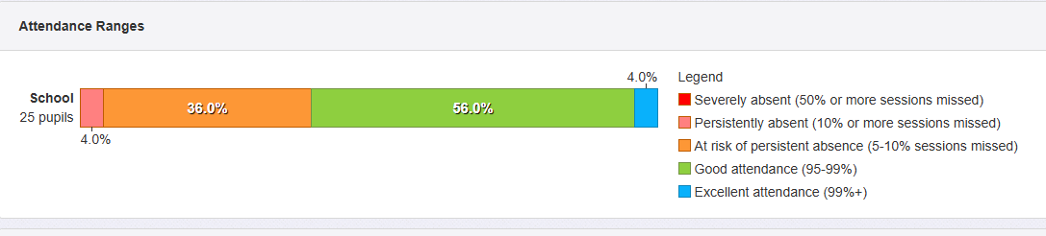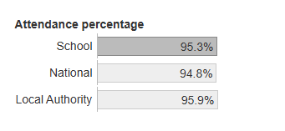
2023/2024
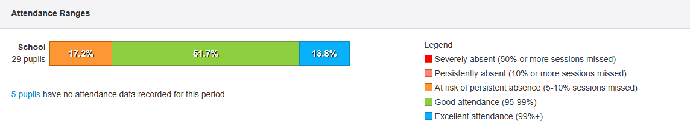

Summary
Attendance for Pupil Premium children has declined compared to the previous academic year. In Year 6, four children were identified as being at risk due to low attendance; these children have now left the school. One pupil remains persistently absent and is currently being supported through our attendance management procedures. We continue to monitor attendance thoroughly, with clear evidence that our long-term strategies are effective. Pupil Premium children are separately tracked and regularly discussed in attendance meetings to ensure timely intervention and support.
Other Impact Measures

Educational Visits
100% of Pupil Premium children were able to attend educational visits free of charge and all were offered a payment plan for residential visits, of which 71% attended (5 of 7).

Extra-curricular clubs (free)
A comprehensive menu of internal and external clubs is in place with priority given to PP children for internal clubs, and school covering the cost of a term’s worth of external club attendance. All children are offered the opportunity to attend a free lunchtime and all children were offered the opportunity of one term of a free (charged) after school club. All PP children attended an internally ran club.

Extra-curricular clubs (paid for – inc music)
40% of PP children (10/25) attended a paid for sports club during the academic year.

Sports Participation
64% (16/25) of PP children represented the school in one or more sporting events across the academic year. The majority of the remaining children were in KS1 where there no opportunity to do so.

SEMH Provision
48% (13/25) of PP children received targeted or specialist pastoral support. The other 12 children did not require the support.

Behaviour
26% of pupil premium children had a behaviour incident logged as part of school’s internal behavioural process.

