|  |  |
| --- | --- |
| **Holy Name – Religious Education knowledge map** | |
| **Year 3** | **Topic 3.3 ‘Sacrament of Reconciliation’** |

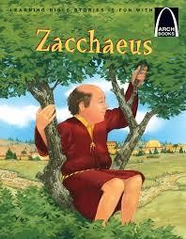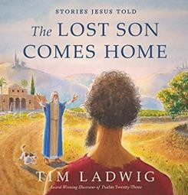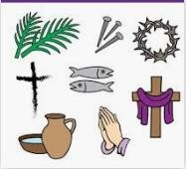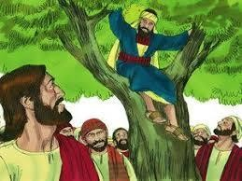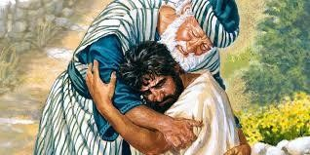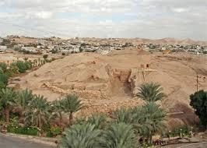

|  |
| --- |
|  |
| What should I already know? |
| * The children will build on previous topics from R and Y2 about Lent and The Good News. * Children will have had opportunities to reflect on their friendships and how, after they fall out, they put things right again. * Children will know what it means to forgive somebody. |

# What will I know at the end of the unit?

|  |  |
| --- | --- |
| Key Vocabulary | |
| Almsgiving | Charitable giving |
| Act of Sorrow | A prayer to say how sorry to God we are for our sins |
| Celebrate | To rejoice and be happy, and to do something special |
| Confession | In the Sacrament of Reconciliation, when you tell the priest  your sins |
| Forgiveness | When someone forgives someone else, pardons or lets them  off |
| Liturgy | Worshiping God in public prayer |
| Love | The virtue by which we love God above all things for his own  sake, and our neighbour as ourselves for the love of God. |
| Reconciliation | The sacrament we receive when we confess and receive  forgiveness for our sins |
| Sacrament | A very important gift from Jesus, when we receive special help  and grace |
| Sinner | A person who sins by making the wrong choice |
| Sorrow | A feeling of deep sadness |
| Sorry | Feeling regret for something and trying our best not to do it  again |

|  |  |
| --- | --- |
|  | |
|  | |
|  |  |
|  |  |
|  |  |
|  |  |
|  |  |
|  |  |
|  |  |
|  |  |
|  |  |
|  |  |
|  |  |
|  |  |

* Retell one of Jesus’ stories of forgiveness, ensuring it is accurate in its sequence and detail.
* Describe with increasing detail and accuracy the beliefs that Christians hold about God, from the stories of forgiveness.
* Make a simple link between the stories of forgiveness and beliefs about reconciliation
* Make a simple link between the beliefs Christians hold about Lent (Lenten promise, three Christian duties- prayer, fasting, and almsgiving) and how it affects their behaviour.
* When considering the stories of Zacchaeus and the Lost Son, suggest answers to questions like, ‘Why is forgiveness so amazing?’ Is change easy or hard? Why? Why does forgiveness sometimes seem unfair? Is it?’
* Make a simple link between the beliefs Catholics hold about the Sacrament of Reconciliation and how it affects their behaviour.
* In liturgy, make a simple link between the signs used in Lent and their meaning (cross-made out of branches and draped with a purple cloth; stones, sand and pebbles, sandals and footprints etc.)

Key Prayers Act of Sorrow The Confiteor

Key People and places

People: Zacchaeus, The Lost Son and his Father, The Lost Shepherd and His Sheep

Place: Jericho

Books for Home

Key Scripture Luke 19: 1-10

Luke 15: 4-7

Luke 15: 11-32

Mark 10: 17-22

Luke 5: 27-29

# (I confess)

Kyrie eleison (Lord have Mercy)