Sight Word Rocket – Set 12
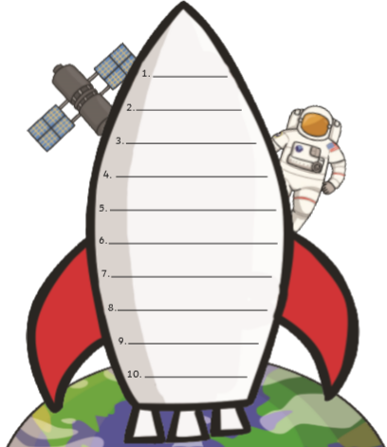
Can you practise reading and writing these sight words?
children
went
looked
please
down
eyes
house
play
going
work

