ELECTRICITY
Year 4 - Electricity
National Curriculum Objectives:  • Identify common appliances that run on electricity.  • Construct a simple series electrical circuit, identifying and naming its basic parts, including cells, wires, bulbs, switches and buzzers.  • Identify whether or not a lamp will light in a simple series circuit, based on whether or not the lamp is part of a complete loop with a battery.  • Recognise that a switch opens and closes the circuit and associate this with whether or not a lamp lights in a simple series circuit.  • Recognise some common conductors and insulators, and associate metals with being good conductors.  • Know the difference between a conductor and an insulator; giving examples of each.  • Safety when using electricity.  Pupils should construct simple series circuits, trying different components, for example, bulbs, buzzers and motors, and including switches, and use their circuits to create simple devices. Pupils should draw the circuit as a pictorial representation, not necessarily using conventional circuit symbols at this stage; these will be introduced in year 6.  Note: Pupils might use the terms current and voltage, but these should not be introduced or defined formally at this stage.  Pupils should be taught about precautions for working safely with electricity. Pupils might work scientifically by: observing patterns, for example, that bulbs get brighter if more cells are added, that metals tend to be conductors of electricity, and that some materials can and some cannot be used to connect across a gap in a circuit. |  |  |  |  |  |  |  |  | Key Ideas  a) A source of electricity (mains of battery) is needed for electrical devices to work.  b) Electricity sources push electricity round a circuit.  c) More batteries will push the electricity round the circuit faster.  d) Devices work harder when more electricity goes through them.  e) A complete circuit is needed for electricity to flow and devices to work.  f) Some materials allow electricity to flow easily and these are called conductors. Materials that don’t allow electricity to flow easily are called insulators
Prior Learning | Making Electrical Circuits Work |  |  |  |  |  |  |  |  | Vocabulary
Not applicable | Chapter 1: Electrical power sources.  Lots of devices are powered by electricity; these need a source of electricity, which could be mains or battery. |  | Chapter 2: What batteries do.  The battery’s job is to push electricity to the device, but it needs something to carry the electricity all the way from the supply to the device, this is what we call a circuit |  | Chapter 3: Making devices work harder.  If there are more batteries they push harder and so the device will work harder e.g. brighter or faster |  |  | Chapter 4: Insulators and conductors.  However not everything can carry the electricity from the source to the device, some materials allow the electricity through (conductors) and others don’t (insulators) |  | Electricity, electric current, appliances, mains, crocodile clips, wires, bulb, battery cell, battery holder, motor, buzzer, switch, conductor, electrical insulator, conductor
 | Identify and name devices and justify if it is mains or battery powered and if battery powered, find it.  • give children a range of different battery powered devices and ask them to predict how the battery would need to be different. They remove the batteries and categorise how batteries need to be different and why. |  | Give children leads, batteries and lamps and let them get it to light.  • Give children some broken circuits. they have to identify what is wrong and make it work.  • How does the length of time a battery is on for affect how well a device works? |  | How does the number of batteries added to the circuit affect a device? |  |  | Give them a battery and a bulb and lots of junk material and they have to make the lamp light.  • Scenario where they have to make a switch from junk (maybe a light or/and buzzer goes on when burglar steps on a mat)
In Year 6:
• Associate the brightness of a lamp or the volume of a buzzer with the number and voltage of cells used in the circuit.
• Compare and give reasons for variations in how components function, including the brightness of bulbs, the loudness of buzzers and the on/off position of switches.
• Use recognised symbols when representing a simple circuit in a diagram
Year 6 - Electricity
National Curriculum Objectives:  • Associate the brightness of a lamp or the volume of a buzzer with the number and voltage of cells used in the circuit.  • Compare and give reasons for variations in how components function, including the brightness of bulbs, the loudness of buzzers and the on/off position of switches.  • Use recognised symbols when representing a simple circuit in a diagram.  Building on their work in year 4, pupils should construct simple series circuits, to help them to answer questions about what happens when they try different components, for example, switches, bulbs, buzzers and motors. They should learn how to represent a simple circuit in a diagram using recognised symbols. Note: Pupils are expected to learn only about series circuits, not parallel circuits. Pupils should be taught to take the necessary precautions for working safely with electricity. Pupils might work scientifically by: systematically identifying the effect of changing one component at a time in a circuit; designing and making a set of traffic lights, a burglar alarm or some other useful circuit. |  |  |  |  |  |  | Key Ideas:  a) Batteries are a store of energy. This energy pushes electricity round the circuit. When the battery’s energy is gone it stops pushing. Voltage measures the ‘push.’  b) The greater the current flowing through a device the harder it works.  c) Current is how much electricity is flowing round a circuit. d) When current flows through wires heat is released. The greater the current, the more heat is released
Prior Learning |  | Controlling Electrical Circuits |  |  |  |  |  |  |  | Vocabulary
In Year 4:  • Identify common appliances that run on electricity.  • Construct a simple series electrical circuit, identifying and naming its basic parts, including cells, wires, bulbs, switches and buzzers.  • Identify whether or not a lamp will light in a simple series circuit, based on whether or not the lamp is part of a complete loop with a battery.  • Recognise that a switch opens and closes the circuit and associate this with whether or not a lamp lights in a simple series circuit.  • Recognise some common conductors and insulators, and associate metals with being good conductors.  • Know the difference between a conductor and an insulator; giving examples of each.  • Safety when using electricity. |  | Chapter 1: Pushing electrical current  The power supply pushes the current round the circuit. The voltage of the power supply is a measure of this push. Batteries have a limited store of energy, when it is gone they no longer push the current.  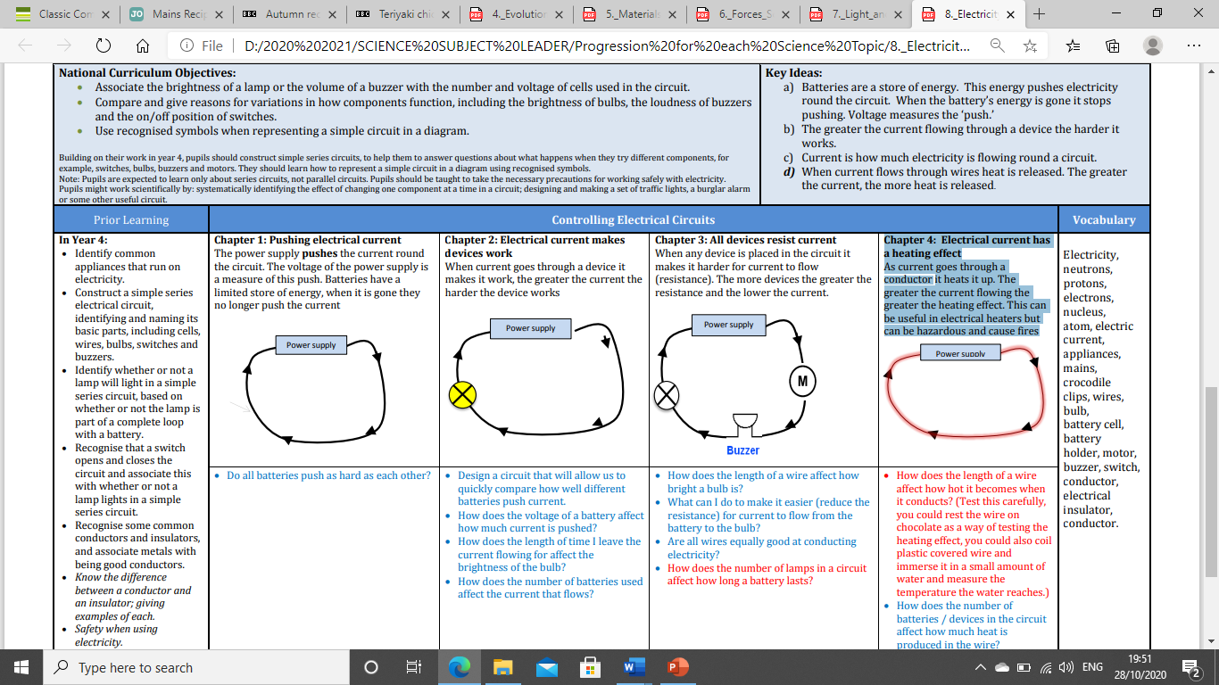 |  | Chapter 2: Electrical current makes devices work  When current goes through a device it makes it work, the greater the current the harder the device works  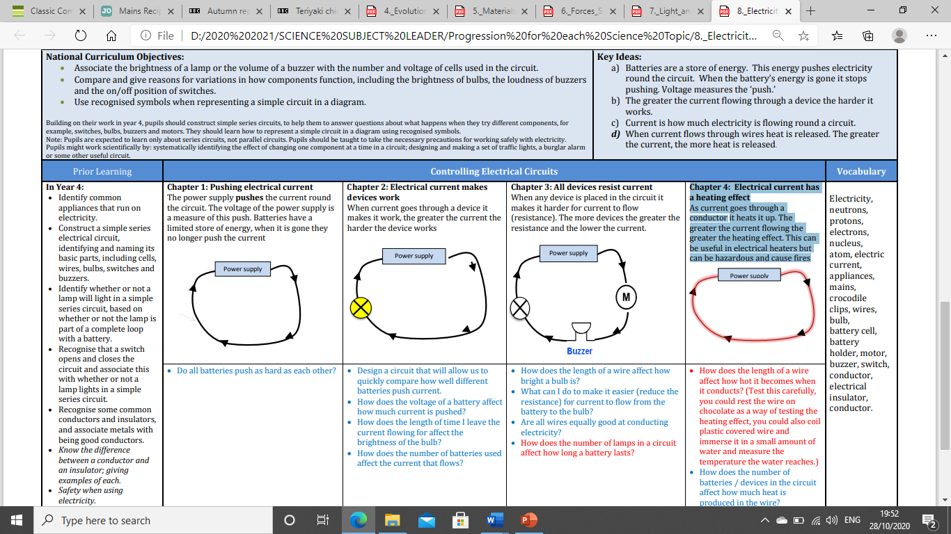 |  | Chapter 3: All devices resist current  When any device is placed in the circuit it makes it harder for current to flow (resistance). The more devices the greater the resistance and the lower the current.  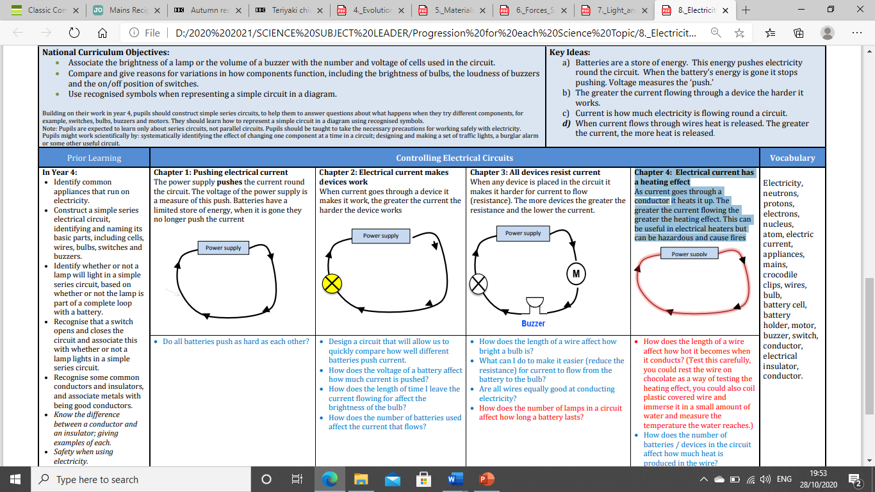 |  |  | Chapter 4: Electrical current has a heating effect  As current goes through a conductor it heats it up. The greater the current flowing the greater the heating effect. This can be useful in electrical heaters but can be hazardous and cause fires  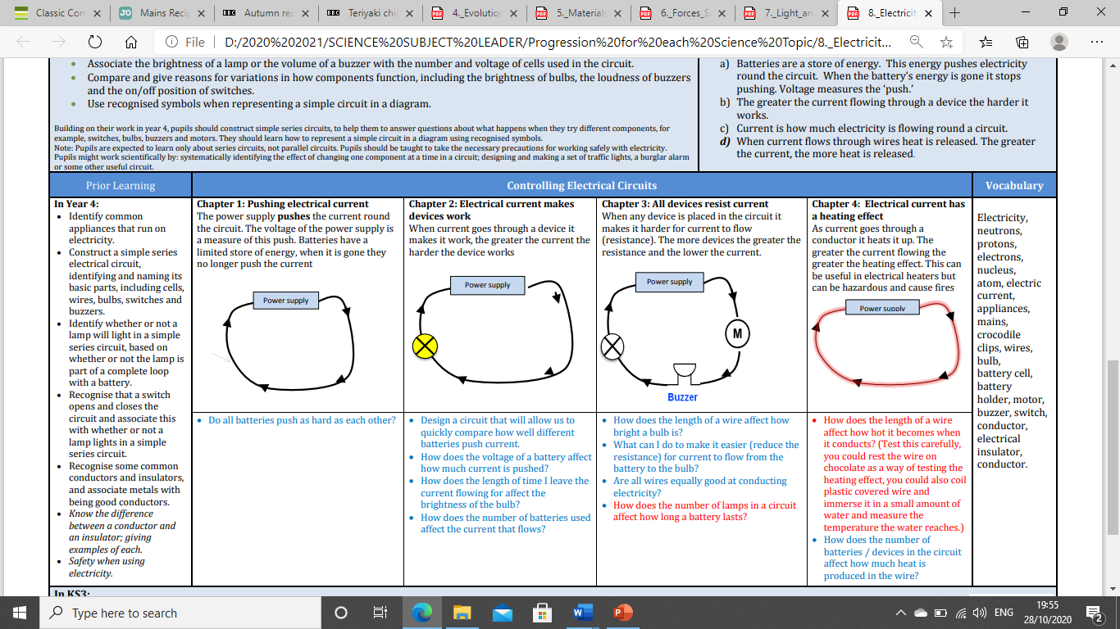 | Electricity, neutrons, protons, electrons, nucleus, atom, electric current, appliances, mains, crocodile clips, wires, bulb, battery cell, battery holder, motor, buzzer, switch, conductor, electrical insulator, conductor.
 |  | Do all batteries push as hard as each other? |  | Design a circuit that will allow us to quickly compare how well different batteries push current.  • How does the voltage of a battery affect how much current is pushed?  • How does the length of time I leave the current flowing for affect the brightness of the bulb?  • How does the number of batteries used affect the current that flows? |  | • How does the length of a wire affect how bright a bulb is?  • What can I do to make it easier (reduce the resistance) for current to flow from the battery to the bulb?  • Are all wires equally good at conducting electricity?  • How does the number of lamps in a circuit affect how long a battery lasts? |  |  | • How does the length of a wire affect how hot it becomes when it conducts? (Test this carefully, you could rest the wire on chocolate as a way of testing the heating effect, you could also coil plastic covered wire and immerse it in a small amount of water and measure the temperature the water reaches.)  • How does the number of batteries / devices in the circuit affect how much heat is produced in the wire?

