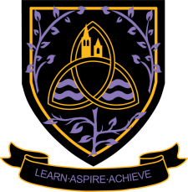
Politics A Level
2024 - 2026
Wigston College

Examination Board
Edexcel (specification from 2017) 9PLO
Entry Requirements:
GCSE Grade 5 in English Language or English Literature
What will I be studying?
UK Politics and core political ideas
• Democracy and participation • Political parties • Electoral systems • Voting behaviour and the media • Core ideas: Liberalism, Conservatism and Socialism
UK Government
• The constitution • Parliament • The Prime Minister and executive • Relationships between the branches • Non-core idea: Feminism
Comparative politics: Global Politics
• The state and globalisation • Global governance: political and economic • Global governance: human rights and environmental • Power and developments • Regionalism and the European Union • Comparative theories (realism and liberalism)
How will I be studying?
Within Politics there are many opportunities for activities such as group work, research tasks, group teaching and discussion. There is a focus on written answers throughout the course and an understanding of current political events is essential.
How will I be assessed?
• Paper 1: UK Politics and core ideas: one 2 hour exam paper with a choice of questions from the topics studied. Worth 33.3% of the qualification.
• Paper 2: UK Government and non-core ideas: one 2 hour exam paper with a choice of questions from the topics studied. Worth 33.3% of the qualification.
• Paper 3: Comparative politics: one 2 hour exam paper with a range of both choice based questions from the topics studied and a source based question. Worth 33.3% of the qualification.
Where Next?
Students may choose to study degrees in areas such as Politics or International Relations. This can then lead onto future careers such as researching, working for local and national governments, teaching, journalism, working in the legal profession, running to be your local Member of Parliament or even Prime Minister!

