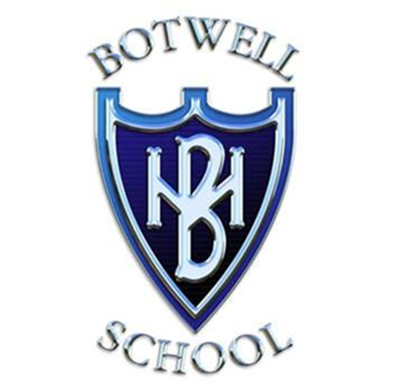

Artificial Intelligence Policy for Staff

Mission Statement
Botwell House Catholic Primary School is distinguished by the care, courtesy and concern extended to all its members, regardless of cultural differences and strives to follow the teachings of Jesus Christ to:
“Love one another as I have loved you”
Through an effective partnership between home, school and parish and through a broad and balanced curriculum, each valued individual is encouraged to grow in their journey of faith and strive towards excellence.

Botwell House Catholic Primary School seeks to ensure that all pupils receive a full-time education which maximises opportunities for each pupil to realise his/her potential.

Current revision: July 2025
Date for further revision: November 2027
Delegated to: Data Protection Lead
Reviewer: Helen Slater
(Headteacher) Kevin Oakley

Artificial Intelligence Staff Policy
Background to the policy
Although Data Protection law does not specifically define or discuss the guidelines for Artificial Intelligence (‘AI’), the guidance from the Information Commissioner’s Office and the UK government defines it as using non-human systems to imitate human intelligence.
In this time of constant development and increased usage, there is a need to provide staff with guidelines for use and to recognise an employer’s right to monitor such usage. We have also set out expectation on AI usage by pupils.
Introduction
The use of AI is transforming the way individuals are working. Informed and responsible use of AI has the potential to increase efficiency and improve decision making.
With these benefits come potential risks, including data protection breaches, the protection of confidential information, ethical considerations, and compliance with wider legal obligations.
We permit the informed and responsible use of authorised AI applications by staff, in carrying out specific and authorised tasks. This policy must be complied with when using AI to carry out such tasks.
The purpose of this policy is to set out our rules on the use of AI in the workplace and how it should be adopted by staff to ensure we maximise the benefits of AI while minimising any risks or concerns.
Where personal data is used with AI applications, an ICO risk assessment and/or data protection impact assessment (‘DPIA’) has been carried out to ensure transparency in how AI will be used and what mitigating steps have been taken to reduce any potential risk of harm to pupils, staff and any other data subjects whose data might be shared with the authorised systems.

This policy covers all employees, officers, consultants, contractors, volunteers, interns, casual workers and agency workers.
Pupil usage of AI
As part of this policy, staff should be aware of how the school permits limited pupil usage of AI applications in accordance with the AI policy for pupils. It is important to monitor pupil usage whilst in class and for homework to ensure compliance with this policy or how to monitor when reviewing homework.
For pupils, they must sign an Acceptable Use Statement to ensure appropriate usage of AI and they are reminded of the permitted usage along with an outline of what classes as AI misuse.
The school permits pupil usage of AI in the following circumstances:
- As a research tool
- Idea generation for projects
- For use with homework with the above requirements fulfilled
Examples of AI misuse include, but are not limited to, the following:

- Copying or paraphrasing sections of AI-generated content so that the work is no longer the pupil’s own;
- Copying or paraphrasing whole responses of AI-generated content;
- Using AI to complete parts of the assessment so that the work does not reflect the pupil’s own work, analysis, evaluation or calculations;
- Failing to acknowledge use of AI tools when they have been used as a source of information;
- Incomplete or poor acknowledgement of AI tools; or
- Submitting work with intentionally incomplete or misleading references.

Authorised AI applications
The school allow access to the following AI applications for business purposes:
- Chat GP
- TeachMate AI
- Century
- AIR moderation

The listed AI applications may be updated at any time. Should staff wish to use another AI application not listed, they must contact the Headteacher (Kevin Oakley) to review permission to do so, or in the absence of the Headteacher, they must contact the GDPR Data Controller (Helen Slater).

Authorised usage of AI for staff

Authorised AI applications must only be used by staff for the following business purposes:
- Drafting internal guidance, training and presentations;
- Lesson planning
- Conducting research
- Developing code
- Providing summaries
- Idea generation
All other purposes must be authorised in advance by School Business Manager or Kevin Oakley, Headteacher.
Before using any AI applications, staff will be provided training to ensure human reviewers (those who conduct monitoring of these applications) have a correct understanding and do not add any bias into the AI systems.
Monitoring
We reserve the right to monitor all content on any AI applications used for business purposes. This will only be carried out by the school to comply with a legal obligation or for our legitimate business purposes, in order to:
- prevent misuse of the content and protect confidential information (and the confidential information of our pupils, staff or other stakeholders);
- ensure compliance with our rules, standards of conduct and policies in force;
- monitor performance at work;
- ensure that staff do not use AI for any unlawful purposes or activities;
- comply with legislation for the protection of intellectual property rights;

The school will also conduct monitoring under our IT and Communications Systems policy and Bring Your Own Device to Work policy.
Breach of this policy
Breach of this policy may, where appropriate, result in disciplinary action up to and including dismissal or termination of your employment or engagement with us.

Where disciplinary action is appropriate, it may be taken whether the breach is committed during or outside normal hours of work and whether or not use of AI is on an individual's own device or one of our devices, and whether at home, in the office or from a remote working location.

You are required to assist with any investigation into a suspected breach of this policy. This may involve providing us with access to AI applications, whether or not this is an authorised application, and any relevant passwords and login details.

You must report any breach of this policy immediately to Helen Slater, the school’s Data Controller, or to Susan Yu, School Business Manager, in the first instance. We advise referring to the school’s current data breach policy which can be found on the school website.

Related Policies
Staff should refer to the following policies that are related to this AI Staff Policy: -

- Acceptable Use of Technology Policy
- Diversity, Equity and Inclusion Policy
- Code of Conduct
- Data Protection Policy
- Privacy Policy for staff.
- Staff Handbook

These are available in the E-staffroom for staff.

Appendix A – Exert from Staff Handbook
Every staff member has to ensure appropriate use of AI that is consistent with the schools AI policy.
AI tools can only be used as set out within this policy and any additional usage will be reviewed and updated when SLAT have discussed it and reviewed the policy.

