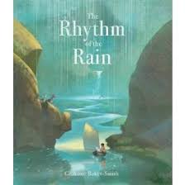
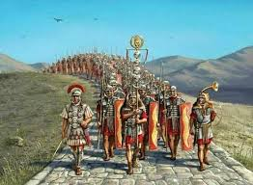


Spring 1 Term Newsletter Year 4
P.E.
P.E. – Tuesdays
Swimming – Thursdays
We will be continuing our swimming lessons on Thursdays. We will also be looking into health related fitness and how we can use sport as a tool for long-term fitness and health.
Humanities
Year 4 will be learning about the Romans, the children will investigate ‘Why the Romans invaded, how the Celts reacted and how the Romans changed life in Britain.
Computing
We will be exploring ‘Repetition in Shapes’. The children will create programs by planning, modifying, and testing commands to create shapes and patterns. They
will use Logo, a text-based programming language.
Science
Our science topic this term is Rocks and Soil. We will explore the physical properties of rocks, soil and fossil formation.

Maths
We will begin the term exploring length and perimeter. Later on, the children will be focusing on fractions. They will develop their understanding of fractions, learning how to add, subtract, count in, and use mixed numbers.
English
This term we shall explore the book “Rhythm of the Rain”. This is a beautiful picture book that explores the remarkable journey of the water cycle. From a few drops of rain in a little boy’s jar to the depths of the vast ocean and back to clouds in the sky above, wonderful water is given centre-stage in this gentle narrative that evokes awe at the sheer beauty and scale of nature’s systems. Our primary focus will be on extending ideas/ sentences using more information.



Music
We will be learning ‘Ensemble Skills 2: Melody and Accompaniment using either Glockenspiel or Recorders.
Art
We will be exploring ‘Pattern’. The children will have the opportunity to explore pattern and develop a range of technical skills and knowledge through drawing and collage.
R.E.
This half term we will focus on the key question: Is Scripture central to religion?
We will reflect on what revelation means to some people and children will explore the significance of some scriptures. We will be looking at various different religions throughout.
PSHE
Year 4 will be focusing on perseverance and positive attitudes when it comes to personal challenges. We will look at effective teamwork and how we can all achieve our goals.

