Transition Pack
A Level Geography

2024
Name: _________________________________________
Deadline for completion 5th September 2024

Human Geography – two units
– Gloablisation and regenerating places
Globalisation
- Reading articles
  - https://www.wired.com/2016/04/iphones-500000-mile-journey-pocket/ Read article
  - https://georghiadesgeography.files.wordpress.com/2017/08/containerisation-article.pdf - Robert Morris - Containerisation – the unsung hero of globalisation
- You tube vidoes to watch
  - https://www.youtube.com/watch?v=5SnR-e0S6Ic&t= & https://www.youtube.com/watch?v=s_iwrt7D5OA &
https://www.youtube.com/watch?v=IH4gSwAeraQ

1.Assessment Question – need to give TWO sides to your argument and conclusion with your answer (need to use examples to support – using reading and videos )
“Globalisation is undoubtedly a force for good” Do you agree with this statement? 10marks
……………………………………………………………………………………………………………………………………………………………………………………………………………………………………………………………………………………………………………………………………………………………………………………………………………………………………………………………………………………………………………………………………………………………………………………………………………………………………………………………………………………………………………………………………………………………………………………………………………………………………………………………………………………………………………………………………………………………………………………………………………………………………………………………………………………………………………………………………………………………………………………………………………………………………………………………………………………………………………………………………………………………………………………………………………………………………………………………………………………………………………………………………………………………………………………………………………………………………………………………………………………………………………………………………………………………………………………………………………………………………………………………………………………
………………………………………………………………………………………………………………………………………………………………………………………………………………………………………………………………………………………………………………………………………………………………………………………………………………………………………………………………………………………………………………………………………………………………
………………………………………………………………………………………………………………………………………………………………………………………………………………………………………………………………………………………………………………………………………………………………………………………………………………………………………………………………………………………………………………………………………………………………
……………………………………………………………………………………………………………………………………………………………………………………………………………………………………………………………………………………………………………………………………………………………………………………………………………………………………………………………………………………………………………………………………………………………………………………………………………………………………………………………………………………………………………………………………………………………………………………………………………………………………………………………………………………………………………………………………………………………………………………………………………………………………………………………………………………………………………………………………………………………………………………………………………………………………………………………………………………………………………………………………………………………………………………………………………………………………………………………………………………………………………………………………………………………………………………………………………………………………………………………………………………………………………………………………………………………………………………………………………………………………………………………………………………

REGENERATING PLACES
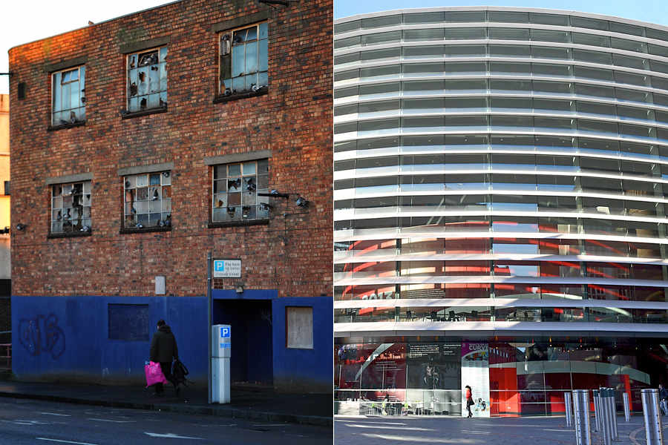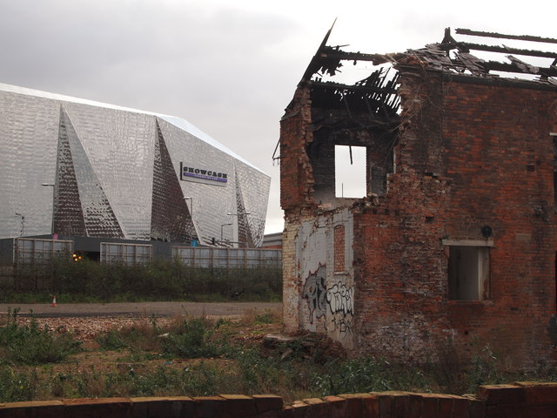
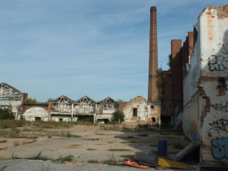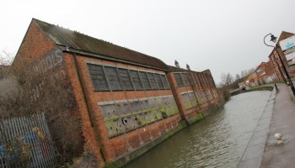
You will study four enquiry questions whilst exploring ‘Regenerating Places’ -
- How and why do places vary?
- Why might regeneration be needed?
- How is regeneration managed?
- How successful is regeneration?

Answer briefly each of the questions in the table using resources and data and then complete the exam question at the end.
ENQUIRY QUESTION 2: WHY MIGHT REGENERATION BE NEEDED?
Why did Leicester need to be regenerated?
Use the internet, (city centre director report Leicester City council – excellent resource (census 2021, (https://explore-local-statistics.beta.ons.gov.uk/areas/E06000016-leicester), IMD (https://mapmaker.cdrc.ac.uk/#/index-of-multiple-deprivation?d=11110000&m=imdh19_dc&lon=-2.5&lat=53.7&zoom=7) local libraries, the Records Office and your own knowledge to find out why Leicester needed to be regenerated. You need to consider a wide range of questions and find out if they applied or apply to Leicester, such as;
Has the city experienced deindustrialisation?
Have industries closed down and for what reasons?
What was/is the level of unemployment?
Are there skills shortages?
Has the area experienced outward migration?
What has happened to property prices?
Does the area suffer from social deprivation (health, education, crime and access to services)?
Is there any evidence of sink estates, commuter villages or declining rural settlements?
Are local communities engaged in the area (consider election turnout and local community groups)?
What is the ethnic mix/make-up of the area?
What is the population structure of the area?
Are there many new residents (students, in-migrants)?
Is there evidence of conflict between different groups within communities?
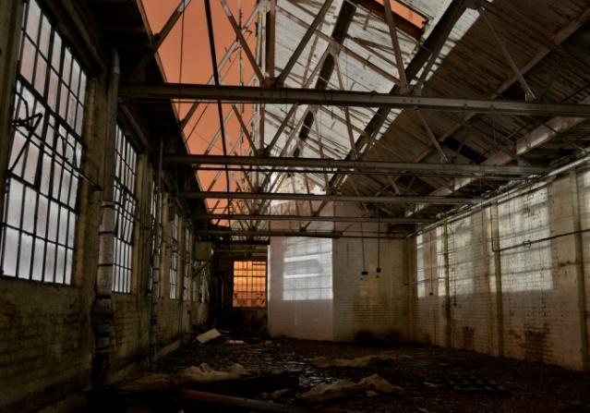

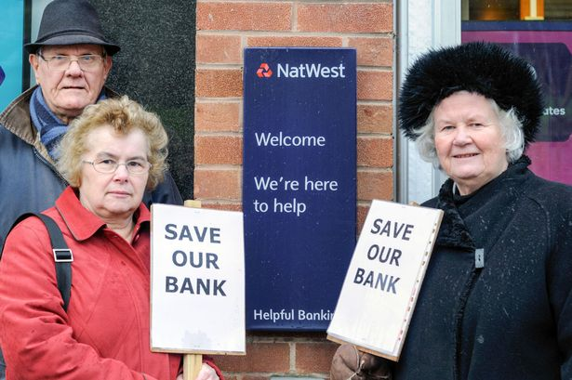

ENQUIRY QUESTION3: HOW IS REGENERATION MANAGED?
Leicester has a number of regeneration projects – you need to choose two from list (or add own and research answers to questions
You could use – Waterside, High cross, Jubilee square, Grand central Square (Lane 7), Richard III/ Cathedral gardens, Space Park
 | Regeneration example 1 | Regeneration example 2
Name of project
Where is it?
What was area like before?
What is it like now?
Has the regeneration been successful?
Has rebranding taken place to change the public’s perception of the area?
Has the urban area been rebranded around industry, culture, heritage or sport?

Regeneration section = ASSESSMENT: EXAM STYLE QUESTION
Assess the need for regeneration in your local place studied (12 marks)
(Give reasons why Leicester needs to be regenerated – think about demographics, ethnicity, economic activity, employment levels etc – use your research from Enquiry question 2)
……………………………………………………………………………………………………………………………………………………………………………………………………………………………………………………………………………………………………………………………………………………………………………………………………………………………………………………………………………………………………………………………………………………………………………………………………………………………………………………………………………………………………………………………………………………………………………………………………………………………………………………………………………………………………………………………………………………………………………………………………………………………………………………………………………………………………………………………………………………………………………………………………………………………………………………………………………………………………………………………………………………………………………………………………………………………………………………………………………………………………………………………………………………………………………………………………………………………………………………………………………………………………………………………………………………………………………………………………………………………………………………………………………………
………………………………………………………………………………………………………………………………………………………………………………………………………………………………………………………………………………………………………………………………………………………………………………………………………………………………………………………………………………………………………………………………………………………………
…………………………………………………………………………………………………………………………………………………………………………………………………………………………………………………………………………………………………………………………………………………………………………………………………………………………………………………………………………………………………………………………………………………………………………………………………………………………………………………………………………………………………………………………………………………………………………………………………………………………………………………………………………………………………………………………………………………………………………………………………………………………………………………………………………………………………………………………………………………………………………………………………………………………………………………………………………………………………………………………………………………………………………………………………………………………………………………………………………………………………………………………………………………………………………………………………………………………………………………………………………………………………………………………………………………………………………………………………………………………………………………………………………………………………………………………………………………………………………………………………………………………………………………………………………………………………………………………………………………………………………………………………………………………………………………………………………………………………………………………………………………………………………………………………………………………………………………………………………………………………………………………………………………………………………………………………………………………………………………………………………………………………………………………………………………………………………………………………………………………………………………………………………………………………………………………………………………………………………………………………………………………………………………………………………………………………………………………………………………………………………………………………………
Paper 1
Paper 1 has two topics; 1) Tectonic Processes and Hazards and 2) Landscape Systems, Processes and Change – Coastal landscape and change

Tectonic Processes and Hazards.
Areas of study
- Why are some locations more at risk from tectonic hazards?
- Why do some tectonic hazards develop into disasters?
- How successful is the management of tectonic hazards and disasters?

This topic develops your knowledge from GCSE. Use the information below, your own knowledge AND additional research to complete the tasks below.

Plate Boundaries

1. For each plate boundary identify the different tectonic hazards to be found and the key features.
Plate boundary | Earthquakes and/or volcanoes | Key features (direction of plate margin, type of plate,
Destructive
Constructive
Collision
Transform (Conservative)

2 - Explain the cause of earthquakes at constructive plate margins (4)
………………………………………………………………………………………………………………………………………………………………………………………………………………………………………………………………………………………………………………………………………………………………………………………………………………………………………………………………………………………………………………………………………………………………………………………………………………………………………………………………………………………………………………………………………………………………………………………………………………………………………………………………………………………………………………………………………………………………………………………………………………………………………………………………………………………………………………………………………………………………………………………………………………………………………………………………………………………………………………………………………………………………………………………………………………………………………………………………………………………………………………………………………………………………………………………………………………………………………………………………

3 - Explain the cause of volcanoes at destructive plate margins (4)
………………………………………………………………………………………………………………………………………………………………………………………………………………………………………………………………………………………………………………………………………………………………………………………………………………………………………………………………………………………………………………………………………………………………………………………………………………………………………………………………………………………………………………………………………………………………………………………………………………………………………………………………………………………………………………………………………………………………………………………………………………………………………………………………………………………………………………………………………………………………………………………………………………………………………………………………………………………………………………………………………………………………………………………………………………………………………………………………………………………………………………………………………………………………………………………………………………………………………………………………

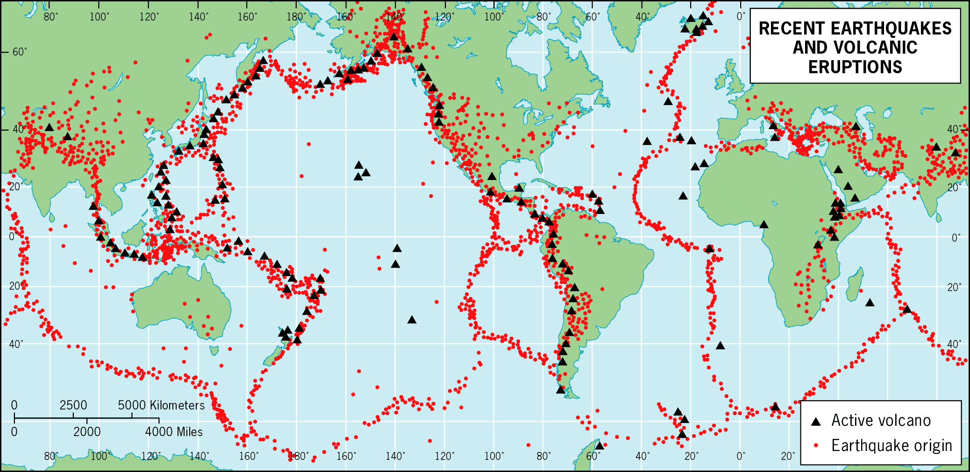
4. Describe the distribution of volcanoes and earthquakes (6)
………………………………………………………………………………………………………………………
………………………………………………………………………………………………………………………
………………………………………………………………………………………………………………………
………………………………………………………………………………………………………………………
………………………………………………………………………………………………………………………
………………………………………………………………………………………………………………………
………………………………………………………………………………………………………………………
……………………………………………………………………………………………………………………………………………………………………………………………………………………………………………………………….…………………………………………………………………………………………………………………………………………………………………………………………………………………………………………………………………………………………………………………………………………………………………………………………………………………………………………………………………………………………………………………………………………………………………………………………………………………………………………………………………………………………………………………………………………………………………………………………………………………………………………
5 - Case Study – Research

Complete research into ONE of the following hazards and produce a comprehensive case study with photographs and maps to support your research:

- Volcanic Eruption – Eyjafjallajokull, Iceland 2010
- Earthquake – Turkey and Syria 2023

For either hazard identify the cause, impacts (Social, Economic and Environmental) and management of the hazard.

Landscape Systems, Processes and Change – Coastal landscape and change
Areas of study
- Why are coastal landscapes different and what processes cause these differences?
- How do characteristic coastal landforms contribute to coastal landscapes?
- How do coastal erosion and sea level change alter the physical characteristics of coastlines and increase risks?
- How can coastlines be managed to meet the needs of all players?

This topic also develops your knowledge from GCSE. Use the information below, your own knowledge AND additional research to complete the tasks below.

Coastal landscapes
The Jurassic Coastline in Dorset is one of the most famous stretches of coastline in terms of landforms and features.

6 - Your task is to research this stretch of coastline to create a case study. You will need to include photos and annotated maps to identify the different features along this stretch of coastline and start to explain how and why the different landforms are created. You can use the maps and photos below to support your own research.

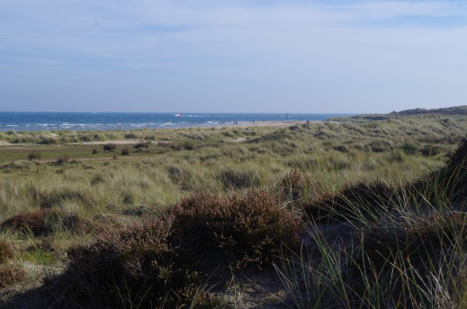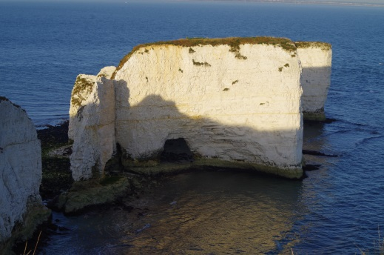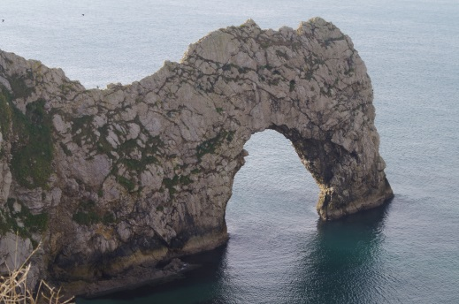

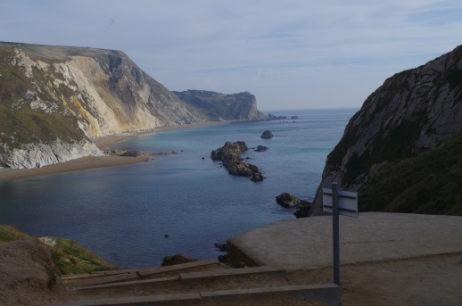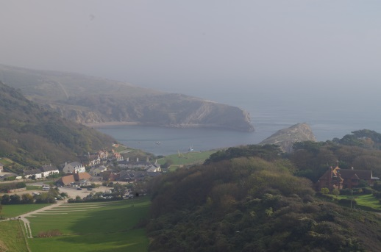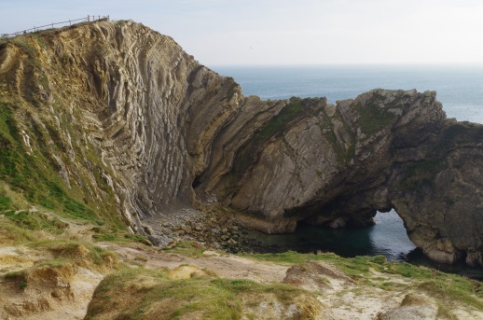

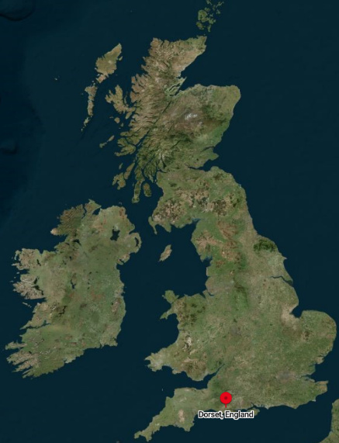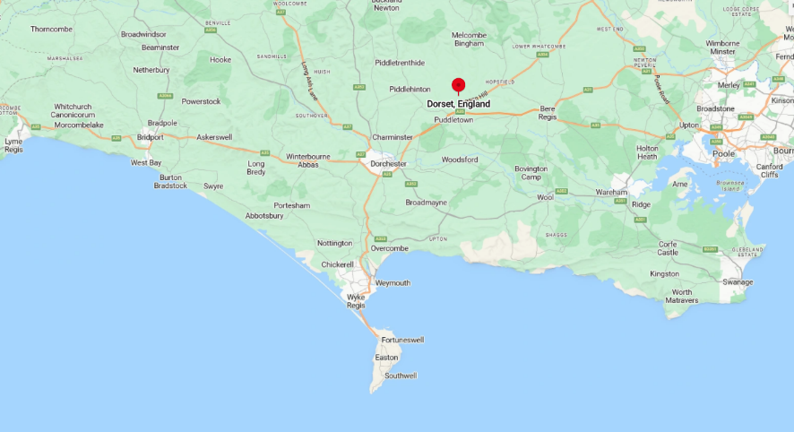

7 - Explain the relationship between geology and how the coastline has developed along the Dorset Coastline (8 marks). Think about the different landforms and HOW they are forms. Why does different types of geology lead to different landscapes?

……………………………………………………………………………………………………………………………………………………………………………………………………………………………………………………………………………………………………………………………………………………………………………………………………………………………………………………………………………………………………………………………………………………………………………………………………………………………………………………………………………………………………………………………………………………………………………………………………………………………………………………………………………………………………………………………………………………………………………………………………………………………………………………………………………………………………………………………………………………………………………………………………………………………………………………………………………………………………………………………………………………………………………………………………………………………………………………………………………………………………………………………………………………………………………………………………………………………………………………………………..……………………………………………………………………………………………………………………………………………………………………………………
