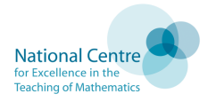

MATHS - Teaching for Mastery

Mastering maths means pupils acquiring a deep, secure and adaptable understanding of the subject.

The phrase ‘teaching for mastery’ describes the elements of classroom practice and school organisation that combine to give pupils the best chances of mastering maths.

Achieving mastery means acquiring a solid enough understanding of the maths that’s been taught to enable pupils to move on to more advanced materials.

The Five Big Ideas in the Teaching for Mastery
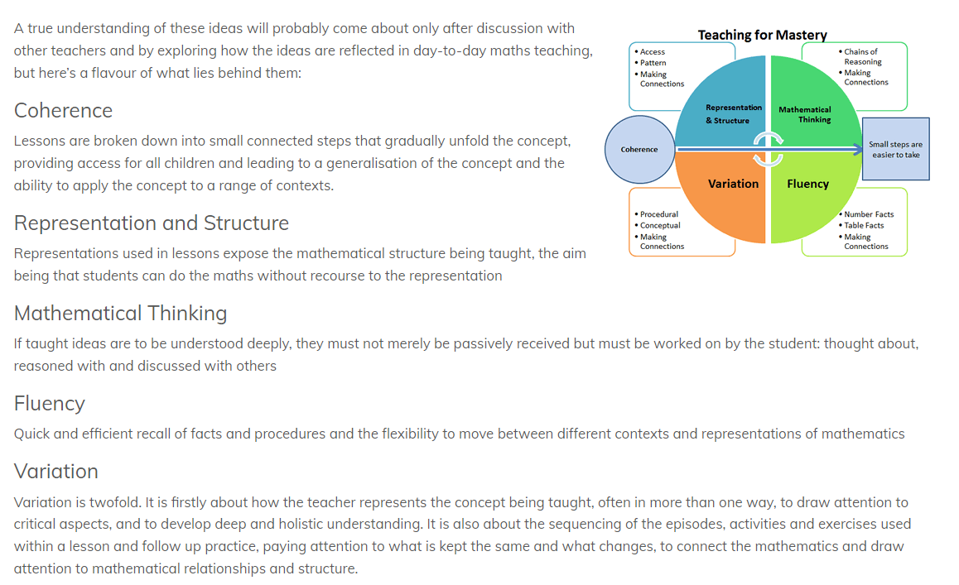

The Essence of Maths Teaching for Mastery

- Maths teaching for mastery rejects the idea that a large proportion of people ‘just can’t do maths’.
- All pupils are encouraged by the belief that by working hard at maths they can succeed.
- Pupils are taught through whole-class interactive teaching, where the focus is on all pupils working together on the same lesson content at the same time, as happens in Shanghai and several other regions that teach maths successfully. This ensures that all can master concepts before moving to the next part of the curriculum sequence, allowing no pupil to be left behind.
- If a pupil fails to grasp a concept or procedure, this is identified quickly and early intervention ensures the pupil is ready to move forward with the whole class in the next lesson.
- Lesson design identifies the new mathematics that is to be taught, the key points, the difficult points and a carefully sequenced journey through the learning. In a typical lesson pupils sit facing the teacher and the teacher leads back and forth interaction, including questioning, short tasks, explanation, demonstration, and discussion.
- Procedural fluency and conceptual understanding are developed in tandem because each supports the development of the other.
- It is recognised that practice is a vital part of learning, but the practice used is intelligent practice that both reinforces pupils’ procedural fluency and develops their conceptual understanding.
- Significant time is spent developing deep knowledge of the key ideas that are needed to underpin future learning. The structure and connections within the mathematics are emphasised, so that pupils develop deep learning that can be sustained.
- Key facts such as multiplication tables and addition facts within 10 are learnt to automaticity to avoid cognitive overload in the working memory and enable pupils to focus on new concepts.

Key features of the mastery approach

Curriculum design:
A detailed, structured curriculum is mapped out across all phases, ensuring continuity and supporting transition. Effective mastery curricula in mathematics are designed in relatively small carefully sequenced steps, which must each be mastered before pupils move to the next stage. Fundamental skills and knowledge are secured first. This often entails focusing on curriculum content in considerable depth at early stages.
Teaching resources:
A coherent programme of high-quality curriculum materials is used to support classroom teaching. Concrete and pictorial representations of mathematics are chosen carefully to help build procedural and conceptual knowledge together. Exercises are structured with great care to build deep conceptual knowledge alongside developing procedural fluency. The focus is on the development of deep structural knowledge and the ability to make connections. Making connections in mathematics deepens knowledge of concepts and procedures, ensures what is learnt is sustained over time, and cuts down the time required to assimilate and master later concepts and techniques.

