TEAM POINTS

- Using team point systems has been shown to have a positive impact on motivation and behaviour, as well as encouraging a sense of identity and belonging among school pupils.
- Such systems include all pupils, not just the highest achievers, and help develop a variety of skills other than just academic.
- A sense of camaraderie, teamwork and healthy competition is nurtured, which contributes to a thriving school culture.
- Team leaders are selected as they are positive role models across the school. They are also actively involved in building good relationships with younger members of their team and for motivating and encouraging them.
Here at The Coppice we have four teams that our children belong to.
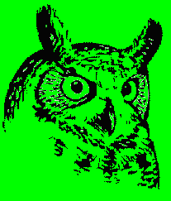  The Owls | 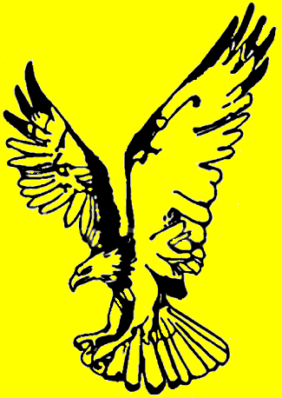  The Eagles | The Hawks  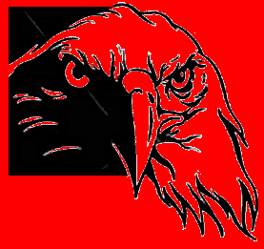 | 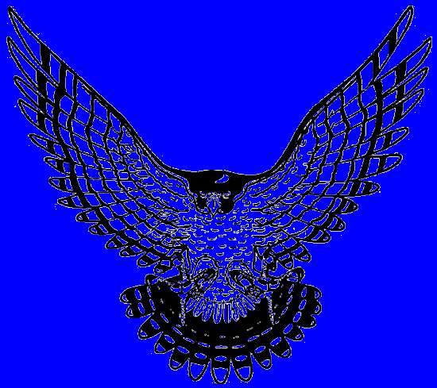  The Falcons

We use praise and rewards routinely, highlighting those pupils who are going above and beyond expectations to encourage desired behaviours.

The four teams have banners in the main hall and we have a visual display showing the accumulation of points throughout the year. Every member of staff in school also belongs to a team which helps to raise the profile of ‘belonging’ and working together.

Throughout the year we hold different events that enable the children to compete in a fun and friendly way to earn points. These include:

*Sports day * Times table challenges *Reading Challenges *Spelling Bee *Sporting events

Team points can be given out by staff verbally in class, written in books or through distributed team point cards. Class teachers keep a track of these points. Behaviours that warrant team points are detailed on the following table. Team points are added to a class tracker and each teacher shares the team points totals with their class on a weekly basis. This helps to promote a sense of camaraderie, teamwork and healthy competition.

This then leads to a half termly celebration assembly where the top three team point earners in each class are celebrated and awarded medals (Gold, Silver and Bronze). We also celebrate the overall winning team and the team Point cup located in the library is decorated with the appropriate coloured ribbons.

The team with the most points at the end of the year wins the overall house competition.

