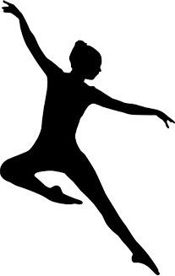
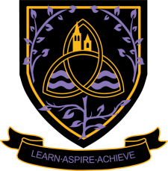
Dance
A Level 2024 - 2026
Wigston College

Examination Board
AQA
Entry Requirements:

GCSE Grade 5 Dance or BTEC Dance Merit. If you have not studied this subject at GCSE level you will need appropriate Dance school grades or to take part in an audition.

What will I be studying?

Component 1 – Performance and Choreography worth 50% of the whole course
This unit involves both solo and group work and the opportunity to explore the movement styles of a range of choreographers. You will learn and perform a solo dance based on the movement style of Matthew Bourne, Sidi Larbi Cherkaoui, Akram Khan, Christopher Bruce, Robert North or Richard Alston. You will dance in a quartet with your peers or other dancers in your preferred style: contemporary, jazz or ballet. All learners create a piece of choreography in response to a stimuli set by AQA.
Component 2 – Critical Engagement - worth 50% of the whole course
This unit explores two major areas of dance in Britain. We will look at the history of the Rambert company and research the company directors, choreographers and dance works. The Independent Contemporary Dance Scene in Britain explores choreographers who are creating history in the dance scene today.

How will I be studying?

Component 1 will be taught in our purpose built dance studios with wooden sprung floors, mirrors and air conditioning. We are also very lucky to have lots of workshop leaders who are keen to work with us so our students have many opportunities to work with professionals in the performing industry. Component 2 is taught in a classroom designated for dance theory. Group discussions are at the heart of dance theory lessons and each student is able to express their own observations of practical dance works. You will be given the opportunity to attend trips to ensure you have seen live work relevant to the areas of study.

How will I be assessed?

Component 1 is assessed as a live performance of the three dance pieces for a visiting examiner.
Component 2 is assessed in a written examination lasting 2hrs 30mins
Where Next?

Dance is a wonderful subject for boosting self-esteem and confidence, the skills you learn will enhance your ability to interact well with others and take on the role of being a strong leader in any job role. This course is the ideal platform for moving on to degree level dance either at a university or conservatoire and we are experienced in supporting students with these applications.

