Year 5 Spellings


Autumn Term 2

Children will be set 10 spellings to learn each week.
A new set should be tackled from each Friday and it is expected that the children will have learnt them by Wednesday of the following week. They will be tested in school at some point from Wednesday to Friday.
This spelling book contains all the spellings for this half term and will be sent electronically. However, in order to learn spellings, it is expected that children will physically write them out on a piece of paper. They should copy each word twice, then practice two more times with the word covered. Writing out spellings helps muscle memory and it is therefore easier for them to recall.
They should then use the word in a sentence or two, ensuring that their spellings and punctuation are accurate.
There are a number of websites online that also generate word searches or games to play in order to aid with memory if children need additional activities. e.g. www.thewordseach.com

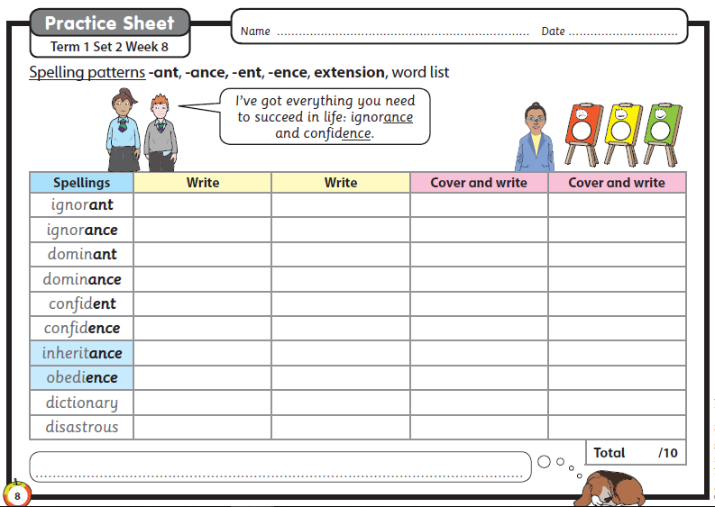
Week 1 – Friday 28th October

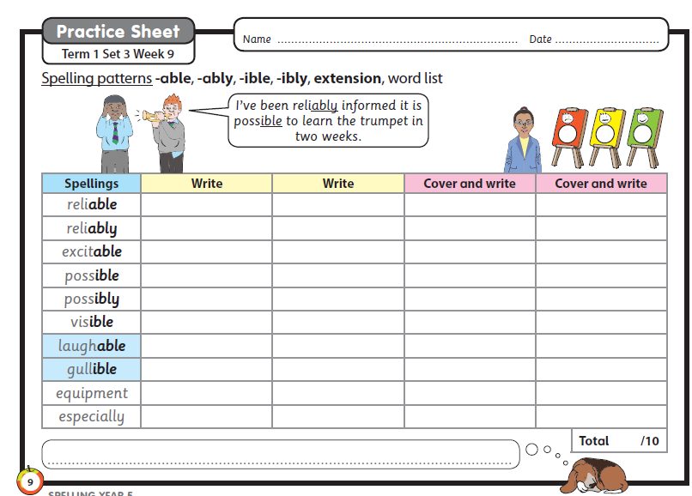
Week 2 – Friday 4th November

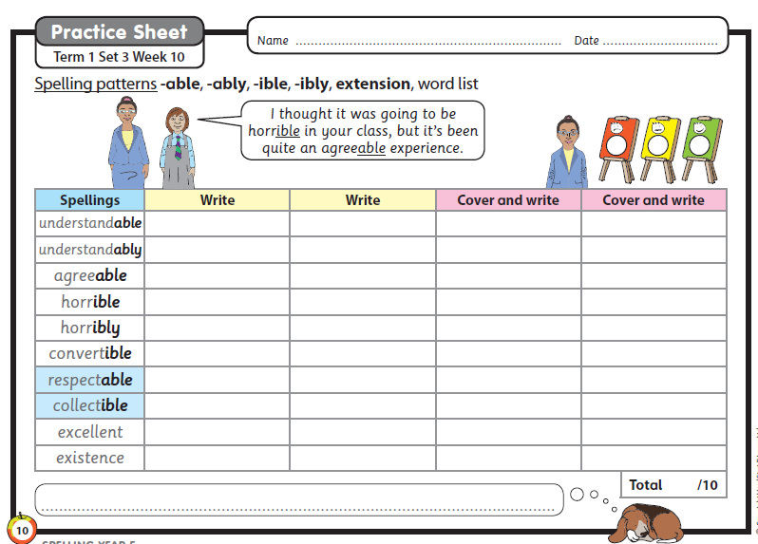
Week 3 – Friday 11th November

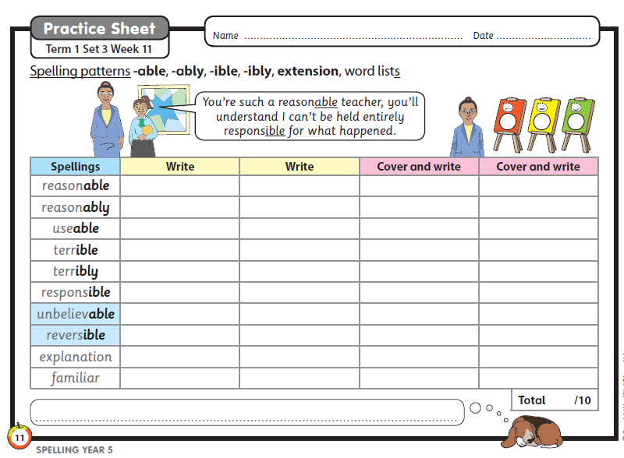
Week 4 – Friday 18th November

Week 5 – Friday 25th November
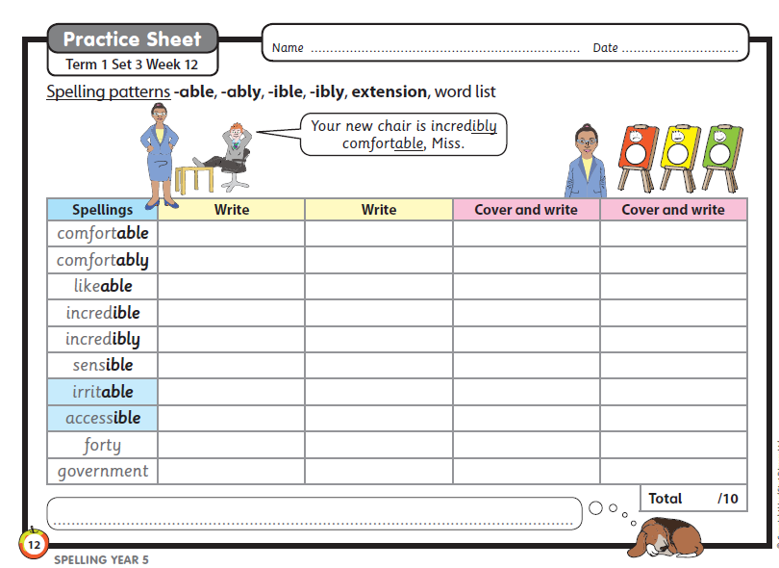
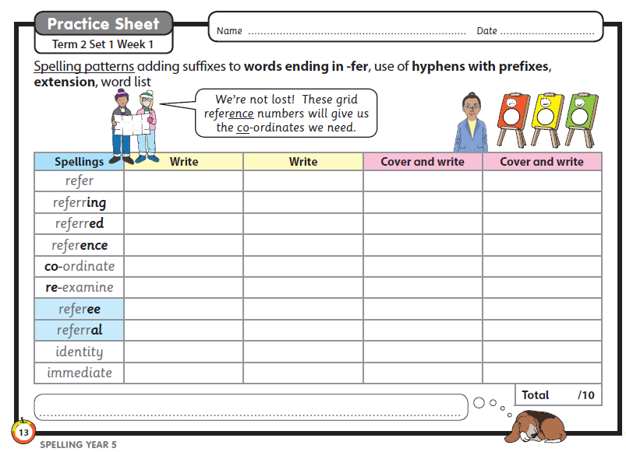
Week 6 – Friday 2nd December

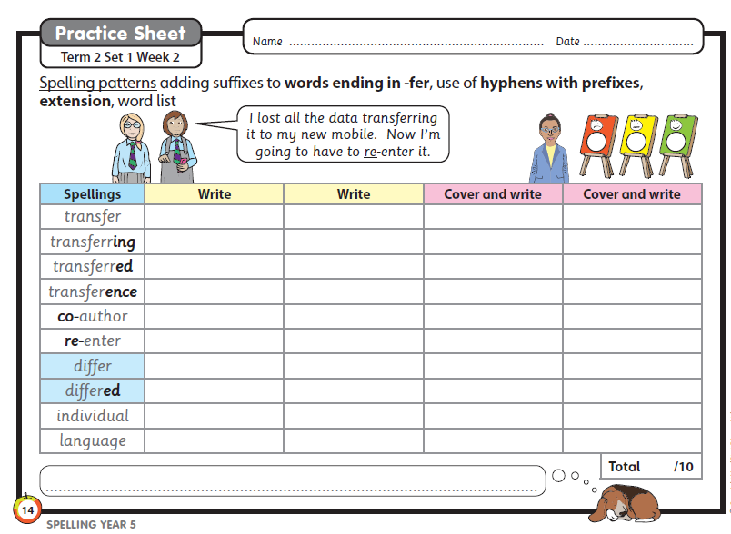
Week 7 – Friday 9th December

Week 7 – Friday 16th December
