St Marys – Religious Education knowledge map
Year 4 | Topic 4.3 ‘Jesus, the Teacher’
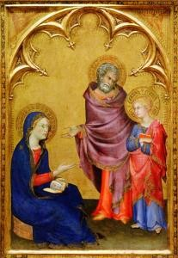
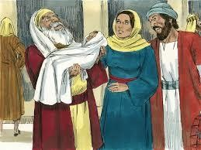
We will be looking at the painting ‘Finding in
the Temple’ by Simone Martini when reflecting in this unit.
What will I know at the end of the unit?

- Retell one of Jesus’ parables, ensuring it is accurate in its sequence and detail.
- Ask and respond to questions about their own and others experiences of following Jesus in their own life.
- Make a simple link between the chosen parables and Jesus’ message about how we should live.
- Describe the beliefs that Christians hold from God, from the given Beatitudes and parables.
- Give a point of view on an aspect of Jesus’ teaching.
- Express a preference (e.g ‘which is, what is, which parable…what do you like/not like about…’ etc on an aspect of learning from this unit.
- Suggests answers to questions like, ‘How can God’s Word grow in you?’ ‘Why is it important to forgive?’
Key Vocabulary
Ark | The place where the ten commandments were kept. It was the  most holy place for the Jews.
Good News | The meaning of the word Gospel
Jewish | The religion which began with Abraham and to which Jesus  belonged
mission | The task of teaching or preaching the Word of God
Presentation in the  temple | When Mary and Joseph took Jesus to the Temple for the first  time
Rabbi | An ordained Jewish teacher. Often the religious leader of a  Jewish community.
Sabbath | Every week religious Jews observe the Sabbath, the Jewish holy  day, and keep its laws and customs.
scrolls | Rolls of paper or parchment where the Word of God was  written
Synagogue | A place of worship and learning for Jewish people.
Temple | The special house God’s people used to have for Him
Torah | The Torah is the first part of the Jewish bible. It is a sacred text  for Jewish people.

What should I already know?
- Children will have knowledge about Jesus’ Presentation in the Temple from Y1.
- Children may know that Jesus was a Jew.
- Children will be familiar with some of the parables Jesus told.

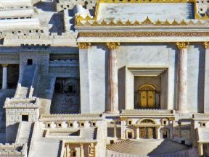

Key People and places
People: Anna and Simeon

Place: Temple in Jerusalem as Jesus would have seen it
Key Scripture Key Prayers  Luke 2: 22-32  Luke 4: 14-22 Canticle of  Matthew 5: 44 Simeon  John 15: 12  Luke 8: 4-8 Glory Be  Matthew 18: 23-35 | Books to read at home  