Geography Extra-Curricular Activities

Reception exploring the local area

During the Autumn Term, our Reception children learn about 'our local area'. In this early stage, we lay the groundwork for studying Geography as a subject discipline strongly through the ‘Understanding the World’ area of learning. Our children plan their journey to the local postbox by drawing maps, and then explore the local surroundings by walking to the postbox. In the Spring Term, the children then compare their local area, Wythall to the South Pole using the story ‘Lost and Found’ by Oliver Jeffers.

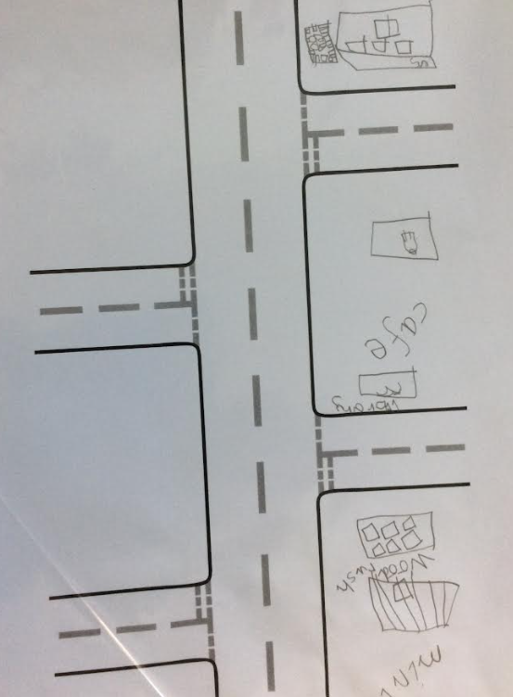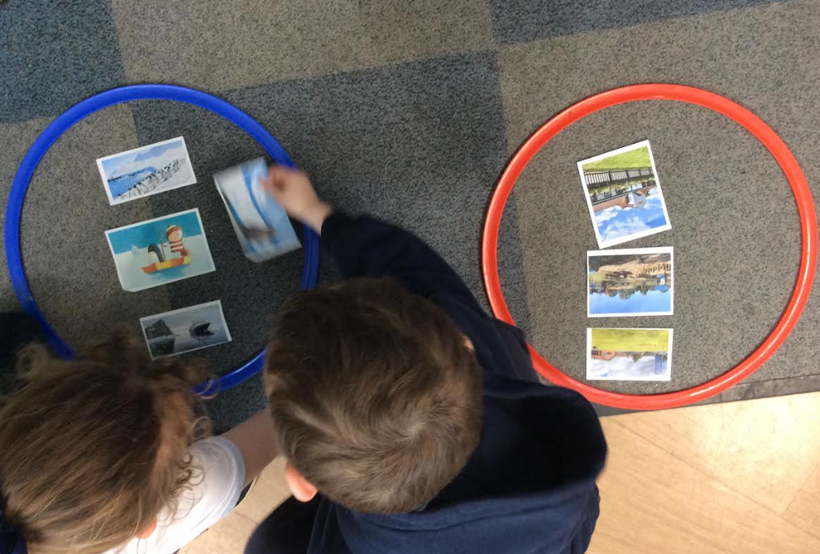

Year 3 trip to Lapworth Museum

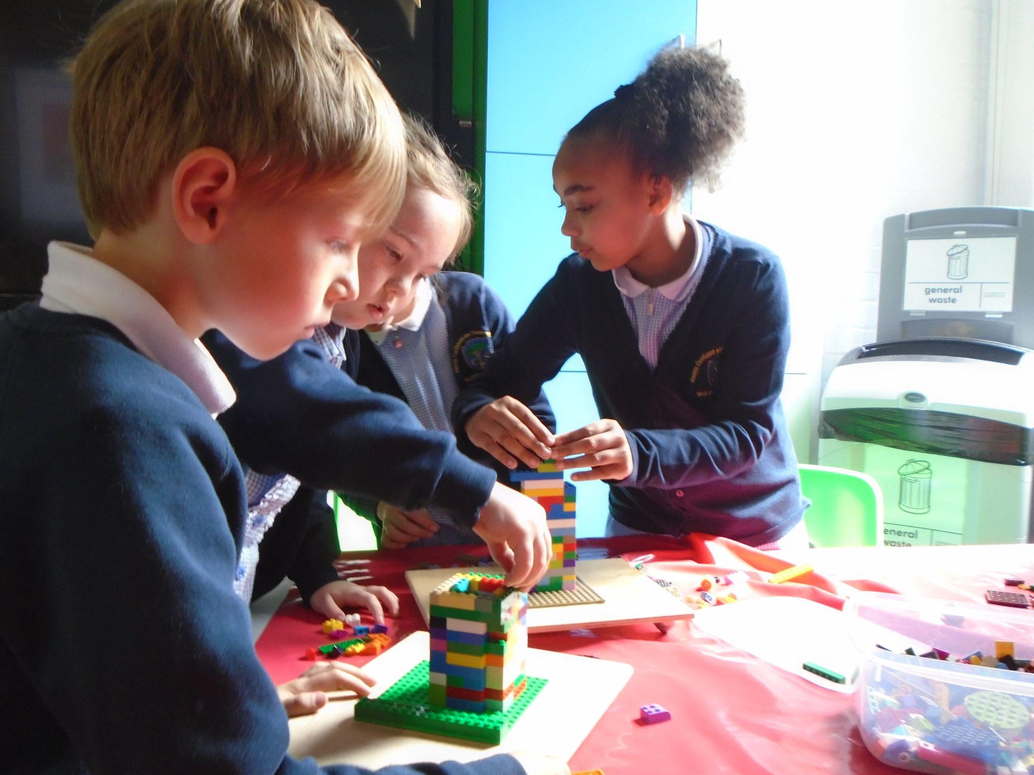
Our Year 3 children have the exciting opportunity to visit Lapworth Museum at the University of Birmingham. Throughout their tour, they explore each geological period, looking at the life on Earth at that time and the fossils we find from each period. They also explore the Extreme Earth Room and the Mineralogy Room. Year 3 are also welcomed into Lapworth's classroom by a palaeontologist who introduces them to a range of different volcanic rocks that the children can interact with up close. The children then get the chance to build earthquake-proof houses out of Lego, which they test on a shaking board.

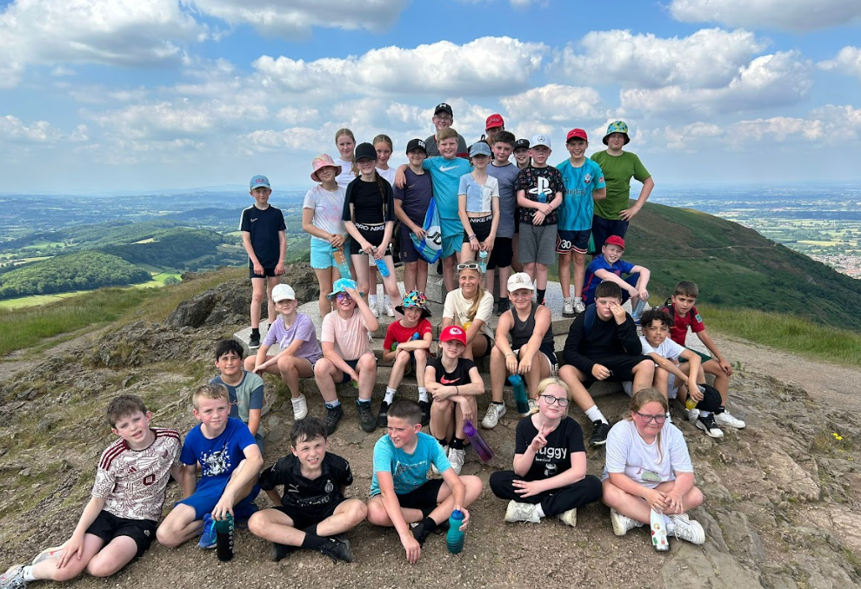
Year 6 trip to Malvern

Our Year 6 children have a fantastic opportunity to take part in many outdoor adventure activities during their residential in Malvern, giving them the chance to try new things and develop new skills. During this trip, the children climb the Malvern Hills summit, the Worcestershire Beacon, standing at 425 meters (1,395 feet) as the highest point in the range. This allows the children to see a real-life example of a physical feature and see how it shapes our landscape.

Eco at The Coppice Primary School

Our Eco Leads and Eco Ambassadors are helping to ensure that sustainability education is embedded throughout the school. This links simultaneously with our Geography curriculum whilst enabling pupils to learn the National Curriculum through real-world examples. The Eco team help promote understanding of place knowledge, geographical skills and fieldwork through connecting our school grounds to our wider community and beyond to create a global perspective of the positive and negative impacts that humans can have on the natural world. Human and Physical Geography is a core focus of our Eco team by striving to improve our water, energy and waste management. Eco also works alongside OPAL to promote ‘reduce, reuse and recycle’ when utilising play equipment and creating green spaces on our school grounds. The pictures below show the Eco team litter picking and planting over 200 saplings to create a 50m hedgerow.
