STRUCTURE OF A MATHS LESSON
Maths fluency task (15 minutes)  At least 3 times a week during register time.  Maths fluency is usually completed in:  KS1, on whiteboards  KS2, in maths fluency books.  Minimal input or support should be required. It is a retrieval practice of concepts previously taught. | 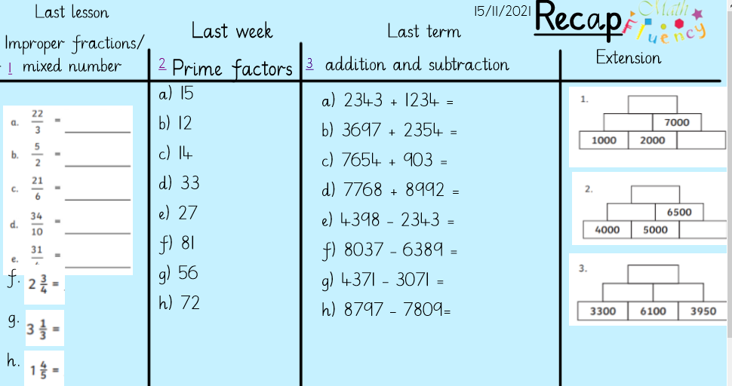 | Assessment opportunity:  As this is a retrieval practice of previously taught concepts, this is a great assessment opportunity to see what has been remembered.  KS1: Check of what is on the Whiteboards and individual responses  KS2: Self-mark and checked by Teacher/TA. Common misconceptions addressed with ’Wobble’ interventions if required.
Structure of the lesson: | Example: | Assessment opportunities:
- Recap / revisit  - Identify a skill that is required within the lesson. Short and pacy and will usually be completed on a mini whiteboard | Calculations that feed into the lesson  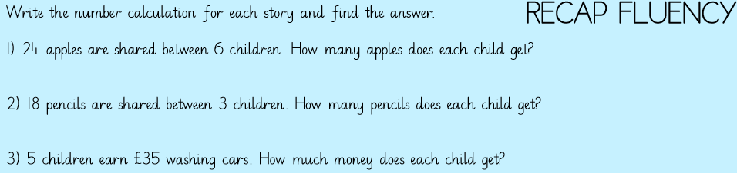 | Adults make observations. Children self-mark. ‘‘Show me’ on the whiteboards is used to check individual understanding.  All responses are checked to inform steps forward.
- Key vocabulary  New and previously taught vocabulary.  Ambiguous vocabulary may need to be unpicked - examples given when needed.  Examples of how the Vocabulary matches with parts of the calculation may be used | 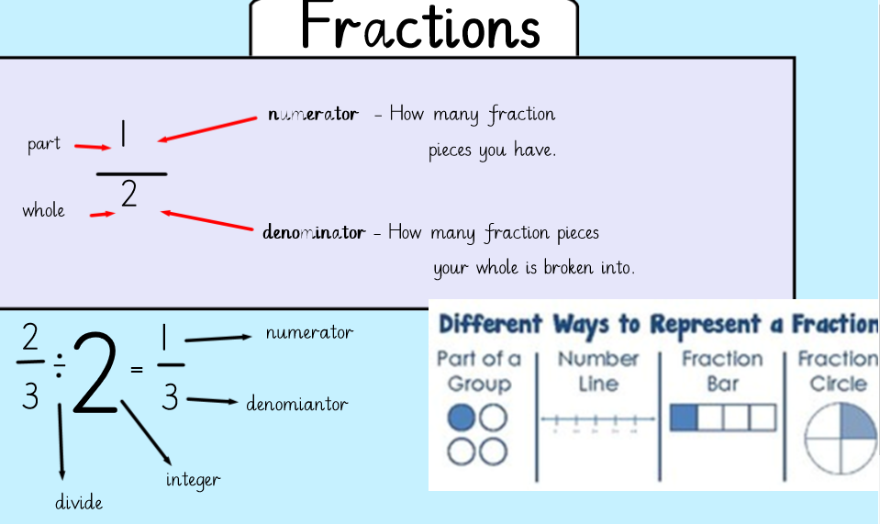  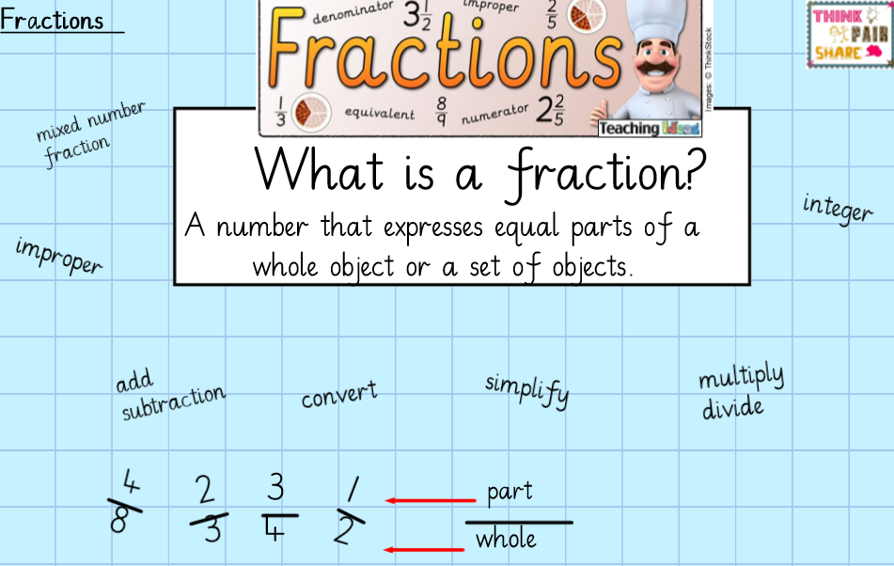 | Check understanding of key vocabulary. Paired talk can be used to share and embed knowledge.  Check how the vocabulary can be used within the correct context.  Address any misconceptions.
- Anchor task /In Focus question  Exploratory task: Poses a question or a problem  Completed on whiteboards. Teacher to scaffold where needed. Teachers to then go through and model how the problem/questions should be solved. | 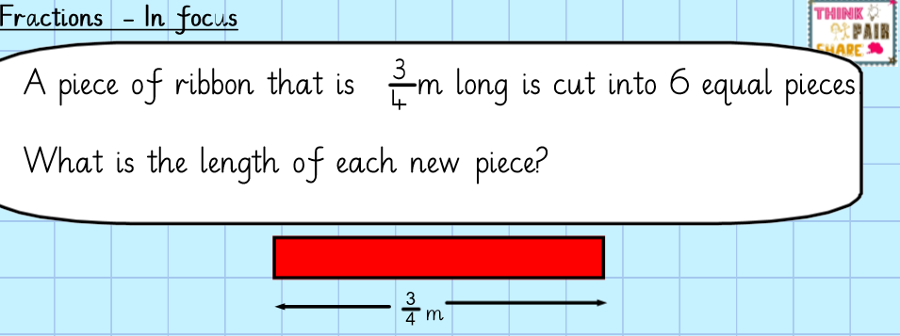 | Target questioning.  Paired talk to talk through the problem.  Scaffold and support where needed. Assess where understanding is not secure.
- Teach the skill (I do)  Main teaching (Let’s Learn)  Learning and exploration  A series of practical/pictorial representations with clear modelling from the class teacher.  This may be adapted if additional support if required (extra steps added) | 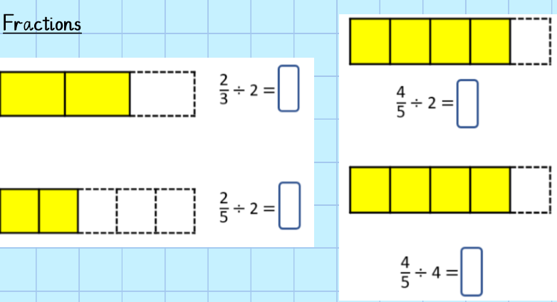  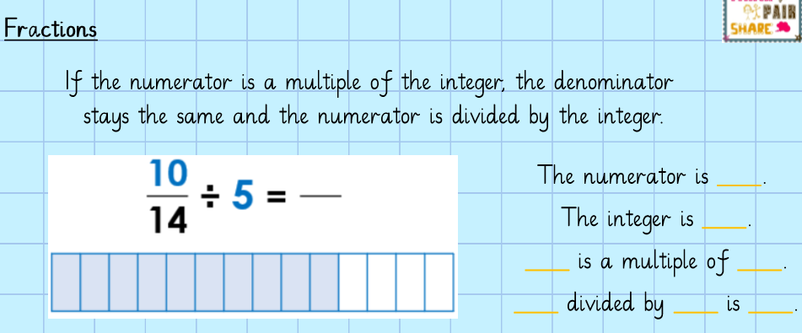  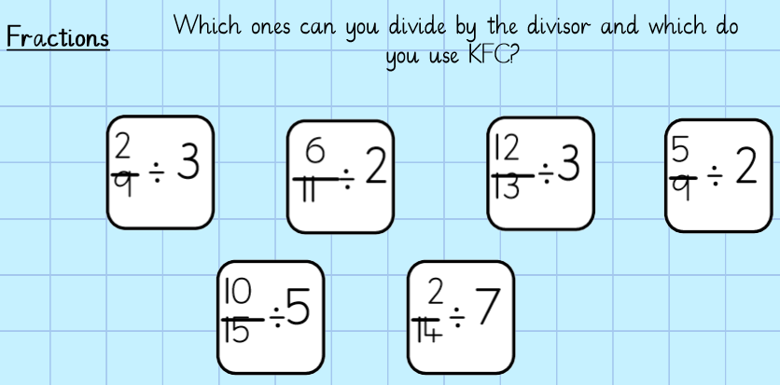  Try to build a stem sentence into the learning  Eg. The numerator is _____. The integer is _____. _____ is a multiple of _____.  _____ divided by _____ is _____. | Check through direct questioning, show me on whiteboards.  Additional steps may be added based on observations made during the modelling and explanation stage.
- Guided task (We do)  A series of questions – using the skills they have been practising.  Most of the time, this should be completed in maths books.  Teacher-talk to support learning as the children practise the taught skill. | 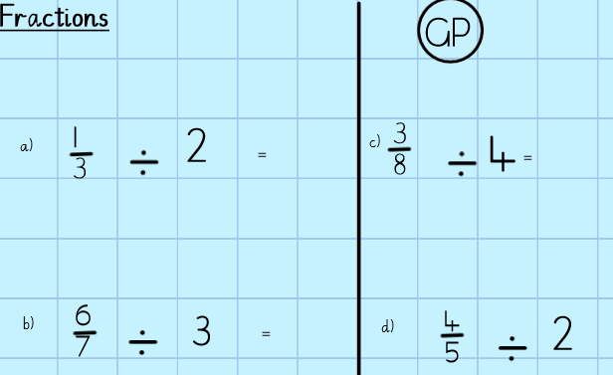 | This checks their understanding, ready for the independent task by going through the questions/answers together. This may be as a class or individually.
6) Independent / Intelligent work  (You do)  Children complete the planned task (Reasoning and problem solving – applying the skills  Do it: Simple examples (fluency). There may be extra ‘do it’ questions for children who need more practise.  Secure it: Slight variation, Active argument – yes/no, true/false, misconceptions, show me, convince me (reasoning)  Deepen it: Probing Questions, Deeper reasoning, Problem solving, Thinking ‘Out of the Box’ application within a variety of contexts  *Precheck activity (adaptive)  This task is a similar objective but may be from a previous objective. This should allow the children who are working below ARE in a particular area to still be challenged by allowing them to access the work independently for at least some of the time. This will be a more scaffolded task to begin with, leading to more independence as they work through the task.  *Additional adaptive measures may be used (manipulatives / more structured model/ additional guidance/ collaboration) | 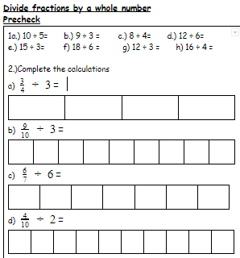  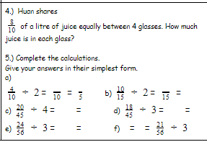  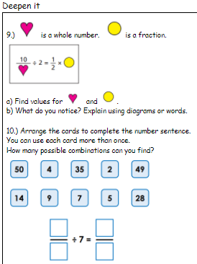  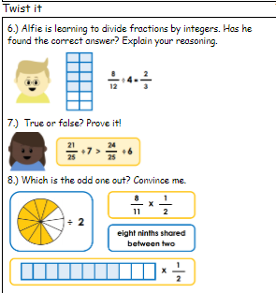  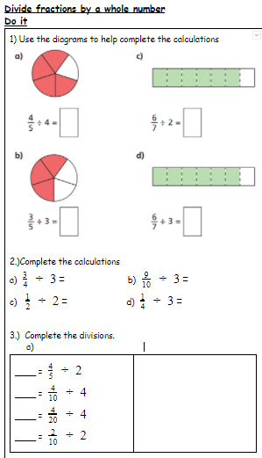 | Feedback against the success criteria is provided.  This may be done through questioning, observations of outcomes and analysing the work being completed.  Work is self-marked at the end of the lessons and key misconceptions should be addressed if they have not already.  Identify where there may be gaps in learning and use them to plan next steps in learning.
8) Apply/Check: Use your head (Not required every lesson)  Apply their knowledge from the day to a calculation/problem. May include some reasoning and explanation. | 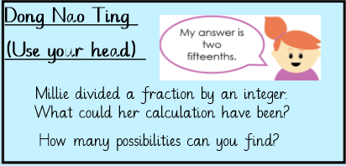 | To be used at the end of the lesson (when appropriate) as a check to see if their learning from the lesson can be applied.

