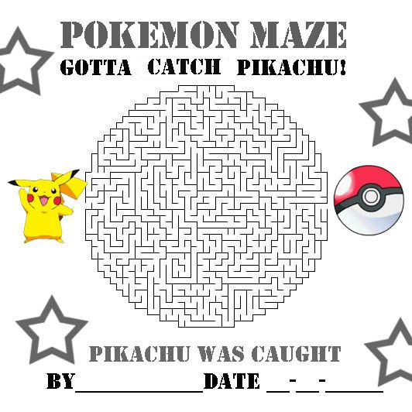
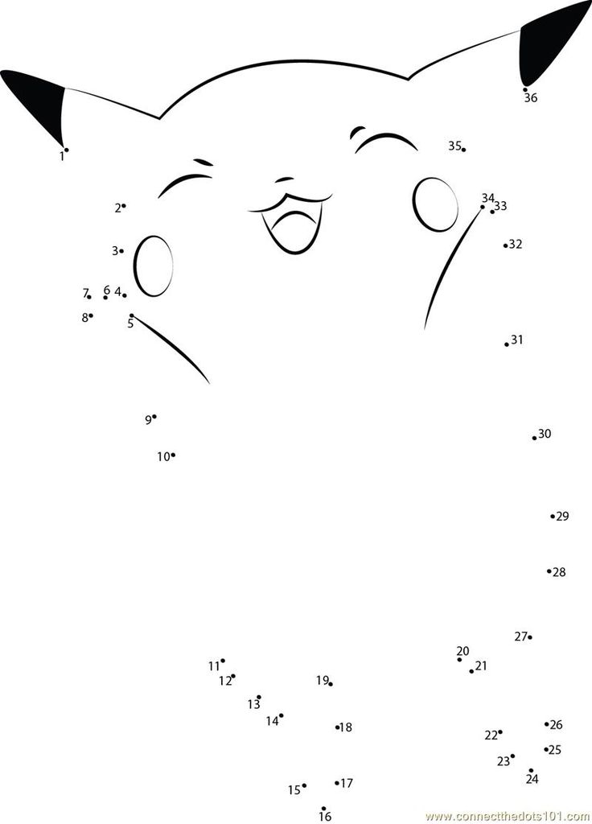

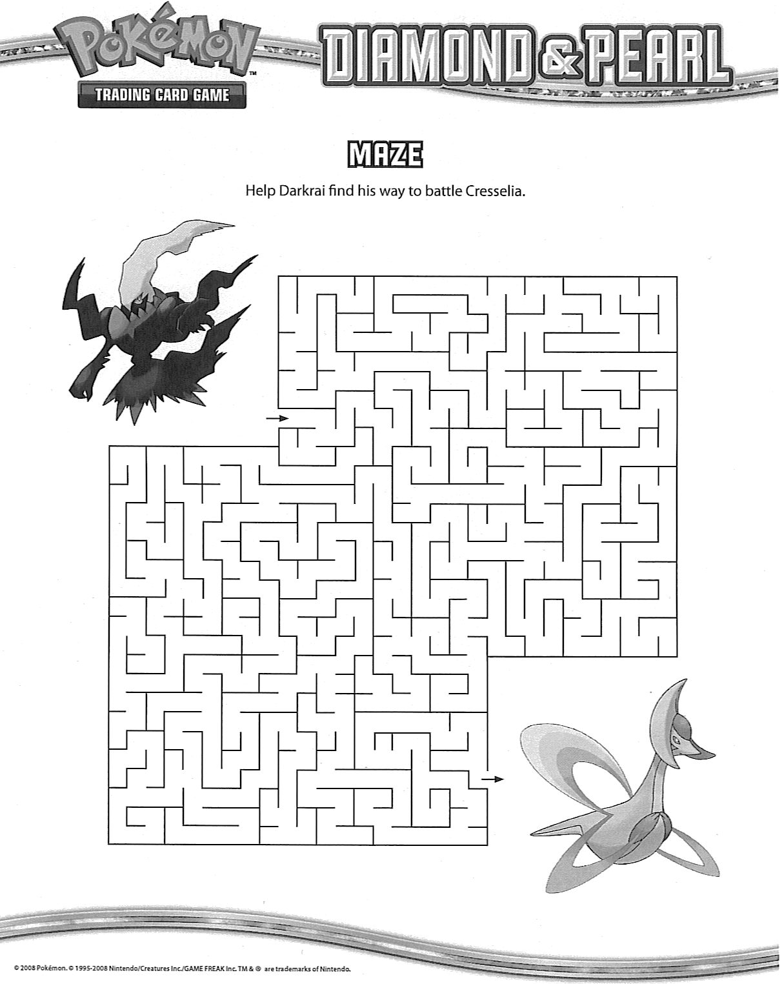

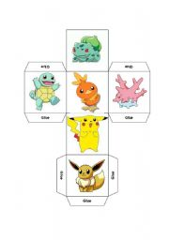

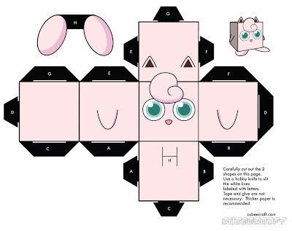

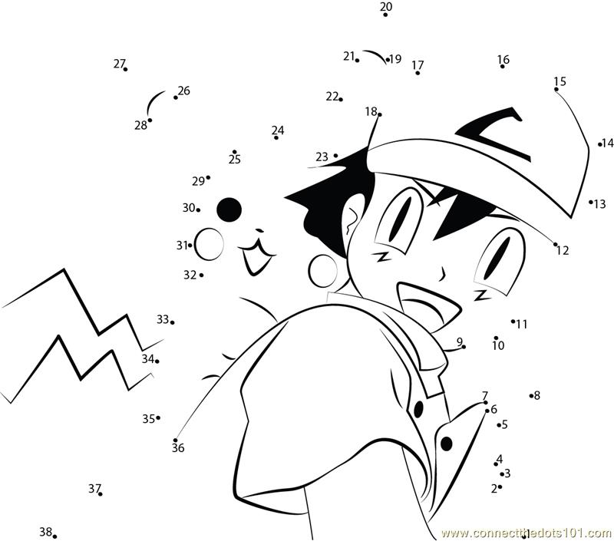

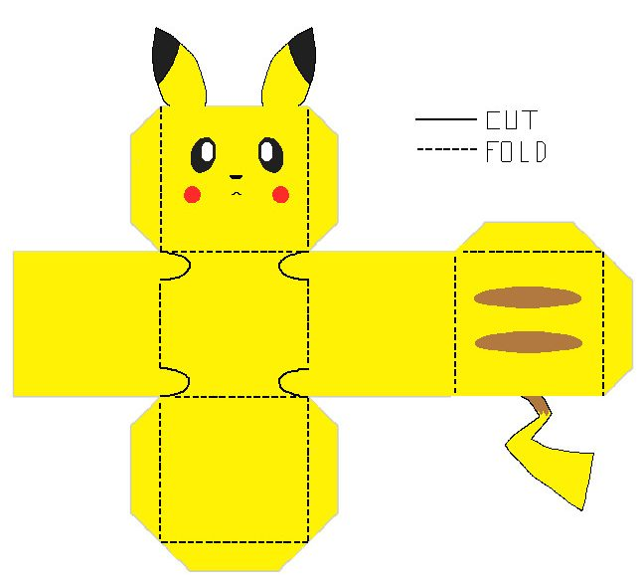

1. If You Build It
Use your imagination to design a Minecraft building such as a shop, cave dwelling, mansion, or theater. What will you design? How will you persuade others to come to your building? Make a list of 6-10 reasons why people will love this place.

2. Minecraft Scenario
After a terrifying shipwreck, you find yourself on a beach. You don’t know where you are, and it will soon be dark. What will you do?

3. Avatar Adventures
Write a story about your Minecraft avatar. How did you arrive in your world? What are some of your goals? Who are your allies?

4. It’s a Zoo!
You have been hired to build an enclosure for a Minecraft zoo. Choose a mob to live in your enclosure, and describe the enclosure you will build for them.

5. Tools of the Trade
Describe three Minecraft tools and explain how you like to use them.

6. Dear Grandma
Your grandma has never seen Minecraft, and she has asked you to help her understand it. Write a letter in which you explain what Minecraft is and why you enjoy playing the game.

