

**Roman Britain**

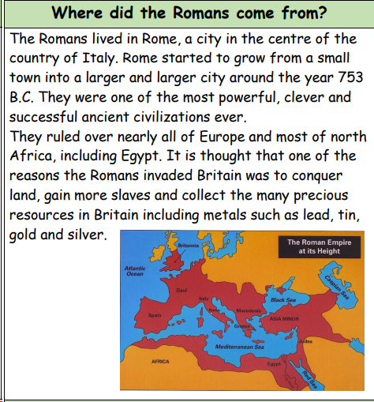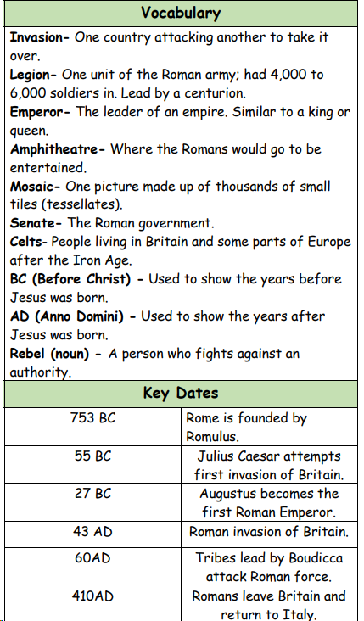

Lesson 1: To understand the terms ‘invade’ and ‘settle’ and to place the Romans on a timeline

Lesson 2:  To find out why and how the Romans successfully invaded Britain

Lesson 3: To find out who was in Britain when the Romans invaded and learn about their way of life

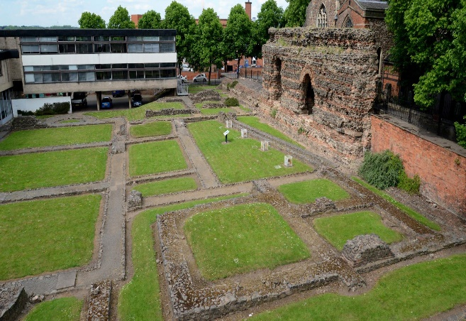

Lesson 4: To find out about life in Roman Leicester.

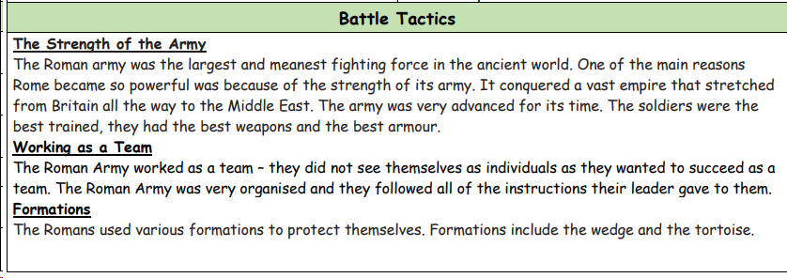#

Lesson 5: To explore Leicester’s Roman remains

Lesson 6: To know how the Romans have influenced our lives today.



**Roman Britain.**

**At the end of Spring** 1**:**

**At the beginning of Spring 1:**