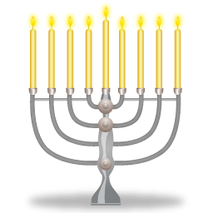
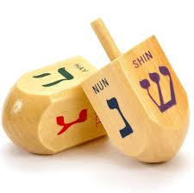
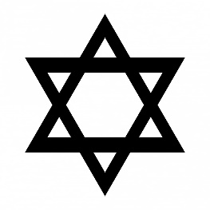
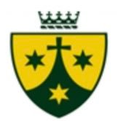
Hanukkah reminds Jewish people that God cares for his people.
Hanukkah is celebrated in November or December every year.
Hanukkah is the Jewish Festival of Lights.
OUR BIG QUESTION
What is Hanukkah?

JUDAISM – Hanukkah
EYFS
KEY VOCABULARY
Hanukkah oil
Feast of lights
Menorah

