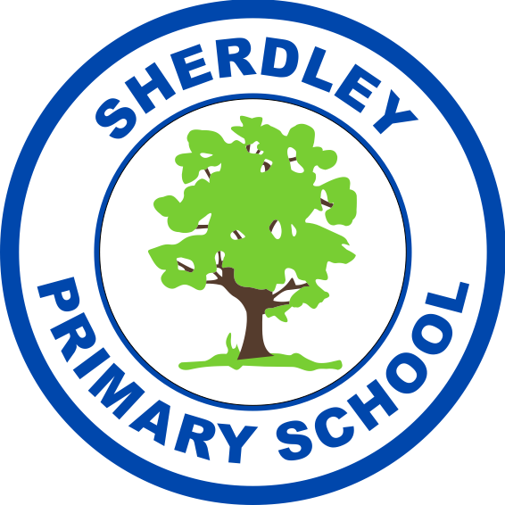
Sherdley Primary School 2023-24
Music Curriculum Map

 | Autumn 1 | Autumn 2 |  | Spring 1 | Spring 2 | Summer 1 |  | Summer 2
Preschool | Dance/Music - Fantasia – Disney; Beauty and the beast instrumental; Bagpipe music – Flower of Scotland; Banjo music -Bluegrass; Vivaldi – Autumn (The Four Seasons); Music of the Night – Phantom of the Opera; Glenn Miller band - Christmas music; Tchaikovsky – The Nutcracker  Music - Voice sounds; Environmental sounds; Animal sounds; Musical instruments – learning how we play them and what sounds they make; Play guess the sound of the instrument.  Nursery rhymes - Incy wincy Spider; Humpty Dumpty; Miss Polly had a dolly; Hey Diddle diddle; Jingle bells; When Santa got stuck up the chimney  Songs: Five little speckled frogs; Pigs in the mud; Five Little Pumpkins; Jingle bells; When Santa got stuck up the chimney |  |  | Dance/Music - Dancing boogie beebies Penguin bop and I wish it would snow; Moving to the beat  The Frog Chorus song; Vivaldi – Winter (The Four Seasons); Soft to loud music; I have seen the light  Beethoven Symphony No 5; Holst Mars; Puccini -Madam Butterfly  Music - Voice sounds – boom chic a boom in different voices; Learning the names of the instruments; Playing different instruments – learning that some we have to shake and some we need a beater for; Playing instruments quietly and loudly.  Nursery rhymes - London Bridge; The Grand Old Duke York; Orange and lemons; Teddy bears picnic; I’m a little teapot; Mary Mary Quite Contrary  Songs - I’m a little snowman; The bear song; The winter hokey pokey; Penguin bop; I wish it would snow; 5 Little Ducks; Cauliflowers fluffy |  | Dance/Music; Movements to sounds; Gross motor ribbon sticks; Korsakov– Flight of the Bumblebee; Jazz – Everyone wants to be a cat; Steel bands – Under the Sea; Fast and slow music: Zobra’s Dance – Mikis Theodarakis; Grieg – The Hall of the Mountain King; Brahms – Hungarian Dance No 5  Music - Play instruments to express feelings and ideas; To match pitch; To copy a melodic shape of a familiar shape; To create their own songs; Playing instruments fast and slow.  Nursery rhymes - Old Macdonald; The farmer in the dell; Mary had a little lamb  Songs - The Gruffalo; Julia Donaldson songs; Pull a funny face; What the ladybird heard; The farmer’s in the dell; Begin learning new songs for Graduation; Who’s afraid of the big bad wolf
Preschool | Performance: Nativity |  |  | Performance: Family Learning (Voice sounds) |  | Performance: Graduation (singing)
Reception | Me! And Stories.  Singing set songs.  Game track – keep the rhythm using different sounds – clapping, tapping.  Copy simple rhythms – names.  High and low games (pitch).  Including percussion instruments. |  |  | Everyone and Our World.  Game track – find the pulse in different ways.  Copy simple rhythms – copycat using chime bars.  High and low games (pitch).  Dynamics – soft and loud sounds.  Create own sounds. |  | Big Bear Funk.  Game track – find the pulse in different ways.  Copy simple rhythms – copy back teacher then child led.  Explore pitch by creating own sounds with voices and instruments.  Compose with the songs already learnt.  Focus on the language of music.  Prepare for the performance of the songs.
Reception | Performance: Nativity |  |  | Performance: Easter Singalong for Parents |  | Performance: Class Assembly
Year 1 | My Musical Heartbeat | Dance Sing and Play! |  | Exploring Sounds | Learning to Listen | Having Fun with Improvisation |  | Let’s Perform together!
Year 1 | Performance: Nativity |  |  | Performance: Class Assembly |  | Performance: Music Festival
Year 2 | Pulse Rhythm and Pitch  Short Term Project with St Helens Music Service - Boomwhackers | Playing in an Orchestra |  | Inventing a Musical Story | Recognising Different Sounds | Exploring Improvisation |  | Our Big Concert
Year 2 | Performance: Nativity |  |  | Performance: Class assembly |  | Performance: Music Festival
Year 3 | Writing Music Down |  | Playing in a Band | Compose Using Your Imagination | More Musical Styles | Enjoying Improvisation | Opening Night
Year 3 | Performance: Carol Service |  |  | Performance: Recorder Assembly |  | Performance: Music Festival
Year 4 | Musical Structures | Exploring Feelings When You Play |  | Composing With Your Friends | Feelings Through Music | Expression and Improvisation |  | The Show Must Go On!
Year 4 | Performance: Carol Service |  |  | Performance: Class Assembly. Ukulele performance for parents |  | Performance: Music Festival
Year 5 | Wider Opportunities: Brass for the year, delivered by St Helens Music Service
Year 5 | Melody and Harmony in Music | Sing and Play in Different Styles |  | Composing and Chords | Enjoying Musical Styles | Freedom to Improvise |  | Battle of the Bands!
Year 5 | Performance: Carol Service |  |  | Performance: Brass Music Concert |  | Performance: Music Festival  Performance: Brass Music Concert
Year 6 | Music and Technology | Developing Ensemble Skills |  | Creative Composition | Musical Styles Connect Us | Improvising with Confidence |  | Farewell Tour  Short Term Project with St Helens Music Service - Samba
Year 6 | Performance: Carol Service |  |  | Performance: Class Assemblies |  | Performance: End of Year Production

