(Teign School Ten Tors Kit list
The following kit is what students need for Ten Tors, the number of items listed includes those worn e.g. two base layers means; one worn and one spare, to be carried.
This list is the minimum kit required and a lot of you will need to wear and carry more layers during our winter training walks.
If you have any questions about kit, please speak with one of us before or after any walk or email at the normal email address.
Clothing items include those you are wearing
Items highlighted yellow are required for all PRE XMAS walks, camps and the event.
Items highlighted blue are additions, required for all POST XMAS walks, camps and the event.
Items highlighted green are required for all camps and the event.
The weight of your rucksack should be increased on every walk. One way of doing this is to start including more of the items listed early on. Also, you could include extra water – this means the weight can be decreased if needed.
Walk 1: 3-4.5kg
Walk 2: 4.5-6.5kg
Walk 3: 6.5-8kg
Walk 4: 8-9.5kg
Walk 5: 9.5-11kg
Walk 6: 11-13kg
From Walk 7 onwards the approx. weight of your rucksack will be: 13-15kg

CLOTHING
Waterproofs
Waterproofs should be of breathable fabric with all the seams taped and should be robust enough to withstand two days of wind driven rain.
Jackets should have
A NON detachable hood [mandatory] with a stiffened peak, water resistant zips with a storm flap behind or in front of the zip.
Trousers should have
Zips of at least ¾ length so that they can put on and removed over boots. These zips are often two way and can be undone from the top to provide ventilation in warmer showery weather.

Base Layers
2 no. These should be of a synthetic quick drying, high wicking material which will transport moisture away from the body leaving the skin feeling warm and dry. Most modern sports wear has these properties as well as specific outdoor items. Cotton is a definite no as it retains moisture, rapidly cools the body and takes a long time to dry.

Intermediate Layer
2 no. (Lightweight fleece 100gsm – 175gsm)
Static Insulating Layer
1 no. Our recommendation is an insulated jacket with a synthetic fibre fill. These are ideal as they are wind proof and water resistant which means they can be put on over a waterproof when you stop for a break, doing away the need to take a waterproof off in bad weather as is the case with the old type of layering system when you needed to put a fleece under your waterproof as it is not wind proof.

Please note If you wear your insulation layer during training walks you will need to carry a spare

Trousers /leggings
2 no. Must completely cover lower limbs to provide protection against sun and insects. Ideally wind resistant and quick drying. Shorts/track suits/jogging trousers are not acceptable.
A poly cotton mix is acceptable but Is not ideal as they do take a fairly long time to dry.
Trousers and leggings must be robust enough and have adequate thermal protection to cope with the various environmental elements that Dartmoor frequently presents.

Leggings: ¾ Leggings/Leggings with windows or clear panelling/ Leggings with designer holes are all PROHIBITED.

Socks
2 pairs. These should be walking socks not sports type. They should be of a high wicking fabric which will feel dry even if they get wet, this will greatly reduce the chance of blisters. This is also the case as we move into warmer weather when your feet start to get hot. If you wear liner socks these do not count towards your two pairs.

Gloves
1 pair. Although one pair of gloves will suffice we recommend a spare pair is carried.

Hats
1 no. The mandatory army kit list states a hat to suit the conditions. That means throughout training you will need a warm hat and it is strongly recommended you carry a spare. As the weather improves you may need a sun hat as well, this needs to have a brim which protects the ears. A brimmed sun hat will be required on the event.
Boots
Boots need to be high enough to support the ankle, have a sole with deep lugs that will grip on wet grass and mud and if possible be waterproof.

Gaiters
These are optional but are very useful keeping water out of your boots and your trousers clean and dry. Remember do not tuck waterproof trousers inside your gaiters or the water will run straight down between trouser and gaiter into your boot. The bottom of your gaiter needs to fit tightly down onto your boot, if there is gap between the bottom of your gaiter and the top of your boot, your boot will fill with water.

EQUIPMENT
Rucksack for day walks
A 20-25lt walking rucksack

Large Rucksack
This should be of 60-65 litre capacity with an adjustable back length and supportive waist band. It is important to get the ruck sack fitted and most outdoor shops will have weighted bags to enable you to try it in the store. A common problem for boys trying to use a man’s sack is the waist band does not pull in tight enough, this can often be overcome by using a woman's version.
There are a number of spares in the store which you are welcome to try on to get an idea of fit etc.

Sleeping Bag
Sleeping bags must be stowed in a waterproof bag and provide thermal support for the user down to a lower limit temperature of -2 degrees C tested to an International, European or British standard. These would be signified with the letters BS, EN or ISO (or a combination) followed by the standard number 23537 or 13537.
Examples of this on a bag would be: BS EN ISO 23537 or BS EN13537.
N.B bags may show one or all combination of letters against the relevant number. Sleeping bags give three ratings, comfort, lower and extreme. It is the lower limit rating you are looking for. This is shown as the middle temperature in the examples below all three of these would comply.
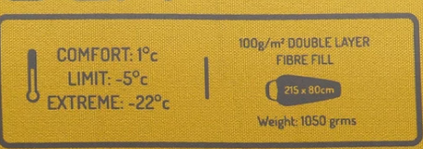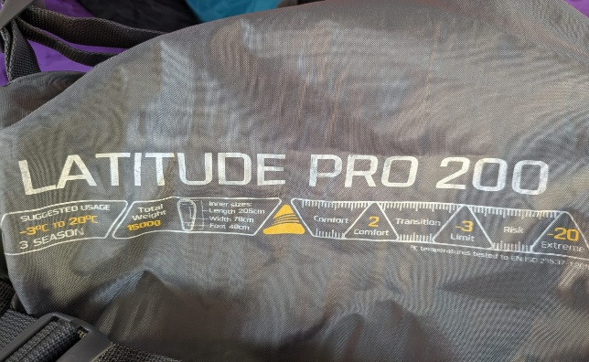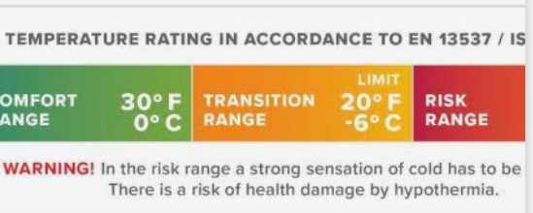
Please be aware these are the minimum requirements (anything not meeting these ratings will not be accepted by the Ten Tors Event Organisers) for sleeping bags on the event in May. As we start camping late February early March we would recommend a warmer bag to cover the winter period.
The example below would NOT comply
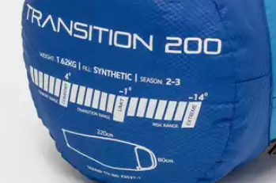

Sleeping mat
A sleep mat needs to be full length.

Water bottle
2 no. Two water bottles of one litre are required. This is to enable one to be filled and a sterilisation tablet added, so the water is purifying whilst the other is available for drinking. One needs to be rigid but the other can be a bladder system. The water from the rigid bottle can be poured into the bladder once it has purified and the process started again. One will suffice for day walks. You may want to carry a flask containing a hot drink on day walks.

Map and compass
The army rules are each team should have two maps and compasses between them, but we expect everyone to carry their own and be able to use them.
Torch
A head torch is preferred to a hand held version but not essential, although spare batteries must be part of your kit.

Personal first aid kit
Comprising of Blister plasters e.g compeed, waterproof plasters, medi wipes. You may also wish to keep any medication including inhalers here. This should be in the top pocket of your rucksack where it is easily accessible.
You may wish to consider carrying paracetamol or ibuprofen if you normally use them. As first aiders staff are not permitted to issue you with them.
Sundry items
Whistle, (must be separate from those supplied on some rucksack clips)
notebook and pencil,
water purifying tablets
Emergency rations comprising of high energy food such as nuts, protein bars, chocolate etc.
Survival bag
sun cream
Sundry items
mug
eating utensil
bowl / plate if not using boil in bag or dehydrated food
personal medication [location to be made known to all team members]

Dry bags
These can be rubble sacks or specialist outdoor type but all of your spare clothing and sleeping bag should be in dry bags. Preferably not all in the same bag. Carrier bags are not strong enough and have holes in them.

Food
One hot evening meal, boil in the bag or de hydrated are best. There are re-sealable bags available which can be used for your own precooked meals which will keep the cost to a minimum.
One hot breakfast, again boil in the bag or dehydrated cereal packs or porridge pot which only require water.
Two lunches which are suitable to be kept unrefrigerated for two days.
The above food is required for the event please adjust quantities to suit the number of nights camping during training walks.

TEAM KIT supplied by school
Tent [2 per team of six] February onwards.
Trangia [2 per team of six] February onwards.
First aid kit [2 per team of six] this includes a tent repair kit
Poles [2 sets per team of six] February onwards.
Rubbish bag
Hi-viz [ 2 per team]
Gas [2 per team]
Trowel [2 per team]

Group shelter
TEAM KIT not supplied by school
Waterproof Matches [2 boxes per team]
Watch [1 per team]
Tent pegs [2 sets x 20 per team

