St Chad’s C.E. Primary and Nursery School
Thankfulness and Gratitude
Reflection areas from the Vision Group (Display on reflection board)
Watch the story of the Dog and his bone https://www.youtube.com/watch?v=Oq-vK6nyPDY
What might have happened if he had just been happy and thankful for what he had got?
Not every day is good, but every day has good in it. What good has there been in your day? What are you thankful for today?
Watch https://youtu.be/auSo1MyWf8g What are you thankful for in the world? What do we enjoy about seeing nature?

Bible verses to explore:
Give thanks to the Lord for he is good. His love endures forever. Psalm 118:1
So then, just as you received Christ Jesus as Lord, continue to live your lives in him, rooted and built up in him, strengthened in the faith as you were taught, and overflowing with thankfulness. Colossians 2:6-7 • Rejoice always, pray continually, give thanks in all circumstances; for this is God’s will for you in Christ Jesus. Thessalonians 5:16-18
Do not forget to do good and to share with others, for with such sacrifices, God is pleased. Hebrews 13:15-16

Use Treasure Champs to explore gratitude https://www.bbc.co.uk/teach/school-radio/articles/zxvd7v4

Make a thankfulnesss chain – choose an everyday item – who and what was involved in creating it? Using it? You could do the same with an item of food or meal and trace back where ingredients come from and who is involved in creating it, shipping it, selling it etc

Make an acrostic of THANKFULNESS use each letter to choose some things we are thankful for.

Week Beginning |  | Value – Truth and Honesty | Leader
Week 1 6/1/25  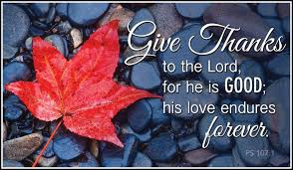 | Monday | Lord Shaftsbury and the Ragged schools | CS  DW HP LE EB
 | Tuesday | God’s Greatest Gift KS2  KS1 Reflection area | Rev Callum  PA and KA
 | Wednesday | Abraham’s Journey  https://www.assemblies.org.uk/pri/3744/abrahams-journey | Year 6 and CHa  JM and NH
 | Thursday | Godly play KS1  KS2 Reflection area | CS  All KS1 staff
 | Friday | Celebration Worship  Prayers Reception | CS  All Staff
Week 2 13/1/25  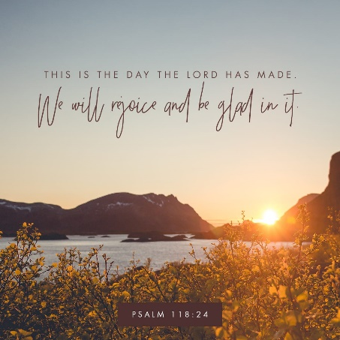 | Monday | 9.05 Composer Launch | JH  EB and EC
 | Tuesday | KS1 Count Your Blessings  KS2 Reflection areas | Rev C  JH and NH
 | Wednesday | Giving thanks for the Start of the day  https://www.assemblies.org.uk/pri/2907/giving-thanks-at-the-start-of-the-day | Year 5 and JM  HS FD
 | Thursday | KS2 Window on the World  KS1 Reflection areas | CS  KS2 Teachers
 | Friday | Celebration Worship  Prayers Year 1 | CS  All staff
Week 3 20/1/25  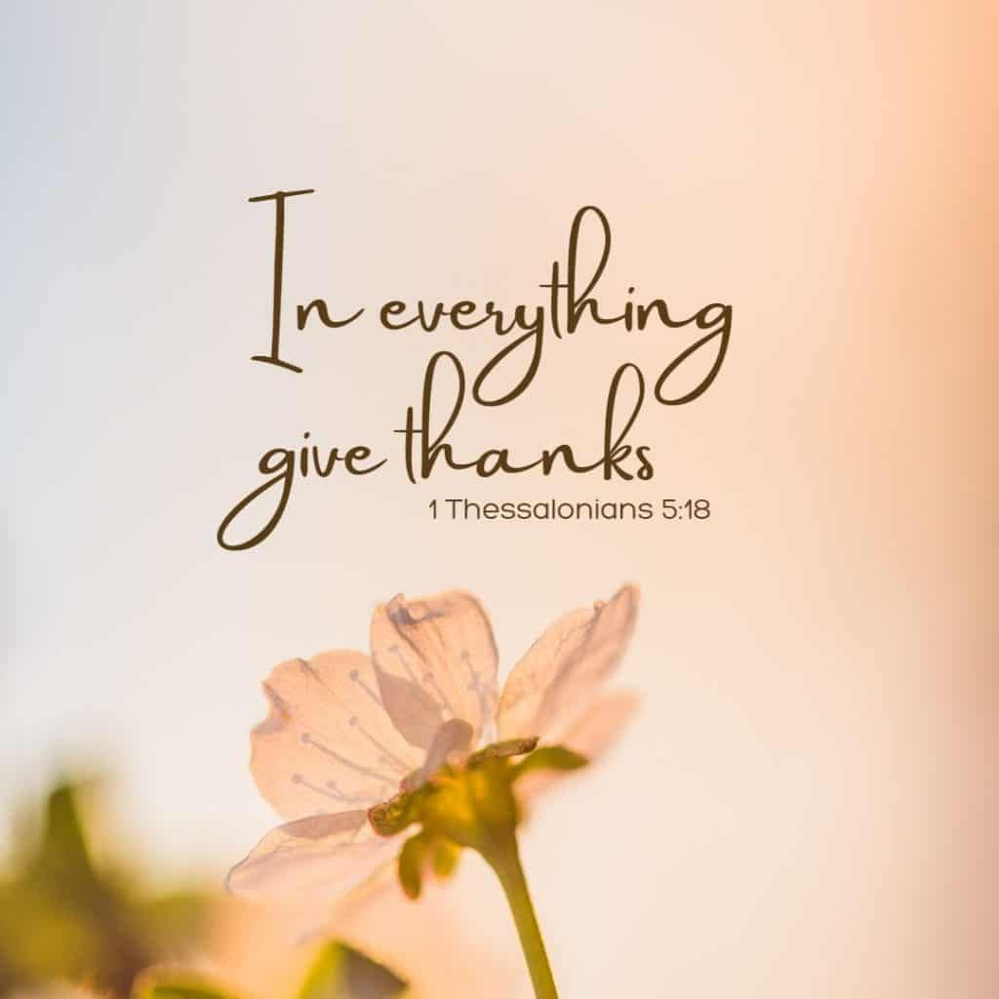 | Monday | Singing Worship | JH  DW and HS
 | Tuesday | KS2 Saying Thank you  KS1 Reflection areas | Rev C  CHa and EC
 | Wednesday | If wishes came true…  https://www.assemblies.org.uk/pri/2196/thankfulness | PA and Year 4  KA and HP
 | Thursday | KS1 Godly Play:  KS2: Reflection areas | CS  KS1 teachers
 | Friday | Celebration Worship  Prayers Year 2 | CS
Week 4 27/1/25  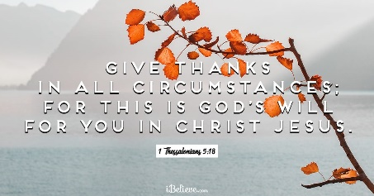 | Monday | Sing and Praise Worship | JH  JM and DW
 | Tuesday | KS1 Being Grateful for God’s creation  KS2 Reflection areas | Rev C  HS and HP
 | Wednesday | Being Grateful  https://www.assemblies.org.uk/pri/3242/being-grateful | Year 3 and EC  FD and NH
 | Thursday | KS2 Window on the World  KS1 Reflection areas | CS  KS2 Teachers
 | Friday | Celebration Worship  Prayers Year 3 | CS  All Staff
Week 5 3/2/25  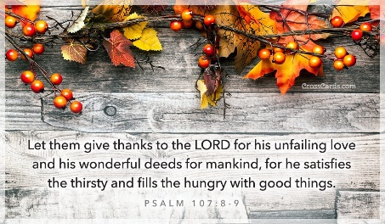 | Monday | Sing and Praise Worship | JH  PA and LE
 | Tuesday | KS2 Envy Stops us being thankful | Rev C  CHa and HP
 | Wednesday | Thankful Wells  https://www.assemblies.org.uk/pri/1696/well-thankful | Year 2 and HS  EB and KA
 | Thursday | KS1 Godly Play:  KS2 Reflection areas | CS  KS1 teachers
 | Friday | Celebration Worship  Prayers Year 4 | CS  All staff
Week 6 10/2/25  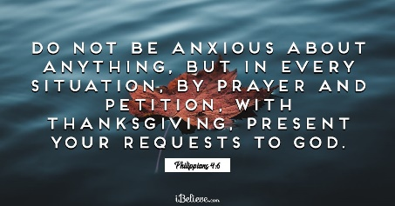 | Monday | Sing and Praise Worship | JH  LE and EB
 | Tuesday | KS1 Saying Thank you | Rev C  FD and DW
 | Wednesday | Thankful for trees and the environment  https://www.assemblies.org.uk/pri/222/the-jewish-festival-of-tu-bshevat | Rec and FD  NH and EC
 | Thursday | KS2: Window on the World  KS1 Reflection areas | CS  KS2 Teachers
 | Friday | Privilege Cards  Prayers Year 5 | CS
Songs | Out of the Ark Living and Learning OR https://youtu.be/phy2jTi1Ls4  I want to say thank you https://www.youtube.com/watch?v=eiq2JrZuQgU  Thankful – see worship folder on Onedrive  Thank you https://www.youtube.com/watch?v=wU60o7Kn3k8  Thanksgiving https://www.youtube.com/watch?v=488HEflx2ao with lyrics (https://www.youtube.com/watch?v=b-yHxNhGPPM )  Praise God from whom all Blessings flow https://www.youtube.com/watch?v=nPJPgu4mhGQ

