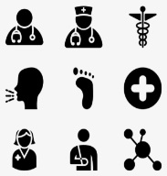
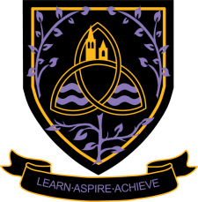
Health and Social Care Level 3 Cambridge Technical Diploma
2024 - 2026
Wigston College

Examination Board
OCR (Diploma – 5833)
Entry Requirements:

You will require a Pass in Level 2 Health and Social Care. If you have not studied this subject at GCSE level you will need GCSE Grade 4 in English Language or English Literature.

What will I be studying?

In the Level 3 Diploma, there are six units; three in year 12 and three in year 13. These are in addition to the six units studied as part of the Level 3 Extended Certificate in Health and Social Care.
Year 12: Unit 5: Infection control [internally assessed], Unit 7: Safeguarding [exam], Unit 14: Impact of long-term physiological conditions [internally assessed]
Year 13: Unit 6: Personalisation & a person-centred approach to care [exam], Unit 8: Creativity & activity for children [internally assessed], Unit 15: Promoting health & wellbeing [internally assessed]

How will I be studying?

Through discussion, group work, individual work, presentations, written coursework and conducting research.

How will I be assessed?

Year 12:
Unit 5: Infection control. Internally assessment: coursework, Unit 7: Safeguarding. External assessment: 90 minute written examination, Unit 14: Impact of long-term physiological conditions. Internally assessment: coursework.
Year 13:
Unit 6: Personalisation & a person-centred approach to care. External assessment: 90 minute written examination, Unit 8: Creativity & activity for children. Internally assessment: coursework, Unit 15: Promoting health & wellbeing. Internally assessment: coursework.

Where Next?

This specification provides a suitable foundation for the study of health and social care or a related area through a range of higher education courses, progression to the next level of vocational qualifications or employment. In addition, the specification provides a coherent, satisfying and worthwhile course of study for learners who do not progress to further study in this subject. Students studying health and social care can move successfully on to courses in nursing, midwifery, psychology, sociology, criminology, law and police studies, social work, teaching and human resources and many others. These can be studied via the usual apprenticeship or university route.

