Modern Foreign Languages (MFL) at St John the Baptist C of E Primary School
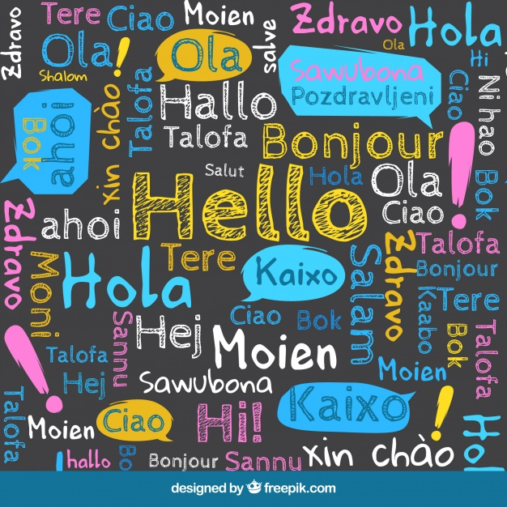

At our school, we believe that learning another language (perhaps the third or fourth for some of the pupils within our incredibly multicultural and multilingual school community) opens the doors to new and exciting cultures, fosters curiosity and deepens pupils’ understanding of the world. The weekly teaching of French enables pupils to develop their ability to express their ideas in another language and respond to its speakers both verbally and in writing. Children learn to communicate in Spanish for practical purposes and are exposed to books and songs in the target language. This early grounding in the basics of the Spanish language provides children with a firm foundation for further language learning and equips pupils to potentially study or work abroad in the future.

The MFL Curriculum
Through the teaching of Spanish, we aim to enable children to understand and respond to spoken and written language; speak with increasing confidence, fluency and spontaneity; write at varying length, for different purposes and audiences, using the variety of grammatical structures that they have learnt; and discover and develop an appreciation of a range of writing in the language studied. We also encourage children to engage with the culture of Spanish countries and their traditions.

Early Years Foundation Stage (EYFS)
Children in EYFS do not undertake lessons in Spanish but they can listen to songs on our Youtube channel playlist.

Key Stage 1
In Years 1 and 2 your child will begin to take their first steps on the journey to becoming a confident speaker of Spanish. Through games, songs, story books and video clips, children are exposed to simple French phrases, which allow them to introduce themselves and find out information about others. They also learn some key vocabulary, for example numbers, colours or pets. All activities involve speaking and listening, allowing children to attune their ears to the sounds and rhythms of the Spanish language and begin to pronounce with increased accuracy, ready for the exploration of written language at Key Stage Two.
Key Stage 2
As children move into Key Stage Two, they begin to develop the skills of reading and writing in Spanish, alongside a continued focus on the ability to speak and listen with accurately. Through the discrete teaching of phonics, they begin to understand the relationship between sounds (phonemes) and their written representations (graphemes) and use these to spell first words, and gradually more complex phrases and sentences, with accuracy and increased independence.
Children are also introduced to key grammatical concepts, such as adjective and noun order and agreement; the conjugation of regular verbs; and gender. These build in complexity over the four years of study at Key Stage 2 and are regularly revisited to ensure that children can use them with increasing independence as they move further up the school.
As in Key Stage 1, lessons continue to involve lots of games, songs, picture books and practical activities to maximise pupil engagement and embed key vocabulary and grammatical structures in an accessible and enjoyable way. After all, learning another language should be fun!

How can you support your child with Spanish?
The curriculum content may appear daunting, but do not panic! You don’t have to be able to speak Spanish to support your child with their learning at home. Simply talking to your child about what they have been learning in their language lessons that week and asking them to teach you some key words or phrases is a fantastic way of helping children recall previous learning. Perhaps they have a younger sibling or other family members that they might want to teach some key words, for example numbers, to as well?
Access the lessons and games online on the school website links or directly at languageangels.com. Each class in has its own virtual log in with links to songs, games and activities that will support pupils’ learning for the term. Ask your child to show you their favourite activity. Perhaps you could sing a song or play a game together?
Search YouTube for songs, clips or short TV shows in Spanish with your son or daughter. They could search for a song that they have been learning in school or the Spanish version of their favourite cartoon. Whilst children may not be able to understand everything that they are hearing, by simply listening to the lyrics of song or the words of a TV show, their ears are becoming attuned to the sounds and rhythms of French and they may be able to eventually pick out familiar words or phrases.
Hunt for bilingual books at the library. Many libraries have a bilingual book section where children might find simple stories in Spanish. They can have a go at reading the Spanish parts whilst you provide the translation in English.
Keep your eyes open when out and about in town or the supermarket. Challenge your children to find Spanish products on the supermarket shelves and see if they can read the packaging or work out exactly where the item is from. Do they recognise any ingredient names in Spanish? Perhaps they could make their own list of things to buy in Spanish? When you are walking around town, children might also try and spot words in English that have been borrowed from Spanish?
Encourage older children to create a resource for younger pupils in the school to use. This could take the form of a ‘Knowledge Organiser’ (which presents all the vocabulary for a particular unit of work), a game or a poster with key words on it.

Support and useful websites
https://www.languageangels.com/schools/ log in with stjohns as your username and the password is playspanish  https://www.languageangels.com/homeschool/ - log in with username stjohn4085 and the password lahome  If you message your teacher, you have a class log in to play games too.  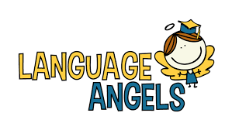 | A fantastic site full of interactive lessons and games to get children practising vocabulary or grammatical concepts that they have learned in school.
https://www.bbc.co.uk/bitesize/subjects/zxsvr82   | BBC Bitesize Spanish for  Key Stage 2 offers games and other activities linked to the National Curriculum.
https://www.youtube.com/playlist?list=PLrF5Rra5NPwvZEkrSdv_sDH7ghAUD2MYR   | A playlist of Spanish songs created by Mrs Sharpe for all children to sing at home.
https://www.duolingo.com/course/es/en/Learn-Spanish  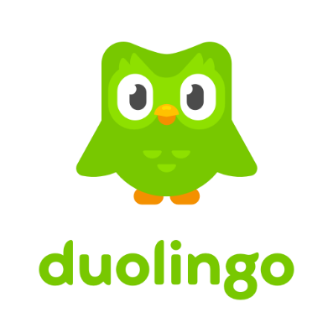 | A great app for keen linguists to spend a few minutes a day learning key words and phrases in Spanish (and many other languages besides).

