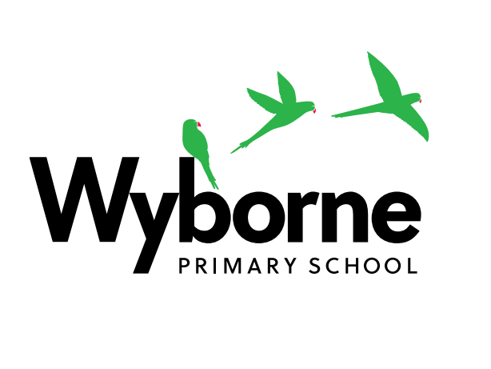

Wyborne Primary School
Footscray Road New Eltham London SE9 2EH
Tel: (020) 8850 4933 Fax: (020) 8850 3969)
Email: office@wyborne.greenwich.sch.uk
Web: www.wyborne.greenwich.sch.uk

27th April 2026

Dear Parents and Carers,

I am writing to inform you that the school will be closed on Friday 1st May.

This decision has been made as a significant number of staff are likely to take part in industrial action. Based on the information available to us, the level of staff absence is expected to be such that we would be unable to safely supervise pupils or maintain normal school operations. After careful consideration, we have therefore taken the decision to close the school for the day.

We fully recognise that this may cause disruption to families and appreciate that such situations are not easy to manage. Industrial action is never undertaken lightly, and there are important reasons why members of staff may choose to take part. We are grateful for your understanding as we prioritise the safety and wellbeing of all pupils.

To support children’s learning during the closure, teachers will upload activities onto WEDUC. We encourage pupils to engage with these tasks where possible to maintain continuity in their learning.

For families whose children are entitled to free school meals, a packed lunch will be available to collect from the school office on Friday. If you would like to request a packed lunch for your child, please email the school office by Wednesday 29th April so that we can ensure adequate provision.

In the unlikely event that the industrial action is called off, we will inform you as soon as possible and the school will reopen as normal.

If you have any questions or require further support, please do not hesitate to contact the school office, and a member of the team will be happy to assist you.

Thank you for your continued support and understanding.

Yours sincerely,

James Searjeant

Headteacher

