|  |  |
| --- | --- |
| **St Marys –Religious Education knowledge map** | |
| **Year 5** | **Topic 5.3 INSPIRATIONAL PEOPLE** |

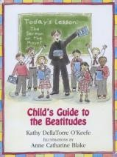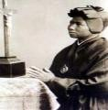

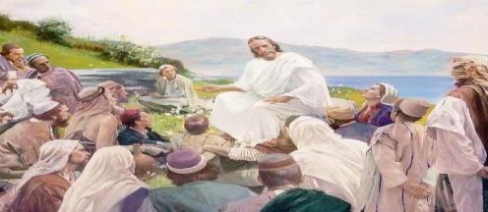

We will reflect on the Beatitudes and how we can be inspirational young people through following Jesus’ teaching on Mount Sinai. We will reflect this through writing and sharing our own prayers.

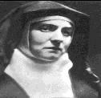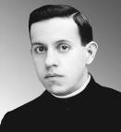

What will I know at the end of the unit?

* Begin to arrive at judgements as to why someone is inspirational.
* Show some understanding of what Jesus meant by The Beatitudes making links between The Beatitudes and Christian living.
* Use sources to support a point of view that a person is inspirational.
* Begin to show understanding how the decisions of two Christians e.g St Josephine Bakhita, St Edith Stein, Blessed Miguel Pro, Fr. Pedro Arrupe, St Leopold Mandic and St Damien de Veuster) are informed by the Beatitudes.
* Show some understanding of discipleship by making links between beliefs about discipleship and sources from scripture (John 13:34-35, Cor 13:4-17)
* Show some understanding of the call for everyone to become a saint by making links between sainthood and virtues or qualities in their own lives.
* Use religious vocabulary (see key vocabulary)

|  |  |
| --- | --- |
| Key Vocabulary | |
| Beatitudes | The blessings of Jesus from ‘the sermon on the mount.’ |
| Celebrity | A famous person. |
| Conscience | The feeling inside us that tells us what is right and what is  wrong. |
| Discipleship | Following Jesus. |
| Inspirational | The feeling of enthusiasm you get from someone. |
| Leprosy | A disease that affects the skin and nerves. |
| Mission | Something you are tasked to do. |
| Persecution | Unfair treatment over a period of time. |
| Prudent | To be careful and avoid risks. |
| Recall | To remember |
| Righteousness | Justice, honesty, goodness. |
| Saint | A Holy person who loved God. |
| Saviour | A name for Jesus, because he died and rose again to ‘save’  everyone from sin and death. |
| Spiritual | To do with your religion, and your spirit, not just your body. |

|  |
| --- |
| What should I already know? |
| * The characteristics of inspirational people. * Names of Saints e.g Martin de Porres, and why they are called Saints. * How to be a good Christian. * To know what a disciple is. |

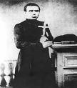

Key People and places

People : Fr Damien de Veuster, St Josephine Bakhita, St Edith Stein, Blessed Miguel Pro Place – Mount Sinai

Key Prayers

Our Father

Act of Contrition Apostles Creed

Key Scripture

Luke 6: 46-49 (The true disciple, the house built on rock) Matthey 25: 31-45 (The Last Judgement ‘The parable of the sheep and goats.

Matthew 18:22 (Peters question about forgiveness) Mark 10: 46-52 (Blind Bartimaeus)

Mark 12:29-30 (Following Jesus) Luke 6: 27-35 (Love of enemies)

John 13:34 (The commandment of love)

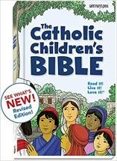

Books to read at home