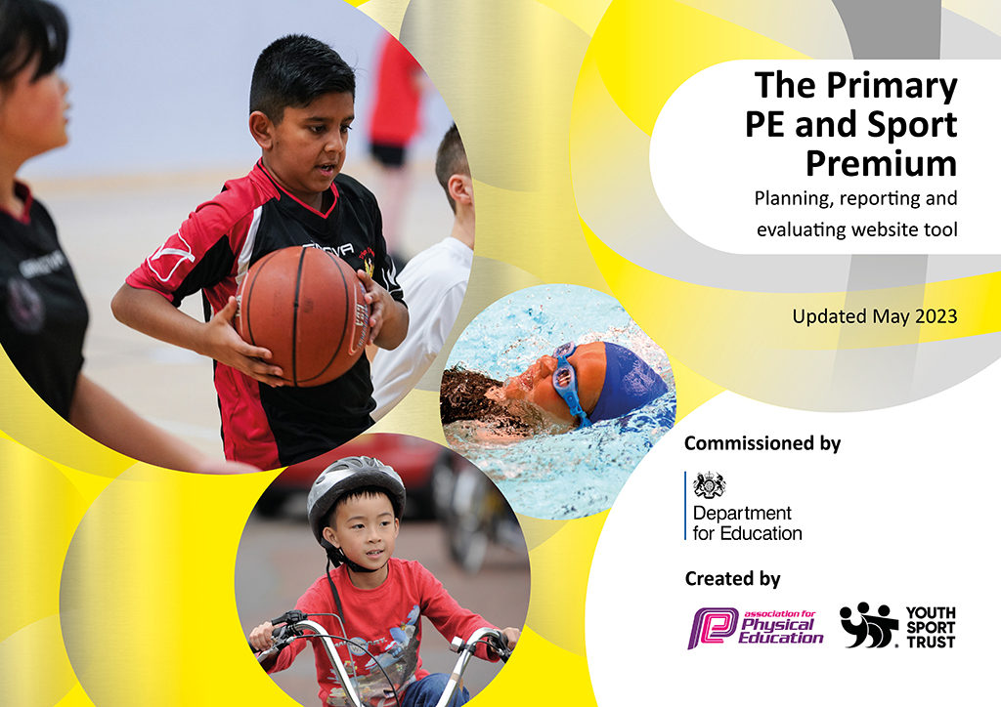
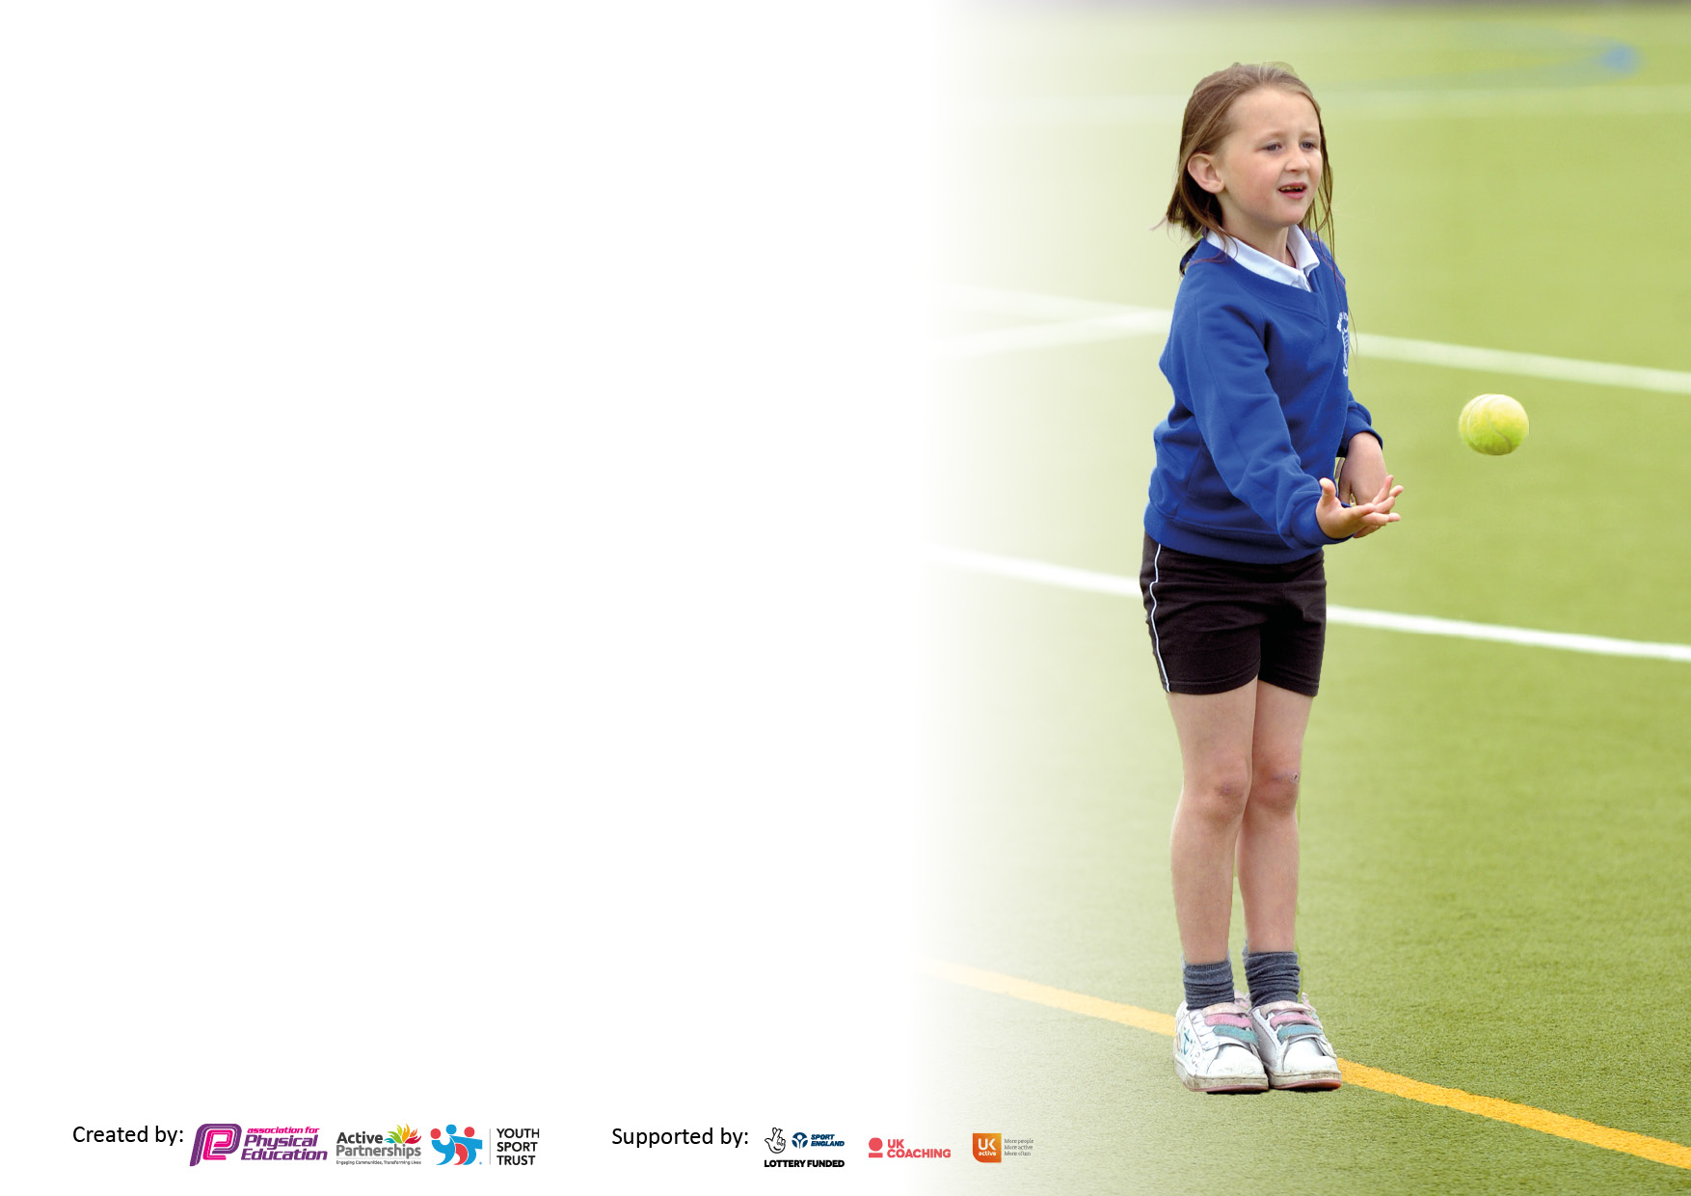

It is important that your grant is used effectively and based on school need. The Education Inspection Framework makes clear there will be a focus on ‘whether leaders and those responsible for governors all understand their respective roles and perform these in a way that enhances the effectiveness of the school’.

Under the Quality of Education Ofsted inspectors consider:
Intent - Curriculum design, coverage and appropriateness
Implementation - Curriculum delivery, Teaching (pedagogy) and Assessment
Impact - Attainment and progress

To assist schools with common transferable language this template has been developed to utilise the same three headings which should make your plans easily transferable between working documents.

Schools must use the funding to make additional and sustainable improvements to the quality of Physical Education, School Sport and Physical Activity (PESSPA) they offer. This means that you should use the Primary PE and sport premium to:

- Develop or add to the PESSPA activities that your school already offer
- Build capacity and capability within the school to ensure that improvements made now will benefit pupils joining the school in future years
- The Primary PE and sport premium should not be used to fund capital spend projects; the school’s budget should fund these.

Pleasevisitgov.ukfortherevisedDfEguidanceincludingthe5keyindicatorsacrosswhichschoolsshoulddemonstrate animprovement.Thisdocumentwillhelpyoutoreviewyourprovisionandtoreportyourspend.DfEencouragesschools to use this template as an effective way of meeting the reporting requirements of the Primary PE and Sport Premium.

We recommend you start by reflecting on the impact of current provision and reviewing the previous spend.

Schools are required to publish details of how they spend this funding, including any under-spend from 2021/2022, as well as on the impact it has on pupils’ PE and sport participation and attainment. All funding must be spent by 31st July 2023.

We recommend regularly updating the table and publishing it on your website throughout the year. This evidences your ongoing self-evaluation of how you are using the funding to secure maximum, sustainable impact. Final copy must be posted on your website by the end of the academic year and no later than the 31st July 2023. To see an example of how to complete the table please click HERE.

Details with regard to funding
Please complete the table below.

Total amount carried over from 2021/22 | £0
Total amount allocated for 2021/22 | £20,740
How much (if any) do you intend to carry over from this total fund into 2022/23? | £0
Total amount allocated for 2022/23 | £21,030
Total amount of funding for 2023/23. To be spent and reported on by 31st July 2023. | £ 20,909
Swimming Data
Please report on your Swimming Data below.

Meeting national curriculum requirements for swimming and water safety.

N.B. Complete this section to your best ability. For example you might have practised safe self-rescue techniques on dry land which you can then transfer to the pool when school swimming restarts.
Due to exceptional circumstances priority should be given to ensuring that pupils can perform safe self rescue even if they do not fully meet the first two requirements of the NC programme of study
What percentage of your current Year 6 cohort swim competently, confidently and proficiently over a distance of at least 25 metres?  N.B. Even though your pupils may swim in another year please report on their attainment on leaving primary school at the end of the summer term 2022.  Please see note above | 84%
What percentage of your current Year 6 cohort use a range of strokes effectively [for example, front crawl, backstroke and breaststroke]?  Please see note above | 72%
What percentage of your current Year 6 cohort perform safe self-rescue in different water-based situations? | 93%
Schools can choose to use the Primary PE and sport premium to provide additional provision for swimming but this must be for activity over and above the national curriculum requirements. Have you used it in this way? | Yes

Action Plan and Budget Tracking
Capture your intended annual spend against the 5 key indicators. Clarify the success criteria and evidence of impact that you intend to measure to evaluate for pupils today and for the future.

Academic Year: 2022/23 | Total fund allocated: £0 | Date Updated: 10/07/23
Key indicator 1: The engagement of all pupils in regular physical activity – Chief Medical Officers guidelines recommend that primary school pupils undertake at least 30 minutes of physical activity a day in school |  |  |  | Percentage of total allocation:
Intent | Implementation |  | Impact
Your school focus should be clear what you want the pupils to know and be able to do and about  what they need to learn and to  consolidate through practice: | Make sure your actions to achieve are linked to your intentions: | Funding allocated: | Evidence of impact: what do pupils now know and what can they now do? What has changed?: | Sustainability and suggested next steps:
Continuation of the Daily Mile – To  get all pupils undertaking an additional 15 minutes of activity per day.  Active Break Times and Fitness  Gym  Activities targeting all groups of children to be more active. Encouraging active breaks and lunchtimes.  Introduce new After School Club Sport to encourage new pupils to take up sport or pupils to take up new sports. – Initial cost may need to be covered if there is initial low uptake.  Promote active travel  More children to be utilising active travel to get to school rather than be driven to school.  Embed in curriculum, teaching and  learning and create active environments.  Less active and reluctant children to join in PE  Professional sports coach to run activities and clubs to increase motivation and popularity of the reward.  & develop and deliver multicomponent interventions. | Development of the Daily Mile course  Promote the Daily Mile during assembly and have a whole school launch.  Daily Mile course now accessible and useable all year round.  All break and lunchtime staff trained to promote ‘Happy Lunchtimes’. Pupils have a structure to focus on positive play and positive behaviour management. It enthuses everyone and leads to many improvements big and small.  Fitness and activity area designed  and built. Children actively encouraged to use and explore the area during breaks and lunchtimes.  Part of the happy lunchtimes cycle. As well as providing a fun fitness alternative to regular outdoor play, our outdoor fitness equipment also provides a range of benefits for KS1 and KS2 children. This includes both improved balance, and coordination.  Sports Leaders Lunchtime Training/  Activities  New Clubs:  Football Fitness  Cricket  Archery  Multisports  Curricular and extra curricular enhancement  - arrange sports around each other to avoid clashes and evenings for practices which don't interfere with other commitments - Arrange friendly competition - inter/intra school - use the local sport partnership.  Beat the Street  Active Travel Initiative  (Living Street travel tracker)  Sports Cool  Chance to Shine Cricket  Active Lessons  Forest Schools  KS1 Tennis sessions  Leicester City Hockey Club  Knighton Tennis Association  Sports for Schools  Develop and deliver multicomponent interventions. Active Learning  - Premier League Super Movers  Sports Cool  Leicester City Hockey Club  Knighton Tennis Association  Sports for Schools | £0  £0  £0  £0  £0  £0 | All pupils will be involved in 15 minutes of additional activity. Reduction of sedentary behaviour.  From the introduction of the Daily Mile all classes have participated in the Daily Mile regularly across the year and children have continued to be motivated by the activity and have set personal goals/challenges.  Increase in pupil’s health and wellbeing as well as increased concentration and attitude in lessons.  Active lunchtime and Outdoor activity gym completed late in the academic year. Children already positive and actively using the equipment. A wider range of children now more active and using the equipment to ensure their breaks and lunchtimes are more active and engaging.  New Afterschool clubs sessions having a huge impact on raising the profile of PE and contributing to an overall school improvement of punctuality in the mornings. Encouraging community activity as parents and siblings are welcomed to take part too.  New after school clubs to be subsidised to maintain and increase our provision and participation in sport for the younger children and children taking on new sports from the previous year. This will encourage children to take part in an active and healthy lifestyle from a younger age and promote more enthusiasm for PE as they progress through the school.  Reducing the number of children who get driven to school and increase the number of children who own bikes and will cycle to school. Encouraging people that live far away to do ‘Park and Stride’.  The school finished 2nd for total points scored during ‘Beat the Street’ with 446 participants  87% of trips are active with a large majority of the children in school achieving awards and more encouraged to walk to school more frequently.  The sports cool  programmes have had a huge impact on raising the profile of sports specifically aimed at the less active children which are contributing to an overall  school improvement of enjoyment and activity of pupils in PE, who were previously less active or reluctant to join in. This has been done through the use of different sports like archery.  School Sports Coach takes children to out of hours tournaments and leagues, providing an opportunity for the children to take part in competitive sport at a higher level. Sports coaches introduce new sports to school and children, providing new opportunities and sports for children to get involved in.  Therefore increasing children’s participation in sports activity | Classes to be encouraged to use and promote regular physical activity with the Daily Mile, Gym equipment and active break times.  Wake and shake to be setup for everyday of the week to increase numbers and offer more availability for pupils.  Happy Lunchtimes award achieved and should be maintained every year.  Continue to introduce new afterschool club opportunities to all children across the school and widen the offer.  Support FSM and PP in their options and choices to take part in ASC’s  Work closely with parents to ensure safe travel to and from school but ultimately reducing the number of children who get driven to school and increase the number of children who own bikes and will cycle to school.  Continue to celebrate and actively encourage physical activity to and from school.  Increase the percentage of trips that are active. Encourage those children who get driven to school to change 1 or 2 of their travels to park and stride.  To embed sport and PE in the curriculum further, we will look to build on our use of active lessons and Forest Schools. Some teachers may need to be trained in Forest Schools and Staff meetings could be used to demonstrate some ideas of more active lessons.  Continuation of professional coach but look to reduce cost in the end and to be run internally but with the same motivation and enthusiasm towards to the club. – Ensure the club is seen as a reward.
Key indicator 2: The profile of PESSPA being raised across the school as a tool for whole school improvement |  |  |  | Percentage of total allocation:
 |  |  |  | %
Intent | Implementation |  | Impact
Your school focus should be clear what you want the pupils to know and be able to do and about  what they need to learn and to  consolidate through practice: | Make sure your actions to achieve are linked to your intentions: | Funding allocated: | Evidence of impact: what do pupils now know and what can they now do? What has changed?: | Sustainability and suggested next steps:
Celebration Week  Every week to ensure the whole school is aware of the importance of PE and Sport and to encourage all pupils to aspire to being involved in the assemblies.  Equipment and Kit  To be purchased to allow teachers and staff to provide best possible lessons and learning within PE as well as continuing with the best possible provision of equipment for the children. Equipment has also been purchased to fit in with new SoW.  School Games Kite mark (SSPAN)  (Also linked to Key indicator 2, 3, 4  & 5)  Secure gold mark standard, while moving towards keeping the the Gold Standard.  Provides:  - Competition entry fees  - Reduced training costs  - Festivals  - Conferences  - Links with other schools  - Affiliations to competitions and access to coaching • Increase pupils’ participation in the School Games  Provide existing staff with training or resources to help them teach PE and sport more effectively  Multi Use Games Area  Year 6 Swimming Boosters | Achievements celebrated in assembly (match results + notable achievements in lessons etc.). Achievement, teams, news and reports to be displayed.  PE curriculum resources  - Plus consumables  Continuation of the affiliation to the School Games with the SSPAN. To enable us to have access to the areas provided.  Secure Gold Games mark standards for this years Kite mark, while moving towards sustaining the Gold Standard to lead to the Platinum Level.  Encourage sport across the year, allowing them to play more sports in winter on a safer area.  To ensure each pupil has to opportunity to pass the swimming requirements | £0  £8,500  £2,000  £  £ | Participation certificates are given to all children during Sports events and activities and to children who attend festivals and matches. Stickers are presented to participants during intra-school events relating to the School Game Values. All this promotes enthusiasm for taking part and gives the children positive reinforcement for doing physical activity. It also promotes a healthy level of competition but the children are always encouraged to take part in a fair manner, adhering to the Olympic and Paralympic Values.  Sports kits to be ordered to raise the profile of sport and equipment to keep kit up to date and tidy.  - Maintains high standard and good representation of the school when participating in competitions.  - Staff wearing sports kit encourages and demonstrates the correct clothing to have when participating in sport. While ensuring staff feel comfortable when delivering PE.  Maintain links with other schools and staff with the City Sports Partnership. Learning from other schools best practice as highlighted by City Sports staff. Attend conferences/meetings with the City Sports Partnership to ensure that St John the Baptist is up to speed with current developments in sporting education in Leicester.  A few virtual competitions were entered this year to keep the competitive nature of sport going throughout school and within cohorts.  Take up of virtual events and through home learning was high.  More use of intra games competitions.  15% more have now passed the swimming requirements due to top up boosters. | Management of assemblies and awards still being done as well using sports leaders to aid in the process.  Ensure the notice boards are full of information about matches/clubs/results and make pupils aware of future intra and inter competitions and activities.  Equipment to be brought for new SoW to aid in delivery a wide variety of sports across the school. This  is to ensure minimum damage to equipment and make its safe.  New equipment and older equipment to be replaced as stored in new sport/PE cupboard to ensure longevity of the equipment.  Equipment of new sports purchased and introduced with the aim to enter the SSPAN competitions in those sports next year (New Age Kurling and  Boccia)  - Delayed from previous year.  More outdoor equipment and activities bases to be set up for lunch and break time activities.  Continue to maintain the Gold standard for the kite mark in 2122 academic year.  Use the SSPAN to access more KS1 activities and events and teachers CPD.  More access to virtual events and CPD through the SSPAN due to Covid-19. This still allows for continuous Staff CPD and access to competitions for children.  Enter and compete in more virtual events if appropriate and required next year.

Key indicator 3: Increased confidence, knowledge and skills of all staff in teaching PE and sport |  |  |  | Percentage of total allocation:
 |  |  |  | %
Intent | Implementation |  | Impact
Your school focus should be clear | Make sure your actions to | Funding | Evidence of impact: what do | Sustainability and suggested
what you want the pupils to know | achieve are linked to your | allocated: | pupils now know and what | next steps:
and be able to do and about | intentions: |  | can they now do? What has
what they need to learn and to |  |  | changed?:
consolidate through practice:
Continued and monitored  Implementation of a Whole School  Scheme of Work  Ensure all staff are familiar and comfortable with the use and employment of the lesson plans -Staff meeting to be held to explain and explore the new scheme being used by complete PE.  -Staff training to apply and the use SoW correctly and effectively.  Staff development and whole  school training | Complete PE Scheme of Work and Planning –Staff to begin using SOW and CPD to aid with confidence and understanding of the scheme. To embed skills and knowledge obtained through previous years’ training and ensure a consistency in high quality PE teaching.  Online access to the planning for all teachers.  Employment of specialist PE coaches to deliver PE alongside the Class teacher. –  Sports Cool  Mega Strikers | £150 | lead staff development plan (in consultation with all staff through audit) to include engagement with relevant high quality, external provided training, supporting resources and teaching aids.  Sport based CPD based on a 2 year rolling system to ensure maximum coverage of all areas of PE. Offering more of a variety in sports.  -Positive relationships established with internal staff and high quality child centered external coaches providing a range of enrichment, extension and enabling opportunities accessed by the majority of pupils.  All staff to have CPD. Areas for development identified through discussion with coach and P.E. knowledge audit. This CPD will boost confidence and  understanding of health and safety in teaching PE/Sport so that the quality throughout the school. In particular, being able to see an experienced coach working with a group of children is a valuable source of CPD, as you can see the theory in practice. Possible after school clubs could be developed if staff show an interest.  To embed skills and knowledge obtained through previous years’ training and ensure a consistency in high quality PE teaching High quality coaching allows the children to develop new skills in a variety of different sports from a highly experienced, sport specific coach(es). The class teachers are present and so experience new games and ideas, which adds to their Continued Professional Development in this area. In particular, being able to see an experienced coach working with a group of children is a valuable source of CPD, as you can see the theory in practice. | Observe and audit staff at times throughout the year to perceive staff’s confidence and understanding in the implementation of the Scheme of Work. Recognise staff’s confidence and understanding of PE.  New scheme of work to be used to aid teachers in CPD training as it offers the use of videos within sequences of lessons. Training in specific sports areas/activities to be given to Schools Sports staff to then be delivered to whole school.  SSPAN to deliver 2/3 days of PE CPD to develop PE teaching and delivery within the school.  To ensure that new staff receive training in line with that provided to existing staff. Where possible, staff recognized through P.E. audit to also be involved in PE CPD, such as gymnastics, cricket and few others. This has been identified as an area for development as staff are lacking in confidence in teaching specific sports. This  CPD will boost confidence and understanding of health and safety in teaching gymnastics and teaching of a variety of sports, so that the provision for our children is high quality throughout the school.  An end result will provide Staff, who will work together and share good practice which will lead to better confidence all round and more staff keen to get involved thus ensuring the extra activities will not only continue but there will also be an expansion.  The school is no longer dependent on 'experts' coming in to teach PE and Sport as staff are more confident and  keen.
Key indicator 4: Broader experience of a range of sports and activities offered to all pupils |  |  |  | Percentage of total allocation:
Intent | Implementation |  | Impact
Your school focus should be clear | Make sure your actions to | Funding | Evidence of impact: what do | Sustainability and suggested
what you want the pupils to know | achieve are linked to your | allocated: | pupils now know and what | next steps:
and be able to do and about | intentions: |  | can they now do? What has
what they need to learn and to |  |  | changed?:
consolidate through practice:
Additional achievements:  Offer Choice and Variety in PE and  Sports  Develop a minimum offer for all including traditional sport, alternative sport, physical activity and exercise. Competitions to be offered and entered for a wider range of children including: SEND, PP, less active.  B and C teams to be entered into level 2 competitions within the School Games.  Sports Days to focus on ALL children participating in active sports and activities across the school – Increased competitiveness and feeling of achievement for ALL children that participate. – Rewards (Stickers, Trophies, certificates).  Introduce new After School Club Sport – Initial cost may need to be covered if there is initial low uptake. | -Undertake all PL which is offered through the sports partnership/LA/ National  Associations (AfPE & YST)/ NGBs/ Awarding Organisations with an aim to get more staff up-skilled and involved.  - Arrange a pupil survey to ascertain what pupils would like. - Involve external coaches to work with staff in clubs.  Chance to Shine  Additional achievements:  Continue to offer a wider range of activities both within and outside the curriculum in order to get more pupils involved.  Inspire Together – Planning and training ahead of time to enter more than 1  team into School Games Competition.  Continue to develop Sports day to be fun, enjoyable and inclusive for all across the whole school. (FS and KS1 Sports day to be done separately to KS2- but teams to be shared and worked together). - Celebration of successes and rewards assembly to follow.  Subsidies to facilitate sport participation  -Focus particularly on those pupils who do not take up additional PE and Sport opportunities.  New Sports and activities introduced to lunch and after school clubs through sports leaders.  -Sports and Playtime leaders to be utilized to encourage participation and promote sports and PE in a variety of different ways. | £ | Professional sport clubs involved in school to promote and encourage children participation within the sport- Lessened impact due to restrictions in school.  Sports coach teaching for pupils as well as CPD for teachers. Activities and learning utilised in teachers own lessons.  A wider range of Inclusive sports activities offered to all pupils in and after school.  90 children experiencing a different sport linked to other curriculum areas (Maths and Reading).  242 pupils competed at a virtual competitions throughout the year. | Continued provision of Tigers  SEND and Tackling Health sessions to be utilised within  and across the school to support: SEND, PP, less active transition into a more sporting lifestyle.  Additional staff to be trained and supported in their preferred sports to encourage more staff participation in the introduction of other and new sports clubs for the pupils.  The children are enjoying the opportunities to compete in school so will look to increase the number of level 1 competitions and trials.

Key indicator 5: Increased participation in competitive sport |  |  |  | Percentage of total allocation:
 |  |  |  | %
Intent | Implementation |  | Impact
Your school focus should be clear | Make sure your actions to | Funding | Evidence of impact: what do | Sustainability and suggested
what you want the pupils to know | achieve are linked to your | allocated: | pupils now know and what | next steps:
and be able to do and about | intentions: |  | can they now do? What has
what they need to learn and to |  |  | changed?:
consolidate through practice:
Increased Participation in competitive sport  Entering more competitive events for all.  Transport  Transport is essential to enable our children to experience competition further afield. | SSPAN Membership  - Enter an increased number of competitions from the  SSPAN  - More parallel/SEND sports and event entered through SSPAN competition calendar as well as links to NGB events.  These programs and schemes to be continued and offered to previous and new participants.  Football Affiliation and Competition Costs.  - Entry into the Leicester City Football League  - Entry into 2 of the football knockout cups.  Links with other schools to hold inter school games/tournaments.  Transport Costs  - Transport to events to ensure we are maximising the competition calendar and allowing as many of our pupils to compete in the events as possible.  We walk to any events within walking distance (Also promoting active travel). | £ | Maintain links with other schools and staff with the City Sports Partnership. Learning from other schools’ best practice as highlighted by City Sports staff. Attend conferences/meetings with the City Sports Partnership to ensure that St John the Baptist is up to speed with current developments in sporting education in Leicester.  Competition provides children with a purpose for taking part in sport – learn social, communication, teamwork and leadership skills. Children are exposed to and become interested in a variety of different sports. This promotes lifelong active lifestyle.  Citywide competitions enable our children to play against tough competitors and strive to increase their skills in that area.  Reduced training costs enable us to up skill our current staff so that PE and Sport provision is of a high  quality for all children in the school.  Transport is essential to enable our children to experience competition further afield. Our school team and athletes play and compete in the Leicester City league and Inspire Together Competition calendar and often need to play away matches. We do however  walk to as many local fixtures/festivals as possible. Competition provides children with a purpose for taking part in sport – learn social, communication, teamwork and leadership skills. Meet other similar aged children from other local schools – helpful with transition to secondary school. Children are exposed to and become interested in a variety of different sports. This promotes lifelong active lifestyle. | Increase opportunities for KS1 with competitions and festivals offered through the Inspire Together. These have been identified for the following year with the aim to participate in as many of these as we can.  (KS1 Festival and Energise Club).  Increased competitions and events held at the school in both intra and inter school events. – Create links with other schools to form a round robin competition/tournament.  Utilising staff transport for reducing costs where possible and looking at other events that could be within walking distance.  With our increased competition calendar and entry for more teams this year we could see increased costs next year. Higher engagement in Level competition has led to more level 2 success and a higher level of overall participation across a range of sports.

Signed off by
Head Teacher:
Date:
Subject Leader: | Courtney Foran and Jemaine Knott
Date: | 10/07/2023
Governor:
Date:

