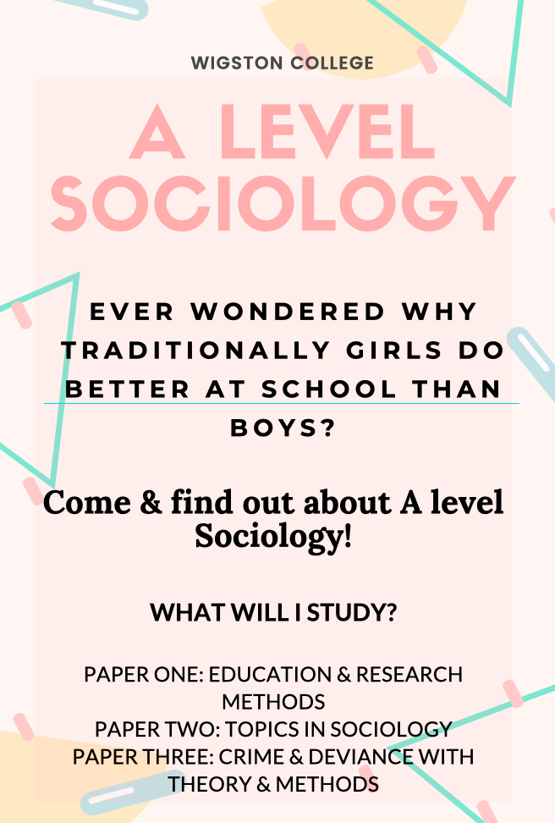

Welcome to Sociology! This is an activity pack of things that you can do before you start the course in the autumn term. These tasks are aimed to support you in starting your Sociology A level. It contains one piece of work which needs to be completed and handed in during your first week at the college, the additional tasks are optional but recommended.
We follow the AQA examination board.
In year one you will study two units: 1) Sociology of Education and 2) Sociology of Families and Households. In year two you will study two units: 1) Sociology of Crime and Deviance and 2) Sociology of the Media.
You will also have an ongoing theme of sociological theory and methods running throughout both of the two years.
The course will be assessed at the end of the two years with three exams; Paper 1: Education and Theory and Methods, Paper 2: Families and Beliefs/Media and Paper 3: Crime and Deviance and Theory and Methods.

REVISION GUIDES
We recommend the Tutor 2 U revision guides for Sociology. Booklets can be purchased for Crime and Deviance, Education, Theories and Methods, Families & Households and Media
Sociology Student Resources | Shop | Sociology | tutor2u

TASKS TO PREPARE YOU FOR A LEVEL SOCIOLOGY
TASK ONE:
One of the first things we would encourage you to do before starting in the autumn term is organise your folder with dividers labelled as below which you can file your class notes in to during the autumn term. You may wish to have 2 folders – one for families and one for education.
Education and Methods
- Introduction to Sociology.
- Sociology of Education: Class differences in achievement (External factors)
- Sociology of Education: Class differences in achievement (Internal factors)
- Sociology of Education: Ethnic differences in achievement
- Sociology of Education: Gender differences in education
- Sociology of Education: The role of education in society.
- Sociology of Education: Educational policy & inequality
- Sociology of Education: Methods in context
- Research methods: Experiments, Questionnaires, Interviews, Observation, Secondary sources
Families and households
- Sociology of Families & Households: Couples
- Sociology of Families & Households: Childhood
- Sociology of Families & Households: Theories of the family
- Sociology of Families & Households: Demography
- Sociology of Families & Households: Changing family patterns
- Sociology of Families & Households: Family diversity
- Sociology of Families & Households: Families and social policy.

TASK TWO:
In Sociology we spend a lot of time talking about different theories/perspectives and what they think of each topic we study. The theories all have different views on how society works, and why it works in the way that it does.
Find out about all of the below, what are their general views on society?
- Functionalists
- Marxists
- Feminists (Radical, Liberal, Marxists and difference)
- Postmodernists
- The New Right
Answer the following question:
Outline and explain 2 Functionalist views of society. (10)
______________________________________________________________________________________________________________________________________________________________________________________________________________________________________________________________________________________________________________________________________________________________________________________________________________________________________________________________________________________________________________________________________________________________________________________________________________________________________________________________________________________________________________________________________________________________________________________________________________________________________________________________________________________________________________________________________________________________________________________________________________________________________________________________________________________________________________________________________________________________________________________________________________________________________________________________________________________________________________________________________________________________________________________________________________________________________________________
ADDITIONAL PROGRAMMES YOU MAY WISH TO WATCH:
You could watch the below clips to introduce yourself to key areas and concepts we may refer to in Sociology at A level.

Sociology of the family: Childhood- “Cheated of childhood”
https://www.youtube.com/watch?v=xEBz9NPioe4

Sociology of the family: Childhood- “Baby beauty queens”
https://www.youtube.com/watch?v=I0keCRE3iik

Sociology (General): Social class- “Rich house, poor house”.
https://www.youtube.com/watch?v=9p2Xp79_38Y

Sociology of Education: Class and education: “Rich kid, poor kid”.
https://vimeo.com/81133029

Sociology (General): Gender stereotypes “How stereotypes in TV shows and movies impact your child’s development”.
https://www.youtube.com/watch?v=5NMkdBseE1g
(Linked to above: Disney sexism and gender roles)
- https://www.youtube.com/watch?v=Hh-xk0TFNM4 )

Sociology on Netflix:
“Explained” series- season 1: Why women are paid less

IF YOU HAVE ANY ADDITIONAL QUESTIONS:
Please email one of the department below:

(Head of Social Science) Mrs N Espiner: nespiner@wigstonmat.org
(Head of Social Science) Mrs E Sperring: esperring@wigstonmat.org
Miss K Lad (Social Science Teacher) klad@wigstonmat.org

