The Coppice Primary School SEN Information Report: July 2025

Our aim, at The Coppice Primary School, is that ALL of our children should become “Happy, confident and successful learners.” Encapsulated within this, we ensure that our school will support and make provision for pupils with special educational needs (SEND) and explain the roles and responsibilities of everyone involved in providing for pupils with SEND. At The Coppice, we have a commitment to all of our pupils and their parents/caregivers that we will place the child’s individual needs at the heart of our provision and, that regardless of age, race, gender, religious or cultural belief, additional needs or economic situation, ALL of our pupils will receive a high quality and appropriate education. We also ensure that all pupils have an equal right to enjoy and participate in all aspects of school life and to benefit from the many and varied opportunities open to them.

In response to the SEND Code of Practice 2014 (statutory guidance on supporting children with special educational needs and disabilities), Worcestershire Local Authority have produced their local offer which details the services and support that they will give to children and parents. The local offer can be found on our school website, under the SEND Information tab and is entitled ‘SEN Ordinarily Available in Worcestershire Schools’. It is a requirement that all schools deliver a school offer that is in line with the local offer.

This report details the provision that will be offered at The Coppice Primary School for children with Special Educational Needs and Disabilities (SEND).

- What are Special Educational Needs and Disabilities?

Our school currently provides additional and/or different provision for a range of needs (the first four of which are outlined in the SEND Code of Practice), including:
- Communication and interaction, for example, autistic spectrum disorder (ASD), speech and language difficulties,
- Cognition and learning, for example, dyslexia, dyspraxia, ADHD
- Social, emotional and mental health difficulties (through Thrive etc), for example, attention deficit hyperactivity disorder (ADHD) and attachment disorder.
- Sensory and/or physical needs, for example, visual impairments, hearing impairments, processing difficulties, epilepsy,
- Moderate learning difficulties,
- SEND issues relating to serious childhood illness and prolonged hospital stay
Provision at The Coppice is made for pupils that fall into one or more of these categories.

- Admission for pupils with SEND:

Link to The Coppice Admissions Policy: https://www.coppice.worcs.sch.uk/assets/Uploads/Coppice-Admissions-Policy-202122-updated-with-new-School-Admission-Code-amendments2.pdf

Our admissions process for children with SEND does not vary from that of other pupils. However, we do expect parents/caregivers of children with a known or suspected SEND need to pass this information on to the admissions officer: Mrs Emery. On receipt of a place at our school, we require parents/caregivers to provide all relevant and up to date paperwork connected to their child’s SEND needs to the office staff so that this can be handed over to the SEND Team.

Children in receipt of an EHC (Education Health Care) Plan, where The Coppice is the named preference, will be given priority alongside LAC (Looked After Children). For any pupils with an EHC Plan, who have requested a transfer from another educational setting, we will require the most up-to-date copy of their EHC Plan to be sent to the school SEND team and Headteacher so that we can ensure that we are best placed to meet the needs of the child. We reserve the right to contact previous schools, nurseries or Local Authority SEND representatives in order to verify the needs of the child.

- How do we identify Special Educational Needs?
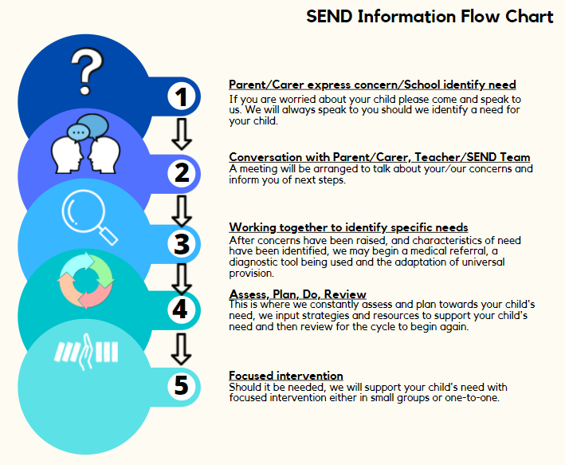
Our pupils’ needs are identified and assessed in a variety of ways:

- Transitional conversations and documentation,
- Analysis of data from previous settings,
- Analysis of assessments made by class teacher and Senior Leadership Team (SLT) through pupil progress meetings,
- Observations made by SENDCo and SEND Inclusion Teacher,
- Parent, carer or teacher concerns raised (through our cause for concern process),
- Involvement of external agencies and assessors.

- Information regarding our school’s policies for making provision for children with SEND:

- Before a ‘cause for concern’ is officially raised, parents, carers or class teachers will seek advice from the SENDCo to ensure that quality first teaching strategies are being deployed through differentiation and by making reasonable adjustments in the classroom.
- If issues or the concern persists, an official ‘cause for concern’ can be raised by the class teacher using our Cause for Concern process, detailed in our school SEND policy. Parents or carers can also raise concerns with the class teacher or directly to the SENDCo via telephone, email or face to face.
- Dependent on the severity of need, the SENDCo, class teacher and SLT will discuss the pupil’s needs using the following:
i) Observations of the pupil in question in the setting where their needs are most prevalent,
ii) Conversations with all people that have a concern regarding the pupil’s academic progress and well being (this may include: class teacher, SLT, pupil, parents/carers, subject specialists),
iii) Analysis of both previous and current data, and using the pupil’s workbooks or previously completed intervention work with all adults involved.
- Based on conversations had by all involved, an intervention may be set up by the class teacher under the direction of the SENDCo, Speech and Language Lead, SLT or subject specialists. Alongside this, the class teacher will implement the appropriate strategies which may include: bespoke differentiation of tasks in lessons, adaption of the learning environment, adjusting access to additional support (both resources and adult support), and seeking advice from our thrive specialists to ensure social, emotional and mental health needs are being met.
- Should the pupil’s profile suggest a particular SEND need then parents will be contacted, a meeting will take place, and with their permission, external agencies will be involved.
- Once a report has been completed by an external agency, the SENDCo will need to meet with the class teacher, parents/carers and support staff in order to create a tailored intervention, reasonable daily adjustments to resources or the learning environment. In specific cases a provision map may be required and for more challenging needs the SENDCo will be responsible for applying for additional funding to gain more tailored support for the pupil in question. All applications for additional funding will be discussed with the parents/caregivers in advance and final documents will be shared with them. Funding applications and Individual Provision Maps will adhere to the assess, plan, do, review process. For the highest level of funding, including EHC Plans, a minimum of a six monthly assess, plan, do, review cycle must be completed. The final decision regarding an EHC Plan application will be made by the SENCO following consultation with the class teacher and parents/caregivers and will follow the guidelines laid out by the relevant authority.
- All staff and relevant agencies will continue to work collaboratively to ensure that ongoing support and advice are afforded to the pupil and their family/advocate. This contact will then go on to inform the nature of their future provision. All pupils in receipt of an EHC Plan will have an annual review of their needs in accordance with local authority requirements.
- All pupils with SEND needs that require additional support to the majority of their peers are listed on the SEND Code of Practice. This is a flexible working document and is reviewed and amended termly by the school SENCO. The Code of Practice has three distinct tiers, Wave 1, Wave 2 and Wave 3. Pupils with SEND will be allocated to a Wave tier dependent on their needs and individual support requirements.

5. Expertise and training of staff in relation to children with SEND:

Our staff at The Coppice take part in all aspects of professional development that are arranged by our SLT. These include the following:
- Inset days and gathering as a whole school.
- Allocation of specialist staff based on staff strengths and interests.
- A Career and Professional Development (CPD) library with access to pedagogical texts and resources in all aspects of school life.
- Access for all staff to the National College Platform in order to access bespoke CPD where necessary.
- Carefully and strategically arranged staff meeting allocation based on our School Development Plan and subject specific action plans, including webinars, blogs, podcasts that support our staffs’ progress.
- Specific and tailored support given to key teachers, support staff regarding the support of certain pupils in our school.

6. Equipment and facilities to support children with SEND:

Our learning environments are set up to cater for all children’s needs, particularly those with SEND. Any adjustments made to the classroom environment or teaching strategies are carefully considered and take into account the needs and wishes of the parents and pupils. We use practical resources to underpin learning where appropriate and ensure that we make meaningful links throughout our curriculum which build on prior experience and therefore enhance retrieval and fluency skills. We also ensure that all teaching is delivered in a way that is accessible to all children.

7. Arrangements for consulting parents/carers and children with SEND about, and involving them in, the education of their child and their own education:

At The Coppice, we pride ourselves on establishing and maintaining positive working relationships with families and caregivers and pupils in our care. We operate an open door policy within the SEND department whereby parents/caregivers are able to set up face to face meetings as necessary. We also carry out targeted SEND appointments during all Parents’ Evenings and conduct termly review meetings for all pupils with a provision map.

8. Complaints from parents/carers of children with SEND concerning our school’s SEND provision:

In the first instance complaints regarding SEND provision can be made through the class teacher, or SENDCo who will have oversight of all SEND concerns within the school. Depending on the nature of the complaint, this will then either be resolved through a formal discussion process with parents/carers, advocates and SENDCo. Should a resolution not be reached, the complaint will be passed on to the Senior Leadership Team (SLT) for further consideration.

9. The Coppice prides itself on providing all of our vulnerable and SEND families with advice, support and links to services which can offer assistance with their particular area of need. On our staff team we have two designated SENCO’s and DSL’s (Designated Safeguarding Leads), a Medical and Attendance Officer who also acts as EWO (Educational Welfare Officer) and a Family Liaison Officer.

We work with a variety of external support agencies including Health Visitors, the School Nurse, Social Service Teams and Social Workers, Speech and Language Services, Preschool Forum and Family Support Services. We also commission support from Chadsgrove School Support Services, who provide access to a variety of professional agencies such as Learning Support Team, Occupational Therapy, The Dyspraxia Team and The CCN (Complex Communication Needs) Team.

Finally, over the years we have set up links with several specialised and bespoke services such as, Touchstone and other bereavement Counsellors, ACE (Adoption Support Service) and the NDA (National Dyslexia Association), etc.

10. Contact details of support services for the caregivers of children with SEND:
Please see below for the link to the Local Offer. However, should you need guidance or support and cannot find what you are looking for please see Section 11 for the contact details of the SEND Team at The Coppice School.

For more information regarding SEND, please follow this link:
https://www.worcestershire.gov.uk/sendlocaloffer

Should you wish to speak to someone with any queries you can also contact

11. Contact details for SEND Team:

SENDCo: Mr C McGarry
Email Address: cm362@coppice.worcs.sch.uk

SEND Inclusion Teacher: Mrs R Heptinstall
Email Address: rjh136@coppice.worcs.sch.uk

