HFW Rocket – Set 11
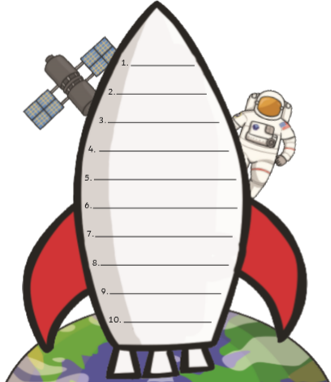
Can you practise reading and writing these sight words?
any
different
friends
who
because
laughed
many
though
again
through

