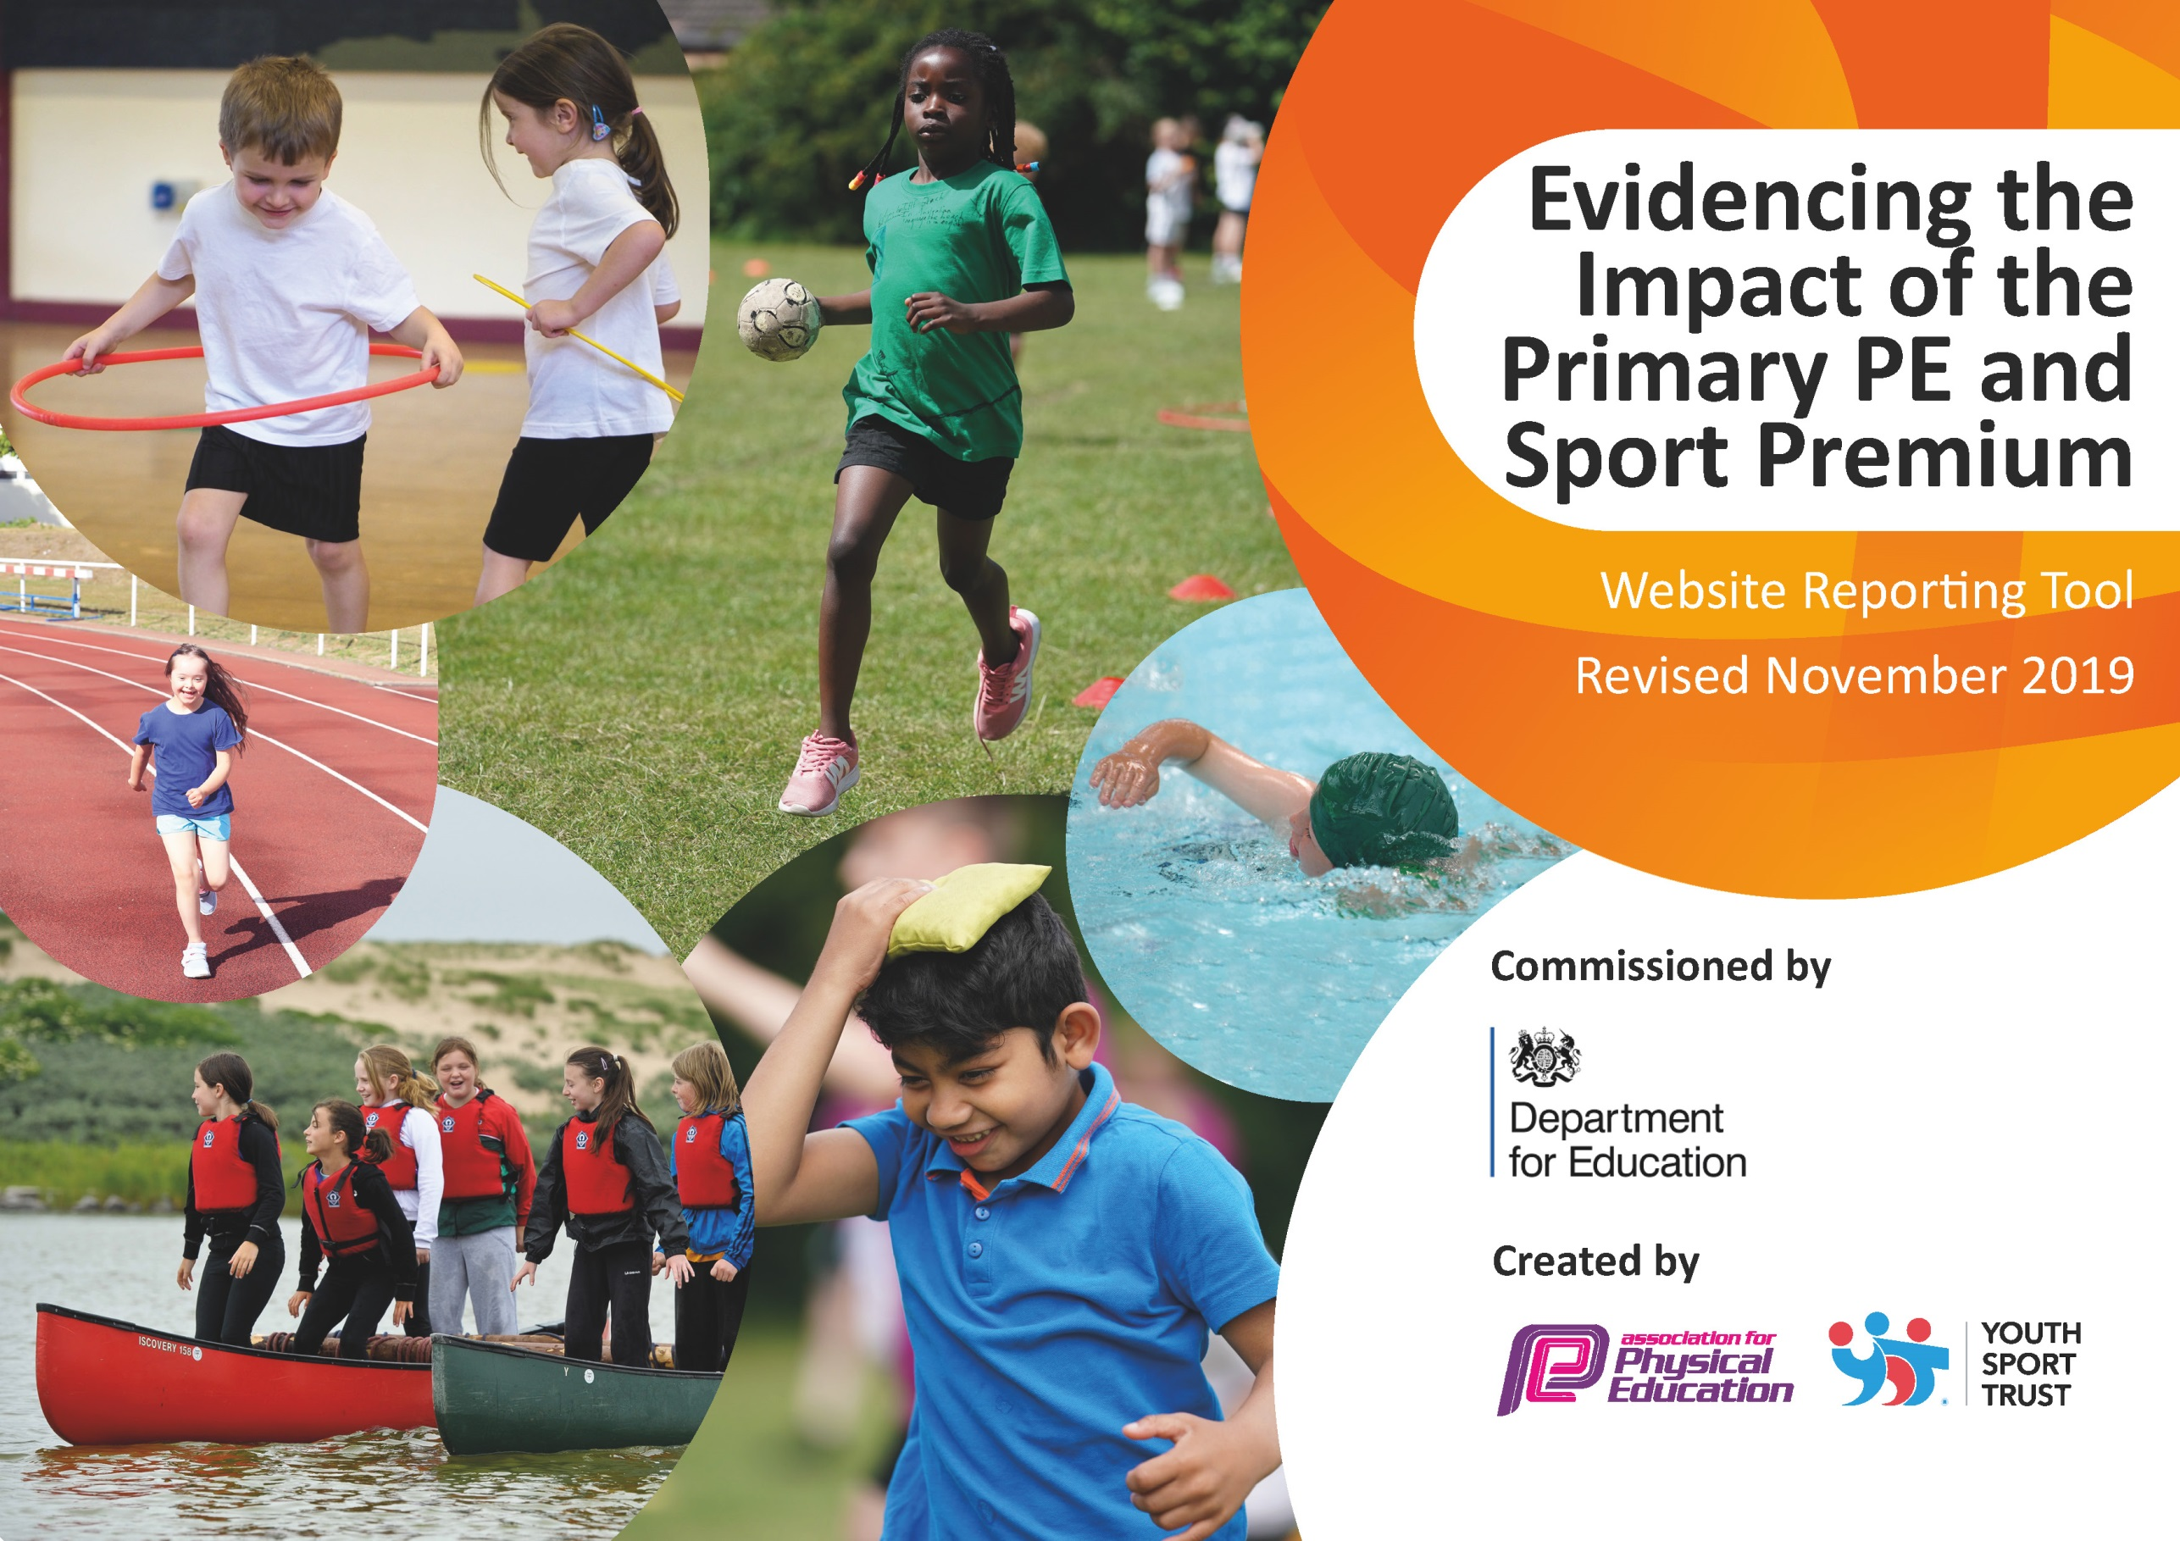
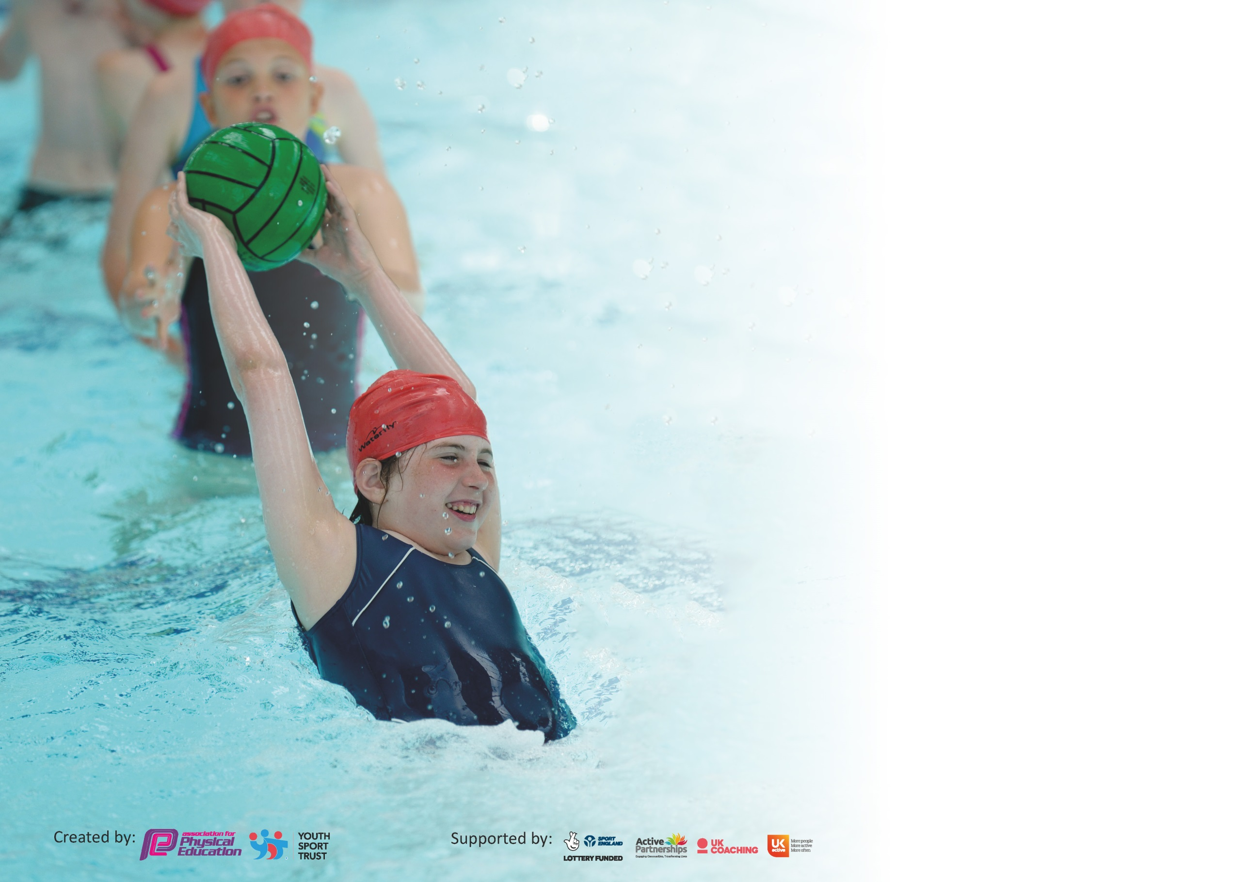

It is important that your grant is used effectively and based on school need. The Education Inspection Framework (Ofsted 2019 p64) makes clear there will be a focus on ‘whether leaders and those responsible for governors all understand their respective roles and perform these in a way that enhances the effectiveness of the school’.

Under the Quality of Education criteria (p41) inspectors consider the extent to which schools can articulate their curriculum (INTENT), construct their curriculum (IMPLEMENTATION) and demonstrate the outcomes which result (IMPACT).

To assist schools with common transferable language this template has been developed to utilise the same three headings which should make your plans easily transferable between working documents.

Schools must use the funding to make additional and sustainable improvements to the quality of Physical Education, School Sport and Physical Activity (PESSPA) they offer. This means that you should
use the Primary PE and Sport Premium to:

- Develop or add to the PESSPA activities that your school already offer
- Build capacity and capability within the school to ensure that improvements made now will benefit pupils joining the school in future years

Please visit gov.uk for the revised DfE guidance including the 5 key indicators across which schools should demonstrate an improvement. This document will help you to review your provision and to report your spend. DfE encourages schools to use this template as an effective way of meeting the reporting requirements of the Primary PE and Sport Premium.

We recommend you start by reflecting on the impact of current provision and reviewing the previous spend.

Schools are required to publish details of how they spend this funding as well as on the impact it has on pupils’ PE and sport participation and attainment by the end of the summer term or by 31st July 2020 at the latest.

We recommend regularly updating the table and publishing it on your website throughout the year. This evidences your ongoing self-evaluation of how you are using the funding to secure maximum, sustainable impact. Final copy must be posted on your website by the end of the academic year and no later than the 31st July 2020. To see an example of how to complete the table please click HERE.

Support for review and reflection - considering the 5 key indicators from DfE, what development needs are a priority for your setting and your pupils now and why? Use the space below to reflect on previous spend and key achievements and areas for development.

Key achievements to date until July 2019: | Areas for further improvement and baseline evidence of need:
- School Game Gold Standard Kite Mark continued for 2019-20.  - PE is taught across the school with classes receiving the 2 hours a week required  - PE is all-inclusive  - Reasonable outcome and targets are set for all pupils  - Higher targets are set for children to achieve and push themselves (KS2)  - Continual implementation of the Merton Scheme of Work  - Reinforcement of respect and sportsmanship  - Inclusion of whole school in PE, sports and activities, including competitions (EAL, SEND, PP, Less Active Children)  - Celebration of achievements – Sport focused whole school assemblies.  - Participation with the wider community and other Local schools – Through SSPAN and Tigers community coaches and competitions, plus club links.  - Employing the 6 core values of the 'Spirit of the Games' : Passion, Self- belief, Respect, Honesty, Teamwork, Determination. | - Further Implementation of the new Merton Scheme of Work across the school  - Maintenance and up keep of PE Equipment  - Some teachers still feel that they would benefit from further training/support.  - CPD from professional sports coaches or NGB’s to build on and reinforce teachers skill set.  - Increase of competitive opportunities, especially for KS1.  - Observations of PE lessons (Professional coaches & Staff), to ensure a high level of PE is being taught and that staff haven’t been ‘de-skilled’ but rather benefit from training.  - Sports leaders to have increased responsibility. (To be paired with a teacher to aid in delivery and setting up of PE if required).  - Increased involvement in extra curricular activities and PE enrichment activities (Introduction of new sports clubs and lunch time activities).

Meeting national curriculum requirements for swimming and water safety.
What percentage of your current Year 6 cohort swim competently, confidently and proficiently over a distance of at least 25 metres?  N.B. Even though your pupils may swim in another year please report on their attainment on leaving  primary school at the end of the summer term 2020. | 88%
What percentage of your current Year 6 cohort use a range of strokes effectively [for example, front crawl, backstroke and breaststroke]? | 88%
What percentage of your current Year 6 cohort perform safe self-rescue in different water-based situations? | 59%
Schools can choose to use the Primary PE and Sport Premium to provide additional provision for swimming but this must be for activity over and above the national curriculum requirements. Have you used it in this way? | Yes/No

Action Plan and Budget Tracking
Capture your intended annual spend against the 5 key indicators. Clarify the success criteria and evidence of impact that you intend to measure to evaluate for pupils today and for the future.

Academic Year: 2019/20 | Total fund allocated: £21,490 | Date Updated: 06.07.20
Key indicator 1: The engagement of all pupils in regular physical activity – Chief Medical Officer guidelines recommend that primary school pupils undertake at least 30 minutes of physical activity a day in school |  |  |  | Percentage of total allocation:
 |  |  |  | 12%
Intent | Implementation |  | Impact
Your school focus should be clear what you want the pupils to know and be able to do and about  what they need to learn and to  consolidate through practice: | Make sure your actions to achieve are linked to your intentions: | Funding allocated: | Evidence of impact: what do pupils now know and what can they now do? What has changed?: | Sustainability and suggested next steps:
Continuation of the Daily Mile – To get all pupils undertaking an additional 15 minutes of activity per day.  Introduce new After School Club Sport to encourage new pupils to take up sport or pupils to take up new sports. – Initial cost may need to be covered if there is initial low uptake.  Promote active travel  More children to be utilising active travel to get to school rather than be driven to school.  Embed in curriculum, teaching and learning and create active environments.  Less active and reluctant children to join in PE  Professional sports coach to run activities and clubs to increase motivation and popularity of the reward.  & develop and deliver multi-component interventions. | Up keep of the Daily Mile course  Promote the Daily Mile during assembly and have a whole school launch.  Wake and Shake  Sports Leaders Lunchtime Training/ Activities  New Clubs:  KS1 Football  Table Tennis (Lunchtime)  Curricular and extra curricular enhancement  - arrange sports around each other to avoid clashes and evenings for practices which don't interfere with other commitments - Arrange friendly competition - inter/intra school - use the local sport partnership.  Bikeability  Rugby Reading Champions  Chance to Shine  Active Lessons  Forest Schools  KS1 Tennis sessions  Develop and deliver multi-component interventions.  Active Learning  - Premier League Super Movers  Rugby Reading Champions  (Leicester Tigers)  Chance to Shine Cricket  (Leicestershire CCC) | £774  £600  £700  £400  (Potential transport cost – to participate in NGB/Professional Club event) | All pupils will be involved in 15 minutes of additional activity.  Reduction of sedentary behaviour.  From the introduction of the Daily Mile all classes have participated in the Daily Mile regularly across the year and children have continued to be motivated by the activity and have set personal goals/challenges.  Increase in pupil’s health and wellbeing as well as increased concentration and attitude in lessons.  Morning whole school wake and shake sessions are having a huge impact on raising the profile of PE and contributing to an overall school improvement of punctuality in the mornings. Encouraging community activity as parents and siblings are welcomed to take part too.  New after school clubs to be subsidised to maintain and increase our provision and participation in sport for the younger children and children taking on new sports from the previous year. This will encourage children to take part in an active and healthy lifestyle from a younger age and promote more enthusiasm for PE as they progress through the school.  Reducing the number of children who get driven to school and increase the number of children who own bikes and will cycle to school. –More Year 5 and 6 Children cycling to school.  (Not started due to Covid-19)  The Rugby and Cricket programmes have had a huge impact on raising the profile of PE and contributing to an overall school improvement of enjoyment and activity of pupils in PE, who were previously less active or reluctant to join in.  School Sports Coach takes children to out of hours tournaments and leagues, providing an opportunity for the children to take part in competitive sport at a higher level. Sports coaches introduce new sports to school and children, providing new opportunities and sports for children to get involved in. Therefore increasing children’s participation in sports activity through after-school clubs promoting a lifelong active lifestyle.  Support and increased participation of the least active children by providing targeted activities and session.  -Leading to increased participation in PE lessons as well competitions. | During the Summer months and when its dry, using the field will be first choice. However during the wet and winter months the field will become too muddy and damaged for continued use out of PE lessons.  Field maintenance used to keep the field and Daily mile track in good condition for use all year round.  A more permanent track might be needed to reduce damage to the field and allow for all year round access to the same Daily Mile course.  Wake and shake to be setup for everyday of the week to increase numbers and offer more availability for pupils.  Work closely with parents to ensure safe travel to and from school but ultimately reducing the number of children who get driven to school and increase the number of children who own bikes and will cycle to school.  - Look to extend bikeability program for longer in school to allow for missed time for Year 5s.  Sign up for ‘Beat the Street’ as an alternative or extra initiative to get more children being active on the way to school.  Reintroduction of Golden Ticket club Or Activity led by Sports leaders, however introducing bring a friend to combat staleness and those who are still reluctant to join in on their own.  To embed sport and PE in the curriculum further, we will look to build on our use of active lessons and Forest Schools.  Some teachers may need to be trained in Forest Schools and Staff meetings could be used to demonstrate some ideas of more active lessons.  Continuation of professional coach but look to reduce cost in the end and to be run internally but with the same motivation and enthusiasm towards to the club. – Ensure the club is seen as a reward.
Key indicator 2: The profile of PESSPA being raised across the school as a tool for whole school improvement |  |  |  | Percentage of total allocation:
 |  |  |  | 35% + 25%
Intent | Implementation |  | Impact
Your school focus should be clear what you want the pupils to know and be able to do and about  what they need to learn and to  consolidate through practice: | Make sure your actions to achieve are linked to your intentions: | Funding allocated: | Evidence of impact: what do pupils now know and what can they now do? What has changed?: | Sustainability and suggested next steps:
Celebration assembly  Every week to ensure the whole school is aware of the importance of PE and Sport and to encourage all pupils to aspire to being involved in the assemblies.  Equipment and Kit  To be purchased to allow teachers and staff to provide best possible lessons and learning within PE as well as continuing with the best possible provision of equipment for the children.  School Games Kite mark (SSPAN)  (Also linked to Key indicator 2, 3, 4 & 5)  Secure Silver Games mark, while moving towards achieving the Gold Standard.  Provides:  - Competition entry fees  - Reduced training costs  - Festivals  - Conferences  - Links with other schools  - Affiliations to competitions and access to coaching  - Increase pupils’ participation in the School Games  Provide existing staff with training or resources to help them teach PE and sport more effectively | Achievements celebrated in assembly (match results + notable achievements in lessons etc.).  Achievement, teams, news and reports to be displayed.  PE curriculum resources  - Plus consumables  Sports Kit Purchases  Sports Leaders Kit/Badges  Ringed fenced money – Being carried forward toward playground and gymnastics equipment  Continuation of the affiliation to the School Games with the SSPAN. To enable us to have access to the areas provided.  Secure Gold Games mark standards for this years Kite mark, while moving towards sustaining the Gold Standard to lead to the Platinum Level. | £300  £5359  £118  £112  £5416  £1650 | Participation certificates are given to all children during Sports events and activities and to children who attend festivals and matches. Stickers are presented to participants during intra-school events relating to the School Game Values. All this promotes enthusiasm for taking part and gives the children positive reinforcement for doing physical activity. It also promotes a healthy level of competition but the children are always encouraged to take part in a fair manner, adhering to the Olympic and Paralympic Values.  Sports kits to be ordered to raise the profile of sport and equipment to keep kit up to date and tidy.  - Maintains high standard and good representation of the school when participating in competitions.  - Staff wearing sports kit encourages and demonstrates the correct clothing to have when participating in sport. While ensuring staff feel comfortable when delivering PE.  Maintain links with other schools and staff with the City Sports Partnership. Learning from other schools best practice as highlighted by City Sports staff.  Attend conferences/meetings with the City Sports Partnership to ensure that St John the Baptist is up to speed with current developments in sporting education in Leicester. | Management of assemblies and awards still being done as well using sports leaders to aid in the process.  Ensure the notice boards are full of information about matches/clubs/results and make pupils aware of future intra and inter competitions and activities.  Equipment to be brought if or when it’s needed for year. This is to ensure minimum damage to equipment and make its safe.  New equipment and older equipment to be replaced as stored in new sport/PE cupboard to ensure longevity of the equipment.  Equipment of new sports purchased and introduced with the aim to enter the SSPAN competitions in those sports next year (New Age Kurling and Boccia)  More outdoor equipment and activities bases to be set up for lunch and breaktime activities.  Continue to maintain the Gold standard for the kite mark in 20-21 academic year.  Use the SSPAN to access more KS1 activities and events and teachers CPD.  More access to virtual events and CPD through the SSPAN due to Covid-19. This still allows for continuous Staff CPD and access to competitions for children.

Key indicator 3: Increased confidence, knowledge and skills of all staff in teaching PE and sport |  |  |  | Percentage of total allocation:
 |  |  |  | 2%
Intent | Implementation |  | Impact
Your school focus should be clear | Make sure your actions to | Funding | Evidence of impact: what do | Sustainability and suggested
what you want the pupils to know | achieve are linked to your | allocated: | pupils now know and what | next steps:
and be able to do and about | intentions: |  | can they now do? What has
what they need to learn and to |  |  | changed?:
consolidate through practice:
Continued and monitored Implementation of a Whole School Scheme of Work  Ensure all staff are familiar and comfortable with the use and employment of the lesson plans  -Staff meeting to be held to explain and explore the Sow.  -Staff training to apply and use SoW correctly and effectively.  Staff development and whole school training | Merton Scheme of Work and Planning – Scheme to be purchased and given to all staff.  -Staff to begin using SOW and CPD to aid with confidence and understanding of the scheme. To embed skills and knowledge obtained through previous years’ training and ensure a consistency in high quality PE teaching.  Online access to the planning for all teachers.  PE lessons led by both Class Teacher and PE Teacher (DS), delivering from the Merton SoW to allow class teachers to observe how a PE specialist would deliver a PE from the lesson plans.  Employment of specialist PE coaches to deliver PE alongside the Class teacher. | £100  £300 | Need-led staff development plan (in consultation with all staff through audit) to include engagement with relevant high quality, external provided training, supporting resources and teaching aids.  Sport based CPD based on a 2 year rolling system to ensure maximum coverage of all areas of PE.  -Positive relationships established with internal staff and high quality child centered external coaches providing a range of enrichment, extension and enabling opportunities accessed by the majority of pupils.  All staff to have CPD. Areas for development identified through discussion with coach and P.E. knowledge audit. This CPD will boost confidence and understanding of health and safety in teaching PE/Sport so that the provision for our children is high quality throughout the school. In particular, being able to see an experienced coach working with a group of children is a valuable source of CPD, as you can see the theory in practice. Possible after school clubs could be developed if staff show an interest.  To embed skills and knowledge obtained through previous years’ training and ensure a consistency in high quality PE teaching  High quality coaching allows the children to develop new skills in a variety of different sports from a highly experienced, sport specific coach(es). The class teachers are present and so experience new games and ideas, which adds to their Continued Professional Development in this area. In particular, being able to see an experienced coach working with a group of children is a valuable source of CPD, as you can see the theory in practice. | Observe and audit staff at times throughout the year to perceive staff’s confidence and understanding in the implementation of the Scheme of Work. Recognise staff’s confidence and understanding of PE.  Coaches to be used less to avoid deskilling teachers. Training in specific sports areas/activities to be given to Schools Sports staff to then be delivered to whole school.  To ensure that new staff receive training in line with that provided to existing staff.  Where possible, staff recognized through P.E. audit to also be involved in PE CPD, such as gymnastics, cricket and few others. This has been identified as an area for development as staff are lacking in confidence in teaching specific sports. This CPD will boost confidence and understanding of health and safety in teaching gymnastics and teaching of a variety of sports, so that the provision for our children is high quality throughout the school.  An end result will provide Staff, who will work together and share good practice which will lead to better confidence all round and more staff keen to get involved thus ensuring the extra activities will not only continue but there will also be an expansion.  - The school is no longer dependent on 'experts' coming in to teach PE and Sport as staff are more confident and keen.
Key indicator 4: Broader experience of a range of sports and activities offered to all pupils |  |  |  | Percentage of total allocation:
 |  |  |  | 17.5%
Intent | Implementation |  | Impact
Your school focus should be clear | Make sure your actions to | Funding | Evidence of impact: what do | Sustainability and suggested
what you want the pupils to know | achieve are linked to your | allocated: | pupils now know and what | next steps:
and be able to do and about | intentions: |  | can they now do? What has
what they need to learn and to |  |  | changed?:
consolidate through practice:
Offer Choice and Variety in PE and Sports  Develop a minimum offer for all including traditional sport, alternative sport, physical activity and exercise.  Competitions to be offered and entered for a wider range of children including: SEND, PP, less active.  B and C teams to be entered into level 2 competitions within the School Games.  Sports Days to focus on ALL children participating in active sports and activities across the school – Increased competitiveness and feeling of achievement for ALL children that participate. – Rewards (Stickers, Trophies, certificates).  Introduce new After School Club Sport – Initial cost may need to be covered if there is initial low uptake.  Swimming Support and Assistance.  - To ensure all existing swimmers increase their attainment by 10 metres thus increasing their confidence in water.  - All remaining non-swimmers achieve 25 metres thus meeting the statutory requirements of the national curriculum for PE.  - All pupils can perform safe self-rescue over a varied distance so they are confident and safe in water.  Year 6 Swimming Booster Sessions  Identified children who are unable to meet the national expectations in swimming in Year 5 or have very little water experience/confidence. | -Undertake all PL which is offered through the sports partnership/LA/ National Associations (AfPE & YST)/ NGBs/ Awarding Organisations with an aim to get more staff up-skilled and involved.  - Arrange a pupil survey to ascertain what pupils would like. - Involve external coaches to work with staff in clubs.  Tigers Rugby Reading Champions Programme  Chance to Shine  Leicester Swifts  Additional achievements:  Continue to offer a wider range of activities both within and outside the curriculum in order to get more pupils involved.  SSPAN – Planning and training ahead of time to enter more than 1 team into School Games Competition.  Continue to develop Sports day to be fun, enjoyable and inclusive for all across the whole school. (FS and KS1 Sports day to be done separately to KS2- but teams to be shared and worked together).  - Celebration of successes and rewards assembly to follow.  Subsidies to facilitate sport participation  -Focus particularly on those pupils who do not take up additional PE and Sport opportunities.  New Sports and activities introduced to lunch and after school clubs through sports leaders.  -Sports leaders to be utilized to encourage participation and promote sports and PE in a variety of different ways.  -Lunchtime Sports Leaders  ASA Swimming Charter  - Affiliation to the ASA providing certificates, CPD, Planning and ideas to support and promote swimming in and out of school.  Using Year 5 swimming data to identify non-swimmers (Not meeting national expectations) and those who lack water confidence.  Provide extra swimming sessions to improve those children. | £1200  £50  £2500  (£1000 spent with another £1500+ ring fenced to provide catch up and boosters for potential larger group from Year 5 due to Covid-19) | 4 Professional sport clubs involved in school to promote and encourage children participation within the sport.  Sports coach teaching for pupils as well as CPD for teachers.  A wider range of Inclusive sports activities offered to all pupils in and after school.  Two Year 4 classes active within extra sports and activities through Tigers programme and a large number of SEND pupils have taken part in a competitive level 2 event.  68 children experiencing a different sport linked to other curriculum areas (Maths).  128 pupils competed at a level 2 event.  Numbers of pupils and number of teams competing in different sports this year impacted by Covid-19  However all sports competitions that had their level 1 competition completed in school all had a higher number of participants than the previous years.  All children involved in a sports day with increased competiveness with children proud of their achievement on a variety of different activities. Parents involved and enjoying the day too. Children showing off and encouraged by rewards of stickers embedding the school games values.  Sports Day was virtual this year due to Covid-19 – Still following the same principles and values. Activities adapted to allow for all children to compete from home.  2 more staff involved in extra- curricular activities and teachers are feeling more confident teaching new activities.  - 2 new clubs (Table tennis and KS1 Football) now running with an uptake of over 30 pupils (Avg of 7 new children of which have never attended before in each club).  Table tennis has been supported by Lunchtime staff and has therefore shown an increase in participation over the year.  Maintain links with other schools, pools and staff with the ASA Affiliation, learning from other schools and the ASA best practice as highlighted by ASA Charter Standard to ensure that St John the Baptist is up to speed with current developments in sporting education in Leicester.  More children leaving St John the Baptist being able to swim 25m with a range of strokes as well as having an improved water confidence. | Continued provision of Tigers SEND and Tackling Health sessions to be utilised within and across the school to support: SEND, PP, less active transition into a more sporting lifestyle.  Tigers Rugby Reading Champions to be started next year to promote and link a love a sport with a cross curricular activity.  Additional staff to be trained and supported in their preferred sports to encourage more staff participation in the introduction of other and new sports clubs for the pupils.  The children are enjoying the opportunities to compete in school so will look to increase the number of level 1 competitions and trials as well as potential for inter house competitions.  KS2 sports day was modelled around the Quadkids format this year to allow for a more competitive sports day. Next year the aim would be to have each Key Stage on a different day to allow for more participation and competition in more events.  The Schools Games Competition and other school links have been made in Table tennis to allow the children already interested to compete as well as promote this sport in different ways.  Teachers and support staff identified to be supported and gain knowledge of support pupils in the water and poolside, along with the teaching of swimming.  - Booster sessions to be funded to ensure the maximum number of pupils leave the school being able to swim 25 meters.  Identifying and preparing children in advance to ensure they wish to take part and will make the most of the sessions available to them.

Key indicator 5: Increased participation in competitive sport |  |  |  | Percentage of total allocation:
 |  |  |  | 8.5%
Intent | Implementation |  | Impact
Your school focus should be clear | Make sure your actions to | Funding | Evidence of impact: what do | Sustainability and suggested
what you want the pupils to know | achieve are linked to your | allocated: | pupils now know and what | next steps:
and be able to do and about | intentions: |  | can they now do? What has
what they need to learn and to |  |  | changed?:
consolidate through practice:
Increased Participation in competitive sport  Entering more competitive events for all.  .  Transport  Transport is essential to enable our children to experience competition further afield. | SSPAN Membership  - Enter an increased number of competitions from the SSPAN  - More parallel/SEND sports and event entered through SSPAN competition calendar as well as links to NGB events.  Greggs Tackling Health & Leicester Tigers SEND tag rugby  These programs and schemes to be continued and offered to previous and new participants.  Football Affiliation and Competition Costs.  - Entry into the Leicester City Football League  - Entry into 2 of the football knockout cups.  Links with other schools to hold inter school games/tournaments.  Athletics Network &  Cross Country Network  To introduce additional competitive sports identified by pupils in recent survey in order to engage more pupils. - Engage more girls in inter/intra school teams particularly those who are disaffected.  Increased number of competition entered  -More sporting opportunities for a wider range of pupils (SEND, PP EAL, less active and Girls).  - Activity Alliance (Disability Inclusion Sport) – For the Entry into the National Junior Athletics Championships  Transport Costs  - Transport to events to ensure we are maximising the competition calendar and allowing as many of our pupils to compete in the events as possible.  - We walk to any events within walking distance (Also promoting active travel). | £1650 (Accounted for in Key Indicator 2).  £450  £44  £46  £38  £1225 | Maintain links with other schools and staff with the City Sports Partnership. Learning from other schools best practice as highlighted by City Sports staff.  Attend conferences/meetings with the City Sports Partnership to ensure that St John the Baptist is up to speed with current developments in sporting education in Leicester.  Competition provides children with a purpose for taking part in sport – learn social, communication, teamwork and leadership skills. Children are exposed to and become interested in a variety of different sports. This promotes lifelong active lifestyle.  Citywide competitions enable our children to play against tough competitors and strive to increase their skills in that area.  Reduced training costs enable us to up skill our current staff so that PE and Sport provision is of a high quality for all children in the school.  Numbers of pupils and number of teams competing in different sports this year impacted by Covid-19  Appropriate and broad range of competitive sports and activities/experiences developed for all of ages and abilities.  Competition used as a tool for learning with regular opportunities for intra and inter school competition.  Our football team competes in the Leicester City Schools League and other associated Cup competitions. With the school having recent successes in a few of these Leagues and Cup, continuation of the entry and affiliation to the association has already shown it’s worth.  Competition provides children with a purpose for taking part in sport – learn social, communication, teamwork and leadership skills. They will meet other similar aged children from other local schools – this is helpful with transition to secondary school. This promotes a lifelong active lifestyle. Affiliating to the league will maintain our competition participation from the previous year.  Maintain links with other schools and staff with the Athletics Association. Learning from other schools best practice and attend conferences/meetings with the Partnership to ensure that St John the Baptist is up to speed with current developments in sporting education in Leicester.  Access to competitions, festivals and coaching.  Entry into the National Junior Athletics Championships for 2 of our SEND pupils where they competed in the National Event in Derby  Transport is essential to enable our children to experience competition further afield. Our school team and athletes play and compete in the Leicester City league and SSPAN Competition calendar and often need to play away matches. We do however walk to as many local fixtures/festivals as possible.  Competition provides children with a purpose for taking part in sport – learn social, communication, teamwork and leadership skills. Meet other similar aged children from other local schools – helpful with transition to secondary school. Children are exposed to and become interested in a variety of different sports. This promotes lifelong active lifestyle. | Increase opportunities for KS1 with competitions and festivals offered through the SSPAN. These have been identified for the following year with the aim to participate in as many of these as we can.  (KS1 Festival and Energise Club).  Increased competitions and events held at the school in both intra and inter school events. – Create links with other schools to form a round robin competition/tournament.  Success of the football teams has continued on and off the pitch. We have had a higher number of girls and boys competing in the trials, training and After school clubs, with the aim now to open up to lower key stages.  Athletics training to begin earlier in the school year to encourage more participation and support pupils progress into a competitive arena. (This has already begun and shown an impact alongside the After School Club to allow are athletes to succeed at both Level 2 and 3 Competitions.  - Role model or professional athlete assembly to promote athletics, along with training and health.  Identify, prepare and select more of our SEND pupils for entry into the parallel athletics events to potentially have more individual success and promotion of sport for all our children.  Utilising staff transport for reducing costs where possible and looking at other events that could be within walking distance.  With our increased competition calendar and entry for more teams this year we have seen increased costs this year.

Signed off by
Head Teacher:
Date:
Subject Leader:
Date:
Governor:
Date:

