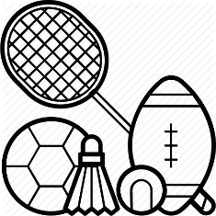
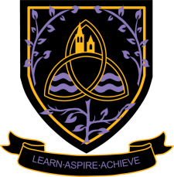
PE
A Level 2024 - 2026

Wigston College

Examination Board
OCR
Entry Requirements:
GCSE Grade 5 PE or merit in a vocational sport qualification and Grade 5,5 in Combined Science. If you have not studied this subject at GCSE level you will need a professional sport qualification at Grade 5, 5 in Combined Science
What will I be studying?
1. Anatomy & Physiology: The Skeletal and Muscular Systems, Joints and Movement, The Cardiovascular and Respiratory Systems, Energy Systems, Altitude/Heat and the Effects on the Body.
2. Diet, Nutrition and Performance: Components of Diet, Ergogenic Aids, Drugs in Sport.
3. Biomechanics: Levers and Forces, Angular and Linear Motion, Projectile Motion, Movement Analysis with Technology.
4 Training Methods: Types of Training, Aerobic, Flexibility, Strength, Training and its Effect on Diseases.
5 Skill Acquisition: Skill Classification and Learning, Guidance and Feedback, Psychological, Personality and Aggression, Arousal and Motivation, Group Dynamics.
6 Socio-cultural Issues in Physical Activity and Sport Contemporary issues in sport: Sport and Society, Evolution of Sport, The Media and Commercialisation, Modern Technology.
How will I be studying?
Lessons are primarily theory based, but whenever possible elements of the course will be taught in a practical environment.
How will I be assessed?
Physiological factors effecting performance (01): 2hr written paper (30%)
Physiological factors effecting performance (02): 1hr written paper (20%)
Socio-cultural issues in physical activities and sport: 1hr written paper (20%)
Performance in physical education: NEA (30%)
Where Next?
All universities and degree- awarding institutions recognise A level PE. The transferable skills gained through the course are valuable in a wide range of careers; you will develop a problem solving approach to your learning, and a capacity to deal with challenging situations as well as building a sound knowledge and understanding of the subject that will be relevant to a whole range of studies. It also gives an insight into the many diverse opportunities that are available within the world of sport. Students often go on to university to study Sports Science, Physical Education or coaching degrees. Possible career options include: PE teaching, Physiotherapy, Sports Coaching/Management, Sports Psychology or Nutrition, Personal Trainer.

