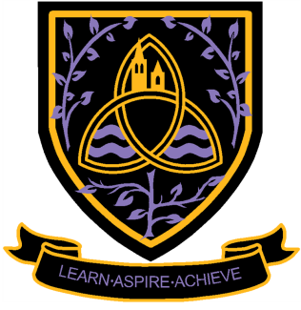
Level 3
Wigston College
2017/
National Certificate in Applied Science
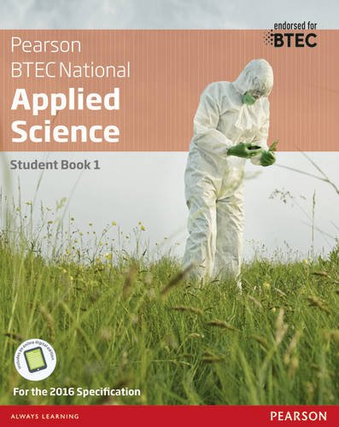
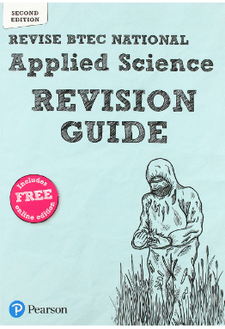
Books useful for the course. Revision guide strongly recommended for use over the 2 years.
Transition Pack
2024/25

Welcome
We are glad that you have chosen to study BTEC Level 3 National in Applied Science at Wigston College.
You will be completing the Certificate in year 12 which includes two mandatory units, one externally assessed exam and one internally assessed unit of assignments. Learners must complete and achieve at pass grade or above for both these units to gain a BTEC qualification.

These units are:
Unit 1- Principles and Applications of Science (Examined 50%);
Unit 2- Practical Scientific Procedures and Techniques (Assignment based, internally assessed 50%).

On the BTEC course, your work will be assessed to one of five levels:
U- Unclassified (no qualification awarded)
P - Pass (equivalent to E at AS-level)
M - Merit (equivalent to C at AS-level)
D - Distinction (equivalent to A at AS-level)
D*- Distinction*(equivalent to A* at AS-level)

You can continue this course into Year 13 for the Extended Certificate which is equivalent in content and UCAS points to an A-Level.

You will receive regular feedback and support from your teachers during the internally assessed assignment. The external exam needs to be at least a ‘Pass’ to gain a qualification. The exam will be taken in January 2025.

How do I succeed in BTEC Applied Science?
Workload
At first, you will notice the difference in work load compared to year 11. You will need to take notes in class and read around the subject in your own time to support your learning. Make sure you ask for help if you feel you need it. Many people leave it too long before asking for help. At the start you need to recognise that Year 12 will take some getting used to.
Planning
You will be given deadlines for assignments and tasks. You have to meet deadlines so make sure you plan for them in your study schedule. For each hour you have in class, you should spend at least another hour in personal study time, completing notes and writing up experiments. Your teacher will tell you what is coming up and you need to complete tasks for lessons so you maximise your time in the lab.
Practical work
As this is a vocational and practically based course, you will be completing a substantial amount of practical work in all areas. Most of this will be as part of your assignments or exam. Therefore, any tasks that are completed should be written up as notes.
Resources
It is strongly recommended that the course text book shown on the front cover is purchased and it is extremely helpful for both years of the course. A USB stick is a necessity to back up and keep your digital work safe.

Transition Tasks
Your knowledge of GCSE science (Chemistry, Biology and Physics!) will be essential to support your success at BTEC. Research the following topics that have been covered at Key Stage 4 and make notes for use in the course.
- Atomic bonding – Covalent and ionic
- Writing chemical formulae
- Animal and plant cells
- Waves (P2)
Now have a go at applying or researching scientific knowledge to answer these questions that have been taken from sample assessment material online.
1)

2)

3)
Find out what parts A, B, C and D are and their function in the cell:
A: _________
Role:____________________________________________________________
B:__________
Role:____________________________________________________________
C:_____________
Role:____________________________________________________________
D:____________
Role:____________________________________________________ (8marks)
4)

5)

(b)
(b)
6)

Hand in all your tasks during the first lessons with your teacher. Completion of these tasks is required over the Summer holidays to show a commitment to your place on the BTEC Level 3 course.
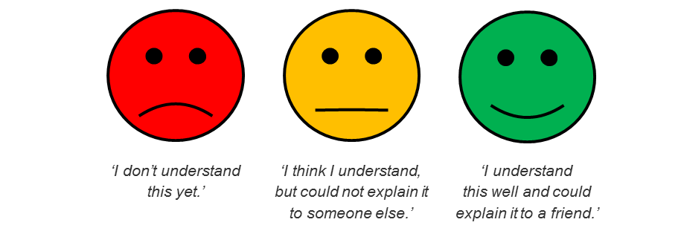
MARK:

We look forward to seeing you in August.

