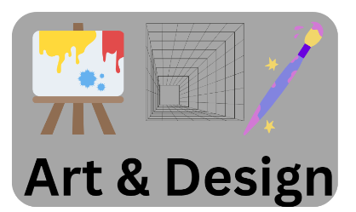

**British inventors**

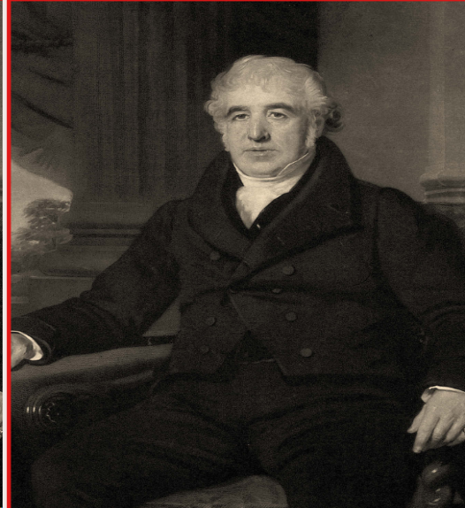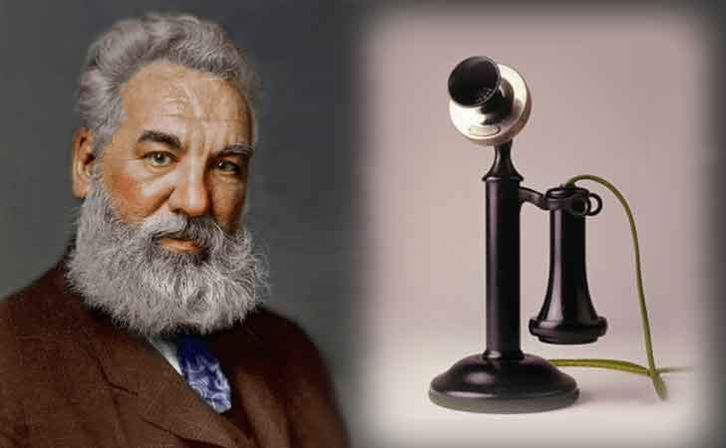

Lesson 1 To investigate the invention of the telephone.



Lesson 2: To investigate the invention of the World Wide Web.





Lesson 3: To investigate how reinforced concrete works.

Lesson 4: To investigate the invention of mackintosh.

Word bank

* Telephone
* World wide web
* Reinforced
* Concrete
* Mackintosh
* Alexander Bell
* Tim Berners-Lee
* W.B. Wilkinson
* Charles Mackintosh

Lesson 5: To reflex on the impact s that inventions have had on our life.



**British inventors**

**At the end of Spring 1:**

**At the beginning of Spring 1:**