

Bridgelea Primary School  Bridgelea Road  Withington  Manchester  M20 3FB | Bridgelea Primary School  Plymouth Grove West  Longsight  Manchester  M13 0AQ

Absconding Policy

Implemented | SLT
Presented by | Amy Robinson
Ratified by Governors | Autumn 2025
Review Date | Autumn 2026

Our overall vision of 'Understanding People' captures our core purpose perfectly. At Bridgelea we want to help our children, families, and communities to understand themselves and others more, whilst keeping their understanding of the statutory and wider curriculum.
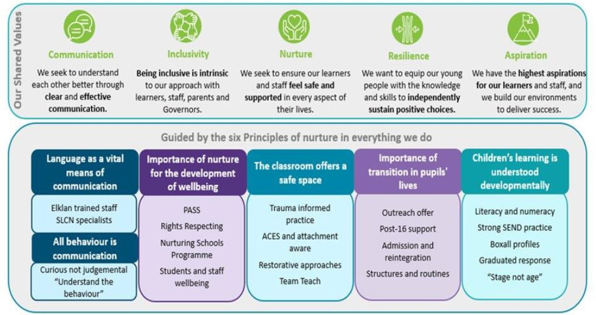

Gold Rights Respecting School

Through the School Council the children decided they would like to focus on the following 10 Articles, whilst understanding no right is more important than another:
Article 12
You have the right to give your opinion, and for adults to listen and take it seriously.
Article 13
You have the right to find out things and share what you think with others, by talking, drawing, writing or in any other way unless it harms or offends other people.
Article 15
You have the right to choose your own friends and join or set up groups, as long as it isn't harmful to others.
Article 24
You have the right to the best health care possible, safe water to drink, nutritious food, a clean and safe environment, and information to help you stay well.
Article 27
You have the right to food, clothing, a safe place to live and to have your basic needs met. You should not be disadvantaged so that you can't do many of the things other kids can do.
Article 28
You have the right to a good quality education. You should be encouraged to go to school to the highest level you can.
Article 29
Your education should help you use and develop your talents and abilities. It should also help you learn to live peacefully, protect the environment and respect other people.
Article 30
You have the right to practice your own culture, language and religion - or any you choose. Minority and indigenous groups need special protection of this right.
Article 31
You have the right to play and rest.
Article 39
You have the right to help if you've been hurt, neglected or badly treated.

Introduction
Under section 3 of the Health and Safety at Work Act, 1974 and in common law, schools and other education settings owe a duty of care towards their pupils.
This duty of care requires that all reasonable steps are taken to ensure that pupils are safe and remain within the care of the school/centre at all times throughout the school day and during school led activities.
The purpose of this guidance document is to provide a framework for schools to develop their individual policy and procedures for dealing with pupils who abscond.
Definition
To abscond is to 'leave without permission'.
Internal Absconding | External Absconding
Where a pupil leaves the care of the responsible person without permission but remains on the school site. (Leaving the building without permission) | Where a pupil leaves the school site without permission. (Absconding from school grounds)
Where a pupil leaves a lesson without permission but remains on the school site. (Leaving the room without permission) | Where a pupil leaves an offsite provision without permission, e.g., curriculum swimming, alternative education provision, etc. (Absconding off-site)
 | Where a pupil leaves a defined area or supervision of the responsible adult without permission, e.g., when undertaking fieldwork or on an educational visit. (Absconding off-site)
 | Where a pupil leaves the designated transport provided for them without permission (Absconding from transport)

Control measures and procedures to prevent absconding.
Site security
▪ The site should have a secure perimeter and gates, which can be locked if necessary. Gates/doors should be closed outside of your stated drop off and pick up times.
▪ Unsecured gates should be locked during break times if there is a significant risk of absconding.
▪ Doors into school should be locked from the outside with magna locks.
Effective supervision
Effective supervision is dependent on a number of factors including:
- Age of the pupils
- Ability of the pupils
- Number of the pupils
- Activities being undertaken
- Pupil behaviour
- Site layout and security
- Specific identified risks e.g. pupils with history of absconding, public rights of way through school grounds, building work, etc.
Information to pupils.
• School rules and expectations are clearly displayed and reinforced throughout the school year.
• There is a clear and consistent system in school which covers absconding pupils.
Individual Pupil Risk Assessments.
• Where there is a foreseeable risk of absconding, there should be an individual risk assessment in place.
• The individual risk assessment should clearly detail the individual control measures required to reduce the risk of absconding
External visits/sites.
• On an Educational Visit the security of the venue/location should be assessed and supervision levels altered accordingly.
• Ensure that there are robust systems in place so that each group has specified members and leaders, and regular head counts occur throughout the visit.
• In the planning for an educational visit the risks of absconding must be clearly assessed, particularly in the case where known absconders are in attendance. This should include transport.
• Communication between the groups and robust emergency procedures should be place.
• When using staff cars to transport known absconders the RA should specifically refer to the risk of absconding.

Actions to be taken in the event of a child absconding.
Any action taken must be proportionate to the risk and in the best interest of the child.
• A system for notifying the SLT on call immediately. This system must NOT place the remaining pupils at risk.
• A procedure for securing and systematically searching the site in the event of a child absconding and their whereabouts being unknown.
• A system for notifying the parents /carers and the police if a child is known to have left the school site, or they cannot be found.
• Follow up actions to be taken once a child has been found.
• The systems above should cover educational visits and transport where relevant.
If a child leaves the building they are to be followed but only to the boundary of the school premises. The pupil is to be reminded, if appropriate, that if they leave the school site and go out of staff sight the police and their parents/ carers will be informed. Staff must continue to observe/ support as long as the pupil is in sight, perhaps moving back towards the building if the pupil begins to return. If the pupil does go out of sight a phone call is to be made to parents/ carers and the police. If the pupil is younger and/ or of higher risk as noted on their Communication Chart, a member of staff may follow after taking a school mobile from the office and informing the senior member of staff on site.

Absconding Policy
The purpose of this policy is to set out clearly for all stakeholders, the process that will take place should a child abscond from school. To abscond is to 'leave without permission'.
Under Section 3 of the Health and Safety at Work Act, 1974 and in Common Law, schools and other education settings owe a duty of care towards their pupils.
This duty of care requires that all reasonable steps are taken to ensure that pupils are safe and remain within the care of the school at all times throughout the school day and during school led activities.
Where a pupil absconds, the following procedures should be followed:
• Member of staff to inform "On Call" member of SLT and main office.
• Reporting staff member organises search of buildings and known places that the pupil may have gone to.
• If the pupil is not found then all available staff to complete a more thorough sweep of the school and check the perimeter of the grounds.
• Reporting staff member to phone the police when area has been fully checked if the child is not found.
• Reporting staff member to contact parents/carers and inform them of the situation.
• Consideration will be given to whether the search should be extended beyond the school perimeter. This decision will be based on staff's knowledge of the child and on the levels of risk, and on what action is in the child's best interests.
- Any staff who leave school grounds to take mobile phone to contact school.

- Once a pupil has been found then the lead SLT member will use their professional judgement to outline the response towards the pupil and the support the pupil will need in the future.

- A written report will be filed on the incident.

- Member of SLT to brief police and parents.

Where a pupil attempts or is seen to be leaving the school premises without authorisation the following procedures should be followed:
If a child leaves the building they are to be followed but only to the boundary of the school premises. The pupil is to be reminded, if appropriate, that if they leave the school site and go out of staff sight the police and their parents/ carers will be informed. Staff must continue to observe/ support as long as the pupil is in sight, perhaps moving back towards the building if the pupil begins to return. If the pupil does go out of sight a phone call is to be made to parents/ carers and the police.
If the pupil is younger and/ or of higher risk as noted on their Communication Chart, a member of staff may follow after taking a school mobile from the office and informing the senior member of staff on site.
Upon his or her return to school, and when the student is calm, the student must be seen by the SLT so that the reasons for absconding may be discussed in detail. At this point a decision will be made as to the appropriateness of further actions.
An Absconding Risk Assessment to be completed detailing post incident learning and steps to reduce the risk of this happening again.

Procedure if a child is missing or absconds.
Reporting staff member informs SLT that a pupil has absconded
Staff check location of pupil / if pupil still on premises by
• Asking office staff to check CCTV
• Staff check last known location, known hiding points / calm down areas / areas pupil may regularly go to if absconding
