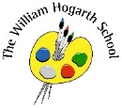
Spring 1 Term Newsletter Year 6
English
This term we shall continue to explore the book “The Story of the Wind”. This book focuses on different human rights and the importance of these human rights in creating a happy, safe and fruitful society. The children will be creating a setting description and a flashback narrative using this book as stimulus.
Science
We will be investigating the topic of living things: evolution and inheritance. Pupils will define and identify variation in organisms and recall that it is caused by inherited and environmental factors.
Maths
We will be focussing primarily on ratio, algebra and decimals. Algebra is introduced in Year 6 to formalise missing number problems pupils have encountered since Key Stage 1, using letters or symbols to represent unknown values.
P.E.
We will be going to Rock’s Lane for padel lessons weekly. We will also have PE specialists visit us for team building and problem solving.

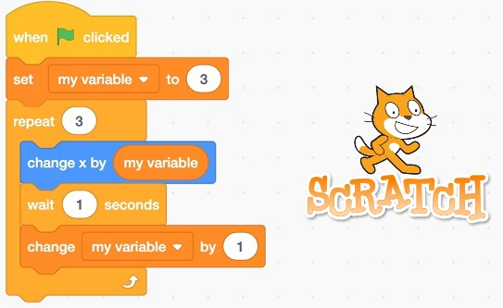
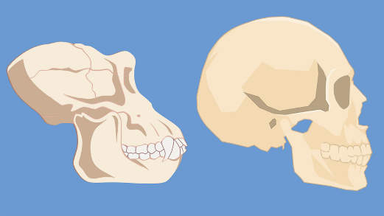
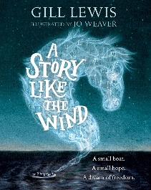
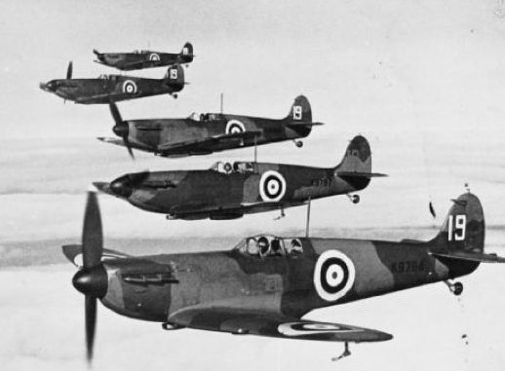

Music
This unit builds upon the learning in Exploring Classical Music 1 in year 5. Children study two new pieces: Symphony No. 1 in E minor (3rd mvt) by Florence Price and the Doctor Who theme tune by Delia Derbyshire, from the BBC Ten Pieces.
PSHE
Year 6 will be focusing on being healthy and making healthy choices. We will discuss health, fitness and nutrition.
R.E.
The children will investigate and answer this key question - ‘Why is it better to be there in person?’
Thinking back to learning about prayer and worship, children find out about significant religious and non-religious journeys and pilgrimages and why going to a particular place is so important to some people.

Computing
We will be exploring ‘Variables in games’ on Scratch.
We will design, create and evaluate our own programs that uses variables.
Humanities
Year 6 will be having an in-depth look at History. Our next topic is What was the impact of World War 2 on the people of Britain? Pupils will identify the causes of World War II, identify the different phases of the battle of Britain, make deductions from the Blitz photographs, describe how children may have felt when evacuated and evaluate different sources.

