History

In History we are going to learn how two people from the past, with pioneering ideas, inventions and reforms, have had an impact on the world we live in today. (Neil Armstrong and Isambard Kingdom Brunel).

Geography

In Geography we are going to use aerial images, photos and pictures to recognise landmarks and physical features.

Music

We will be learning to listen and appraise different styles of music, including Rock songs.

Science

In Science we are going to be learning about

Computing

In Computing we will be learning to

PE - Multiskills

The children will be developing their

Art/DT

We will explore the paintings by

PSHE

We will be learning about Safety - keeping safe at home, outside and online and knowing who can help.

R.E – To learn about

Maths

In maths we are going to focus on money – counting money, making amounts and finding change.

We will also be working on multiplying and dividing by 2, 5 and 10.

We will use the chromebooks to continue to develop basic Maths skills on Numbots and other appropriate games e.g. Topmarks.

English – Reading

In Reading we are going to continue to develop our love of reading. We will work on our VIPERS skills to read fluently and be able to retell a wide range of stories.

English – Writing

In writing we will be revising punctuation and making sure it is always accurate. We will also be developing joined handwriting in the continuous cursive style. We will focus on common exception words in spelling.

Year 2

Spring 1 2023

Pioneers

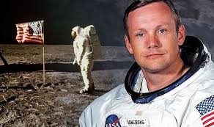

See Knowledge organiser for more details.