Lesson 1  Safety | Lesson 2  Measuring Skills | Lesson 3  Bunsen Burners
Your teacher will have made the safety rules for the laboratory very clear. Below are some important safety rules, which should always be followed, but there may be others which you need to consider in addition to these.  - Always wear eye protection during a practical.  - Carry out a practical while standing up.  - Do not eat or drink in the laboratory.  - Tie long hair back and tuck loose clothing in during practicals.  - If something is spilled or broken, tell the teacher.  - Ensure that the floor and work space is clear of obstacles.  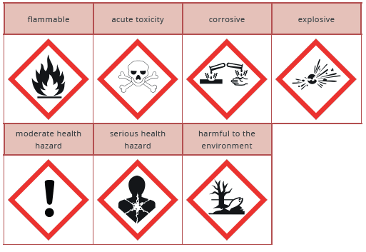 | When taking measurements in science there are various different pieces of equipment you can use and different units as well  Below are examples of measurements the equipment you can use and some units.  Measurement Length  Equipment Ruler, trundle wheel  Units cm, m, Km  Measurement Mass  Equipment Top Pan Balance, scales  Units g, Kg  Measurement Temperature  Equipment Thermometer  Units ºC  Measurement Time  Equipment Stopwatch  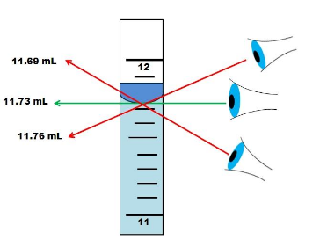  Units seconds (s)  When making measurements always get down to eye level. | 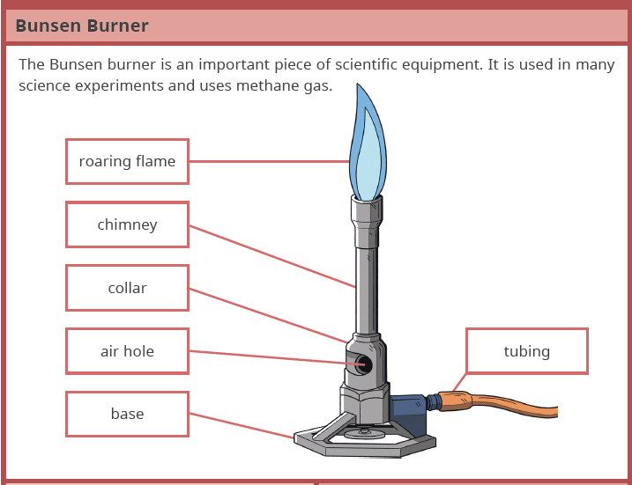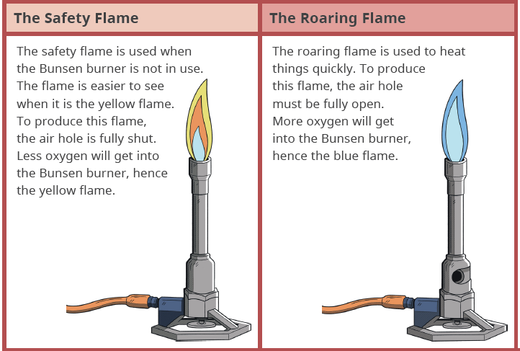

Lesson 4  States of Matter | Lesson 5  Particle Model | Lesson 6  Changes of State
Matter: any substance that has mass and volume.  Mass: how much of something there is  Volume: how much 3D space something takes up  Matter can exist in three physical states:  - Solid  - Liquid  - Gas  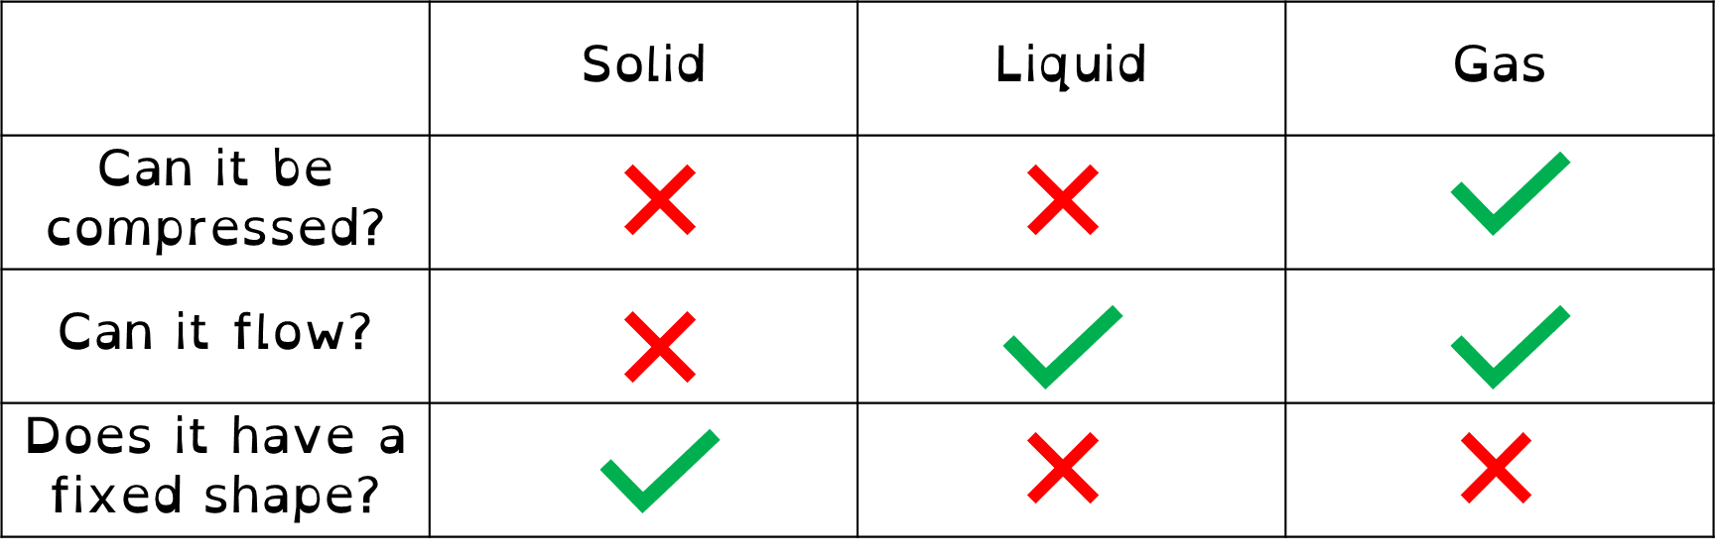 | All substances are made up of particles.  Particles are attracted to each other.  The particles move around.  The higher the temperature of the matter the more the particles move around  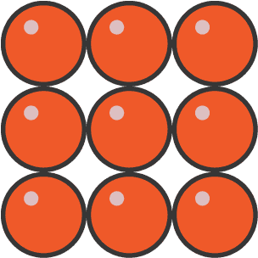  Solid  - Particles in a fixed arrangement  - Particles vibrate around a fixed point  - Particles are close together  - Very strong attraction between particles  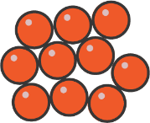  Liquid  - Particles in an irregular arrangement  - Particles move around each other  - Particles are close together  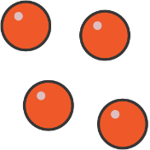  - Strong attraction between particles  Gas  - Particles in a random arrangement  - Particles move randomly in different directions and at different speeds  - Particles are far apart  - Weak attraction between the particles | Changes of state - Substances can change state, usually when they are heated or cooled.  The closeness, arrangement and motion of the particles in a substance change when it changes state.  Melting – The process that occurs when a solid turns into a liquid when heated.  Evaporating – The process by which a liquid changes state and turns into gas.  Condensation – A change in state in which gas becomes liquid by cooling.  Freezing – A change of state in which liquid becomes solid by cooling.  If an object changes state (by heating)  - Particles in a solid will vibrate so much they move further apart and begin to move  - Particles in a liquid will move so fast they get further apart and will begin to move freely  Some chemicals do not exist as a liquid.  - Going from a solid to a gas is called sublimation.  - Going from a gas to a solid is called deposition.

Lesson 7  Investigating Changes of State | Lesson 8  Density | Lesson 9  Diffusion & Brownian Motion
Variables:  - Independent:  What you change in an experiment  - Dependent:  What you measure in an experiment  - Control:  What stays the same in an experiment  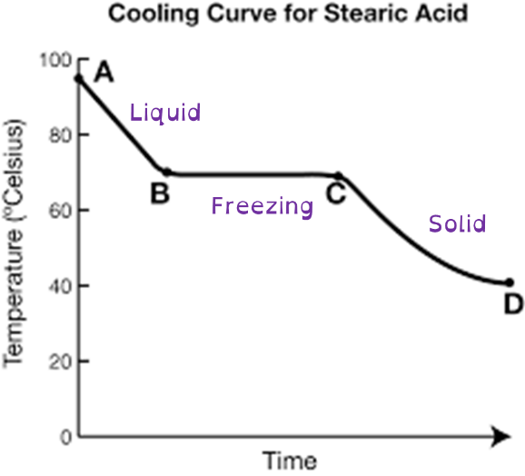 | Density is the amount of mass in a given volume.  Denser objects sink in less dense fluids.  General rule for density:  - Solids > Liquids > Gases  - We know that this is not always the case.  When objects are heated their particles move further apart, this causes their density to decrease.  Limitations to the particle model:  - Only 2D  - Don’t show movement of particles  - Don’t show particle interactions  - Some substances have a higher density as liquid then as a solid | Diffusion is the movement of particles from a high concentration to a low concentration  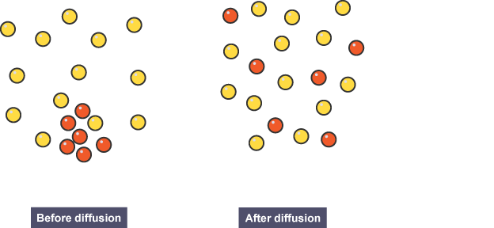  Diffusion can also happen in liquids - particles in liquids can move around each other, which means that eventually they are evenly mixed.  Diffusion in liquids is slower than diffusion in gases because the particles in a liquid move more slowly. It happens faster if the temperature is increased.  Diffusion does not take place in solids as the particles are fixed in solids and can not move round each other.  Brownian motion is the “jiggling” movement of larger particles in gas or liquid because the large particles are constantly hit by smaller particles.
Lesson 10  Gas Pressure | Lesson 11  Elements, Mixtures and Compounds | Lesson 12  Solvent, Solutes and Solutions
The particles in a gas move quickly in all directions.  Gas pressure is caused when gas particles hit the walls of their container.  If you had more gas particles, you would get more frequent collisions  If the gas particles moved faster, you would get more frequent collisions and particles hit the walls harder.  Gas particles move faster at higher temperatures and so gasses at higher temperatures exert more pressure on their containers.  Tyres could burst if they get to hot.  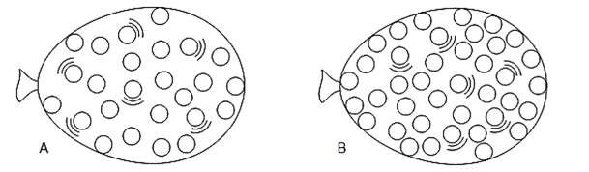 |   Atoms are the smallest particle of an element that can exist.    An element is a pure substance made from one type of atom.  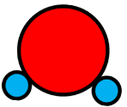  Compounds are substances that are made up of two or more atoms chemically bonded together in a fixed ratio.  Molecules are substances that contain two or more (non-metal) atoms, chemically bonded together.  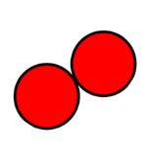  - Molecules can be elements, two or more of the same atom.  - Molecules can be compounds, two or more different atoms.  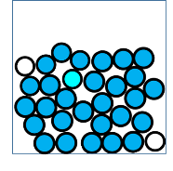  Mixtures can be defined as impure, as they are made from two or more different substances that are not chemically joined together. | A solute is the substance that dissolves to make a solution.  - In salt solution, salt is the solute.  A solvent is the substance that does the dissolving – it dissolves the solute.  - In salt solution, water is the solvent.  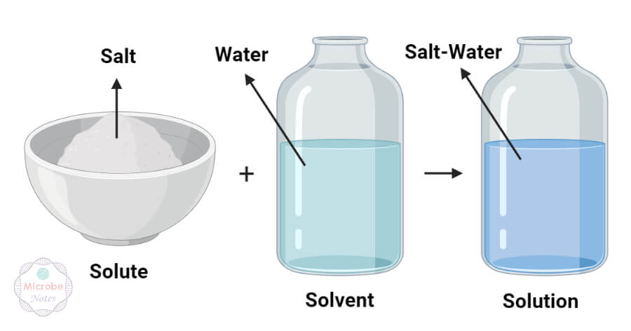  During dissolving, particles of solvent surround the particles of solute, gradually moving them away until the particles are evenly spread through the solvent.  Substances that do not dissolve in a solvent are called insoluble substances  Solubility is a measure of how much of a solute can dissolve in a solvent.

