|  |  |
| --- | --- |
| **St Marys – Religious Education knowledge map** | |
| **Year 4** | **Topic 4.3 ‘Jesus, the Teacher’** |

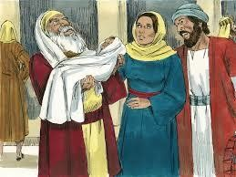

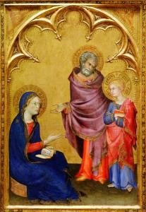

We will be looking at the painting ‘Finding in

the Temple’ by Simone Martini when reflecting in this unit.

What will I know at the end of the unit?

* Retell one of Jesus’ parables, ensuring it is accurate in its sequence and detail.
* Ask and respond to questions about their own and others experiences of following Jesus in their own life.
* Make a simple link between the chosen parables and Jesus’ message about how we should live.
* Describe the beliefs that Christians hold from God, from the given Beatitudes and parables.
* Give a point of view on an aspect of Jesus’ teaching.
* Express a preference (e.g ‘which is, what is, which parable…what do you like/not like about…’ etc on an aspect of learning from this unit.
* Suggests answers to questions like, ‘How can God’s Word grow in you?’ ‘Why is it important to forgive?’

|  |  |
| --- | --- |
| Key Vocabulary | |
| Ark | The place where the ten commandments were kept. It was the  most holy place for the Jews. |
| Good News | The meaning of the word Gospel |
| Jewish | The religion which began with Abraham and to which Jesus  belonged |
| mission | The task of teaching or preaching the Word of God |
| Presentation in the  temple | When Mary and Joseph took Jesus to the Temple for the first  time |
| Rabbi | An ordained Jewish teacher. Often the religious leader of a  Jewish community. |
| Sabbath | Every week religious Jews observe the Sabbath, the Jewish holy  day, and keep its laws and customs. |
| scrolls | Rolls of paper or parchment where the Word of God was  written |
| Synagogue | A place of worship and learning for Jewish people. |
| Temple | The special house God’s people used to have for Him |
| Torah | The Torah is the first part of the Jewish bible. It is a sacred text  for Jewish people. |

|  |
| --- |
| What should I already know? |
| * Children will have knowledge about Jesus’ Presentation in the Temple from Y1. * Children may know that Jesus was a Jew. * Children will be familiar with some of the parables Jesus told. |

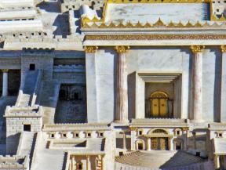

Key People and places

People: Anna and Simeon

Place: Temple in Jerusalem as Jesus would have seen it

|  |  |
| --- | --- |
| Key Scripture Key Prayers  Luke 2: 22-32  Luke 4: 14-22 Canticle of  Matthew 5: 44 Simeon  John 15: 12  Luke 8: 4-8 Glory Be  Matthew 18: 23-35 | Books to read at home |
|  |