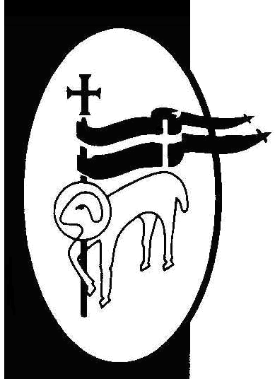
St. John The Baptist Church of England (Aided) Primary School

Loving Learning, Building Community, Growing in Faith

Home Learning Activities – No Internet
Maths - Patterns  Can you create your own secret code?  You could use letters, numbers, pictures or something else. Can you get someone else to crack it?  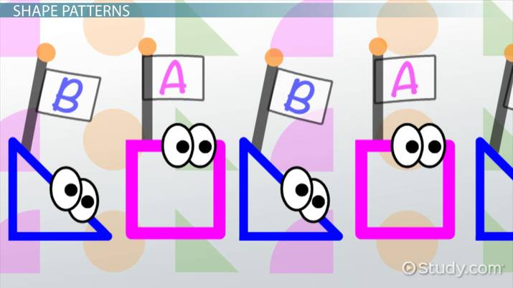 | Science - nature  Start a nature diary.  Each day look out of the window and note everything you see. Birds, flowers, changes in the weather. Draw it and write about it. | Reading  Build a reading den.  Use blankets, sheets, pillows to create your won private reading den. Read every day in your new space. | DT  Make a sock puppet.  Use an old sock to create a puppet. Give them a name and write a story about their adventures.  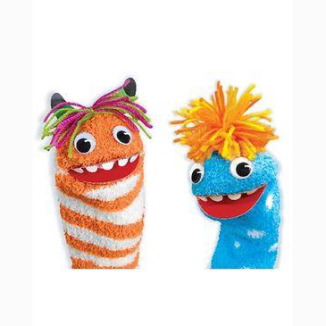
PHSE  Do something kind for someone.  Pay them a compliment, help them with a task or make them something. | Art  Get sketching  Choose an object or toy and create a still life sketch of it. | Reading  Create a story bag  Find a bag and collect items to go in it for your favourite story. If you can’t find something draw it instead. | PE  Get Dancing  Put on your favourite song and create a dance routine.  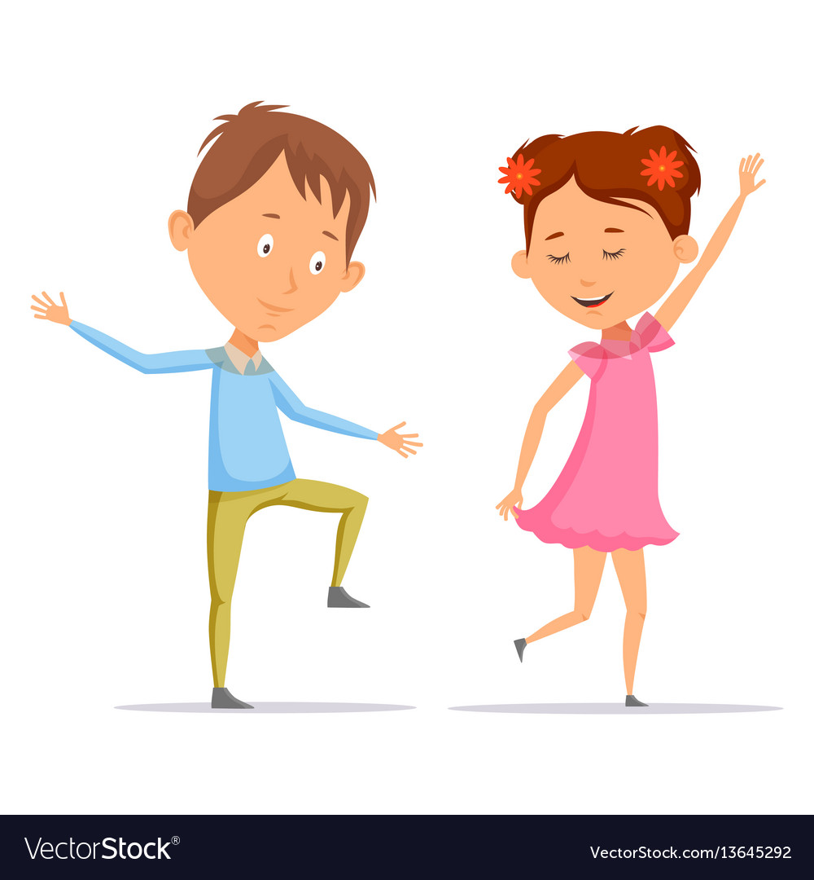
Writing  Letters  Write a persuasive letter to your teacher. Tell them what you like most about class and what would make lessons even better. | Geography  Maps  Create a map of your local are or the school. Highlight interesting landmarks. | History  Toys  Talk to your parents and grandparents (you can use the phone) to find out about toys when they were little. Draw and write a report about your findings. | DT  Junk Modelling  Use old pots, rolls and boxes to create your own masterpiece.  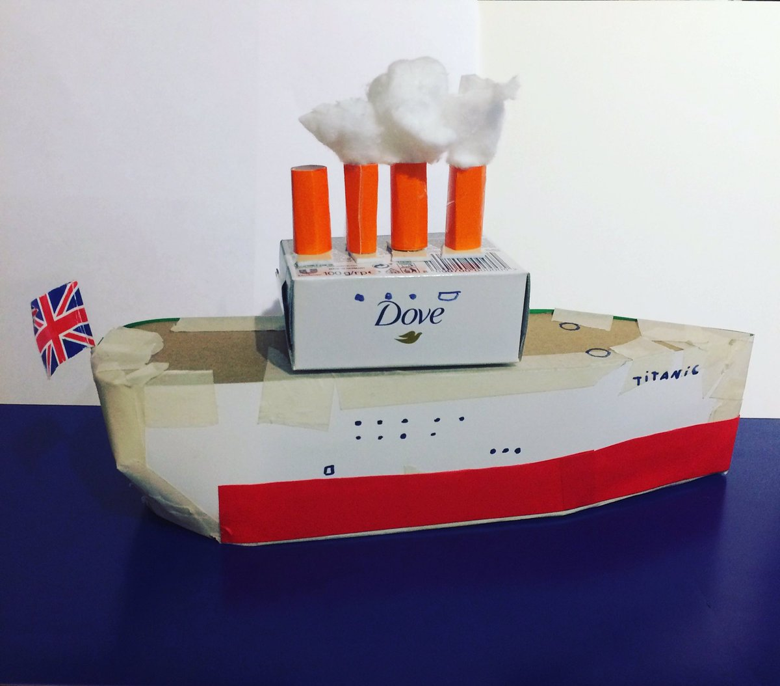
PE  Get Moving  Design and make an obstacle course in your house or garden. Time how fast you can complete it in and try to beat your own time. | Maths  Times Tables  Write out the times tables to 12 x 12. Get someone to test you.  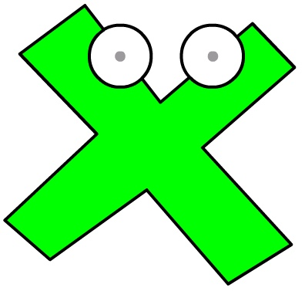 | DT  Board Game  Design and make your own board game. Write a set of instructions and rules. | PHSCE  Climate Change/Plastic  Make a poster, leaflet or booklet to inform others about the effects of climate change or plastic pollution.

