St Chad’s C.E. Primary and Nursery School
Courage and Endurance
Reflection areas from the Vision Group (Display on reflection board)
‘A hero is an ordinary individual that finds the strength to persevere and endure in spite of overwhelming obstacles’ (Christopher Reeve)

LISTEN: The first three songs explore how Christians take seriously trying to live courageous lives but living as God wants them to. It is summed up for many Christians in the verse Micah 6 verse 8 ‘But what does the Lord require of you but to do justly, to love mercy and to walk humbly with your God’ ‘Courageous’ by Casting Crowns https://www.youtube.com/watch?v=pkM-gDcmJeM
‘God of Justice’ by Tim Hughes https://www.youtube.com/watch?v=b3NelRb1LY4
‘Take Courage’ By Bethel Music https://www.youtube.com/watch?time_continue=272&v=z6itgjC2IlY&feature=emb_logo
‘Something inside so strong’ This version is by the Lewisham and Greenwich NHS Choir https://www.youtube.com/watch?v=4zepf15fEPE

WATCH: Derek Redmond’s Olympic Story
https://www.youtube.com/watch?v=t2G8KVzTwfw

Derek Redmond didn’t win a medal at the 1992 Olympic games in Barcelona, but he did bring 65,000
spectators to their feet in a standing ovation recognising his incredible act of courage. Derek Redmond
found courage in himself but also through the support of his father.

Look at Hannah Dunnett’s artwork on Psalm 23:
https://tinyurl.com/y9cjdh7j
Create your own version using the words of Psalm 23 or another poem
that means a lot to you.
Use the EXAMEN prayer to reflect on courage. It has 5 steps, so you might like to count them on your
fingers.
1. GIVE THANKS for something that were good today
2. ASK FOR HELP with something that scares you at the moment
3. REFLECT on your day and think about the things that have given you courage ☺ and the things that have
discouraged you
4. SAY SORRY for the times you have lacked courage, or discouraged someone else
5. DECIDE how you will keep hold of your courage tomorrow

Research one of the following people Rosa Parks, Detrick Bonhoeffer, Harriet Tubman, Malala Yousafzai

Do you ever find it difficult to be courageous?
What or who inspires you and gives you courage to carry on?
How does it make you feel when you see someone else showing courage?
How can you encourage others to be courageous, when they are having a hard time?
What stops you from being courageous? What can help overcome this?

Watch the Christian Aid video of Ngele and Bokiya and talk about how they showed courage: https://www.youtube.com/watch?v=HXxejNZcpAQ

Week Beginning |  | Value – Courage | Leader
Week 1 21/4/25  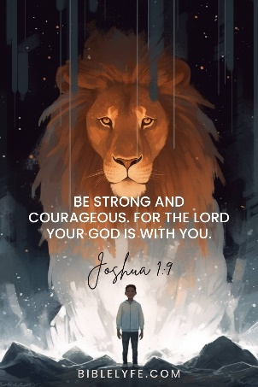 | Monday | Easter Holiday
 | Tuesday | https://www.assemblies.org.uk/pri/666/no-escape  https://www.assemblies.org.uk/pri/796/fear-and-courage | CS
 | Wednesday | https://www.assemblies.org.uk/pri/2868/keep-going  Keep Going | Year 6 and CHa  JH and LE
 | Thursday | Window on the World KS2  KS1 Class worship | CS and KS2 staff
 | Friday | Celebration Worship  Prayers - Rec | CS  All Staff
Week 2 28/4/25   | Monday | Composer Launch | JH  PA and EB
 | Tuesday | Class worship
 | Wednesday | https://www.assemblies.org.uk/sec/4423/fight-for-your-dreams  Fight for your dreams | Year 5 and JM  HS and HP
 | Thursday | KS1 Godly Play:  KS2 Class worship | CS  KS1 teachers
 | Friday | Celebration Worship  Prayers Year 1 | CS  All staff
Week 3 5/5/25  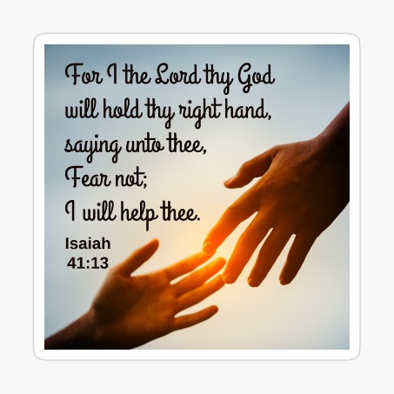 | Monday | Bank Holiday
 | Tuesday | KS1 Rev Callum  KS2 Class worship | FD and NH
 | Wednesday | https://www.assemblies.org.uk/pri/4137/a-stormy-problem  Stormy Problem | Year 4 and PA  EC and KA
 | Thursday | KS2 Window on the World  KS1 Class worship | CS  KS2 Teachers
 | Friday | Celebration Worship  Prayer Year 2 | CS  All Staff
Week 4 12/5/25 SATs week  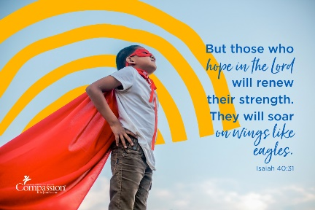 | Monday | Sing and Praise Worship in class
 | Tuesday | Class worship  https://www.assemblies.org.uk/pri/3569/pause-for-thought-standing-up-for-good
 | Wednesday | Class Worship  https://www.assemblies.org.uk/pri/4317/what-are-we-made-for
 | Thursday | Class Worship
 | Friday | Celebration Worship  Prayers Year 3 | CS all staff
Week 5 19/5/25  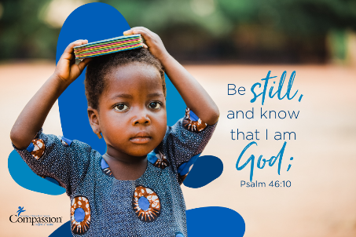 | Monday | Singing Worship | JH  JM and DW
 | Tuesday | KS2 Worship Rev Callum  KS1 Class Worship | CHa and KA
 | Wednesday | https://www.assemblies.org.uk/pri/1968/courageous-animals  Courageous animals | Year 3 and EC  HP and HS
 | Thursday | Sports Day
 | Friday | Celebration Worship – privilege cards  Prayers Year 4 | CS  All Teachers
Songs | Entry music https://www.youtube.com/watch?v=E1f8Tn5UOpU  https://youtu.be/asjSnNgDTrw Joshua 9:1  https://www.youtube.com/watch?v=ZeCcha_gjQ0 Something inside so strong sign language  https://youtu.be/fCC9fGnHH4I Brave  https://youtu.be/YUageJdwyPY My God is so big

