Coombeshead Academy – Registration and the Tutor Reading Programme
At Coombeshead, form tutors read to all students from Years 7 to Year 10 every morning. The books have been chosen to introduce our students to a diverse and challenging literary canon. Here is a list of the books for Year 10, together with some information about each one.

Book Title and Author | Cover | Synopsis
The Day of the Triffids  by John Wyndham | 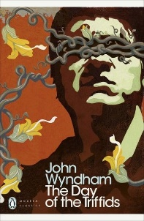 | Set in a post-apocalyptic southern England, probably in the 1960’s-1970’s this novel explores the consequences of genetic engineering and the fallacy of human superiority. When Bill Masen wakes up blindfolded in hospital there is a bitter irony in his situation as he realizes that he is the only person who can see: almost everyone else has been blinded by a meteor shower. Now, with civilization in chaos, the triffids - huge, venomous, carnivorous ‘walking’ plants, can have their day.
Norse Mythology  by Neil Gaiman | 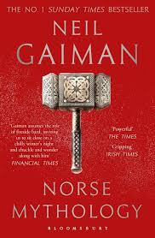 | The great Norse myths have inspired so much of modern fiction. Tales of dwarfs and frost giants, of treasure and magic, and of Asgard, home to the gods: Odin the all-father, highest and oldest of the Aesir; his mighty son Thor, whose hammer Mjollnir makes the mountain giants tremble; Loki, wily and handsome, reliably unreliable in his lusts; and Freya, more beautiful than the sun or the moon, who spurns those who seek to control her. All human emotions are represented in the tales of the Scandinavian gods and goddesses.
The Hitchhiker’s Guide to the Galaxy  by Douglas Adams | 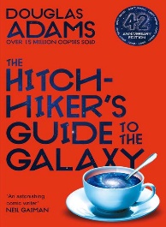 | Anyone who has ever felt powerless in the face of bureaucracy will recognise the emotions experienced by Arthur Dent. Fortunately, Douglas Adams has exposed the absurdity of the situation to great comic effect. Seconds before the Earth is demolished to make way for a new hyperspace express route, Arthur Dent is rescued by his best friend, Ford Prefect, who happens to be an alien. With an assortment of fellow travellers, they journey through space, carrying a towel and a book inscribed with the words: DON'T PANIC………
To Kill a Mockingbird  by Harper Lee | 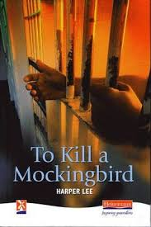 | Published in the 1960’s, thirty years after the events portrayed in the novel, the themes still resonate today. The story, set in Maycomb Alabama, follows lawyer Atticus Finch’s attempts to prove the innocence of Tom Robinson, a black man who has been wrongly accused of raping a white woman. It is narrated by Scout Finch, his six-year-old daughter who lives with him and her ten-year-old brother Jem. It is a trial no-one expects Atticus to win.  Bildungsroman -a novel dealing with one person's formative years or spiritual education.
Beloved  by Toni Morrison | 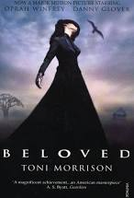 | Set in the mid 1800’s this is a story with supernatural overtones. At Sweet Home in Kentucky, an era is ending as slavery comes under attack from the abolitionists. The worlds of Halle and Paul D. are to be destroyed in a cataclysm of torment and agony. The world of Sethe, however, is to turn from one of love to one of violence and death - the death of Sethe's baby daughter Beloved, whose name is the single word on the tombstone, who died at her mother's hands, and who will return to claim retribution.
The Perks of Being a Wallflower  by Stephen Chbosky | 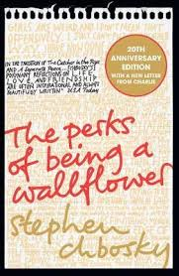 | This novel addresses some challenging themes as the narrator, Charlie, comes of age and matures physically, emotionally and sexually. Set in Pittsburgh, Pennsylvania in the 1990’s Charlie is a freshman. Shy, introspective, intelligent yet socially awkward, he is a wallflower, caught between trying to live his life and trying to run from it. Charlie is trying to navigate his way through uncharted territory – first dates, family dramas and new friends. He can't stay on the sidelines forever.
More Than This  by Patrick Ness | 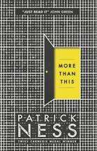 | When a boy called Seth drowns, desperate and alone in his final moments he is living in America. But then he wakes. How is that possible? He remembers dying, so how is he is here? And where is this place? What's going on?  Seth begins a search for answers, hoping that he might not be alone, that there might be more than just this...  The more he learns the less he understands. Increasingly he asks himself who and what is real as he struggles to comprehend what has happened.
Things Fall Apart  by Chinua Acebe | 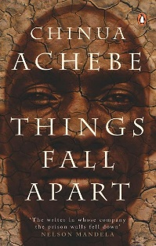 | Set in the late 1880’s, in the village of Umuofia, Nigeria this novel explores the culture, traditions and beliefs of the Igbo and the impact of colonisation. Okonkwo is the greatest wrestler and warrior alive, and his fame spreads throughout West Africa like a bush-fire in the harmattan. But when he accidentally kills a clansman, things begin to fall apart. Then Okonkwo returns from exile to find missionaries and colonial governors have arrived in the village. With his world thrown radically off-balance he can only hurtle towards tragedy.
The 57 Bus  by Dashka Slater | 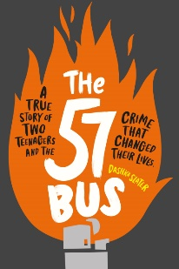 | With challenging and complex themes of institutional racism, hate crimes, trans and non-binary identity, reconciliation, forgiveness, hope and bravery this is a true story. Sasha was born male but identifies as agender, wears skirts and attends a private school. Richard is an African American who attends a rough public school. Every day, they catch the same bus home. And one day, messing about, Richard flicks the flame of his lighter to Sasha’s skirt, and Sasha wakes up in a ball of flame…… One moment that changes both their lives forever.
Heart of Darkness  by Joseph Conrad | 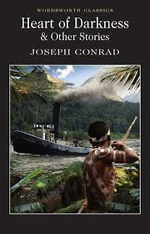 | Set in what is now the Democratic Republic of Congo this adventure story is based on historical events. The author explores the evils of colonisation, the exploitation of the indigenous population and moral corruption of the colonisers. The narrator, Charles Marlow, has been employed by a Belgium ivory trading company to bring back a cargo ship from the Congo River. Once there he journeys deep into the interior in search of the company’s agent Kurtz, once a ‘civilised’ man but now a brutal tyrant driven mad by his time in the jungle.
One of Us is Lying  by Karen M. McManus | 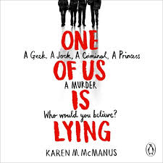 | Set in an American school sometime after 2010, this story examines how the persona we project in our daily lives can be an illusion. It details the power of social media to wreck lives, primarily because it is now the go to place for news and gossip for a whole generation. Many of our students and young people live their lives on social media, desperate for likes and fearing that their perfectly curated image will be exposed. As the four main characters are brought together IRL they discover how wrong they have been to judge each other by the image they project.
Never Let Me Go  by Kazuo Ishiguro | 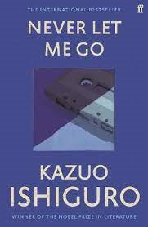 | In one of the most acclaimed novels of recent years, Kazuo Ishiguro imagines the lives of a group of students growing up in a darkly skewed version of contemporary England, although it is not entirely clear exactly when it is set.  Narrated by Kathy, now thirty-one, the novel dramatizes her attempts to come to terms with her childhood at the seemingly idyllic Hailsham School and with the fate that has always awaited her and her closest friends in the wider world. While much remains unsaid it gradually becomes apparent that these children are special and are both needed and feared by the adults of their world. A story of love, friendship and memory, Never Let Me Go is charged throughout with a sense of the fragility of life.​
The Hate U Give  By Angie Thomas | 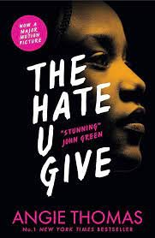 | Written a couple of years before the killing of an African-American man by a police officer, this book depicts the reality of life for many Americans of African descent. It does not shy away from the truth of drug abuse and gangs while also examining the attitudes of those responsible for upholding the law.  Starr lives in two worlds: the poor neighbourhood where she was born and raised and her posh high school in the suburbs. She feels as if she has to present as two different people, depending on who she is with. The uneasy balance between them is shattered when Starr is the only witness to the fatal shooting of her unarmed best friend, Khalil, by a police officer. Now what Starr says could destroy her community. It could also get her killed.​ What’s the point of having a voice if you’re gonna be silent?

