St Chad’s C.E. Primary and Nursery School
Hope & Aspirations
Class worship from the Vision Group (Display on reflection board)
Wonderful World by Louis Armstrong: https://www.youtube.com/watch?v=DRONFXoXsJ0
For many people, looking at the wonder of nature can give them a new perspective and a renewed sense of hope. Where do you go to find new hope? Create a garden of hope with flowers showing your hopes for the world.

WATCH: ‘What is your hope?’ Simple activity for schools - https://www.youtube.com/watch?v=dlcU5uHMdTM

Read the Bible story in which Jesus talks about something very tiny. A seed. A very, very small seed called a mustard seed. Let’s read the story together: https://www.biblegateway.com/passage/?search=matthew+13%3A31-32&version=NIVUK
If we keep hold of our hope it starts to grow… little by little… until before we know it, it’s grown into something huge – like an enormous tree! I wonder, what are you hoping for right now?
‘To help my hope to grow, I will…’
PLANT A SEED and watch it grow.

Use the EXAMEN prayer to reflect on your hopes. It has 5 steps, so you might like to count them on your fingers.
1. GIVE THANKS for something that was good today
2. ASK FOR HELP with something you have lost hope for
3. REFLECT on your day and think about the things that made you feel hopeful and the things that felt unhopeful
4. SAY SORRY for the times you gave up hope, or took away someone else’s hope
5. DECIDE how you will keep hold of hope tomorrow

Watch this inspiring video about The man who planted trees, Jean Giono https://www.youtube.com/watch?v=KTvYh8ar3tc

Watch a film clip from ‘Despicable Me’. An act of sharing something small leads to the restoration of hope: https://www.youtube.com/watch?v=yFd-ubXcoyQ

Questions to think about
Do you ever find it difficult to be hopeful? What or who gives you hope for the future? Can you describe how hope makes you feel inside? Can you think of anyone who might need hope right now? What could you do to help their hope to grow?

Week Beginning |  | Value – Hope | Leader
Week 1 4/11/24  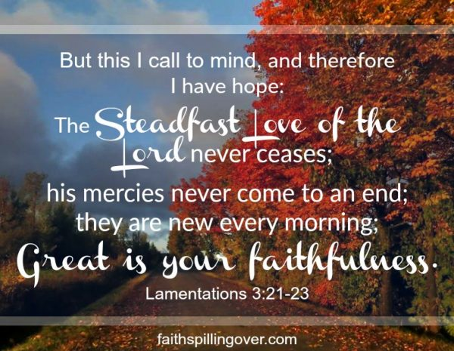 | Monday | Composer launch | JH HS & KA
 | Tuesday | KS2 Worship – The Parable of the Mustard Seed | Rev Callum  JM & HP
 | Wednesday | https://www.assemblies.org.uk/pri/3892/secret-room | CHa and Y6  LE & PA
 | Thursday | KS1 – Godly Play Joseph | CS and KS1 staff
 | Friday | Celebration Worship | CS and all
Week 2 11/11/24  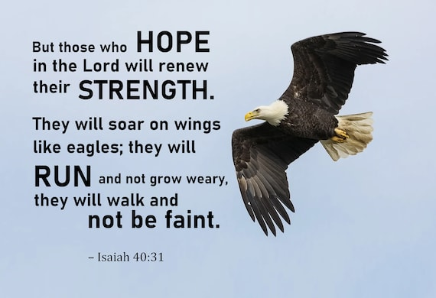 | Monday | Singing Worship | JH  EC & NH
 | Tuesday | KS1 Jesus heals a paralysed man | Rev Callum  FD & DW
 | Wednesday | https://www.assemblies.org.uk/pri/3288/hope-in-a-hard-place | JM and Y5  EB & JH
 | Thursday | KS2 Window on the world | CS and KS2 staff
 | Friday | Remembrance Worship Y2-6 | CS and Y2-6 staff
Week 3 18/11/24  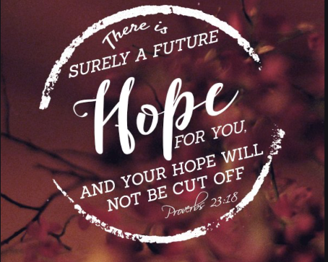 | Monday | Singing worship | JH  HS & LE
 | Tuesday | KS2 Jesus heals a man with leprosy | Rev Callum  CHa & NH
 | Wednesday | https://www.assemblies.org.uk/pri/3627/hopes-dreams-and-the-future | PA and Y4  KA & EC
 | Thursday | KS1 Godly Play | CS and KS1 staff
 | Friday | Celebration worship | CS and all staff
Week 4 25/11/24   | Monday | Singing Worship | JH  EB & EC
 | Tuesday | KS1 Gideon | Rev Callum  FD & DW
 | Wednesday | https://www.assemblies.org.uk/pri/2650/wishful-thinking | EC and Y3  PA & HP
 | Thursday | KS2 Window on the world | CS and KS2 staff
 | Friday | Celebration Worship | CS and all staff
Week 5 2/12/24   | Monday | Singing worship | JH  JM & DW
 | Tuesday | KS2 Simeon and Anna – light in the darkness | Rev Callum  CHa & NH
 | Wednesday | https://www.assemblies.org.uk/pri/4403/its-so-dark | HS and Y2  FD & HP
 | Thursday | KS1 Godly Play Advent | CS and KS1 staff
 | Friday | Celebration worship | CS and all staff
Week 6 9/12/24  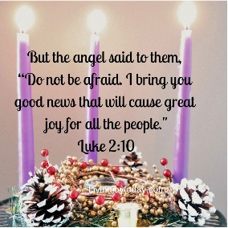 | Monday | Singing Worship | JH  EB & EC
 | Tuesday | KS1 Christmas hope | Rev Callum  FD & DW
 | Wednesday | https://www.assemblies.org.uk/pri/3818/pause-for-thought-a-hopefilled-christmas | FD and Rec  PA & KA
 | Thursday | No worship due to nativity
 | Friday | Privilege cards and afternoon tea | CS and all staff
Week 7 16/12/24   | Monday | Carol Service Practise | JH
 | Tuesday | RE Pause Day worship | CS
 | Wednesday | Carol Service Practise | All
 | Thursday | Christmas Carol Service Y1-6 1.30pm church | CS and Rev C
 | Friday | Christmas Worship | CS
Songs | 10,000 Reasons https://www.youtube.com/watch?v=DXDGE_lRI0E&t=1s  Our God is Great Big God https://www.youtube.com/watch?v=eaXPXWBcE3I  Hope will Rise https://www.youtube.com/watch?v=luZKtkTTiD0  Hope https://www.youtube.com/watch?v=u_JUlnIlLts  Christmas songs from Christmas Play

