Multisensory Learning for Teaching Reading
Introducing and Reinforcing Words and Sounds in 1-1 sessions

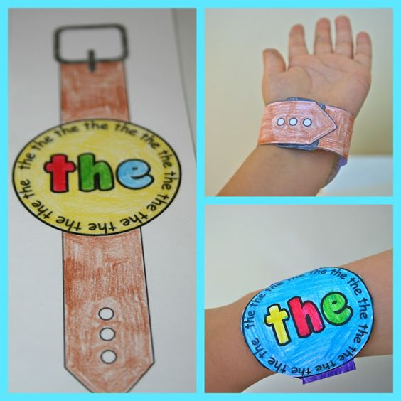  Watch Words  Tricky word? Make a watch to wear! | 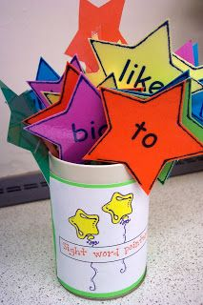  Star Words  Using different colours can help children remember words | 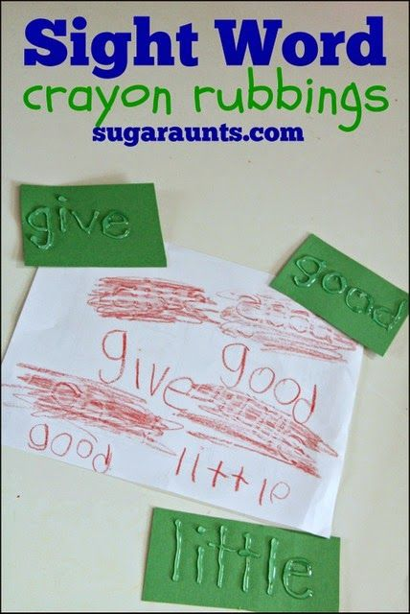  Word Rubbing  Rub over the raised word
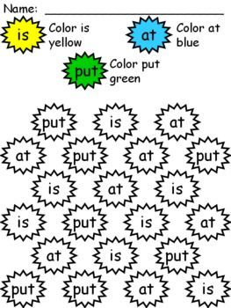  Colour the Word | 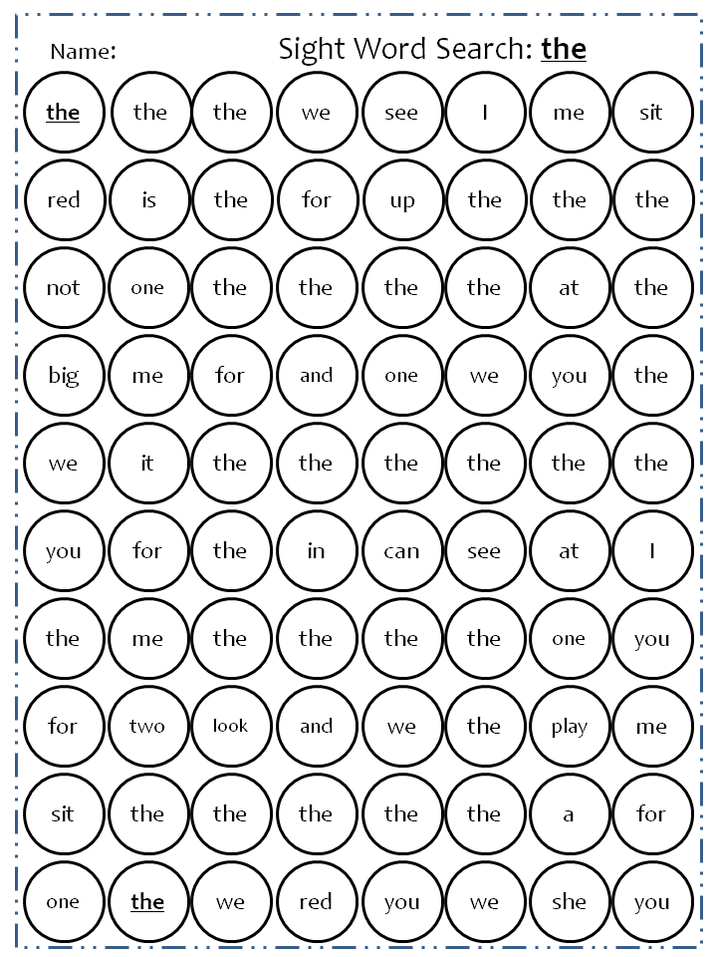  Search the word  Highlight a specific word on a page of words | 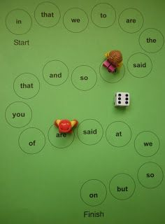  Word Trail  Say the word when you land on it.

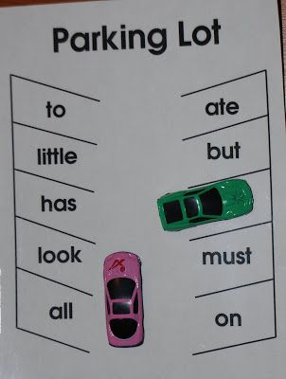  Car Park  Hear the word and park the car in the correct bay | 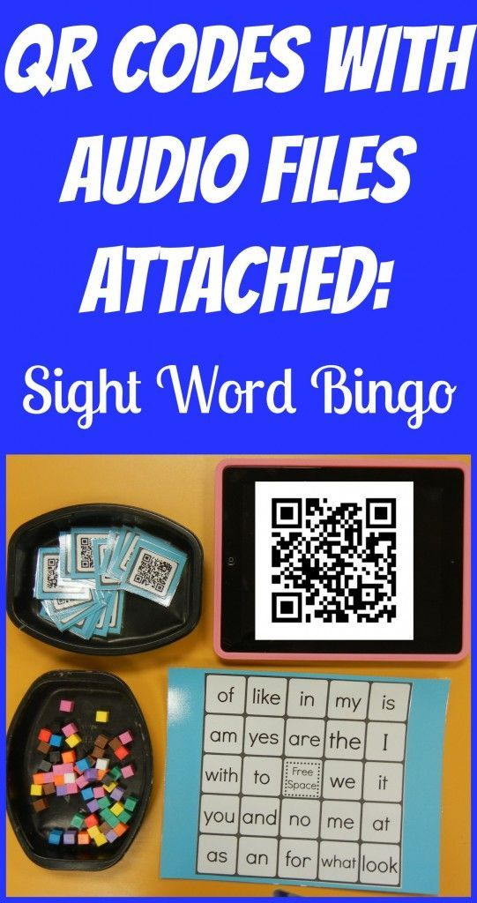  QR Codes  Match the Word  Use the app to scan the code which links to the word being spoken. | QR Codes  Search the Word  Use the app to scan the code which links to a word file of the written word
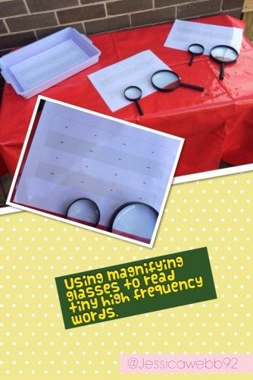  Magnifying Words  Use a magnifying glass to read tiny words | 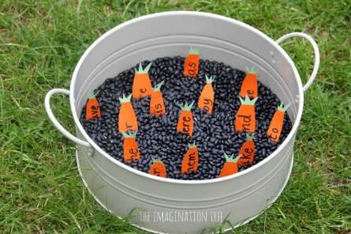  Digging for Carrots  Write words on carrot shaped card and go digging! | 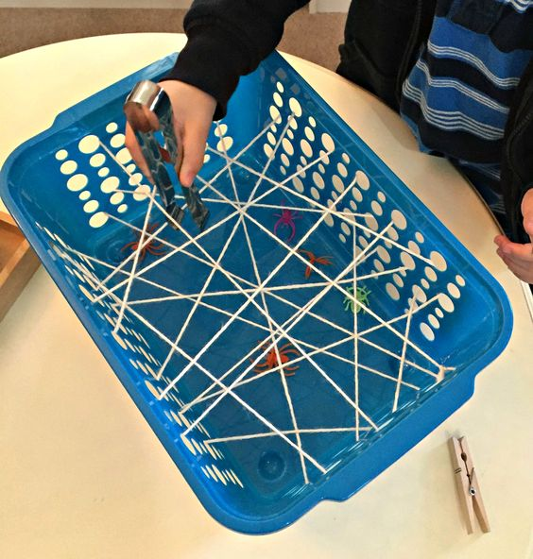  Spider’s Web (small)  Hide words in the web to be rescued!
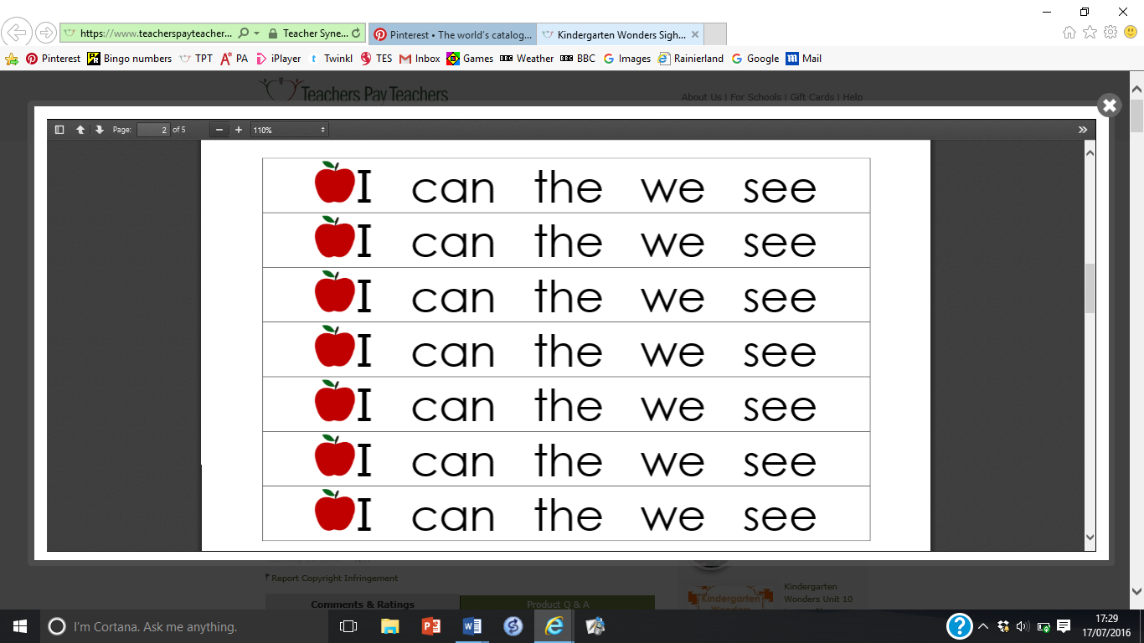  Bracelets | 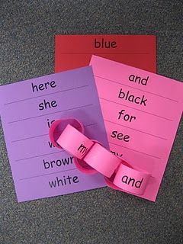  Paperchain  Make a paperchain of the words the child knows. | 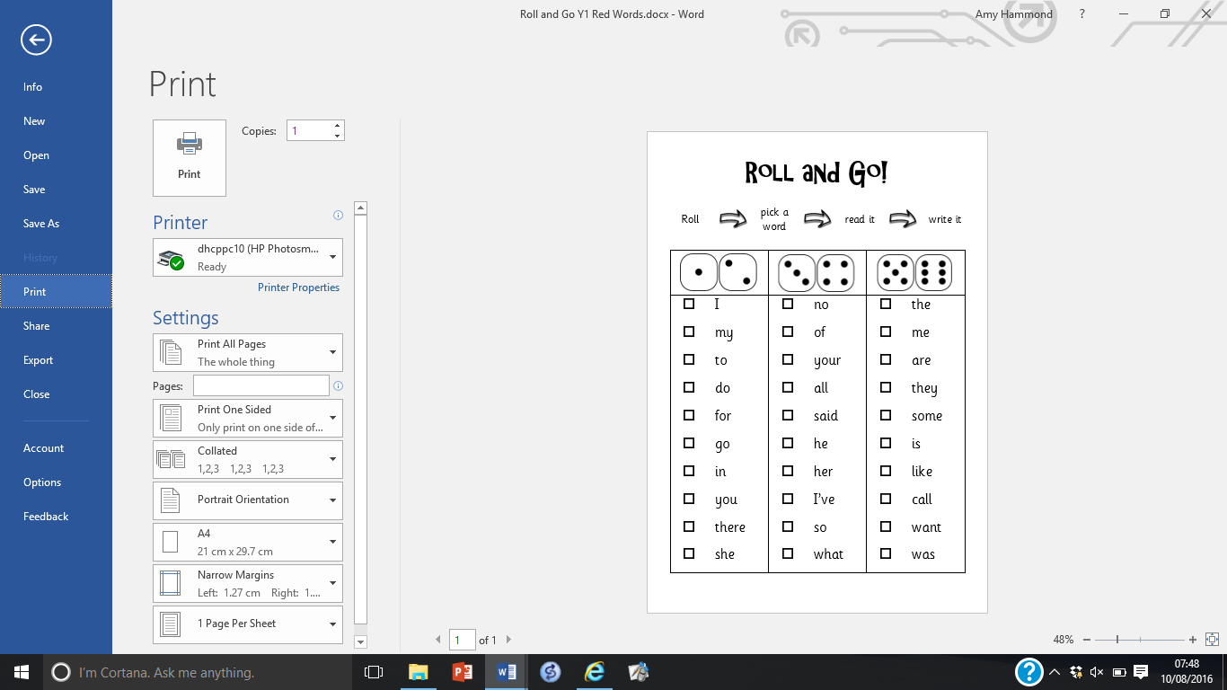  Roll and Go
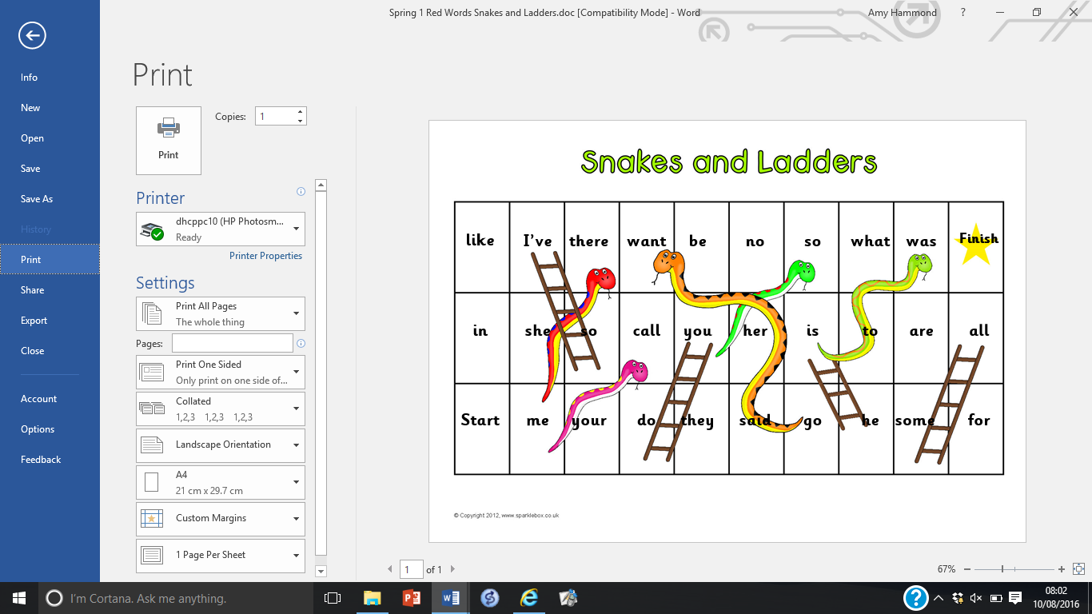  Snakes and Ladders | 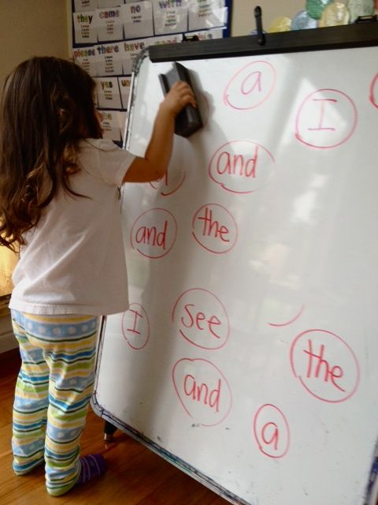  Mini Whiteboard  Say a word and the child rubs it out when they find it | 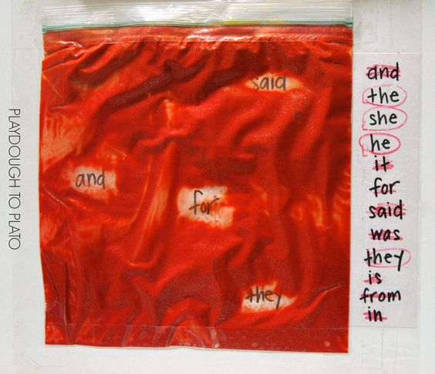  Hide words in a bag with dry sand. Move the sand around to find the words.
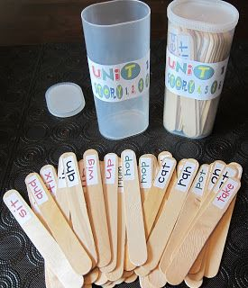  words on sticks – collect the ones they know. | 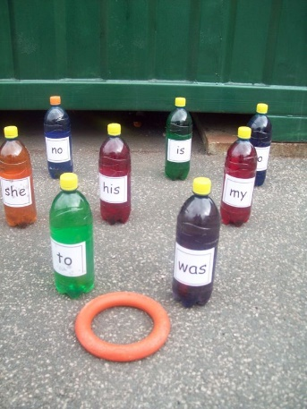  Throw the quoit over a bottle and say the word | 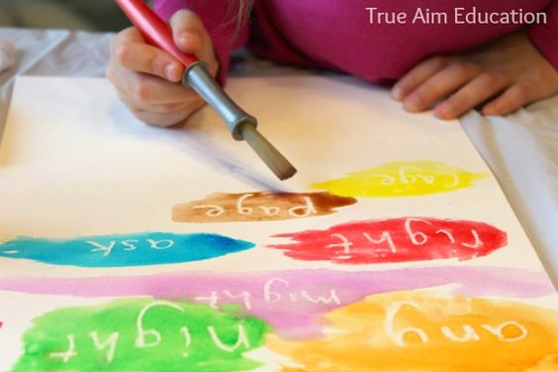  Use white crayons to write invisible words on the paper. Use paint or pens to make these words appear!
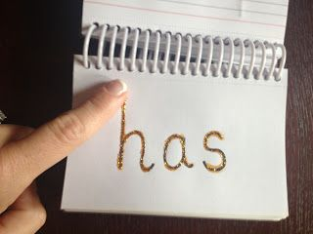  Use glitter glue to write words for the children to trace and read | 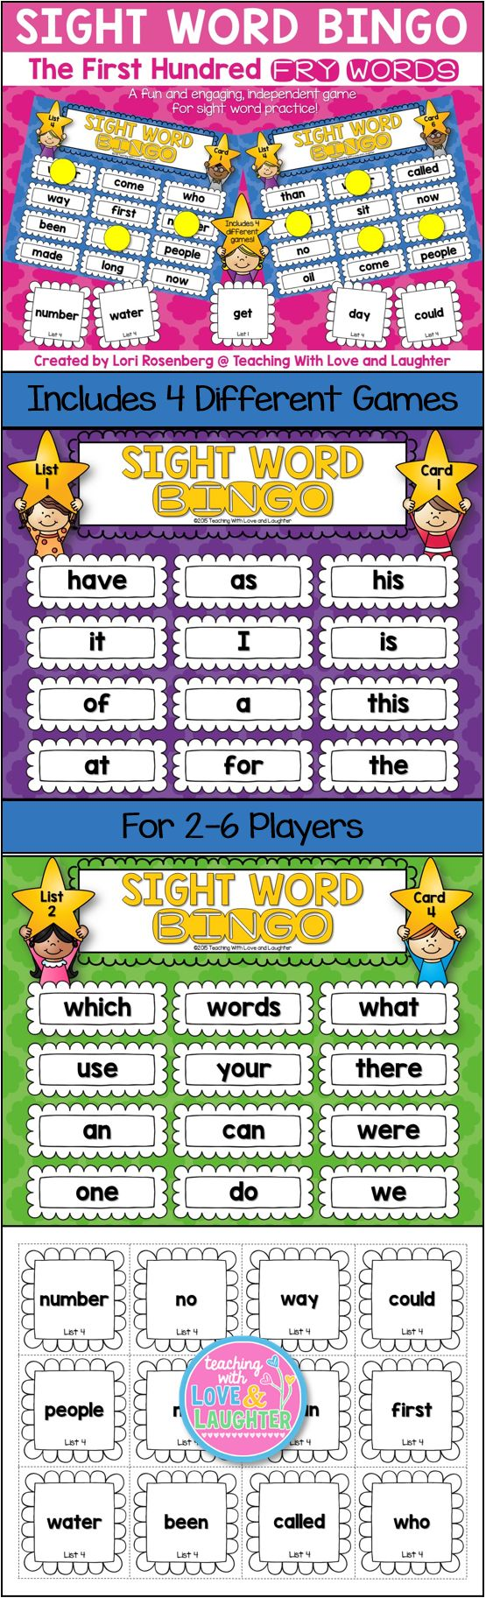  Play a bingo game with words. | 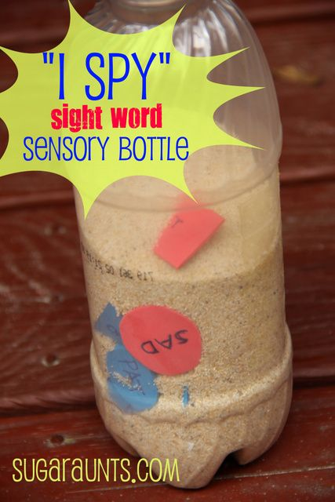  Shake the bottle to find the words

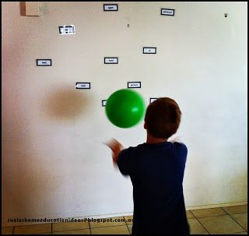  Throw the ball at the word and say it | 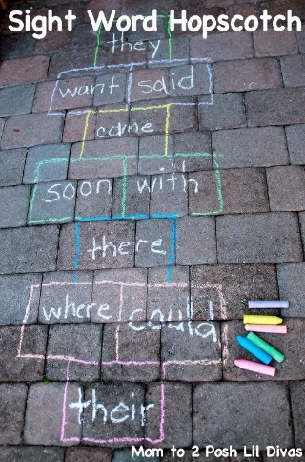  Say the word they can’t land on/say the words as they land on them | 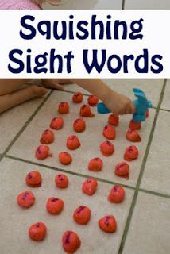  Place words on small balls of playdough. Say a word and the child has to hammer it down!
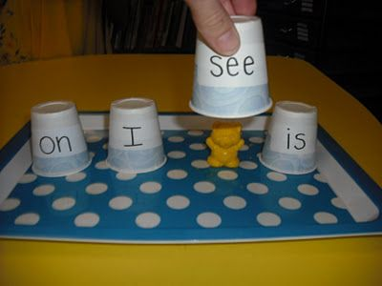  Where’s the bear? | 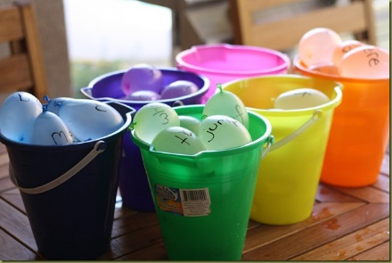  Water Balloons  Say the word and throw the balloon.  Could also be used with normal balloons. | 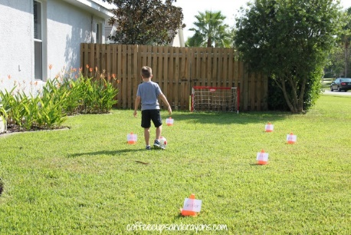  Dribbling skills round words. Fix words to cones and the child dribbles the ball around the cone, sayng the word.
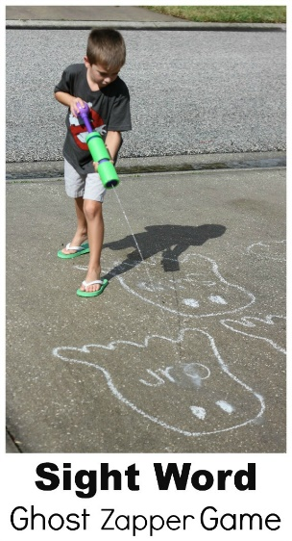  Zap the words with a water gun. | 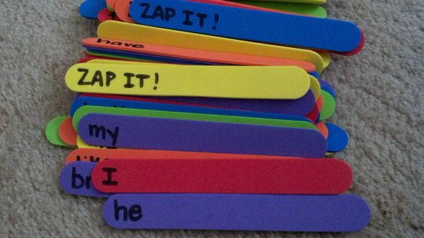  Zap It!  Children take a stick out of the pot and read the word. If they get a Zap It they lose their sticks! | 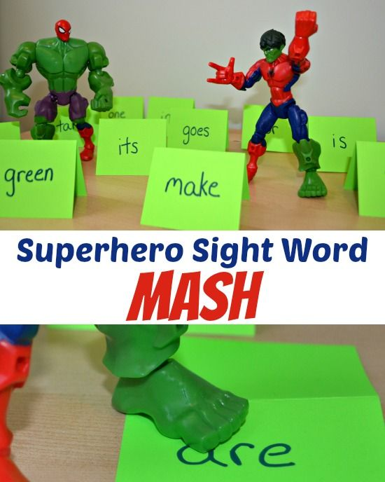  Smash the word with the superhero when you hear it/say the word and smash the word

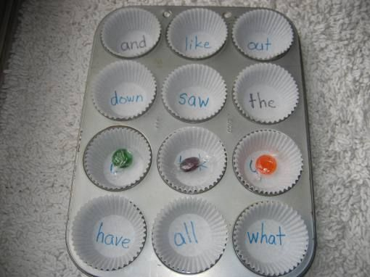
Pop a bean in the case when you hear the word/say the word.

Multisensory Learning for Teaching Reading
Group Games

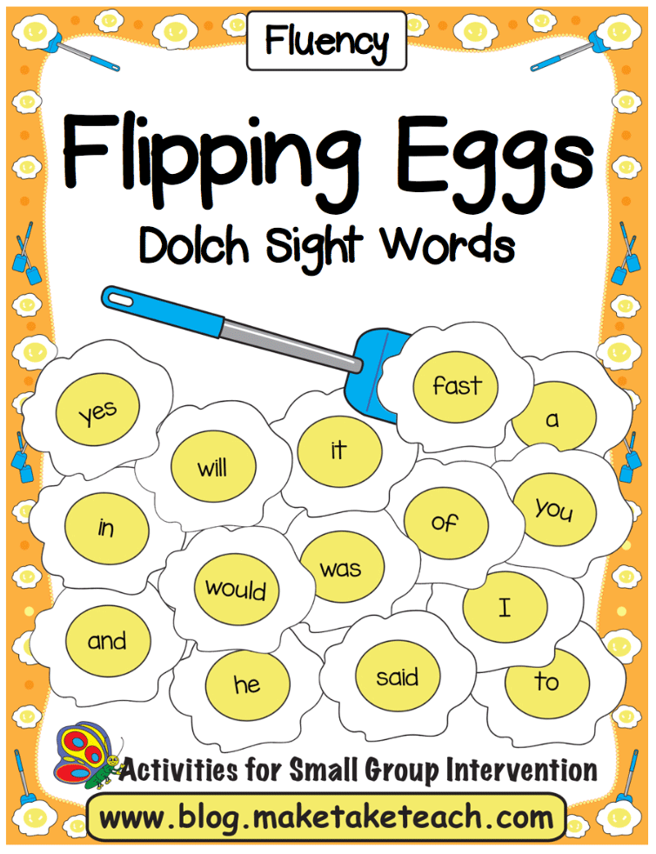  Flip the Egg  Say a word and flip the egg when you find it | 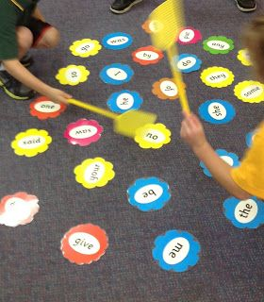  Grab the Flower  First one to swat the word keeps it! | 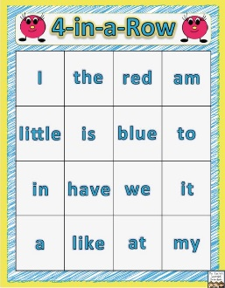  Four in a row  Take turns to read words and put a counter on each one you say. Try and get 4 counters in a row to win – and block your partner!
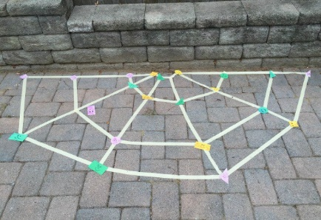  Spider’s Web  Rescue the bugs by walking through the spider web  Make the web using masking tape and have words on the back of the bugs. Say the word, rescue the bug! | 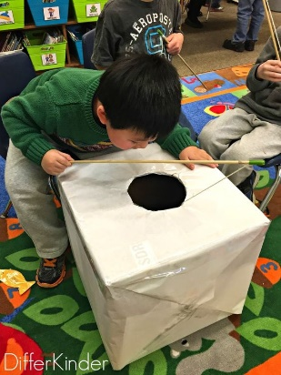  Ice Fishing  Use sticks with magnets on to catch the fish in the box. | 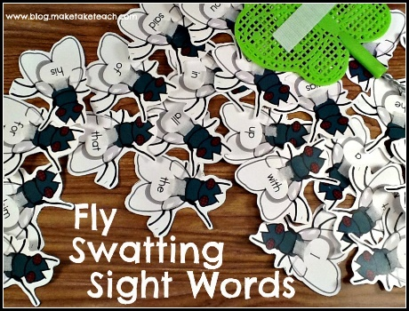  Fly Swat  Invite children in pairs to race each other to be the first to swat the fly with the given word on it.

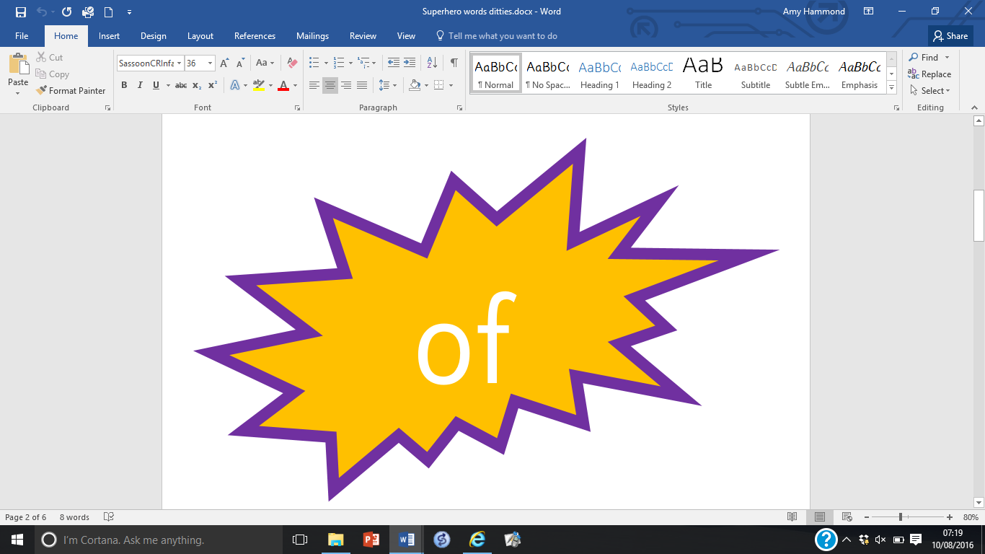  Superhero Sight Words  Display these on a wall or on the floor and aim bean bags at a word as you say it. | 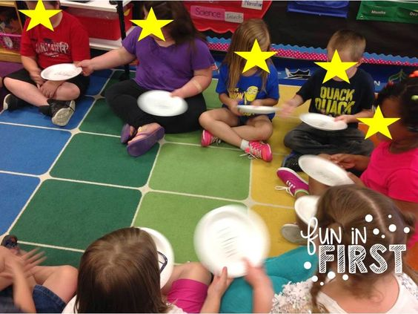  Pass the Plate Words...music stops...go around and say word on your plate | 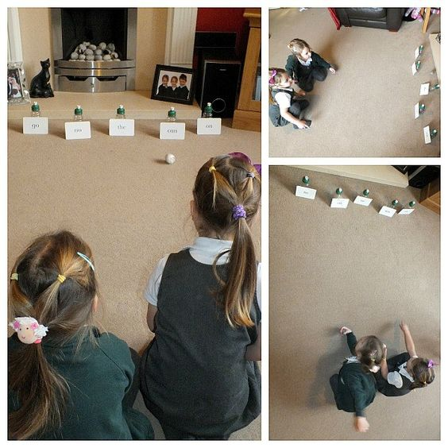  Roll the ball to the words and say the word
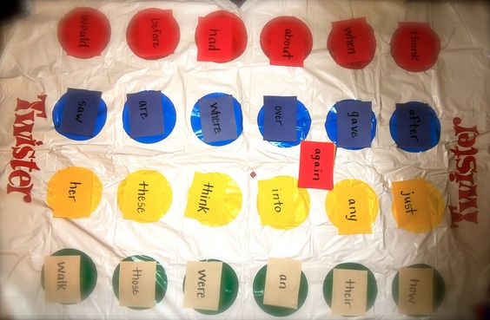  Play Twister! | 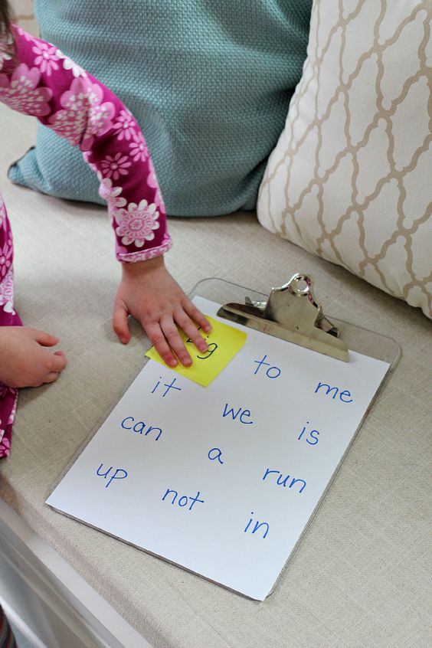  Have a scavenger hunt to find the words on the list | 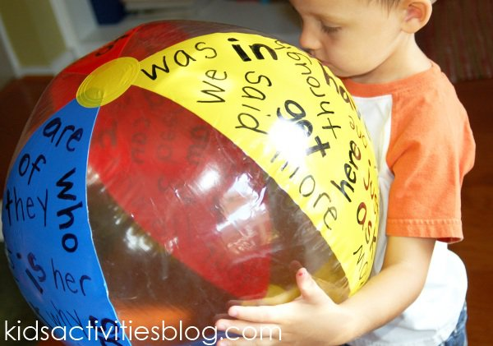  Write words on a beach ball. As the child throws the ball he/she has to say one of the words.
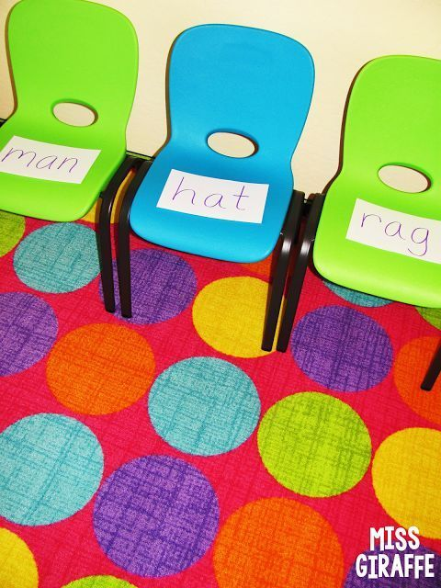  Play musical chairs: when the music stops, stand in front of a chair, pick up the card, read it then sit down. | 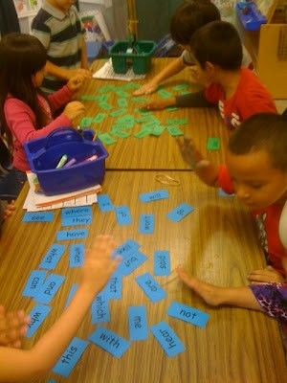  Word slam! Say a word and the first person to find it, slaps it! | 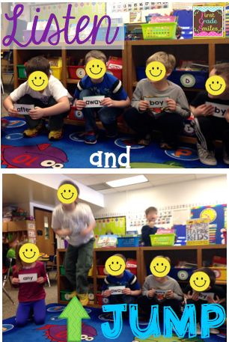  Each child has a word on a card. When they hear their word, jump up! Move the cards round the circle so they get a mixture of words to read.

Multisensory Learning for Teaching Reading
Learning to spell
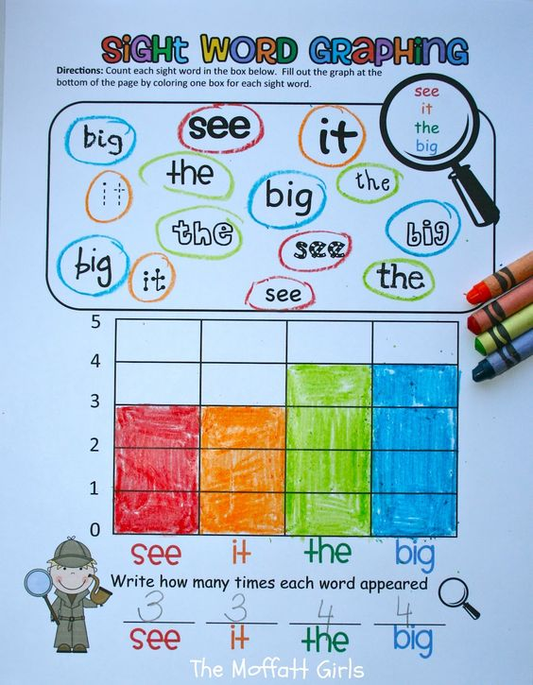  Graph the words | 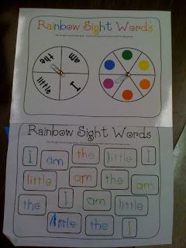  Rainbow Words | 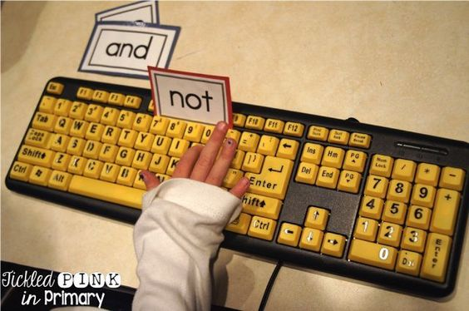  Keyboard  Type out words on a keyboard
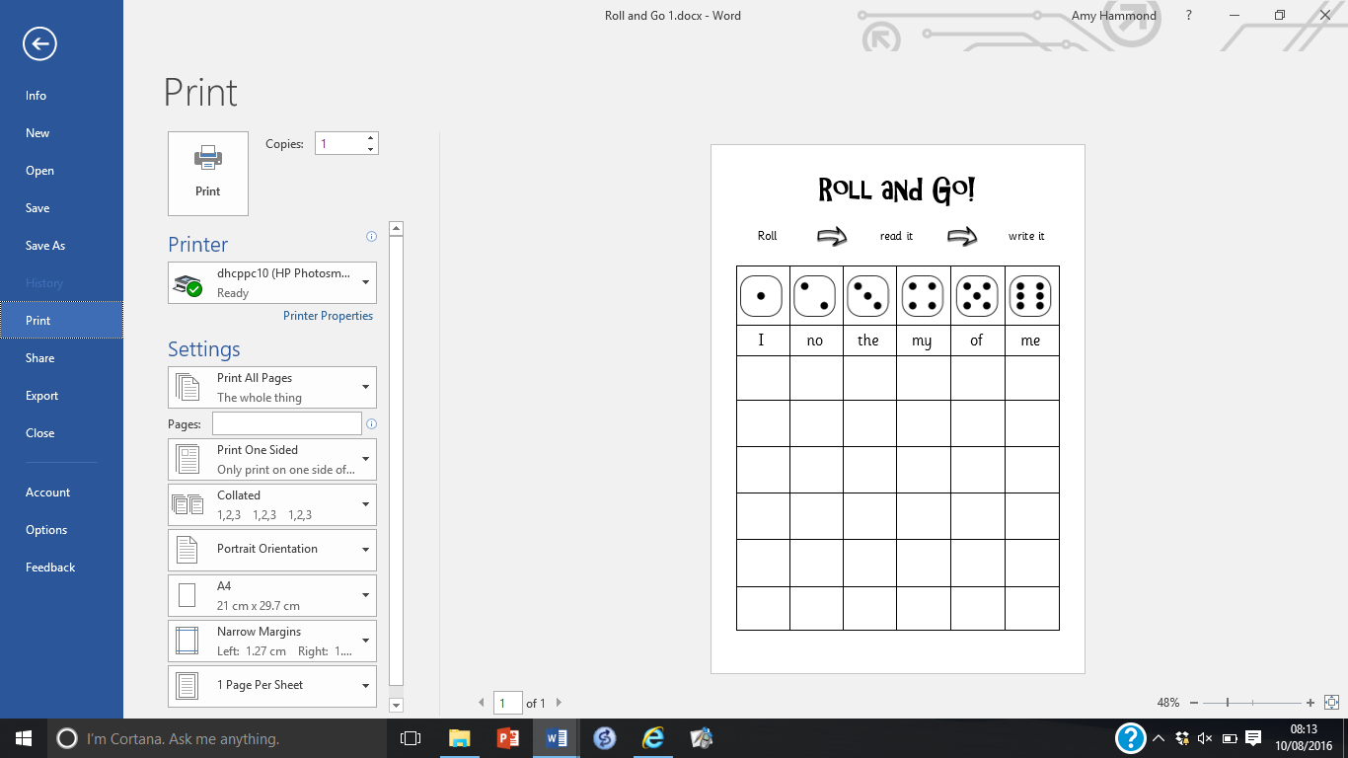  Roll and Go | 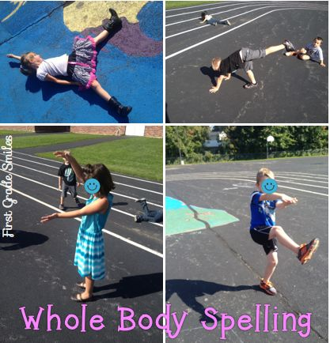  Make shapes with your body for each letter in the word | 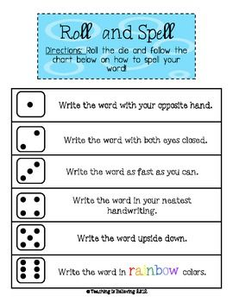
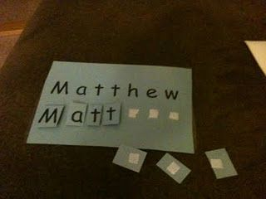  Use letters on Velcro to help children learn the right word order | 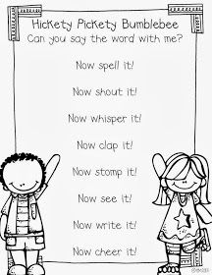 | 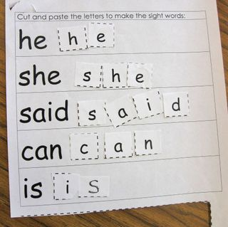  Practise the order of letters in words
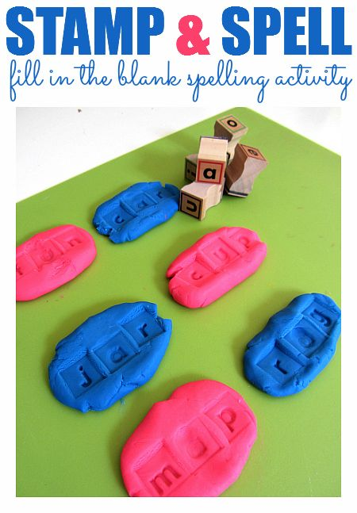  Use letter stamps to make the word in playdough. | 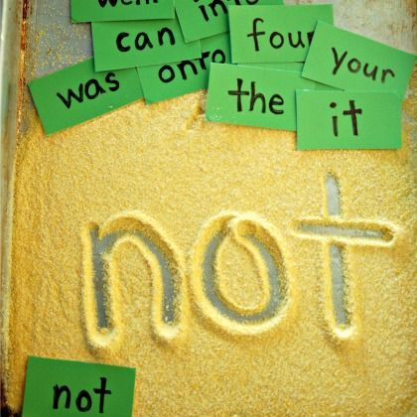  Use different materials to make the words in, such as sand, shaving foam, rice etc | 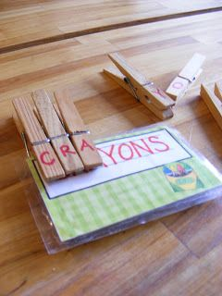  Match the letters in the word with the letters on the pegs
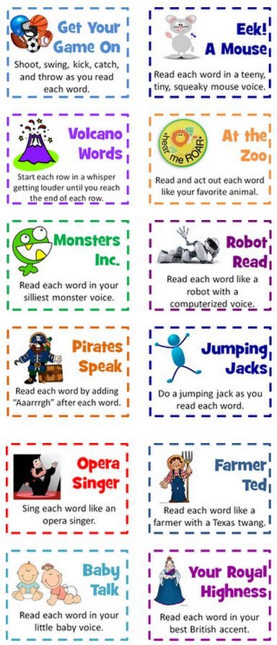  Silly ways of saying/spelling words | 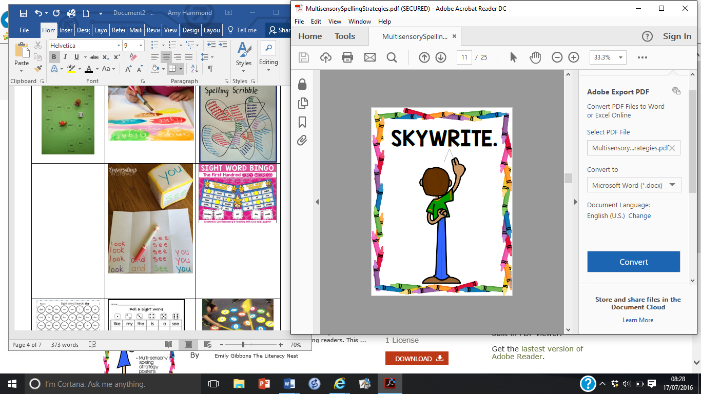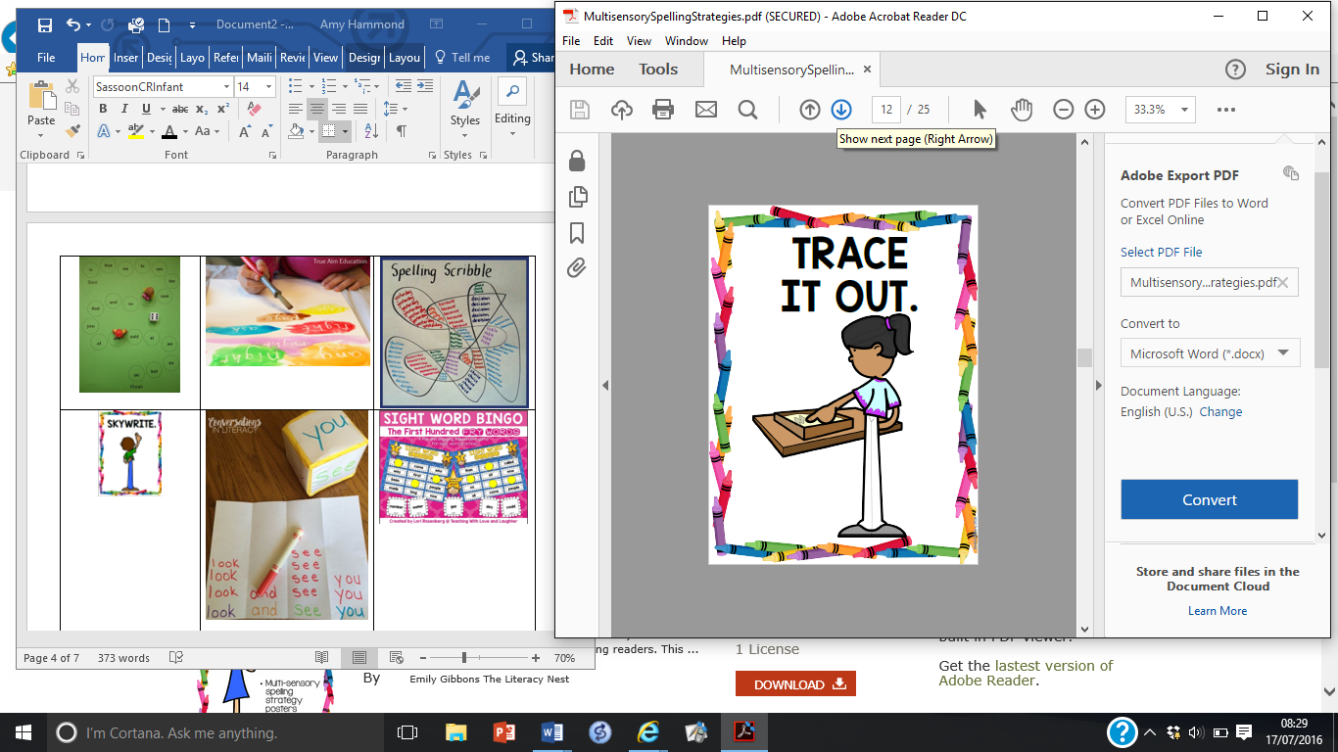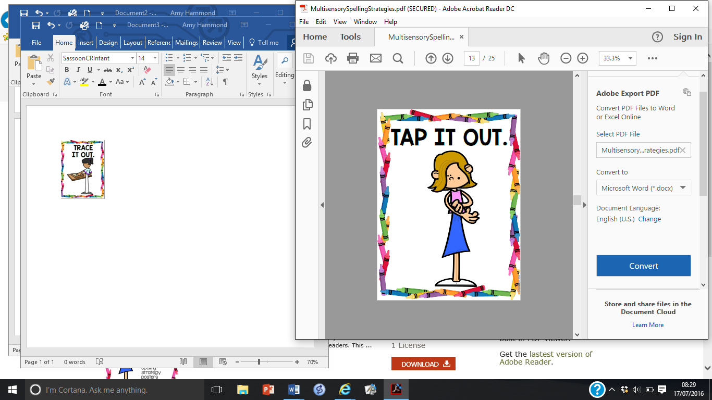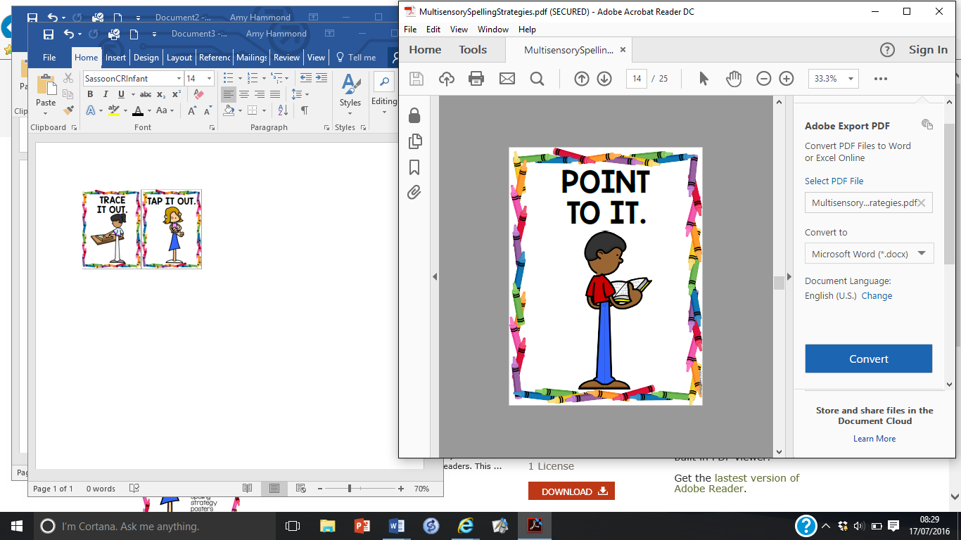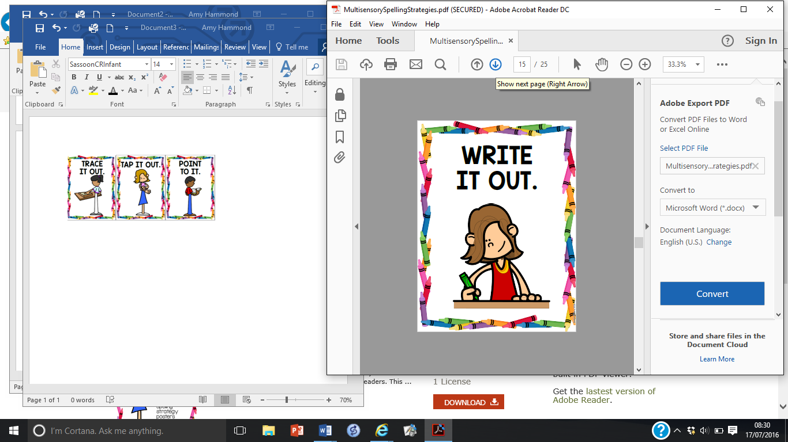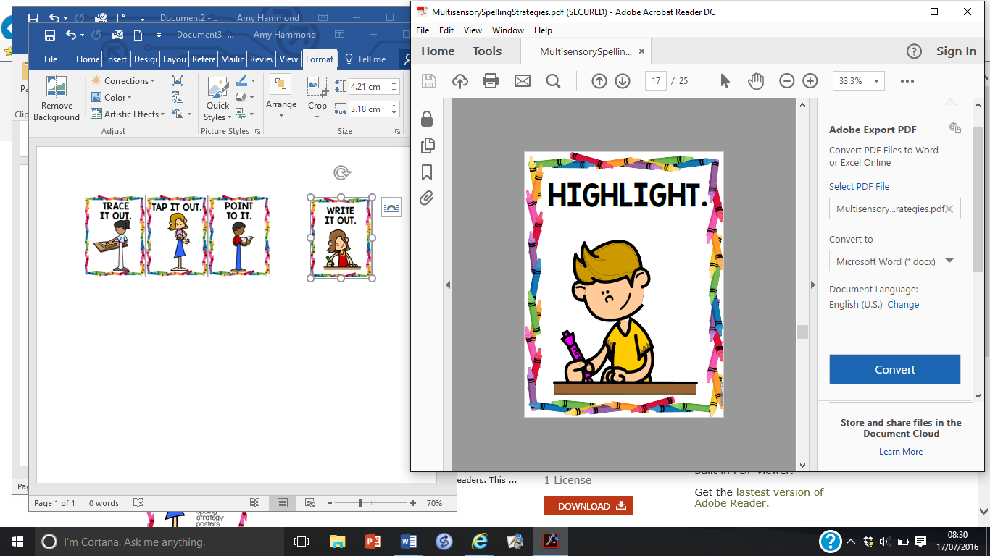 | 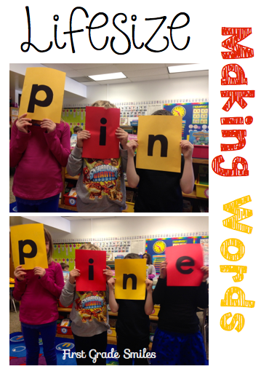  Make life-sized letters to make the word
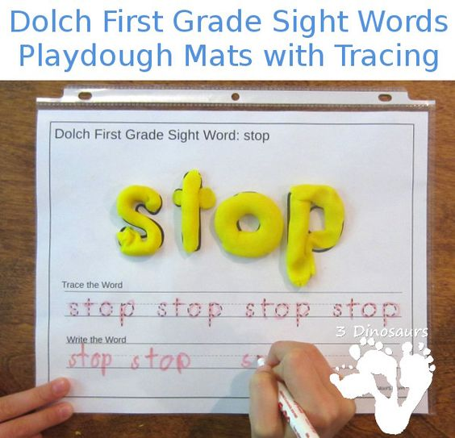
Use playdough to make the word
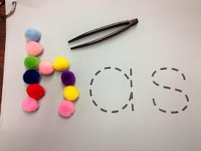  Practise the shapes of words by placing small objects around the letters | 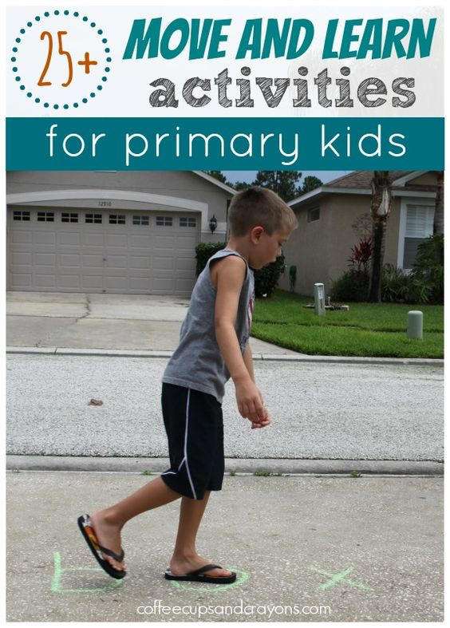  Say the sound as you tread on the letter | 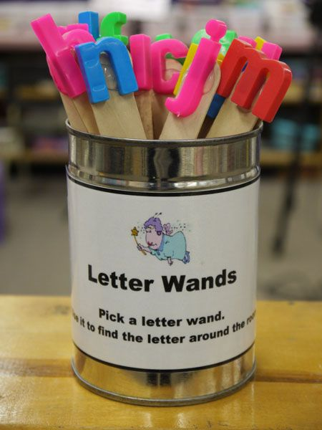  Use the letters to make the word

