# Bridging summer work 2024

Averages

1) Fill in the definition for each different type of average.

|  |  |
| --- | --- |
| Average | Definition |
| Mean |  |
| Mode |  |
| Median |  |
| Range |  |
| IQR |  |

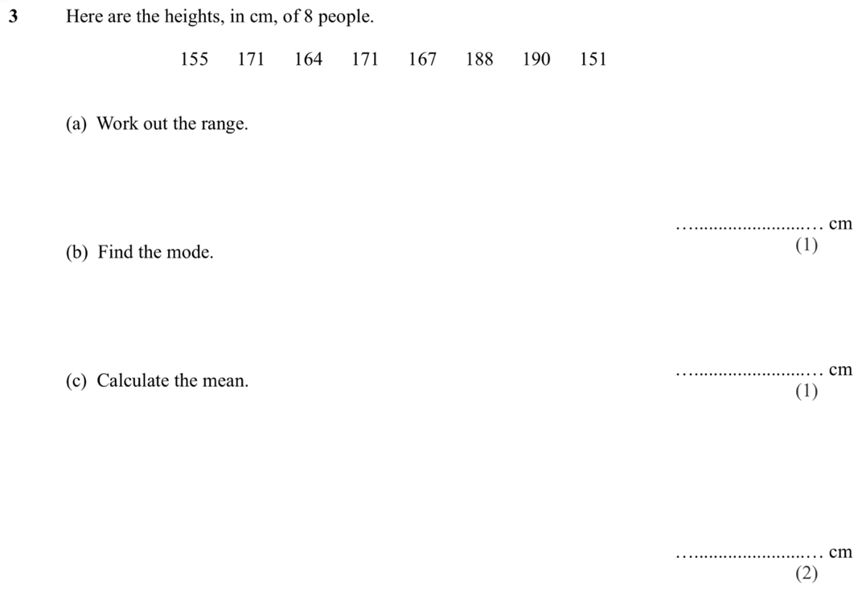2)

3) A teacher surveys a group of students.

He asks how much pocket money they receive each week. They respond:

**£5 £8 £4 £50 £6 £8 £7.50 £10 £8 £7**

(a) Work out the median

(b) Work out the mean

(c) Which average, the median or the mean, is most suitable for this data?

4) James plays six games of darts.

His scores are **120, 71, 80, 14, 90, 117**

Should James use the mean or the median to give him the highest average score?

5) Five numbers have a range of 14.

Four of the numbers are 20, 22, 31 and 25.

Work out the two different possible values for the fifth number.

6) Estimate the median and IQR of the cumulative frequency graph below:

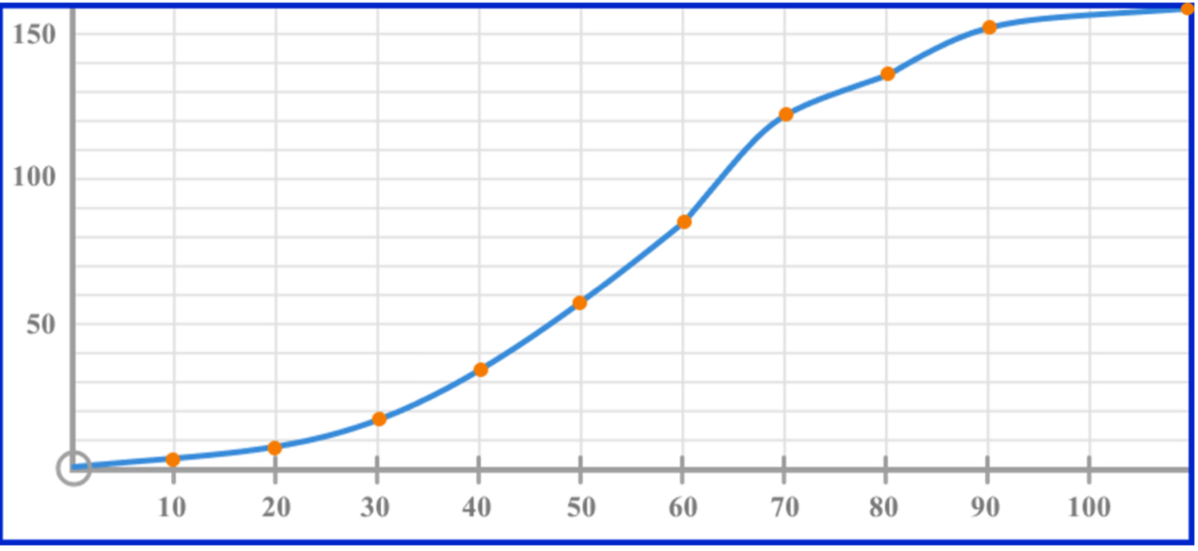

Median -

IQR -

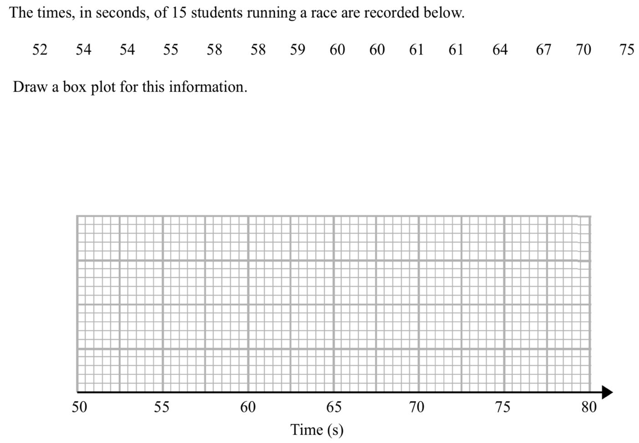

7)

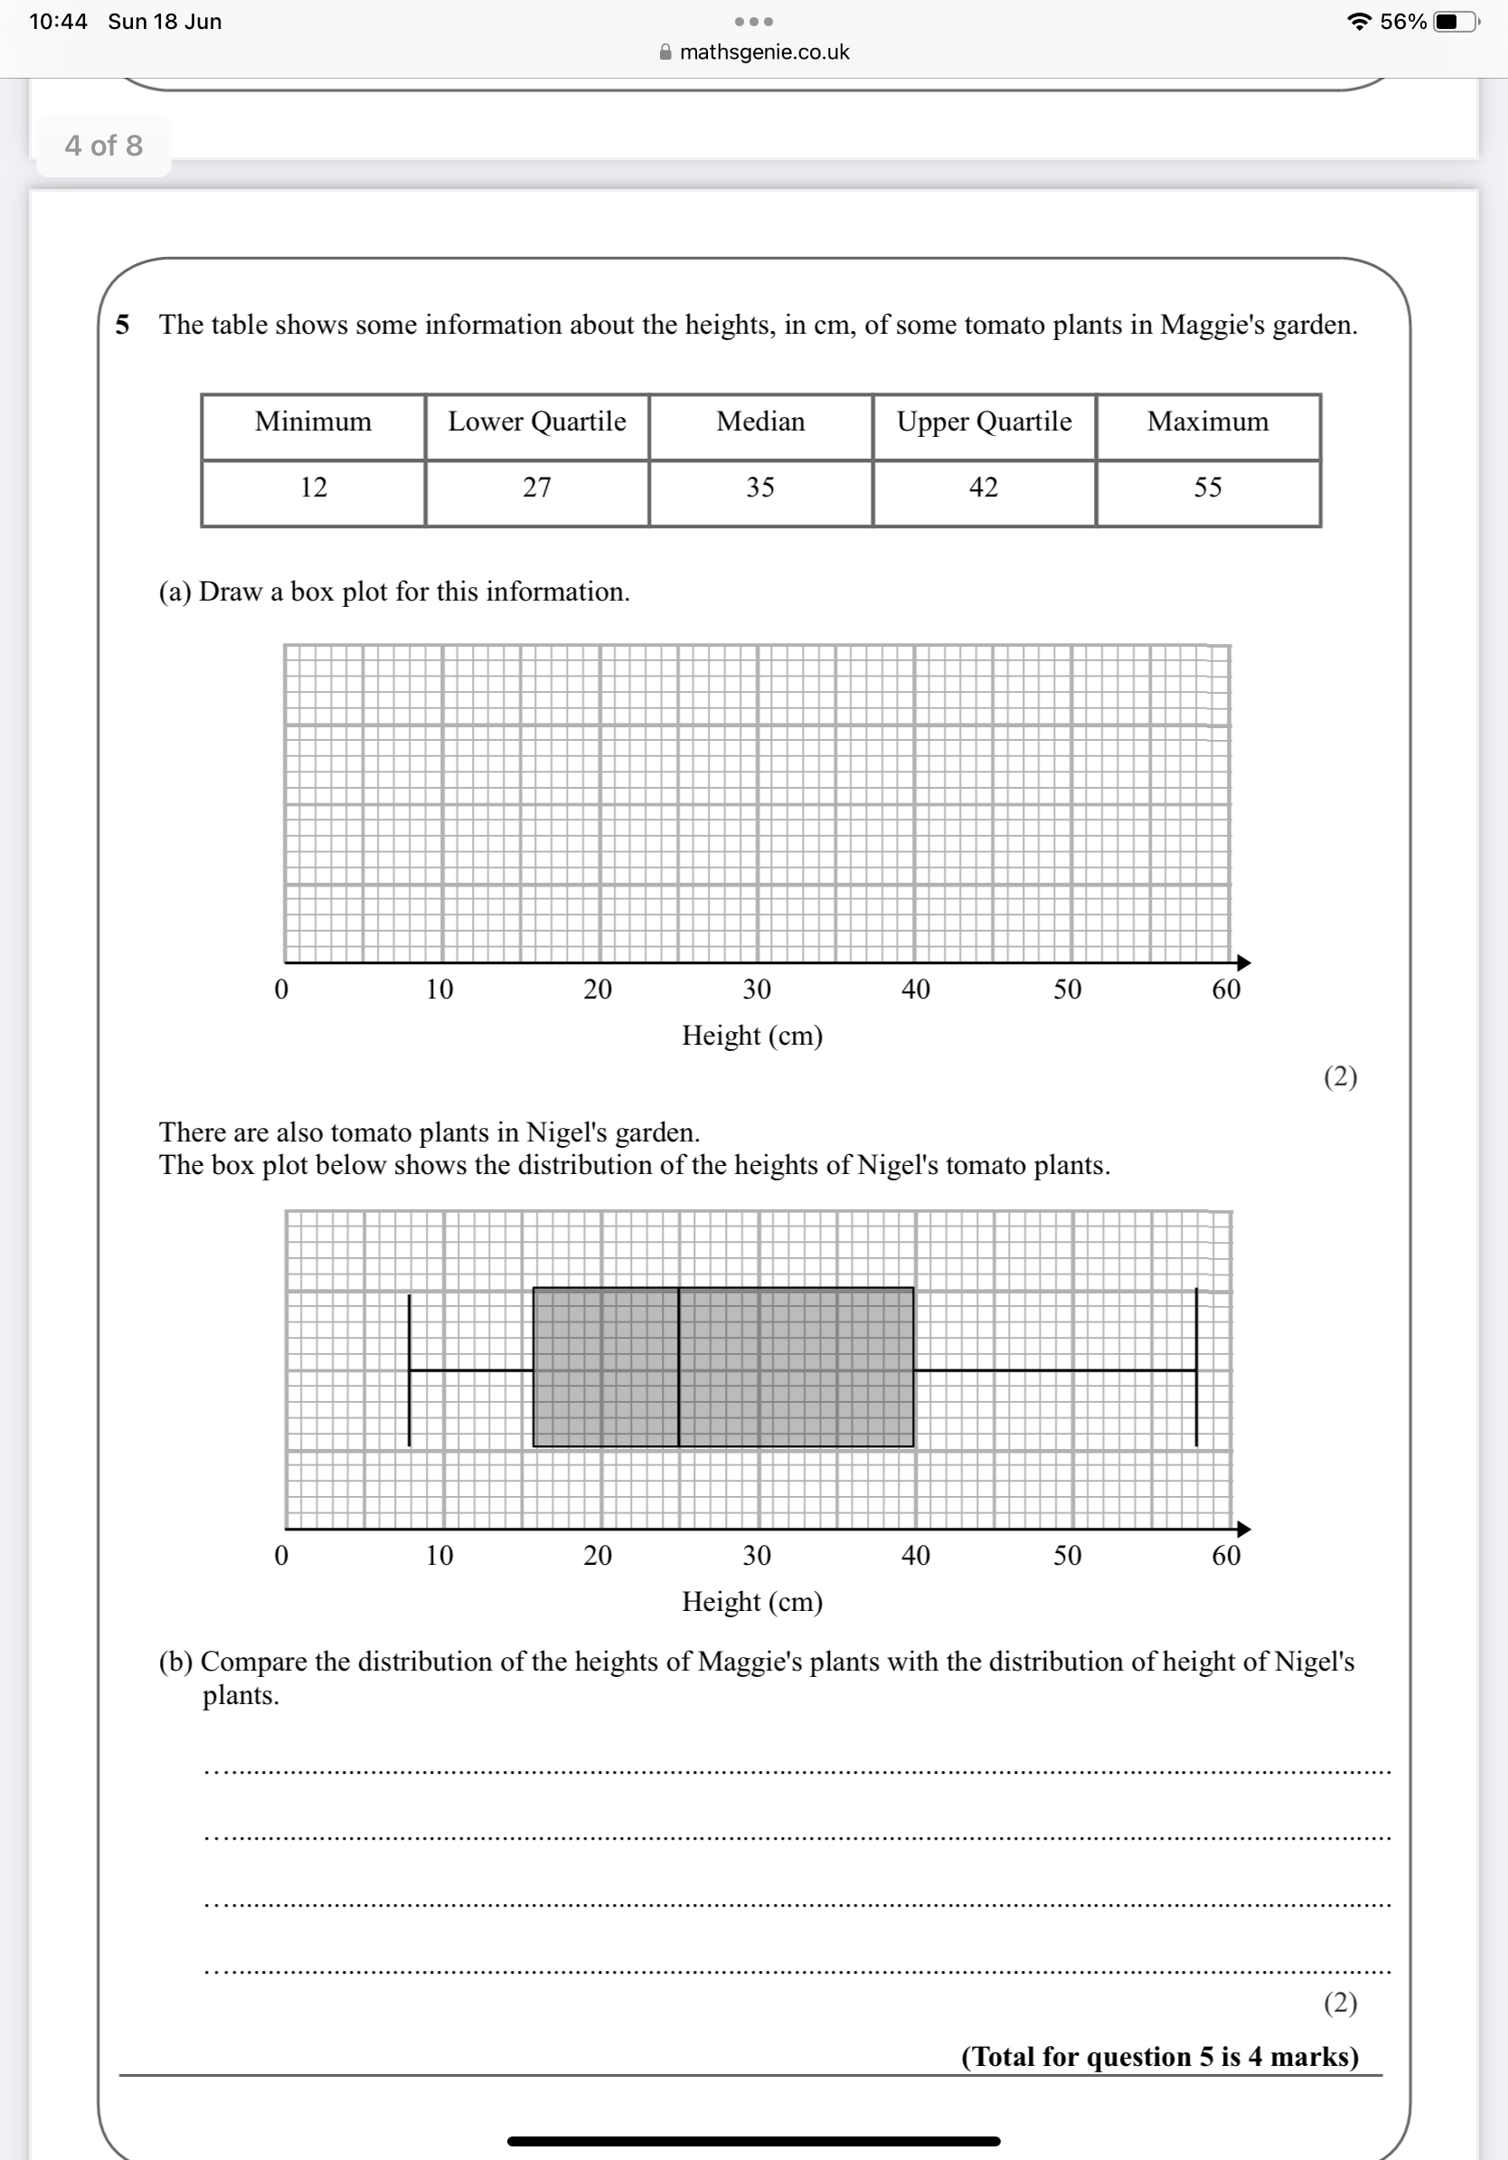8)

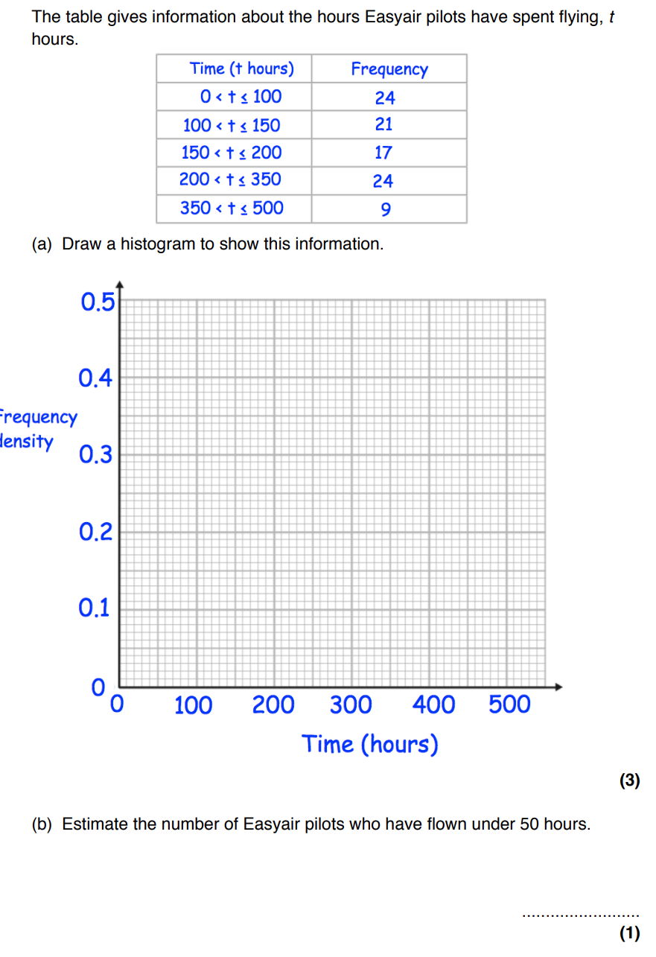9)

10)

