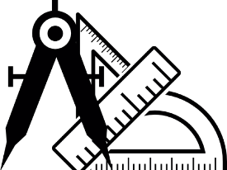
Mathematics
A Level 2024 - 2026
Wigston College

Examination Board
AQA 7357
Entry Requirements:
GCSE Grade 6 Maths
What will I be studying?
You will study Pure Maths (two thirds of the course), Mechanics (one sixth of the course) and Statistics (one sixth of the course). Pure Content – Proof, Algebra and functions, Coordinate geometry in the (x, y) plane, Sequences and series, Trigonometry, Exponentials and logarithms, Differentiation, Integration, Numerical methods and Vectors. Statistics Content – Statistical sampling, Data presentation and interpretation, Probability, Statistical distributions and Statistical hypothesis testing. Mechanics Content – Quantities and units in mechanics, Kinematics, Forces and Newton’s laws and Moments.
How will I be studying?
Students will be set regular homework by each of their teachers, and it is essential that they quickly develop the ability to work independently. For this reason they should not only enjoy maths but also want to follow the course.
How will I be assessed?
The course is assessed externally through three written exam papers sat at the end of the two years, each lasting two hours. There is no coursework element to any Mathematics A level.
Paper 1 – Pure Mathematics. Paper 2 – Pure and Mechanics. Paper 3 – Pure and Statistics
The statistics element in all A level Mathematics courses involves a pre-released, ‘real’ data set that students must become familiar with. This includes the use of technology to support the analysis.
All level 3 Mathematics exams will require students to demonstrate three overarching skills throughout the papers:
- Mathematical argument, language and proof
- Mathematical problem solving
- Mathematical Modelling

Where Next?
Many university courses, and many professions, consider A level Mathematics a desirable entry qualification. In particular you might want to take this A level if you are interested in engineering, computer science, financial services (banking, accountancy etc.), medicine, physical and social sciences.

