Lessons 1 & 2  Conservation and Energy Stores | Lesson 3  Energy Transfers and Energy Diagrams | Lesson 4  Energy Dissipation and Efficiency
Energy is defined as having the ability to do work.  It has a numerical value and is usually measured in Joules (J)  Conservation  to look after something and keep it the same as it has always been.  Conservation of Energy  Energy cannot be created or destroyed, it can only be transferred from one store to another  Energy isn’t something that you can see or pick up – we only notice it when it transferred between different objects and stored in different ways. We use these words to describe energy stores.  Chemical- found in chemical reactions.  Kinetic- found in moving objects.  Gravitational potential- found in objects raised above the ground.  Elastic potential- Energy found in stretched objects.  Magnetic- attraction and repulsion between magnets.  Electrostatic- Attraction and repulsion between charges.  Thermal/ internal - Energy stored as heat e.g. fire.  Nuclear – Energy from the splitting or fusing of atoms. | Energy can be transferred from one store to another but it cannot be created or destroyed. There are 4 energy transfer processes:  - Mechanical - when a force acts and something moves.  - Electrical - when a current flows.  - heating - because of a temperature difference.  - radiation - a wave such as light, IR or sound.  We can show the idea of energy transferring using flow diagrams (energy transfer diagrams)  End Store  Start Store  Transfer Process  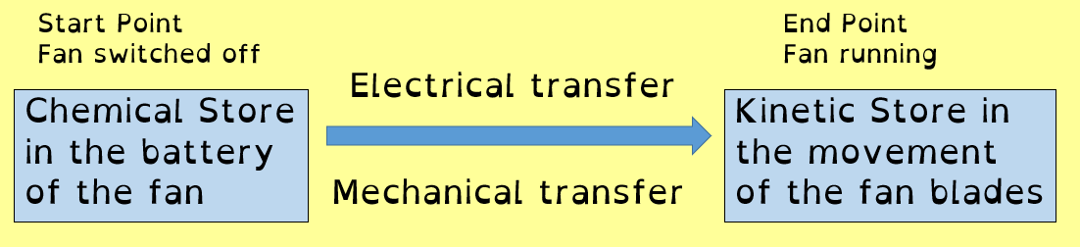  e.g a battery-operated fan | Dissipation of Energy- When energy spreads out it gets less useful.  Input Store - the total amount of energy going into a device or machine.  Output Store - the amount of energy that is transferred into a useful store by the device or machine.  Wasted Store- the amount of energy that is transferred into a wasted store (non-useful store) by the device or machine.  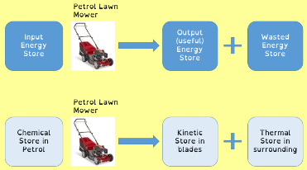  Efficiency - is a measure of how much of the Input energy from a device ends up in a Useful (Output) energy store. The more efficient a machine the less energy is dissipated.  Sankey Diagrams  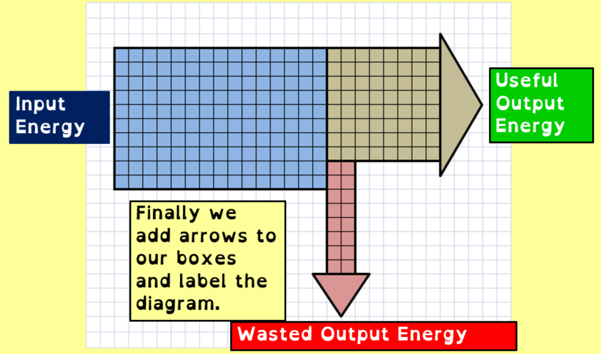
Lessons 5 & 6  Temperature, Heat and Conduction | Lessons 7 & 8  Convection and IR Radiation | Lessons 9 & 10  Reducing Heat Loss
Temperature is a measure of how hot or cold something is  The most commonly used unit for temperature is degrees Celsius °C.  Temperature can also be measured in degrees Fahrenheit °F or Kelvin K. The coldest temperature possible is called Absolute Zero. This is 0K or -273.16 °C.  Using a Thermometer – Always read from the middle of the meniscus at the top or bottom.  Heat (Thermal Energy) - The heat an object contains is the amount of energy in its thermal energy store, measured in joules (J).  Heat Energy depends on two things.  - The mass of the material – the bigger the mass the more heat energy stored  - The temperature of the material – the higher the temperature the more heat energy stored.  Conduction - The transfer of heat energy from particle to particle by vibrations.  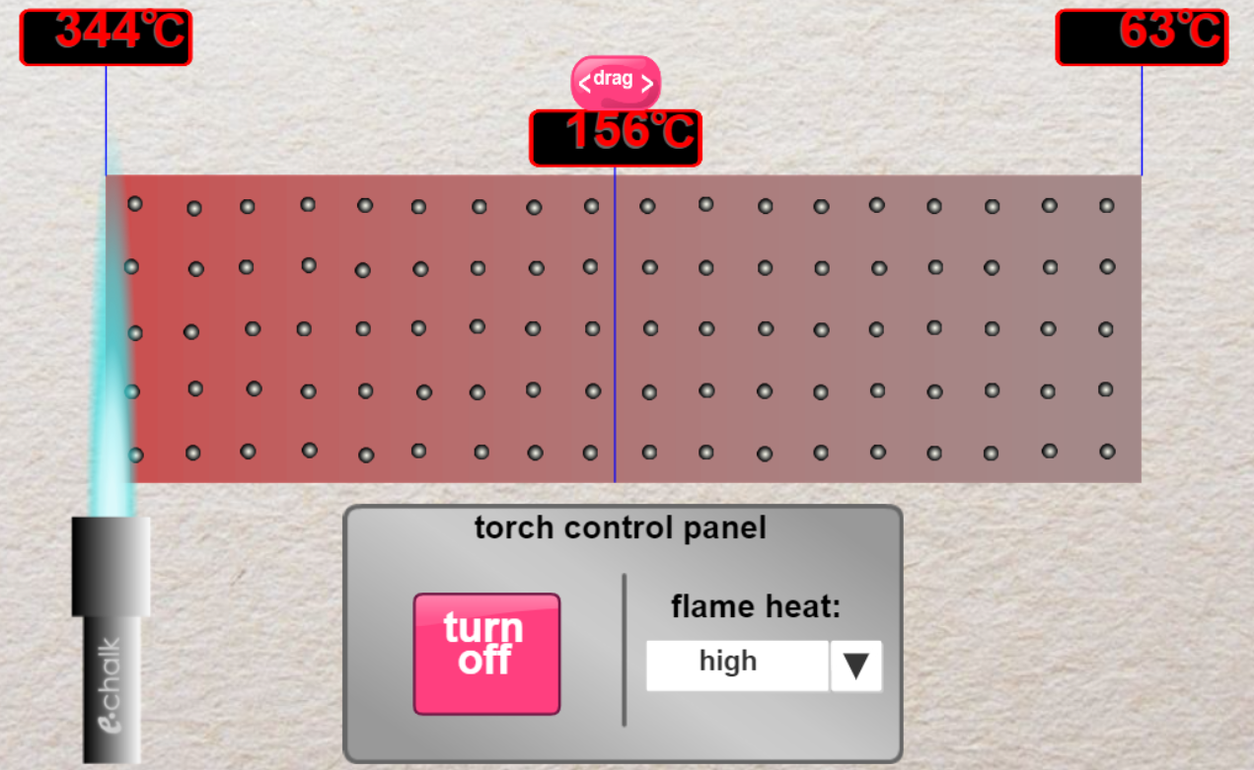 | Convection - the transfer of energy by particles vibrating and carrying their energy with them and is driven by different densities in the gas or liquid.  Convection cannot happen in solids because the particles cannot move past each other, they can only vibrate.  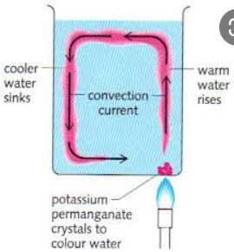  Infra-Red Radiation (IR)  - All warm objects give off Infrared Radiation.  - Infrared Radiation travels in straight lines as waves (like light).  - Infrared will travel out from warm objects in ALL directions.  - Infrared Radiation does NOT need particles to travel through and so can pass through space (vacuum)  - Infrared Radiation travels at the speed of light.  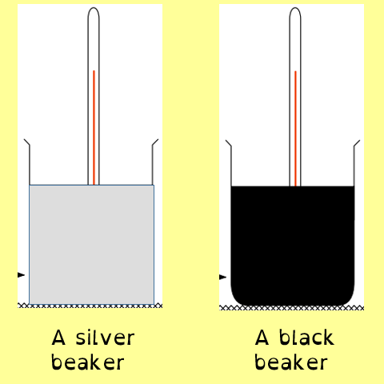 | Dissipation of Energy- When energy spreads out it gets less useful. In our homes we want the thermal energy to be conserved within the walls of our home and not spread out.  A house that dissipates energy easily is a house that will cost more money to keep warm  Heat energy can escape from houses by the processes of Conduction, Convection and IR Radiation  Insulation reduces the energy dissipating.  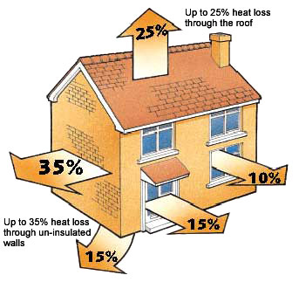  - Loft Insulation  - Cavity Wall Insulation  - Double Glazed Windows  - Draught Proofing  - Curtains and Carpets  - Reflective surfaces behind radiators

